|  |  |
| --- | --- |
|  | |
| National Park Service  U.S. Department of the Interior  Natural Resource Stewardship and Science |  |

Established Invasive Plant Species Monitoring Protocol

Pacific Island Network

*Version 1.01*

Natural Resource Report NPS/PACN/NRR—2012/514

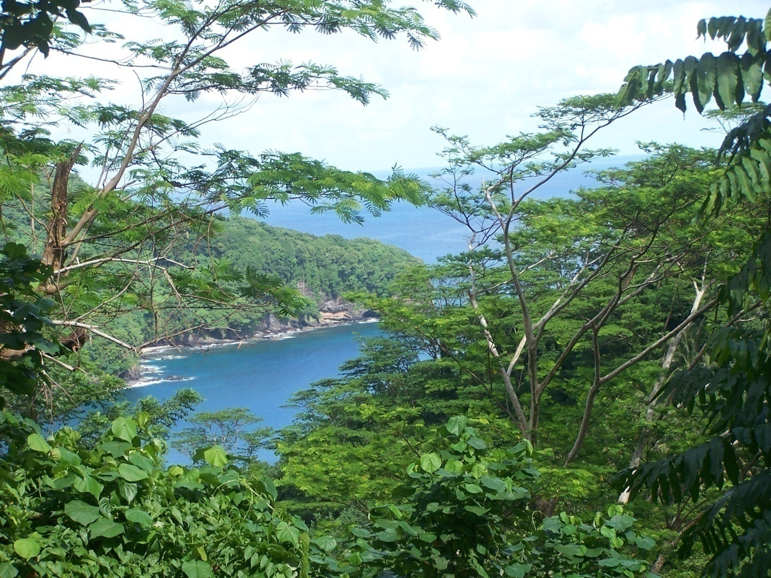

**ON THE COVER**

In and adjacent to the National Park of American Samoa, fast-growing *Falcataria moluccana* trees (known locally as tamaligi) invade and transform wet forest ecosystems.

Established Invasive Plant Species Monitoring Protocol

Pacific Island Network

*Version 1.01*

Natural Resource Report NPS/PACN/NRR—2012/514

Alison Ainsworth1, James D. Jacobi2, Rhonda K. Loh1, Julie A. Christian1, Corie M. Yanger1, and Paul Berkowitz3

1National Park Service  
Pacific Island Network - Inventory and Monitoring Program  
PO Box 52

Hawai‘i National Park, HI 96718

2US Geological Survey  
Pacific Island Ecosystems Research Center  
PO Box 44  
Hawai‘i National Park, HI 96718

3Hawai‘i Pacific Islands Cooperative Ecosystems Studies Unit

University of Hawai‘i at Manoa

Pacific Island Ecosystems Research Center  
PO Box 44

Hawai‘i National Park, HI 96718

April 2012

U.S. Department of the Interior  
National Park Service  
Natural Resource Stewardship and Science Fort Collins, Colorado

The National Park Service, Natural Resource Stewardship and Science office in Fort Collins, Colorado publishes a range of reports that address natural resource topics of interest and applicability to a broad audience in the National Park Service and others in natural resource management, including scientists, conservation and environmental constituencies, and the public.

The Natural Resource Report Series is used to disseminate high-priority, current natural resource management information with managerial application. The series targets a general, diverse audience, and may contain NPS policy considerations or address sensitive issues of management applicability.

All manuscripts in the series receive the appropriate level of peer review to ensure that the information is scientifically credible, technically accurate, appropriately written for the intended audience, and designed and published in a professional manner. This report received formal, high-level peer review based on the importance of its content, or its potentially controversial or precedent-setting nature. Peer review was conducted by highly qualified individuals with subject area technical expertise and was overseen by a peer review manager.

Views, statements, findings, conclusions, recommendations, and data in this report do not necessarily reflect views and policies of the National Park Service, U.S. Department of the Interior. Mention of trade names or commercial products does not constitute endorsement or recommendation for use by the U.S. Government.

This report is available from the Pacific Island Network (<http://science.nature.nps.gov/im/units/pacn/>) and the Natural Resource Publications Management website (<http://www.nature.nps.gov/publications/nrpm/>).

Please cite this publication as:

Ainsworth, A., J. D. Jacobi, R. K. Loh, J. A. Christian, C. Yanger, and P. Berkowitz. 2012. Established invasive plant species monitoring protocol: Pacific Island Network. Version 1.01. Natural Resource Report NPS/PACN/NRR—2012/514. National Park Service, Fort Collins, Colorado.

NPS 988/113810, April 2012

Change History

Only changes in the protocol narrative will be logged here. Version numbers will be incremented by a whole number (e.g., Version 1.3 to Version 2.0) for major changes. Version numbers will be incremented by decimals (e.g., Version 1.6 to Version 1.7) for minor modifications.

The following revisions have occurred to the protocol narrative since February 29,2012.

|  |  |  |  |  |
| --- | --- | --- | --- | --- |
| Version # | Date | Revised by | Changes | Justification |
| 1.01 | 7/27/2012 | Alison Ainsworth | Update responsibilities and safety considerations. | To improve safety and clarify safety responsibilities. |
|  |  |  |  |  |
|  |  |  |  |  |
|  |  |  |  |  |
|  |  |  |  |  |

**Contents**

Page

Figures ix

Tables ix

Appendices xi

Acronyms xv

Executive Summary xvii

Acknowledgements xix

Chapter 1: Background and Objectives 1

Rationale for Monitoring Nonnative Plant Species 1

Established Invasive Plant Species 1

Pacific Islands 2

History of Monitoring Invasive Plant Species 3

Hawai‘i PACN Parks 3

Other PACN Parks 4

Within the State of Hawai‘i 5

Other Inventory and Monitoring Networks 6

Outside Agencies 6

Relationship to other PACN Terrestrial Monitoring Protocols 7

Monitoring Objectives 8

Chapter 2: Sampling Design 9

Rationale for Selection of Sampling Design 9

Target Population 9

Sampling Frame 11

Sampling Units 11

**Contents (continued)**

Page

Selection of Sampling Locations (Spatial Design) 12

Sampling Frequency and Replication (Temporal Design) 14

Level of Change Detection and Management Trigger Points 15

Chapter 3: Field Methods 17

Field Season Preparations 17

Field Methods 17

Locating and Establishing Belt Transects 17

Collecting Data Along Transects 18

After the Field Season 19

Chapter 4: Data Handling, Analysis, and Reporting 21

Project Information Management Overview 21

Pre-season Preparations for Information Management 22

Set Up Project Workspace 22

GPS Loading and Preparation 22

Implement Working Database Copy 22

Overview of Database Design 22

Data Entry and Processing 24

Regular Data Backups 24

Data Verification 24

Field Form Handling Procedures 25

Image Handling Procedures 25

GPS Data Procedures 25

**Contents (continued)**

Page

Data Quality Review 26

Data Edits after Certification 26

Geospatial Data 26

Metadata Procedures 26

Data Certification and Delivery 27

Data Analysis 27

Reporting and Product Development 28

Report Content 28

Standard Report Format 29

Review Products for Sensitive Information 29

Product Delivery, Posting, and Distribution 29

Holding Period for Project Data 29

Special Procedures for Sensitive Information 29

Archival and Records Management 30

Season Close-out 30

Chapter 5: Personnel Requirements and Training 31

Roles and Responsibilities 31

Qualifications and Training 33

Chapter 6: Operational Requirements 35

Annual Workload and Field Requirements 35

Facility and Equipment Needs 36

Startup Costs and Budget Considerations 36

Permits, Permissions and Cooperative Agreements 37

**Contents (continued)**

Page

National Park Service 37

National Environmental Policy Act (NEPA) 38

National Historic Preservation Act (NHPA) 38

State of Hawai‘i 38

Territory of American Samoa 38

Chapter 7: Literature Cited 39

Figures

Page

Figure 4.1. Idealized flow of project information management 21

Tables

Page

Table 2.1. Focal plant communities and number of nonnative species sampling frames selected for monitoring within the selected PACN parks. 10

Table 2.2. Summary of transect allocation by park and sampling frame 12

Table 2.3. Survey schedule for split panel design 14

Table 3.1. Modified Braun-Blanquet cover classes reported for target invasive plant species 18

Table 4.1. Functional comparison of master project database and working database 23

Table 5.1. Roles and responsibilities for the Established Invasive Plant Species Monitoring Protocol 32

Table 6.1. Number of months required for a four person field crew to conduct established invasive plant species monitoring by sampling frame and by cycle year 35

Table 6.2. Annual monitoring costs for the Established Invasive Plant Species Monitoring Protocol…… 37

Appendices

Page

Appendix A. Target Populations and Sampling Frames APP A.1

Appendix B. Vegetation Monitoring in PACN Park Units APP B.1

Appendix C. Sample Size and Power APP C.1

Appendix D. Allocation of Sampling Units to Panel Members APP D.1

Appendix E. Forms for Recording Field Data APP E.1

Appendix F. Established Invasive Plant Monitoring Database Documentation APP F.1

Appendix G. Yearly Project Task List APP G.1

Appendix H. Target Invasive Plant Species List APP H.1

Standard Operating Procedures (SOPs)

Page

Standard Operating Procedure #1: Before the Field Season SOP 1.1

Standard Operating Procedure #2: Training Observers SOP 2.1

Standard Operating Procedure #3: Safety SOP 3.1

Standard Operating Procedure #4: Sanitation SOP 4.1

Standard Operating Procedure #5: Transect Generation SOP 5.1

Standard Operating Procedure #6: Using GPS to Navigate to and Mark Waypoints SOP 6.1

Standard Operating Procedure #7: Sampling Invasive Plant Species SOP 7.1

Standard Operating Procedure #8: Collecting and Vouchering SOP 8.1

Standard Operating Procedure #9: After the Field Season SOP 9.1

Standard Operating Procedure #10: Workspace Setup and Project Records Management SOP 10.1

Standard Operating Procedure #11: Field Data Form Handling SOP 11.1

Standard Operating Procedure #12: Managing Photographic Images SOP 12.1

Standard Operating Procedure #13: Data Entry and Verification SOP 13.1

Standard Operating Procedure #14: Data Quality Review and Certification SOP 14.1

Standard Operating Procedure #15: Metadata Development SOP 15.1

Standard Operating Procedure #16: Sensitive Information SOP 16.1

Standard Operating Procedure #17: Product Delivery Specifications and Schedule SOP 17.1

Standard Operating Procedure #18: Product Posting and Distribution SOP 18.1

Standard Operating Procedure #19: Statistical Data Analysis SOP 19.1

Standard Operating Procedure #20: Reporting SOP 20.1

Standard Operating Procedure #21: Revising the Protocol SOP 21.1

Acronyms

|  |  |
| --- | --- |
| **AMME** | American Memorial National Park |
| **ANOVA** | Analysis of Variance |
| **ANTODO** | *Anthoxanthum odoratum* |
| **Cal-IPC** | California Invasive Plant Council |
| **CYPSPP** | *Cyperus spp.* |
| **EHRSTI** | *Ehrharta stipoides* |
| **FOIA** | Freedom of information Act |
| **FTE** | Fulltime Employment |
| **GIS** | Geographic Information System |
| **GPS** | Global Positioning System |
| **GS** | General Schedule |
| **GzLM** | Generalized Linear Model |
| **HALE** | Haleakalā National Park |
| **HAVO** | Hawai‘i Volcanoes National Park |
| **HOLLAN** | *Holcus lanatus* |
| **I&M** | Inventory & Monitoring Program |
| **KAHO** | Kaloko-Honokōhau National Historical Park |
| **KALA** | Kalaupapa National Park |
| **KF** | Kīlauea Forest |
| **MLBS** | Mauna Loa Boys’ School |
| **MS** | Microsoft |
| **NAWMA** | North American Weed Management Association |
| **NEPA** | National Environmental Policy Act |
| **NHPA** | National Historic Preservation Act |
| **NPS** | National Park Service |
| **NPSA** | National Park of American Samoa |
| **PACN** | Pacific Island Network |
| **PASTAR** | *Passiflora tarminiana* |
| **PK** | Pu‘u Kipu |
| **PSICAT** | *Psidium cattleianum* |
| **PSU** | Primary Sampling Unit |
| **PUHE** | Pu‘ukoholā Heiau National Historic Site |
| **PUHO** | Pu‘uhonua o Hōnaunau National Historical Park |
| **RUBROS** | *Rubus rosifolius* |
| **SE** | Standard Error |
| **SEA** | Special Ecological Area |
| **SETPAL** | *Setaria palmifolia* |
| **SOP** | Standard Operating Procedure |
| **SQL** | Structure Query Language |
| **SRS** | Simple Random Sampling |
| **TSN** | Taxonomic Series Number |
| **USGS** | US Geological Survey |
| **UTM** | Universal Transverse Mercator |
| **VERSER** | *Veronica serpyllifolia* |
| **WAPA** | War in the Pacific National Historical Park |

Executive Summary

This document describes a protocol to monitor nonnative plant species that are established, but still rare in four focal terrestrial plant communities across five national parks within the Pacific Island Network (PACN). Nonnative plant species present a serious threat to Pacific Island ecosystems. Invasion by nonnative plants reduces native plant diversity and abundance, alters vegetation structure, and can lead to significant economic and cultural costs. Nonnative species that have a high potential to severely impact the integrity of terrestrial plant communities and biological diversity through competition and displacement are labeled “invasive.” Prevention of invasion or at least detecting invaders during the initial stages paired with rapid response is the most cost effective defense against invasive species. Once invasive species become established in focal plant communities, detailed distribution and abundance data are necessary to prioritize control efforts.

Long-term monitoring of established nonnative plant species in focal terrestrial plant communities is critical for the effective management of these native ecosystems in PACN parks. These data aid in the identification of new invasive nonnative plant species within specific community types. Due to the high costs of invasive plant management, managers do not have sufficient funds to control all nonnative plant species within focal plant communities. Monitoring provides essential information about the frequency, distribution, and abundance of nonnative species, allowing them to assess changing threats to native ecosystems, formulate appropriate control strategies, and prioritize areas and species for management. Long-term monitoring allows resource managers to evaluate the efficacy of previous management actions such as herbicide treatments, biological controls, ungulate removal, and fencing.

All PACN parks have made efforts to confront invasive plant species on some level (e.g., trail maintenance, habitat restoration, rare species management, ecosystem health), although to date, most invasive plant monitoring has been conducted in Hawaiian Island parks. Still, even within these parks invasive plant species monitoring has generally been limited to small spatial and temporal scales and focused primarily on invasive plant control efficacy.

Using this protocol, each park will be surveyed once every five years, on a rotating basis, by a team of scientists and technicians who will report presence of nonnative plant species found in contiguous subplots along randomly located transects. In addition, for a select set of target species cover classes are assigned. Target species are identified prior to each field season with the assistance of park resource managers and will include all known invasives and any species currently controlled within the plant community. Fixed (permanent) and rotational (temporary) transects will be surveyed using a split panel design. This design allows for the use of permanent, fixed panel transects to detect temporal changes and temporary, rotational panel transects to assess status as well as increase spatial sampling over time. Together permanent and temporary transects provide greater ecological and statistical inference than either method alone.

After each field season, the project lead will analyze these data and produce an annual report. Nonnative species richness and the frequency of each nonnative species are calculated from the presence/ absence data. Cover data aids managers with control prioritization and logistics and can provide a finer scale for detecting change over time. Additionally, data from the contiguous plots along each belt transect are used to (1) generate thematic maps of nonnative plant distributions using GIS and (2) provide additional information to resource managers who benefit from precise location data of nonnative species. After each five-year cycle, when all parks have been surveyed, the project lead will produce a more comprehensive report focusing on broader spatial and temporal trends in the data for all parks surveyed.

This protocol contains three broad sections. The first section consists of a protocol narrative divided into seven chapters that cover the background, rationale, sampling design, methods, data management, personnel requirements, and operational needs. Following the narrative are several appendices that provide supplemental information for the narrative. Lastly, the protocol has twenty-one standard operating procedures that provide step-by-step details on how to carry out various tasks and procedures within the protocol.

Acknowledgements

This document was reviewed by PACN staff and anonymous reviewers. The following people also made important contributions: Linda Pratt of US Geological Survey-Biological Resources Division; Steve Anderson, Ron Nagata, Patti Welton, Bill Haus, and Chuck Chimera at HALE; Tavita Togia, Roger Moder, Peter Craig and Rise Hart at NPSA; Sarah Creachbaum, Chuck Sayon, and Dwayne Minton at AMME and WAPA; and Guy Hughes and Eric Brown at KALA. Statistical guidance was provided by Leigh Ann Starcevich at Oregon State University, Kathryn Irvine at University of Montana, and Kirk Steinhorst at University of Idaho.

Chapter 1: Background and Objectives

Rationale for Monitoring Nonnative Plant Species

One of the major agents of stress or change to plant communities is nonnative species introductions. Nonnative species are species capable of propagating in ecosystems where they were absent prior to intentional or accidental introduction through human activity (Richardson et al. 2000). Some widely used synonyms include alien, exotic, and non-indigenous plants. Plant species introductions are labeled invasive when they have a high potential to severely impact the integrity of terrestrial plant communities and biological diversity through competition and displacement (Williamson 1996, Vitousek et al. 1997). In a Presidential Executive Order (USPEO 1999) addressing this topic, invasive species are defined as nonnative species whose introduction does or is likely to cause economic or environmental harm or damage to humans. Richardson et al. (2000) defines invasive species in a biological context as nonnative plants that produce reproductive offspring, often in very large numbers, at considerable distances from parent plants (for taxa spread by seed and other propagules, >100 m in less than 50 years; for taxa spreading by roots, rhizomes, stolons, or creeping stems, >6 m per 3 years), and thus have the potential to spread over a considerable area. Nonnative plant species may become invasive in a community type after an undefined lag time between arrival and spread or with directional climatic changes and randomly shifting habitat conditions (Kowarik 1995). Species are not equally invasive in different habitats (Lehnhoff et al. 2008). In this document, we will differentiate each of the following using consistent terminology: (1) “nonnative” to describe all species that are naturalized regardless of impacts to native ecosystems, (2) “invasive” to describe species that are both highly dispersable and disruptive to native ecosystems, and (3) “target invasive species” to refer specifically to those species identified by park resource managers as species currently controlled or potentially controlled within specific communities.

Established Invasive Plant Species

Prevention programs that seek to prevent the introduction of invasive plants to islands are clearly the most cost effective defense against invasive species. These may involve legislative actions that prevent the importation of plants known to be invasive elsewhere or implementing an effective screening and quarantine program to intercept invasive plants from entering an island. At present, prevention actions in the Pacific Island Network (PACN) are currently inadequate to prevent incursion of most invasive plants although inroads have been made in recent years. Early detection surveys are a valuable tool to detect and ultimately avoid the island-wide spread of new invasive plants. The PACN Early Detection of Invasive Plant Species Monitoring Protocol (Ainsworth et al. *in prep*) is designed to identify and inform park managers of incipient populations of invasive species before they become established within PACN parks. By targeting invasions at initial stages, significant economic and ecological costs may be reduced or avoided in the long run. Despite improved communication and prevention measures, many nonnative plant species are establishing and naturalizing in PACN parks annually. This protocol focuses on monitoring invasive plant species that are already established or naturalized, but still rare within relatively intact, diverse focal plant communities.

Long-term monitoring of established invasive plant species provides important data for the effective management of native ecosystems. Understanding where invasives occur on the landscape aids predictions of current and future invasions (Rew et al. 2008). Unbiased monitoring designs that are statistically valid generate data that enables managers to prioritize management actions across the landscape (Blossey 1999). Plant management programs are more effective when they are able to target management efforts on specific nonnative plant populations that are determined to be invasive or sources for new populations (Maxwell et al. 2009). Prioritization is critical in parks because long term containment is expensive and typically only a portion of the total population can be managed. Monitoring data over time can then be used to assess changing threats to native ecosystems, formulate appropriate control strategies (e.g., eradication, containment, exclusion, monitoring), and prioritize areas and species for management.

The number of nonnative plant species (richness) is a relatively simple to measure indicator of the overall health of a vegetation community. Increased nonnative plant species richness has been correlated to reductions in native species diversity (Gelbard and Belnap 2003). Higher nonnative diversity increases the potential for facilitative or even synergistic interactions among nonnatives (Simberloff and Von Holle 1999) and the likelihood that some species present will be capable of further expansion following future stochastic events (e.g., wildfires, hurricanes). Additionally, from the management perspective, different life forms of nonnative plant species typically require different control techniques (e.g., types of herbicide, mechanical removal) which can result in greater management effort and cost.

Monitoring changes in the distribution and abundance of invasive plant species that occur at low and intermediate densities will aid managers in prioritizing control efforts within relatively intact focal communities. For nonnative species that are just beginning to establish in communities, monitoring results may allow managers to predict a species’ potential spread and provide managers with the opportunity to reduce or prevent extensive invasions before mechanical or chemical control becomes unfeasible. For nonnative species that may be too widespread and abundant to eradicate completely, alternative management strategies must be developed based on an understanding of current distributions and potential spread. In this instance, long-term monitoring may provide information on the feasibility of control or containment within an invaded area.

Finer scale abundance or cover data for invaders is necessary for managers to strategize control efforts in a community. Presence or frequency data alone may lead to erroneous conclusions when patch sizes differ across the community (Rew et al. 2006). Cover data presented as thematic maps greatly improve control efficiency by allowing resource managers to estimate work loads and chemical amounts. Additionally, monitoring changes in invasive species cover over time allows resource managers to evaluate the efficacy of previous management actions such as herbicide treatments, introduction of biological control agents, ungulate removal, and fencing.

Pacific Islands

Due to their evolution in relative isolation and in the absence of some of the forces shaping continental organisms, oceanic islands are extremely vulnerable to invasion by nonnative plant species from continents (Darwin [1859] 1972, Loope and Mueller-Dombois 1989, Denslow 2003). The catastrophic impacts of plant invaders on native biodiversity and ecosystem processes in subtropical and tropical island ecosystems are well-documented (Huenneke and Vitousek 1989, Walker and Vitousek 1991, Meyer and Florence 1996, Lavergne et al. 1999, Buddenhagen et al. 2004, Asner and Vitousek 2005, Bellingham et al. 2005, Hughes and Denslow 2005). At their very worst, ecologically disruptive species (e.g., nonnative grasses, faya tree [*Morella faya*]*,* miconia [*Miconia calvascens*]*,* strawberry guava [*Psidium cattleianum*]) are able to completely displace native vegetation and alter natural ecosystem processes (Vitousek and Walker 1989, D'Antonio and Vitousek 1992). Nonnative plant invasions can also lead to significant economic and cultural costs (OTA 1993, Leung et al. 2002). For example, some fire-adapted grass species which invade new areas are responsible for increased fire frequency and spread in wildland-urban interfaces as well as the loss or alteration of culturally significant species and landscapes.

Prior to human colonization, it has been estimated that approximately one new species arrived in the Hawaiian islands every 2,500 years (Loope 1998). Today, with the advent of ships and jets, introductions of new species by the activities of humans are increasing to an estimated 90 new species/year, an approximately 50,000-fold increase over the estimated natural rate over the past 5 million years (Loope 1998, Price and Clague 2002). With globalization, the pressure and influx of introduced species to islands pose a chronic problem with no signs of slowing.

Native island vegetation systems of PACN parks are extremely vulnerable to nonnative invasive species spread and establishment. Some introduced species have not invaded parks, others are just beginning to take hold; and many have well-established populations that negatively impact native plant communities. Parks in the Mariana Islands are threatened by invasion of 133 species that have been identified as invasive or potentially invasive for all of Micronesia (Space and Falanruw 1999). The same potential impacts have been described for more than 105 species in American Samoa (Space and Flynn 2000). At Hawai‘i Volcanoes National Park (HAVO), more than 100 nonnative invasive species reside within park boundaries of which one quarter are abundant and widespread; the remainder are generally more localized (Benitez and Loh *in prep.*). Thirty new nonnative species have been added to the park checklist since 1998 (Benitez and Loh *in prep.*), and 13 species have been identified which threaten to invade the park from adjacent lands (D. Benitez, HAVO-Resources Management, pers. com. 2010).

History of Monitoring Invasive Plant Species

For this Established Invasive Plant Species Monitoring Protocol, we reviewed studies on previous monitoring and control projects undertaken by PACN parks. All PACN parks have made efforts to confront invasive plant species on some level (e.g., trail maintenance, habitat restoration, rare species management, ecosystem health), although to date, most nonnative plant monitoring has been conducted in Hawaiian Island parks. Still, even within these parks invasive plant species monitoring has generally been limited to small spatial and temporal scales and focused primarily on nonnative plant control efficacy.

Hawai‘i PACN Parks

Hawai‘i Volcanoes National Park (HAVO) resource managers have been conducting nonnative plant surveys since the early 1980s. These studies examined interactions between pig activity and nonnative plant presence and evaluated an array of nonnative plant control efforts (Tunison et al. 1984, Kageler et al. 1985, Tunison et al. 1994, Loh and Tunison 1999, Loh et al. 2000). The first large-scale monitoring effort took place from 1983 to 1985 and involved a systematic inventory and mapping of nonnative plant distributions across HAVO (Tunison et al. 1992). Since that time the park has prioritized target nonnative invasive species to control park-wide and has worked to control all invasive plants in areas identified as Special Ecological Areas (SEAs). Detailed data on species distribution, population density, and control efficacy was collected for some species such as mullein (*Verbascum thapsis*), strawberry guava, and nasturtium (*Tropaeolum majus*). However, monitoring to date has generally been spatially limited to current and past managed areas and inconsistent over time, which has resulted in unreliable trend detection.

At Haleakalā National Park (HALE), resource managers concentrate most of their nonnative plant control and monitoring efforts on the Kipahulu Biological Reserve, a vast section of dense wet forest making up the eastern portion of the park. Two major nonnative plant surveys have been conducted within the Kipahulu Valley (Yoshinaga 1980, Anderson et al. 1992). The Anderson report describes an intensive study designed to quantify the effects of feral pigs and nonnative plants on native wet forest communities prior to control efforts conducted in the Kipahulu Valley and on Kalapawili Ridge. Transects were monitored over a span of three years and despite successful eradication efforts within this area, no follow up monitoring data has been reported. In addition, no nonnative plant data are available for the high elevation subalpine shrublands.

Kalaupapa National Historical Park (KALA) has reported little vegetation monitoring other than for investigating direct management effectiveness (e.g. outplanting success and nonnative plant control treatments). One study on native and nonnative plant distributions has been published for KALA, although the inventory was performed specifically in the northeast coastal spray zone of the park (Canfield 1990).

The three west Hawai‘i units, Pu‘uhonua o Hōnaunau (PUHO) and Kaloko Honokōhau (KAHO) National Historical Parks and Pu‘ukoholā Heiau National Historic Site (PUHE), all conduct nonnative plant control for trails and firebreak maintenance. Invasive plant monitoring data has been limited to incidental sightings. Additional data has been collected along vegetation inventory transects for PUHO and KAHO in the 1990s (Pratt and Abbott 1996a, b) and with a general vegetation inventory at PUHE (Pratt and Abbott 1996c).

In addition to the studies referenced here, “in house” nonnative plant assessments have been conducted at many of the parks, which provide some baseline data for specific nonnative plants and communities. However, virtually no data analysis has been conducted beyond simple descriptive statistics for any study. Sampling has also been spatially limited and extremely inconsistent over time prohibiting any sort of trend analysis. The PACN protocol for monitoring established invasive plant species will provide consistent nonnative plant monitoring within all focal plant communities identified by park management thus enabling managers to validate or refute suspected trends.

Other PACN Parks

National Park of American Samoa (NPSA) currently has the most intact native plant communities across the PACN network. Park staff have a highly successful community-based collaborative control effort for several nonnative invasive tree species (e.g., albizia [*Falcataria moluccana*] and lopa [*Adenanthera pavonina*]) that have established within the park. University of Hawaii and United States Forest Service research studies on population dynamics of these species are ongoing and aid park managers in assessing and improving their management efforts (Whistler 1995, Hughes et al. 2009, Togia et al. 2009). However, most of these studies were focused on Tutuila and little nonnative plant monitoring has been conducted on Ta‘ū Island.

American Memorial National Park (AMME) in Saipan has identified priorities for invasive plant monitoring and management but as yet has not implemented them. Invasive vines threaten the small relict mangrove forest, which has been mapped twice in the past (Falanruw et al. 1989, Raulerson and Rinehart 1989). The latter publication incorporated data taken from vegetation transects. Raulerson and Witteman (*in prep*) are completing an inventory of the wetland species of AMME.

To date, most monitoring at War in the Pacific National Historical Park (WAPA) on Guam has been concentrated on marine resources. Little invasive plant species monitoring or control within the park has been conducted because nonnative species are prevalent on the island. Yoshioka (2008) performed an inventory of the plants of WAPA.

Within the State of Hawai‘i

Starting in 2003, the State of Hawai‘i created the Hawai‘i Invasive Species Council which in turn established Hawai‘i Invasive Species Committees on five of the main Hawaiian Islands to deal with early detection and control of both terrestrial and aquatic pests (HISC 2008). The committees are made possible by a cooperation of government agencies, non-governmental organizations, and private businesses and are strengthened by public participation and feedback. The Invasive Species Committees pursue an agenda of early detection and control and have collectively surveyed approximately 1,000 miles of roads throughout the state to date. In collaboration with the Hawai‘i Invasive Species Council, botanists with the U.S. Geological Survey (USGS) have driven all accessible roads on Maui, Molokai, and Lanai, a distance of more than 1,200 miles, recording invasive species, interviewing local experts, and marking locations (Starr et al. 2005, Starr et al. 2006, Starr et al. 2007). A similar effort has been conducted on the island of Hawai‘i by USGS and Big Island Invasive Species Committee staff (J. Jacobi, USGS, pers. com. 2010). Together, the Invasive Species Committees and USGS have taken the lead on most of the island-wide early detection of species, but no efforts have been made to systematically investigate the status and trends of those species.

Some conservation entities are employing long-term survey methods for invasive species, though many have not analyzed the data to specifically assess status and trends. Since 1991, the state of Hawai‘i has had nine partnerships form between federal, state, and private landowners dedicated to the protection of watersheds (HAWP 2008). Partnerships such as the East Maui Watershed Partnership on the island of Maui and the Three Mountain Alliance Watershed Partnership on the Big Island of Hawai‘i have National Parks and The Nature Conservancy lands included in their partnerships. One of the main objectives of these partnerships is to control invasive species which pose serious threats to the integrity of the forests comprising the Islands’ watersheds. Within partnership areas, managers have implemented surveys to identify areas with invasive species and prioritize work based on quantitative parameters such as percent cover (Naboa 2006, Rubenstein and Berkowitz 2009). Their approach generally involves surveying specific control areas for invasive plant species, whereas the Established Invasive Plant Species Monitoring Protocol involves monitoring across entire focal communities regardless of present or future management actions. Methods employed under the Established Invasive Plant Species Monitoring Protocol are meant to complement invasive species work being done by the National Park Service (NPS) and its partners by investing in long-term monitoring by continuously and methodically evaluating the status and changes of these areas.

Other Inventory and Monitoring Networks

Concurrent with developing this protocol, nationally- or regionally-adopted protocols were reviewed to see if they could be adapted for PACN parks. Many of the other Inventory & Monitoring Program (I&M) networks such as the San Francisco Bay Area Network, Klamath Network, Eastern Rivers & Mountains Network, Heartland Network, Northern Colorado Plateau Network, Rocky Mountain Network, and the Northeast Temperate Network have developed or are in the process of developing protocols for monitoring invasive species. While most parks have been conducting invasive plant control for decades, standard monitoring protocols have been written and implemented only within the last few years. The networks have drawn from a variety of sources including the North American Weed Management Association (NAWMA), and the U.S. Forest Service to develop invasive species monitoring designs which best satisfy their objectives. Inventory & Monitoring Networks have focused protocol development on several main objectives including: creating and maintaining a list of invasive exotic plant species, targeting monitoring efforts on certain species, identifying potential invasions, and working closely with managers to provide data which will aid in control effort prioritization and efficiency. Most of these protocols involving invasive plants are designed to map populations using systematic surveying along roads, trails, and other corridors and are used primarily to inform restoration planning. Those that do add a monitoring aspect to their mapping often perform either USDA Forestry Inventory and Analysis spoke-wheel plots (USDA Forest Service 2005) or North American Weed Management Association plots (Stohlgren et al. 2003), which capture data on many aspects of the vegetation, not just invasive species. The PACN Focal Terrestrial Plant Community Protocol (Ainsworth et al. 2011) captures similar data.

None of the protocols reviewed exist solely for monitoring the status and trends of invasive plant species, the primary objective of the PACN protocol. The weakness of these protocols is their low ability to detect changes for species that are rare across the landscape, as invasive species often are, especially when first becoming established. This PACN protocol for monitoring invasive plants differs from others in that the monitoring is specifically designed for detecting status and trends of invasive species within select focal plant communities as opposed to mapping new invaders on a park or reserve-wide scale. Nonetheless, park-level corridor monitoring of invasive species is crucial for the maintenance of healthy native plant communities, and methods for this type of monitoring within PACN parks are covered by the PACN Early Detection of Invasive Species Protocol (Ainsworth et al. *in prep*).

Outside Agencies

Only recently has the issue of invasive plant species come to the forefront of land management concerns. Many states have formed councils focused on invasive species issues since the inception of various federal laws such as the National Invasive Species Act of 1996, the Federal Noxious Weed Act (7U.S.C. Sections 2801-2813), the 1990 Food, Agriculture Conservation, and Trade Act, Executive Order 11987, and the Noxious Weed Control Act of 2003 (USFWS 2009). Outside of the National Park System, numerous organizations, associations, and councils have formed throughout the nation for the benefit of both public and private land managers attempting to confront the invasive nonnative plants problem. The NAWMA, which is comprised of professional managers of nonnative plants working on private and public lands, was established in the early 1990s to create a network and foster dialogue among managers so that they might improve their methods and expand their knowledge of nonnative plant-related issues. Since its creation, NAWMA has produced information and methods contributing to the forward movement of invasive plant control efforts. For example, the association has been credited with defining the minimum standards for nonnative plant mapping (NPS 2007a) and its member-produced publications (Stohlgren et al. 2003) are being consulted for nonnative plant control and monitoring protocol development in the National Park System. Similarly, California Invasive Plant Council (Cal-IPC) was established as a non-profit organization in 1992 (Cal-IPC 2006-2010). Cal-IPC is dedicated to protecting native ecosystems in California through education, restoration, and research. Among many of its activities, Cal-IPC offers workshops and classes to train the public and professionals in both nonnative plant distribution mapping and “risk” (or early detection) mapping. Associations like NAWMA and councils like Cal-IPC can now be found throughout the U.S. mainland from Massachusetts to Florida, and Oregon to Alaska.

While these agencies and councils are focused on improving methods to aid in nonnative plant control and on increasing public participation, the Established Invasive Plant Species Monitoring Protocol strictly aims to increase understanding of the status and trends of invasive species within the PACN parks. Methods have been developed for this purpose and with the expectation that managers and researchers will be able to use the resulting information at their own discretion.

Relationship to other PACN Terrestrial Monitoring Protocols

Terrestrial plant communities are central to ecosystem function and in recognition of this importance, four PACN terrestrial plant monitoring protocols were identified: 1) Focal Terrestrial Plant Communities, 2) Focal Terrestrial Plant Species, 3) Early Detection of Invasive Plants, and 4) Established Invasive Plant Species. Together these protocols provide parks valuable information on the status and trends of their vegetation resources and the primary threats to those resources. Sampling will be done by the same personnel for the vegetation protocols in order to increase botanical identification accuracy and field efficiency. The location and frequency of sampling differ among protocols because the primary objectives differ. The Focal Terrestrial Plant Communities Protocol (Ainsworth et al. 2011) involves sampling permanent and temporary plots every five years and provides an overarching picture of plant communities. While invasive species are monitored in these plots, the plots themselves cover less than 5% of the communities and are often far from corridors. By the time a target species were to be reported in a focal community plot, it likely would already have become widely distributed within the community and beyond means of removal. To directly address the severe invasive species threat in island ecosystems, two of the PACN monitoring protocols focus on invasive plant species. Established invasive plant species monitoring is conducted concurrently with the focal community plots every five years and provides greater coverage across communities than the community plots alone. Alternatively, early detection of invasive plants monitoring is conducted more frequently (every three years) along dispersal corridors throughout the parks as opposed to only those within focal communities. More frequent surveys provide park managers critical early detection data that they can respond to before new species become established in a region of the park. Lastly, the Focal Terrestrial Plant Species Monitoring Protocol is still under development and will address the status and aid in identifying some of the limiting factors (e.g., competition with invasive plant species) affecting rare native plant species.

The Established Invasive Plant Species Monitoring Protocol and the Focal Terrestrial Plant Communities Monitoring Protocol were developed to be implemented by the same field crew to save time and money and allow for direct comparison of native and invasive species trends. These two vegetation protocols were also developed, as much as possible, to use the same transects and access routes as the PACN Landbirds Protocol (Camp et al. 2011). These three protocols conduct a substantial amount of monitoring in relatively inaccessible wet forest environments. Using the same transects to access sampling plots reduces logistical requirements, limits site impacts, and minimizes the potential for accidental introductions of nonnative species.

Monitoring Objectives

This protocol takes a long-term systematic approach to monitor nonnative plant species within the major plant communities within parks in Hawaii, American Samoa, and the Mariana Islands to assess status and trends at five-year intervals. The primary monitoring questions and objectives for the Established Invasive Plant Species Monitoring Protocol are listed below:

*Question:* What is the status of nonnative plant species within selected focal plant communities across PACN parks?

*Monitoring Objective:* Determine the number of nonnative plant species (richness), nonnative plant species distribution (frequency) and abundance (cover) along belt transects spanning select focal plant communities in PACN parks. Belt transects will consist of a mixture of fixed transects (including legacy transects) and rotational transects (newly generated transects).

*Question:* What are the trends or changes over time in nonnative plant species within selected focal plant communities across PACN parks?

*Monitoring Objective:* Determine the changes in nonnative plant species richness along belt transects spanning select focal plant communities in PACN parks.

*Sampling Objective:* 80% probability of detecting 20% change in nonnative species richness over a 10 year period, with two-tailed 20% Type I (false-change) error. Ten years is the earliest opportunity for trend estimation given the 5-year sampling frame and based on the power analysis (App. C) this change corresponds to a 2.05% annual increase in richness assuming exponential growth.

*Monitoring Objective:* Determine the changes in the frequency and cover of nonnative plant species along belt transects spanning select focal plant communities in PACN parks.

*Sampling Objective:* 80% probability of detecting 50% change in nonnative species frequency and/or cover over a 10 year period, with two-tailed 20% Type I (false-change) error. Ten years is the earliest opportunity for trend estimation given the 5-year sampling frame and based on the power analysis (App. C) this change corresponds to a 4.61% annual increase in frequency or cover assuming exponential growth.

Chapter 2: Sampling Design

Rationale for Selection of Sampling Design

The proposed monitoring study aims to describe the status of nonnative plant species in focal plant communities and their long-term trends over time. The objectives are to detect a moderate change in nonnative species richness (20%) and frequency and cover (50%) over 10 years at 80% power. In order to accomplish these goals the PACN Established Invasive Plant Species Monitoring Protocol utilizes a split panel design with fixed and rotational belt transects randomly distributed within select focal plant communities. Belt transects are elongated rectangular plots within which nonnative species presence is recorded and for select target invasive species percent cover is also recorded (Mueller-Dombois and Ellenberg 1974). This design allows for the use of fixed transects to estimate trends and temporary rotational transects to estimate status and increase spatial coverage across the sampling frame. Together the fixed and rotational panels allow for both status and trend analysis, providing a hybrid design compromise that works better than either method alone (McDonald 2003).

Fixed, or permanent, transects that have highly correlated attribute values over time or between sampling events (e.g., long-lived plants, proximal seedling recruitment as in many annuals), have increased statistical power to detect change (Elzinga et al. 2001). Fixed transects that allow for paired readings will have greater power to detect change as long as the invader is present in at least some of the plots. Fixed transects provide valuable information about localized spread (or decline) of the invader which can be interpreted in the patchy context of trends occurring within other transects or plots in the sampling frame (e.g., including the focal terrestrial plant communities samples). These transects are also useful for quantifying the effects of disturbance events on vegetation composition. Some of the limitations of using fixed transects are: (1) the extra time required initially to mark the transect, (2) difficulty relocating transects and points along the transects at subsequent sampling periods, (3) negative impacts from previous sampling events, (4) the need for multiple sample events before it can be determined if sample size is adequate, and (5) limited spatial coverage of the sampling frame because no new sampling units are installed over time.

Rotational, or temporary, transects will have very low power to detect change over time (trends), especially if the invaders have a patchy distribution, but over time they can result in greater spatial coverage providing a better assessment of status of the sampled variables. Rotational transects are faster to install and are not systematically impacted by previous monitoring efforts. Greater spatial coverage is important particularly in large plant communities where newly-establishing invasive plants may be rare. Spatial variability across the landscape may be greater than temporal variance for these communities. If vegetation attributes are found to be highly correlated between years, transects may be grouped or combined across years resulting in greater coverage of the area. Additionally, sampling new transects each sampling event minimizes the potential bias associated with repeatedly sampled transects in estimates of status and updates prior estimates through time series calculations (Skalski 1990).

Target Population

The target populations for this monitoring protocol are four terrestrial plant communities found in five PACN parks: wet forest, subalpine shrubland, coastal strand, and mangrove forest (table 2.1). These four focal communities represent discrete plant assemblages identified from a continuum of possible communities, but due to budget and time restraints, not all communities in each park can be monitored. Therefore, inferences based on this protocol are limited to the four focal communities defined above as opposed to entire parks. However it is presumed that monitoring these four communities will allow park managers to detect major changes in their parks since these focal communities are large, integral components of the vegetation of each park. Scientists and resource managers identified the focal communities to monitor based on relative intactness, distinct species compositions made up of endemic species with limited ranges (Price 2004), prevalence across parks, and usefulness as indicators of environmental change, all of which can be negatively affected by invasive species.

In addition to this protocol, PACN has developed two other protocols that in part capture some invasive plant species data. In the Early Detection of Invasive Plant Species Protocol (Ainsworth et al. *in prep*), presence of invasive plant species is recorded along disturbance corridors such as roads, trails, and fencelines. While these data are very important and useful for effective management, they do not provide information on invasive plant species throughout the extent of the focal plant communities. Limited data on invasive species within focal communities are captured through the Focal Terrestrial Plant Community Protocol (Ainsworth et al. 2011); however, it is not designed to be sensitive to changes in rarely-occurring species, which many invasives are across the landscape. The more detailed and more extensive monitoring presented in this Established Invasive Plant Species Monitoring Protocol provides the necessary data for a more complete picture of the status and trends of invasive species in focal communities as well as increases the overall area sampled for incipient populations.

**Table 2.1.** Focal plant communities and number of invasive species sampling frames selected for monitoring within the selected PACN parks.

|  |  |  |  |  |  |
| --- | --- | --- | --- | --- | --- |
| **Focal Plant Community** | **HAVO** | **NPSA** | **HALE** | **KALA** | **AMME** |
| Wet Forest | 3 | 1 | 1 |  |  |
| Subalpine Shrubland | 1 |  | 1 |  |  |
| Coastal Strand |  |  |  | 1 |  |
| Mangrove Forest |  |  |  |  | 1 |

In order to accurately determine the status and trends of invasive species within a focal community, it is important to include the full extent of a plant community (i.e., regions that have been disturbed as well as those that are intact, regions on the community edge as well as regions at the core, etc.). A few of the difficulties inherent in defining plant community extent include the following: (1) indiscrete boundaries between plant communities, (2) continuous rather than clearly delineated environmental conditions (e.g., gradation of wet to mesic conditions), and (3) continually shifting plant community boundaries that respond to restoration, management, species invasions, and climate change. The extent of each focal plant community was defined by substrate and climatic criteria that remain relatively stable over time rather than existing plant community boundaries which tend to reflect recent events such as fires or hurricanes (Price et al. 2007). Although substrate and climate do change over time, the temporal scale of these changes is generally decades and centuries; thus given the time horizon of this protocol, it was considered appropriate to use these criteria to limit and define the geographic extent of each community. For example, the wet forest at HAVO was delineated based on moisture availability indices (i.e., median annual rainfall minus potential evapotranspiration) and substrate (Price et al. 2007) rather than on current vegetation patterns that reflect recent fires, disease outbreaks, and nonnative species invasions.

Sampling Frame

The sampling frames for the Established Invasive Plant Species Monitoring Protocol include all safely accessible (<70% slope) land within each defined focal community (except KALA where sampling extends beyond the defined strand community in order to monitor the buffer zone for an advancing invasion front). Each plant community in each park comprises at least one sampling frame. Multiple sampling frames are necessary for some focal plant communities where park units and/or plant communities exhibit marked differences in environmental variables (table 2.1). For HAVO, the wet forest community is stratified into three sampling frames (Nāhuku/East Rift, ‘Ōla‘a, and Kahuku) based on differences in geographic location and substrate age. For KALA, the coastal strand is stratified into two sampling frames (Rocky Shoreline and Sandy Shoreline) based on environmental differences. Sampling frames for each focal plant community and park are presented in Appendix A “Target Populations and Sampling Frames.”

To ensure interspersion or adequate spatial coverage of sampling transects across the sampling frame extent, some noncontiguous and irregularly shaped frames were subdivided into zones and then weighted by zone area for distribution of transects. The subalpine shrubland sampling frame for HAVO consists of four zones which are separated by recent lava flows as well as state and private land owners. The Kahuku wet forest frame in HAVO consists of two zones based on the two units being discontiguous. The number of transects selected for each zone is proportional to the area of the zone; in this manner, no zone is excluded from sampling.

Sampling Units

The primary sampling unit for monitoring the status and trends of target invasive species in focal plant communities is a belt transect and the secondary sampling unit is a plot or segment within a transect. Plots are laid contiguously along each transect length, and all plots are sampled. Transect length and plot sizes differ among communities due to differences in community attributes as well as sample frame size and shape (table 2.2, Appendix A). In general, fixed and rotational belt transects in the wet forest are 5 x 1000 m with 50 contiguous 5 x 20 m plots. Due to the narrow shape of the Kahuku wet forest frame in HAVO, transects were truncated to 250 m with 25 contiguous 5 x 10 m plots. Fixed and rotational transects in the smaller subalpine shrublands are 5 x 500 m with 25 contiguous 5 x 20 m plots. In order to limit autocorrelation between transects within the smaller coastal strand and mangrove forest sampling frames, only fixed transects are used, and these are of variable length under 350 m consisting of contiguous 5 x 10 m plots. The lengths of each transect for each sampling frame are presented in Appendix A “Target Populations and Sampling Frames.”

Within each plot, the presence of all nonnative species and cover for target invasive species are recorded. Presence/absence data are used to calculate nonnative species richness and nonnative species frequency. Nonnative species richness data for each belt transect are summarized two ways: 1) as the number of nonnatives encountered within the entire belt transect irrespective of the plots and 2) as the mean richness of nonnative plant species per plot for each belt transect. Frequency data are reported for each transect as the proportion of plots occupied by a particular species (or group of nonnative species). Cover data collected for target invasive species only provide a finer scale for detecting change. Additionally, data from the contiguous plots along each belt transect are used to (1) generate thematic maps of nonnative plant distributions and (2) provide additional information to resource managers who benefit from precise location data of invasive species.

**Table 2.2.** Summary of transect allocation by park and sampling frame including the number of fixed and rotational transects, length, and the dimensions of each contiguous plot.

|  |  |  |  |  |  |  |  |  |  |
| --- | --- | --- | --- | --- | --- | --- | --- | --- | --- |
| **Park** | **Focal Community** | **Sampling Frame** | **Fixed Transects** | | |  | **Rotational Transects** | | |
| **No.** | **Length (m)** | **Plot Dimensions (m)** |  | **No.** | **Length (m)** | **Plot Dimensions (m)** |
| *HAVO* | | | | | | | | | |
|  | Wet Forest | Nāhuku/ East Rift | 10 | 1000 | 5 x 20 |  | 10 | 1000 | 5 x 20 |
|  | Wet Forest | ‘Ōla‘a | 10 | 1000 | 5 x 20 |  | 10 | 1000 | 5 x 20 |
|  | Wet Forest | Kahuku | 15 | 250 | 5 x 10 |  | 15 | 250 | 5 x 10 |
|  | Subalpine Shrubland | Subalpine Shrubland | 10 | 500 | 5 x 20 |  | 10 | 500 | 5 x 20 |
| *HALE* |  |  |  |  |  |  |  |  |  |
|  | Wet Forest | Wet Forest | 10 | 1000 | 5 x 20 |  | 10 | 1000 | 5 x 20 |
|  | Subalpine Shrubland | Subalpine Shrubland | 10 | 500 | 5 x 20 |  | 10 | 500 | 5 x 20 |
| *NPSA* | | | | | | | | | |
|  | Wet Forest | Ta‘ū | 10 | 500 | 5 x 20 |  | 10 | 500 | 5 x 20 |
| *KALA* | | | | | | | | | |
|  | Coastal Strand | Rocky Shoreline | 16 | Variable | 5 x 10 |  | 0 | na | na |
|  | Coastal Strand | Sandy Shoreline | 11 | Variable | 5 x 10 |  | 0 | na | na |
| *AMME* | | | | | | | | | |
|  | Mangrove Forest | Mangrove Forest | 6 | Variable | 5 x 10 |  | 0 | na | na |

Selection of Sampling Locations (Spatial Design)

The sampling units are randomly-distributed transects which are well dispersed throughout the sampling frame. In order to accommodate differences in sampling frame sizes, complexity, and accessibility as well as allow the inclusion of legacy transects, stratified random sampling techniques are used. This strategy ensures that every point within the sampling frame has an equal probability of being selected for plot establishment. Since the transect location process is unbiased and ensures that sampling units can be located anywhere, the zone of inference is the sampling frame.

Two types of transects are used: (1) newly established transects and (2) existing legacy transects. New transects are generated in ArcGISTM using a random starting point and azimuth and extend up to 1000 m within the sampling frame. If a transect traverses impassable terrain or reaches a sampling frame boundary before reaching the desired transect length, it is discarded and a new transect is generated. Detailed procedures for generating transects within each sampling frame as well as exceptions are available in SOP #5 “Transect Generation.”

Legacy transects used to sample birds and their habitats including invasive plant species exist in many PACN parks. By integrating legacy transects into this protocol, the existing data from these projects may be incorporated in the analyses. Additionally, field resources and staff may be shared between projects and concerns about spreading invasive species to new areas as a result of disturbances related to sampling are addressed. For HALE, HAVO, and NPSA, this protocol uses a random subset of these legacy transects as fixed transects in the wet forest. These legacy transects were established with a random starting point and follow a systematic layout that is unbiased with respect to topographic features (Scott et al. 1986). For any legacy transect that is longer than the length of a fixed transect in that sampling frame, a subsection of appropriate length was randomly selected for sampling. Since legacy transects use probabilistic sampling, inference can be made to the entire sampling frame.

In addition to stratified random sampling, several other spatial sampling methods were considered for this protocol including: cluster and generalized random tessellation stratified sampling (DeBacker et al. 2005). Cluster sampling involves dividing the population into subgroups prior to sampling. To date, long-term invasive species monitoring results only exist for limited areas within select focal plant communities if at all. Therefore, further stratification (beyond the stratification previously detailed for selecting communities or for dividing target populations into multiple sampling frames) or cluster sampling methods were deemed unnecessary or inappropriate. As data become available from this protocol after several sampling cycles, vegetation parameters in some communities may be found to exhibit different responses to clearly definable habitat features (e.g., age of lava flow and type of substrate at HAVO), at which point further stratification of some sampling frames may be considered. The generalized random tessellation stratified system is similar to stratified random sampling in that plots are randomly distributed, but it also can ensure that plots are interspersed across the sampling frame. Despite these benefits, this protocol did not use that approach because it is difficult to implement in terrain that has limited access due to topography, as is the case for many of the focal plant communities within the PACN.

Stratified random sampling similar to the sampling described in this protocol where legacy transects are incorporated into the scheme has been shown to outperform simple random sampling in terms of precision for larger sampling frames where vegetation density tends to be clumped (Elzinga et al. 2001). As noted in Milne (1959) and reinforced in Elzinga et al. (2001), a systematic sampling approach provides good interspersion of sampling units and can safely be analyzed as random provided adjacent plots are uncorrelated. This type of design ensures adequate spatial coverage across these large frames, increases field sampling efficiency by reducing travel and access difficulties, and incorporates transect locations from previous and on-going studies such as the PACN Landbirds Protocol (Camp et al. 2011) and Focal Terrestrial Plant Community Protocol (Ainsworth et al. 2011). Because transect generation guidelines are similar between the PACN Established Invasives, Landbirds, and Focal Terrestrial Plant Community Protocols, these protocols will use the same fixed and rotational transects for a sampling cycle as much as possible. Shared transects allow for coordination and data sharing among programs and limit the potential for invasive species introductions by multiple monitoring teams, a priority for resource managers in PACN parks.

Sampling Frequency and Replication (Temporal Design)

As described above, nonnative plant species within focal plant communities are sampled using a split panel design (McDonald 2003) with two panels: fixed and rotational. The permanent transects of the fixed panel are reread each sampling event while the temporary transects of the rotational panel are visited only once (table 2.3). In each sampling frame, 20 transects are established with a 1:1 ratio of fixed to rotational transects. This design is based on an analysis of the results of previous studies (Appendix C “Sample Size and Power) and the maximum capacity, due to logistical and financial constraints of each park and the I&M staff. When balancing sampling effort for status and trend estimation, the augmented rotating panel design allows temporal connectivity for trend estimation with the always-revisited panel and increased spatial coverage for status estimation with the rotating panels (McDonald 2003). After the first cycle of sampling, the I&M project lead will analyze the data to determine if the fixed transect panel is different than the rotational transect panel. There is potential for the fixed panel to be biased because it includes legacy transects that often serve as pathways or corridors within these communities. Corridors or areas of repeated use tend to have greater disturbance and higher nonnative species than surrounding sites. For the wet forest and subalpine shrubland sampling frames, half of the transects are fixed (n = 10) and half are rotational (n = 10) during each sampling event. In the mangrove forest at AMME and the coastal strand at KALA, only fixed transects are installed because of sampling frame size and shape. Transect allocation to the panels is summarized in Table 2.2 and is detailed in Appendix A “Target Populations and Sample Frames.”

The planned return interval for monitoring is five years (table 2.3). As transportation to the islands and parks continues to increase so too will the rate of introductions of invasive species (Lockwood et al. 2007). To identify new species introductions at the earliest stages the Early Detection of Invasive Plant Species Monitoring Protocol calls for more frequent surveys of high use corridors including trails and fencelines within focal plant communities. More frequent established invasive species sampling should occur within focal communities when rapid changes are predicted in measured parameters (e.g. following a disturbance event or park management action).

**Table 2.3.** Survey schedule for split panel design. Rotational panel transects are denoted by R and the sampling year.



Level of Change Detection and Management Trigger Points

Power (1-*β*) to detect a moderate change (20%) in nonnative plant species richness over a ten year period was equal to the targeted 80% based on an in-depth analysis of two pilot studies (Jacobi and Bio 2001, Ainsworth et al. 2008) conducted in wet forests neighboring HAVO that have similar methodology to this protocol (Appendix C “Sample Size and Power”). Sampling using 20 transects appears to be sufficient to meet this objective. Increases of greater than 20% in the number of nonnative species present should be considered a trigger point for management action. Higher nonnative plant species diversity in an area increases the likelihood that some nonnative species present will be capable of further expansion following future stochastic events (e.g., wildfires, hurricanes). Additionally, different life forms of nonnative plant species typically require different control techniques (e.g., types of herbicide, mechanical removal) which can result in great differences in management effort and cost.

While nonnative species richness tends to be a good indicator of the general condition of the plant community, for control and management it is important to know which species are present, where they are found, and how abundant they are. Based on the pilot studies, a 20% change in frequency was more difficult to detect, especially for infrequent species (<1%) that had high variability around the mean. However, even a 100% change in these infrequent species may not be biologically relevant as they would occur in only 2% of the transect. In our analysis of Jacobi & Bio, a 50% change in frequency mean over 10 years was detectable with 80% power and should be considered the trigger point for management action, even for infrequent species. By sampling more than twice as many plots as Jacobi and Bio, it is likely that finer change detection will be achieved for some species. As data become available after the first cycle of sampling, the project lead along with park managers will refine desired detection levels to meet the needs and realities of the parks.

Cover data aids managers with control prioritization and logistics and can provide a finer scale for detecting change over time. Trigger points for estimated cover of target nonnative plant species within focal terrestrial plant communities will vary depending on the species, area, rarity, accessibility, patch size, value associated per site (e.g., research, cultural) and the plant community. For instance, in managed portions of ‘Ōla‘a wet forest at Hawai‘i Volcanoes National Park, managers find it very difficult to control target invasive species (e.g., strawberry guava, blackberry) with greater than 5% cover due in part to the forest’s challenging accessibility. In this forest, 5% can be considered the trigger point for managers to reassess control strategies within this community sampling frame. Alternatively, in other communities such as the coastal strand trigger points may be higher cover percentages because these smaller open sites tend to have greater invasion pressure and control is more tractable. Similar to the process of identifying specific target species to focus cover estimation on within parks, identifying appropriate site specific trigger points will be developed in close collaboration with park managers as data become available.

Chapter 3: Field Methods

Field Season Preparations

Before beginning the field season, the project lead, field leader, and field crew members will review this protocol including all SOPs and appendices. The field leader should pay particular attention to the tasks described in SOP #1 “Before the Field Season” and SOP #2 “Training Observers” as these SOPs layout the tasks and scheduling necessary to prepare for the season. Prior to conducting field work in each PACN park, all observers must read and be familiar with SOP #3 “Safety”, the PACN Safety Plan, and SOP #4 “Sanitation.”

Safety and technical training are imperative before beginning field work in each PACN park because the field crew will likely consist of a combination of permanent and seasonal I&M staff, park staff, and cooperators with varying levels of local park knowledge and invasive plant species identification skills. Observers based in parks may be very familiar with safety hazards and the vegetation but may lack experience with the proposed sampling methodology. Alternatively, traveling I&M staff may know the sampling techniques but lack site-specific safety hazard knowledge and plant identification skills. Because the proposed sampling frequency is five years, personnel turnover will likely occur requiring new observers.

Field Methods

Locating and Establishing Belt Transects

Methods for selecting, navigating to, and establishing transects and plots are detailed in SOP #5 “Transect Generation”, SOP #6 “Using GPS to Navigate to and Mark Waypoints”, and SOP #7 “Sampling Invasive Plant Species.” Transects will be accessed using established roads, trails, and landing zones in the backcountry in order to minimize disturbance impacts on the plant communities. Prior to each field season, the field leader will work with local park staff during the permitting process to ensure that access routes are safe (i.e., do not cross areas with >70% slopes) and efficient to minimize disturbance impacts. This permitting procedure facilitates communication and allows for collaboration between the field crew and existing park resource management or trails staff. Shared resources between I&M staff and park staff can reduce overhead costs (e.g., helicopter ferry time) and increase efficiency. Access will typically be through a combination of vehicle and helicopter use, and hiking. A Global Positioning System (GPS) unit is used to navigate to the transect endpoint (SOP #6), but when satellite coverage is poor, compasses, altimeters, measuring tapes and maps will be used. Prior to navigating to a transect, sanitation procedures outlined in SOP #4 “Sanitation” must be followed. While navigating to a transect, any cutting or clearing to ease access should be kept to a minimum to allow quick recovery of the vegetation and minimize disturbance. Once at a transect, no cutting or clearing of vegetation should occur except when necessary for safe navigation and then it should be minimal.

Field maps are created and updated for all permanent plots during each sampling event to ensure future monitoring teams are able to relocate the transects. The field leader includes detailed driving and parking locations on the field form. All transect locations are mapped using GIS. In addition, the field leader creates a hand-drawn route map to the transect start including key geographic features and associated instructional text.

Once at a transect, the field leader must first determine if the transect location is safe (e.g., topography is not too steep) and representative (e.g., not within the boundaries of an agricultural plot). Legacy transects should not contain obstacles as those have been previously established and monitored. While every effort is made to select acceptable transects prior to entering the field, it is possible that the field crew will encounter a transect that proves unsafe or unrepresentative. In some instances the field leader will recognize an unacceptable transect immediately, while in other instances the leader will not know until part way through the sampling process. The only option for addressing unsafe conditions is to avoid the transect. If it can be accomplished safely, staff may read the plot from outside the transect or shift the plot position 10 m to either side of the transect, as presented in SOP #7 “Sampling Invasive Plant Species.”

Once the field crew navigates to the transect origin and the transect is deemed safe and representative, the crew will establish the transect and plots. Contiguous plots are oriented such that the long dimension runs along the transect and the width is centered on the transect. Photographs, GPS coordinates, and markers are installed at the beginning of the transect and after every 20, 10 or 5 plots depending on the length of the transect. For 1000 m transects, markers are installed every 200 m or after 20-5 x 20 m contiguous plots. For 500 m transects markers are installed every 100 m or after 10-5 x 20 m contiguous plots. For transects shorter than 500 m, markers are installed every 50 m or after 5-5 x 10 m contiguous plots. Temporary markers will be used along rotational transects and permanent markers will be used along fixed transects (SOP #7).

Collecting Data Along Transects

For each nonnative species present and alive within 2.5 m of either side of the transect line, a six-letter species code is recorded by plot. For select target invasive species or groups of species, cover class (table 3.1) will also be estimated by plot. Any additional nonnative species opportunistically observed outside of the 2.5 m width are recorded separately without a cover class; however these data will not be analyzed with plot data. For selected plots along each transect, field crew members also record GPS locations of the plot start and take photographs as outlined in SOP #7. Field data forms may be found in Appendix E “Form for Recording Field Data.”

Table 3.1. Modified Braun-Blanquet cover classes (Mueller-Dombois and Ellenberg 1974) reported for each target invasive plant species.

|  |  |
| --- | --- |
| **Cover Class** | **Range of Cover** |
| 1 | >0% - <1% |
| 2 | 1% - <5% |
| 3 | 5% - <10% |
| 4 | 10% - <25% |
| 5 | 25% - <50% |
| 6 | 50% - <75% |
| 7 | 75% - 100% |

After the Field Season

Following the field season, the field leader is responsible for collecting all field gear and data books. General post-season logistics and tasks are detailed in SOP #9 “After the Field Season.” All field data must be compiled in the project database and maps submitted following the chapter “Data Handling, Analysis and Reporting” (also see SOPs #11-14). In addition, the project lead and field leader are responsible for conducting summary analyses and generating the annual report for that season (SOP #20 “Reporting”).

Chapter 4: Data Handling, Analysis, and Reporting

Data handling, analysis, and reporting are treated as three interrelated steps in managing Established Invasive Plant Species monitoring information. Additional details and context for this chapter may be found in the PACN Data Management Plan (Dicus 2006), which describes the overall information management strategy for the network. The PACN website (NPS 2007c) also contains guidance documents on various information management topics (e.g., report development, Geographic Information System [GIS] applications, GPS use).

Project Information Management Overview

Project information management may be best understood as an ongoing or cyclic process, as shown in Figure 4.1. Specific yearly information management tasks for this project and their timing are described in Appendix G “Yearly Project Task List.” Readers may also refer to each respective section below for additional guidance and instructions.

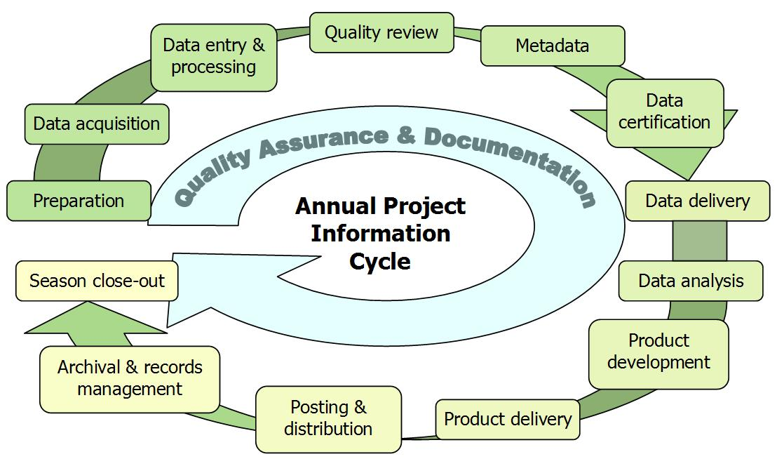

Figure 4.1. Idealized flow diagram of the cyclical stages of project information management, from pre-season preparation to season close-out. Note that quality assurance and documentation are thematic and not limited to any particular stage of the information life cycle.

The stages of this cycle are described in greater depth in later sections of this chapter but can be briefly summarized as follows:

* *Preparation* – Training, logistics planning, print forms, and maps
* *Data acquisition* – Field trips to acquire data
* *Data entry & processing* – Data entry and uploads into the working copy of the database, GPS data processing, etc.
* *Quality review* – Data are reviewed for quality and logical consistency
* *Metadata preparation* – Documentating data collection and results of the quality review for the year
* *Data certification* – Data are certified as complete for the period of record
* *Data delivery* – Certified data and metadata are delivered for archival and uploaded to the master project database
* *Data analysis* – Data are summarized and analyzed
* *Product development* – Reports, maps, and other products are developed
* *Product delivery* – Deliver reports and other products for posting and archival
* *Posting & distribution* – Distribute products as planned and/or post to NPS clearinghouses
* *Archival & records management* – Review analog and digital files for retention (or destruction) according to NPS Director’s Order 19 (NPS 2001). Retained files are renamed and stored as needed.
* *Season close-out –* Review and document needed improvements to project procedures or infrastructure, complete administrative reports, develop work plans for the coming season

Pre-season Preparations for Information Management

Set Up Project Workspace

A section of the networked PACN server is reserved for this project, and access permissions are established so that project staff members have access to needed files within this workspace. Prior to each season, the project lead should make sure that network accounts are established for each new staff member, and that the data manager is notified to ensure access to the project workspace and databases. If network connections are too slow for efficient data entry and processing, individual staff members may set up a workspace on their own workstation, with periodic data transfer to the PACN server. Daily backups of the workstation to an external hard drive will ensure that no data is lost. Additional details may be found in SOP #10 “Workspace Setup and Project Records Management.”

GPS Loading and Preparation

The GIS specialist and field leader will work together to ensure that target coordinates and data dictionaries are loaded into the GPS units and data loggers (if used) prior to the onset of field work, and that GPS download software is available and ready for use. Additional details on GPS use and GPS data handling may be found in SOP #6 “Using GPS to Navigate to and Mark Waypoints” and on the PACN website (NPS 2007d).

Implement Working Database Copy

Prior to the field season, the data manager will implement a blank copy of the working database and ensure proper access on the part of the project staff. Refer to Overview for Database Design for additional information about the database design and implementation strategy.

Overview of Database Design

PACN data management staff designed customized relational database applications to enter, store, and manipulate the data associated with this project. The design of the Established Invasive Plant Species Monitoring Database follows the hierarchical data table organization of the Natural Resource Database Template (NPS 2007b) which is the standard for the NPS I&M Program. For additional details see the table relationships diagram, data dictionary, and other documentation in Appendix F “Established Invasive Plant Monitoring Database Documentation.” The PACN data management staff is responsible for development and maintenance of the database including customization of data summarization and export routines.

The database is divided into two components: (1) one for entering, editing, and error-checking data for the current season (i.e., the “working database copy”), and (2) one that contains the complete set of certified data for the monitoring project (i.e., the “master project database”). A functional comparison of these two components is provided in Table 4.1.

**Table 4.1.** Functional comparison of master project database and working database.

|  |  |  |
| --- | --- | --- |
| **Project database functions and capabilities** | **Working database** | **Master database** |
| Software platform for back-end data | MS Access | MS SQL Server or MS Access |
| Contains full list of sampling locations and taxa | X | X |
| Portable for remote data entry | X |  |
| Forms for entering and editing current year data | X |  |
| Quality assurance and data validation tools | X | X |
| Preliminary data summarization capabilities | X |  |
| Full analysis, summarization and export tools |  | X |
| Pre-formatted report output |  | X |
| Contains certified data for all observation years |  | X |
| Limited editing capabilities, edits are logged |  | X |
| Full automated backups and transaction logging |  | X |
| SQL = Structured Query Language, MS = Microsoft | |

Each of these components is based on an identical underlying data structure (tables, fields and relationships, as documented in Appendix F “Established Invasive Plant Monitoring Database Documentation”). The working database is implemented in Microsoft (MS) Access to permit greater flexibility when implementing on computers with limited or unreliable network access. Eventually, the master database may be implemented in MS Structured Query Language (SQL) Server in order to take advantage of the backup and transaction logging capabilities of this enterprise database software.

Both components have an associated front-end database application (“user interface” with forms and queries) implemented in MS Access. The working database application has separate screens for data entry, data review, and quality validation tools. The master database application contains the analysis and summarization tools, including pre-formatted report output and exports to other software (e.g., for analysis and graphics production). This front-end application arrangement allows for modification and update of the user interface with no disruption to data entry continuity. The improved front-end file can be distributed to data entry staff, who link it to the back-end file, discard the out-dated front-end file, and proceed with their data entry work. Under this arrangement, data entry staff have no need to open the back-end file, thereby reducing the risk of improper deletions or other inadvertent data loss occurring within the protocol-specific data tables. In addition, a multi-user environment can be accommodated by storing the back-end file on a server available to all users via a computer network.

During the field season, each project crew will be provided with their own copy of a working database into which they enter, process, and quality-check data for the current season (refer to the next section and SOP #13 “Data Entry and Verification”). Once data for the field season have been certified they will be uploaded into the master database, which is then used to inform all reporting and analysis. This upload process is performed by the data manager, using a series of pre-built append queries.

Data Entry and Processing

After each field trip, technicians will examine data forms to correct obvious errors and incomplete information as soon after data collection as is practical, and enter data in order to keep current with data entry tasks. The working database application will be found in the project workspace. If the project workspace is located on the network server, it is recommended that users copy the front-end database onto their workstation hard drives and open it there. This front-end copy may be considered “disposable” because it does not contain any data but rather acts as a pointer to the data that reside in the back-end working database. Whenever updates to the front-end application are made available by the data manager, a fresh copy should be made from the project workspace to the workstation hard drive.

The functional components for data entry into the working database are described in SOP #13 “Data Entry and Verification.” Each data entry form is patterned after the structure of the field form, and has built-in quality assurance components such as pick lists and validation rules to test for missing data or illogical combinations. Although the database permits users to view the raw data tables and other database objects, users are strongly encouraged only to use these pre-built forms as a way of ensuring the maximum level of quality assurance.

Regular Data Backups

Upon opening the working database, the user will be prompted to make a backup of the underlying data (see SOP #13 “Data Entry and Verification”). It is recommended that this be done on a regular basis – at least once per day when new records are being entered – to save time in case of file corruption or mistakes. These periodic backup files should be compressed to save drive space and may be deleted once enough subsequent backups are made. All such backups may be deleted after the data have passed the quality review and been certified.

Data Verification

Analyses performed to detect ecological trends or patterns require data that are recorded properly and have acceptable precision and minimal bias. Poor quality data can limit detection of subtle changes in ecosystem patterns and processes, and may lead to incorrect conclusions. Quality assurance/quality control QA/QC procedures applied to ecological data includes five procedural areas (or activities), ranging from simple to sophisticated and inexpensive to costly:

* defining and enforcing standards for electronic formats, locally defined codes, measurement units, and metadata
* visually reviewing or proofing all data after data entry for transcription errors
* checking for unusual or unreasonable patterns in data
* checking for comparability of values between data sets
* assessing overall data quality

To the greatest extent possible, the Established Invasive Plant Species Monitoring Database application incorporates quality assurance/quality control strategies involving the first activity (defining and enforcing standards). The database design and the allowable value ranges assigned to individual fields within the data tables help to minimize the potential for data entry errors and/or the transcription of erroneously recorded data. The other activities are integrated in the validation phase. For more details see the section entitled “Data Quality Review” and SOP #14 “Data Quality Review and Certification.”

Additionally, as data are being entered, the person doing the data entry will visually review them to make sure that the data on screen match the field forms. This should be done for each record prior to moving to the next form for data entry. At regular intervals and at the end of the field season, the field leader should inspect the data being entered to check for completeness and perhaps catch avoidable errors. The field leader may also periodically run the Quality Assurance Tools that are built into the front-end working database application to check for logical inconsistencies and data outliers. This step is described in greater detail in the section “Data Quality Review” and also in SOP #16 “Sensitive Information.”

Field Form Handling Procedures

As the field data forms are part of the permanent record for project data, they should be handled in a way that preserves their future interpretability and information content. To minimize the possibility of data loss, hardcopy data forms and field notebooks should be stored in a well organized fashion in a secure location with photocopies and scanned data forms stored in a separate location (e.g., on the PACN data server). Refer to SOP #11 “Field Form Handling”for more details.

If laptops or other digital devices are used to collect data, then the field crew should back up data in the field at least once a day on an extra memory card. Data files should then be uploaded to a computer and backed up as soon as practical after leaving the field. A hard-copy of the digital dataset should be printed and stored following the procedures developed for field data forms.

Image Handling Procedures

Photographic images should also be handled and processed with care. Refer to SOP #12 “Managing Photographic Images” for details on how to handle and manage these files.

GPS Data Procedures

The following general procedures should be followed for GPS data as described in SOP #6 “Using GPS to Navigate to and Mark Waypoints” and Appendix G “Yearly Project Task List”:

1. GPS data should be downloaded by the field crew from the units at the end of each field trip (or daily if possible) and stored in the project workspace (see SOP #10 “Workspace Setup and Project Records Management”).
2. Raw files should be sent to the GIS specialist for processing (e.g., creating shape files for plot data points, access routes, opportunistic plant sightings) and differential correction if applicable (e.g., Trimble).
3. The GIS specialist will process the raw GPS data and store the processed data in the project workspace.
4. The GIS specialist will upload corrected coordinate information into the database and create any GIS data sets.

The field leader should periodically review the processed GPS data to make sure that any problems are identified early on in the data collection process.

Data Quality Review

After the data have been entered and processed, the project lead needs to review the data for quality, completeness, and logical consistency. The working database application facilitates this process by showing the results of pre-built queries that check for data integrity, data outliers and missing values, and illogical values. The user may then fix these problems and document the fixes. Not all errors and inconsistencies can be fixed, in which case a description of the resulting errors and why edits were not made is then documented and included in the metadata and certification report (see Metadata Procedures and Data Certification and Delivery, and SOP #14 “Data Quality Review and Certification”).

Data Edits after Certification

Due to the high volume of data changes and/or corrections during data entry, it is not efficient to log all changes until after data are certified and uploaded into the master database. Prior to certification, daily backups of the working database provide a crude means of restoring data to the state of the previous day. After certification, all data edits in the master database are tracked in an edit log (refer to Appendix F “Database Documentation”) so that future data users will be aware of changes made after certification. In case future users need to restore data to the certified version, we also retain a separate, read-only copy of the original, certified data for each year in the PACN Digital Library (refer to SOP #17 “Product Delivery Specifications”).

Geospatial Data

The project lead and GIS specialist may work together to review the surveyed coordinates and other geospatial data for accuracy. The purpose of this joint review is to make sure that geospatial data are complete and reasonably accurate and also to determine which coordinates will be used for subsequent mapping and field work.

Metadata Procedures

Data documentation is a critical step toward ensuring that data sets are usable for their intended purposes well into the future. This involves the development of metadata, which can be defined as structured information about the content, quality, condition, and other characteristics of a given data set, both tabular and spatial. Additionally, metadata provide the means to catalog and search among data sets, thus making them available to a broad range of potential data users. Metadata for all PACN monitoring data will conform to Federal Geographic Data Committee guidelines and will contain all components of supporting information such that the data may be confidently manipulated, analyzed, and synthesized.

At the conclusion of the field season (according to the schedule in Appendix G “Yearly Project Task List”), the project lead will be responsible for providing a completed, up-to-date metadata interview form to the data manager. The data manager and GIS specialist will facilitate metadata development by consulting on the use of the metadata interview form, by creating and parsing metadata records from the information in the interview form and by posting such records to national clearinghouses. Refer to SOP #15 “Metadata Development” for specific instructions.

Data Certification and Delivery

Data certification is a benchmark in the project information management process that indicates that: (1) the data are complete for the period of record; (2) they have undergone and passed the quality assurance checks (Quality Review); and (3) that they are appropriately documented and in a condition for archiving, posting and distribution as appropriate. Certification is not intended to imply that the data are completely free of errors or inconsistencies which may or may not have been detected during quality assurance reviews.

To ensure that only quality data are included in reports and other project deliverables, the data certification step is an annual requirement for all tabular and spatial data. The project lead is primarily responsible for completing a PACN Project Data Certification Form, available from the data manager or on the PACN website. This brief form should be submitted with the certified data according to the timeline in Appendix G “Yearly Project Task List.” Refer to SOP #14 “Data Quality Review and Certification” and SOP #17 “Product Delivery Specifications and Schedule” for specific instructions.

Data Analysis

Refer to Appendix G “Yearly Project Task List” for the specific analysis tasks and their timing and to SOP #19 “Statistical Data Analysis”for a more detailed description of analytical procedures.

As part of the overall database design, the project lead and data manager will work together to develop a series of summary queries and tools designed to prepare the data for analysis and reporting. Some of these tools will produce summarized information that goes directly into reports, while other tools will provide data in the proper format for analysis. Database queries will handle this type of conversion and tabulation, while statistical software such as SAS or SPlus will be used for more advanced analyses.

Using the raw certified data as well as database query results, the project lead will perform two general types of analysis at the end of the field season: summary statistics and trend analysis. Chapter 5 outlines the roles of the project lead and the data manager. In short, the data manager is responsible for query design and writing database routines, while the project lead will use the extracted data to run analyses. As outlined in SOP #19 “Statistical Data Analysis,” the project lead will compute summary statistics (means, variances, confidence intervals, etc.) for each of the vegetation attributes measured. Depending on the attribute, these statistics are aggregated across all species, grouped by life form (i.e., tree, shrub, fern, herbaceous), and/or individual species. In some instances the summary statistics are broken down by percent (e.g., proportion of plots that contain a specific species).

In terms of detecting change, two distinct types of analysis will be pursued. Changes over time for a species or group of species can be evaluated using a zero-inflated model (presence data) or a proportional odds model (cover classes) and likelihood ratio tests. For nonnative richness (i.e., number of nonnative species per segment or quadrat), changes over time can be evaluated using a paired t-test, repeated measures-analysis of variance (ANOVA), or a generalized linear model (GzLM) following the methodology described by Schneider (2007). SOP #19 “Statistical Data Analysis” provides further details on the analysis of these data items.

Reporting and Product Development

Refer to Appendix G “Yearly Project Task List” and SOP #17 “Product Delivery Specifications and Schedule” for the complete schedule for project reports and other deliverables and the people responsible for them. Detailed reporting guidelines and table structures are provided in SOP #20 “Reporting.”

Report Content

A summary report will be produced annually, with a more detailed report produced every five years. The annual report focuses on the monitoring effort and results of the current year, while the five-year report brings together five years of results at the close of each complete monitoring cycle. The annual report should:

* List project personnel and their roles.
* List sampling areas, transects and segments completed during the current year.
* Provide maps and brief discussion of the areas sampled during the current year.
* Present summary statistics for all items listed in SOP #19 “Statistical Data Analysis.”
* Provide trend analysis results for parameters with multiple years of data for areas sampled during the current year.
* Identify any data quality concerns and/or deviations from protocols that affect data quality and interpretability.
* Provide brief management recommendations for invasive prioritization based on status and trends data within a given park.

A more comprehensive analysis and report will be produced every five years after each round of cycling (i.e., after each park and community is sampled). In addition to the above, the five-year report should also:

* Summarize the annual results by plant community and transect, allowing for comparisons among parks and within communities (e.g., how does invasive richness vary from one park to the next, and how does invasive frequency vary between different sampling frames of the same community).
* Assess spatial patterns in the cover class and presence/absence data.
* Identify any possible distributional changes within parks, and communities.
* Place network results within the larger context of invasive plant species changes throughout the Pacific.
* Evaluate operational aspects of the monitoring program, such as whether any sampling locations need to be eliminated or moved (e.g., due to access problems), whether the sampling period remains appropriate (the optimal sampling season could conceivably change over time in response to climate change), etc.

Standard Report Format

Annual reports and trend analysis reports will use the NPS Natural Resource Publications template, a pre-formatted MS Word template document based on current NPS formatting standards. Annual reports will use the Natural Resource Report template, and trend analysis and other peer-reviewed technical reports will use the Natural Resource Technical Report template. These templates and documentation of the NPS publication standards are available at the NPS Natural Resource Publications website (NPS 2007b). Reports will include standard vegetation summary tables and figures. Tables for individual species frequency, cover, and nonnative species richness will include means and standard errors. Thematic map figures of nonnative plant species distributions will also be included.

Review Products for Sensitive Information

Certain project information related to the specific locations of rare or threatened taxa or cultural resources may meet criteria for protection and, as such, should not be shared outside NPS except where a written confidentiality agreement is in place prior to data sharing. Before preparing data in any format for sharing outside NPS – including presentations, reports, and publications – the project lead should refer to the guidance in SOP #16 “Sensitive Information” and discuss the matter with the data manager. Certain information that may convey specific locations of sensitive resources may need to be screened or redacted from public versions of products prior to release.

Product Delivery, Posting, and Distribution

Refer to SOP #17 “Product Delivery Specifications and Schedule” for the complete schedule of project deliverables, the people responsible for them, and detailed instructions on how to deliver the final products. Upon delivery products will be posted to the Integrated Resource Management Applications (IRMA) portal as appropriate. Refer to SOP #18 “Product Posting and Distribution”for more information.

Holding Period for Project Data

To permit sufficient time for priority in publication, certified project data will be held upon delivery for a period not to exceed two years after it was originally collected. After the two year period has elapsed, all certified, non-sensitive data will be posted to IRMA. Note that this hold only applies to raw data, and not to metadata, reports or other products which are posted immediately after being received and processed.

Special Procedures for Sensitive Information

Products that have been identified upon submission by the project lead as containing sensitive information will either be revised into a form that does not disclose the specific locations of sensitive resources, or withheld from posting and distribution. When requests for distribution of the unedited version of products are initiated by the NPS, by another federal agency, or by another partner organization (e.g., a research scientist at a university), the unedited product (e.g., the full data set that includes protected information) may only be shared after a confidentiality agreement is established between NPS and the other organization. Refer to SOP #16 “Sensitive Information” for more information.

All official Freedom of Information Act (FOIA) requests will be handled according to NPS policy. The project lead will work with the data manager and the park FOIA representative(s) of the park(s) for which the request applies.

Archival and Records Management

All project files should be reviewed, modified or revised, and organized by the project lead on a regular basis (e.g., annually in January). Decisions on what to retain and what to destroy should be made following guidelines stipulated in [NPS Director’s Order 19](http://data2.itc.nps.gov/npspolicy/DOrders.cfm), which provides a schedule indicating the amount of time that various types of records should be retained. Refer to SOP #10 “Workspace Setup and Project Records Management.”

Season Close-out

After the conclusion of the field season, the project lead, data manager, and GIS specialist should meet to discuss the recent field season, and to document any needed changes to the field sampling protocols, the working database application, or to any of the SOPs associated with the protocol. Refer to the section on Data Entry and Verification for additional close-out procedures not specifically related to project information management.

Chapter 5: Personnel Requirements and Training

Roles and Responsibilities

Implementation of this protocol requires using a combination of park staff and PACN I&M staff. Required PACN staff include a project lead (preferably General Schedule [GS]-11), a field leader (GS-07), and three biological technicians (GS-05), as well as assistance from the I&M data manager (GS-11), GIS specialist (GS-11), and program manager (GS-13). Table 5.1 summarizes the roles and responsibilities of each position for this protocol. The project lead is responsible for project administration, implementation, overseeing data collection, facilitating communication between NPS and cooperators, quality assurance/quality control, data entry, data verification and validation, data backups, data summary, analysis, and reporting. The project lead’s safety responsibilities include ensuring that all safety training and certifications are completed by the field leader and crew and that all safety policies and procedures are clearly communicated and followed. This includes ensuring the project staff read this Protocol narrative, SOP’s, and the PACN Safety Plan. The project lead supervises the field leader, who is responsible for pre- and post- field season preparations including travel arrangements. The field leader is the point of contact for field operations, provides direction for the field biological technicians, and ensures their safety in the field on a daily basis. The field leader and biological technicians are responsible for conducting the field data collection, data entry, data management, and equipment management. If the field leader is not present in the field, they must assign an “acting” field leader who serves as the point of contact. The field leader conducts some data analyses for annual reporting and participates in the preparation of preliminary reports. The project lead, field leader, and biological technicians should be skilled botanists and field technicians capable of performing any of the required invasive plant species monitoring tasks, including plant species identification.

The project lead will oversee the hiring and training of all field technicians including the field leader. In addition, the project lead should directly participate in at least some of the field monitoring in order to ensure consistency of this effort. Field crew members must be proficient at: (1) identifying nonnative and native plants and making voucher collections as needed, (2) using field equipment, and (3) data entry using MS Access. In addition to possessing these skills, the project lead needs to be proficient at data analysis and report generation.

The data management aspect of the monitoring effort is the shared responsibility of the project lead and the data manager. The data manager is responsible for database design, facilitating quality assurance/ quality control procedures, provisions for data archiving, data security, metadata production, web-posting of protocol data products (datasets, data analysis products and metadata), and dissemination of data, while the project lead is responsible for database use (overseeing data entry, data certification, archiving, running queries, data analyses, and generating reports). The data manager is ultimately responsible for ensuring that appropriate data handling procedures are followed. The analysis aspect of the monitoring is primarily the responsibility of the project lead. The GIS specialist assists with plot selection techniques, GPS use, map generation, and metadata development.

The PACN program manager is responsible for general vegetation program oversight. This includes periodic reviews of reports, decisions regarding appropriations of I&M budget to the PACN vegetation monitoring program, and the overall quality and performance of the project lead in relation to the PACN vegetation program. **Table 5.1**. Roles and responsibilities for Established Invasive Plant Species Monitoring Protocol.

|  |  |  |
| --- | --- | --- |
| **Role** | **Responsibilities** | **Position** |
| Project Lead | * Project administration, operations, and implementation * Track project objectives, budget, and requirements * Coordinate and ratify changes to protocol * Lead training of field crew * Ensures field leader and crew are adequately trained in safety procedures * Acquire field equipment * Certify each season’s data for quality and completeness * Complete reports, data summaries and analysis, metadata, and other products according to schedule * Maintain and archive project records * Facilitate communications between NPS and cooperator(s) | Botanist |
| NPS Lead | * The project lead is the NPS Lead for this protocol | N/A |
| Park Ecologists / Botanists | * Assist with logistics planning and coordination * Review reports, data and other project deliverables * Assist in training of field crew members |  |
| Field Leader | * Assist in training and ensuring safety of field technicians * Serves as point of contact for field operations * Plan and execute field visits * Maintain field equipment * Oversee data collection and entry, verify accurate data transcription into database * Complete a field season report | Biological Science Technician |
| Field Technicians | * Collect, record, enter and verify data * Prepare plant voucher specimens, as needed | Biological Technicians (3) |
| Data Manager | * Consultant on data management activities * Facilitate check-in, review and posting of data, metadata, reports, and other products to national databases and clearinghouses according to schedule * Maintain and update database application * Provide database training as needed | Data Manager |
| Statistician | * Consultant on statistical design, analysis and programming | May be hired, Statistician |
| GIS Specialist | * Consultant on spatial data collection, GPS use, and spatial analysis techniques * Facilitate spatial data development and map generation * Work with project lead to analyze spatial data and develop metadata for spatial data products * Primary steward of GIS data and products | GIS Specialist |
| Network Coordinator | * Review annual reports for completeness and compliance with I&M standards and expectations | PACN Network Coordinator |
| Park Curator | * Receive and catalogue voucher specimens | Park Curator, or other designated staff |
| USGS Liaison | * Consultant on technical issues related to project sampling design, statistical analyses, or other issues related to changes in protocol and SOPs | Botanist, USGS-Pacific Island Ecosystems Research Center |

Qualifications and Training

All technical field staff will be trained and responsible for familiarity with the information contained within the protocol narrative, SOPs, the protocol database, and the PACN Safety Plan. All field leaders must have also taken Operational Leadership Training. SOP #2 “Training Observers” provides details on hiring and training all personnel associated with the PACN Established Invasive Plant Species Monitoring Protocol. The project lead position requires a graduate degree or equivalent experience in related disciplines (e.g., botany, ecology, forestry, or other applicable biological/ natural science field), experience in field data collection, statistics, data management, and reporting.

The field leader requires at minimum a bachelor’s degree or equivalent experience in related botanical disciplines, experience in leading vegetation field crews under strenuous field conditions, data collection, data management, post processing, basic data analysis, and equipment maintenance. One of the most important components in collecting credible, high-quality data on invasive plant species is a competent field staff. The quality of the data collected will be directly related to the quality of the field team. The biological technicians are required to have some botanical experience (i.e., able to recognize major plant groups in the field, know how to key out plants, etc.), as well as be able to conduct field work and help with data entry and management tasks.

Field crew members should strive to improve their ability to identify plants in all forms and stages of maturity. All members will be required to participate in training before the field season (see SOP #2). Training will occur over a sufficient period of time to ensure accuracy and consistency in plant identification. In general, training will consist of two phases: (1) an office component in which team members read and review the protocol, equipment lists, species lists, plant images, and herbarium specimens; and (2) a field component emphasizing methodology and data recording, as well as a major emphasis on field identification of plants. The field component will include selected site visits to locations where team members will encounter most if not all plants on the species list. Field training will culminate in the group doing transects together, as a means of developing consistency in species identification, collection of specimens, plot establishment, monitoring methods, and data recording on field forms. Approximately five days of technical training are anticipated prior to the start of sampling, four of which will be in the field. The field leader will work with PACN specialists familiar with the local flora to coordinate the training of all crew members. Field crews will also receive approximately five days of safety training prior to conducting field work. Safety training will include formal group courses as necessary (e.g., NPS’s Operational Leadership Training, Helicopter safety, First Aid/CPR) and self guided online training (e.g., IT Security, Defensive Driver).

The data manager and GIS specialist require bachelor degrees in computer science or related concentration, or other equivalent experience. The data manager must have experience in database management, records certification, SQL programming, and archiving. The GIS specialist requires specific experience with GIS analysis, ArcGISTM base software and extensions, spatial database design, and GPS use.

Chapter 6: Operational Requirements

Annual Workload and Field Requirements

Established invasive plant species will be monitored in four focal community types in five PACN parks. Table 6.1 lists the parks visited each year, the communities monitored, and the time required to monitor established invasive species in these communities. The amount of time estimated to complete the established invasive plant species monitoring is based on a four person field team consisting of a field leader and three crew members. The protocol is designed to allow for exclusion of select PACN communities or units if required due to future unforeseen fiscal constraints. Year 5 requires the least amount of field and data entry time but the most travel.

Table 6.1. Number of months required for a four person field crew to conduct established invasive plant species monitoring by sampling frame and by cycle year.

|  |  |  |  |  |  |
| --- | --- | --- | --- | --- | --- |
| **Cycle Year** | **Park** | **Sampling Frame** | **Community** | **No. of Months** | |
| **Frame** | **Year** |
| 1 | HAVO | Nahuku/East Rift | Wet Forest | 1.25 | 2.5 |
| 1 | HAVO | ‘Ōla‘a | Wet Forest | 1.25 |
| 2 | HAVO | Kahuku | Wet Forest | 1.0 | 1.75 |
| 2 | HAVO | Subalpine | Subalpine Shrubland | 0.75 |
| 3 | HALE | Wet forest | Wet Forest | 1.25 | 2.5 |
| 3 | HALE | Subalpine | Subalpine Shrubland | 0.75 |
| 3 | KALA | Sandy Shoreline | Coastal Strand | 0.25 |
| 3 | KALA | Rocky Shoreline | Coastal Strand | 0.25 |  |
| 4 | NPSA | Ta‘ū | Wet Forest | 1.25 | 1.25 |
| 5 | AMME | Mangrove | Mangrove Forest | 0.5 | 0.5 |

The field season for monitoring established invasives is integrated with the Focal Terrestrial Plant Communities Monitoring Protocol plot work which typically begins each year in April or May. Depending upon the park, community, and sample frame, the field season for both protocols ends by mid-November. The schedule consists of a 5-year rotating cycle, with field crews visiting 1-2 parks each year and revisiting each park every five years. The project lead and field leader will plan to visit specific parks at approximately the same time of year every sampling period in order to minimize seasonal differences from one sampling event to the next. For the lowland tropical climate communities (wet forest and mangrove forests) nonnative detectability will not differ dramatically between spring, summer, and fall. However, in the subalpine shrubland, and to a lesser extent the coastal strand, monitoring will be conducted in the spring during the most prominent growth and flowering or fruiting time.

Before the beginning of the field season, field crew members need to spend an appropriate amount of time on training (safety, sampling methodology, plant identification) and field skills (e.g., navigating, marking plots, using field equipment). The amount of time will vary by year, park and field crew. SOP #2 “Training Observers” and SOP#3 “Safety” discuss training requirements in more detail. Also before each field season, the project lead, field leader, and GIS specialist will need to generate a list of temporary transects to be used in the rotational panel for each sampling frame (see SOP #5 “Transect Generation”). Note that for the first cycle in each park both the fixed and rotational transects have already been generated (Appendix A “Target Populations and Sampling Frames”).

Facility and Equipment Needs

The nature of invasive plant monitoring work does not require special facilities beyond normal office space, a data management workstation, herbarium space, and a storage place for field equipment. SOP #1 “Before the Field Season” contains a list of equipment needed in the field to perform the required monitoring.

Startup Costs and Budget Considerations

Table 6.2 summarizes the Established Invasive Plant Species Monitoring Protocol budget by park and year, breaking down the costs into personnel salary, travel, equipment and supplies. Personnel salaries are based on the 2010 pay schedule with 18% cost of living adjustment and 25% benefits. Expected grade level and step level in the GS as well as the anticipated percent fulltime employment (FTE) are listed in parentheses for each position. Salary costs are expected to increase with step increases if initial hires remain in their positions. The botanist will supervise the field leader, oversee field operations, and analyze and report annual findings and periodic trends (15%). The field leader will spend 25% FTE implementing this vital sign. Primary duties include: preparing for the field season, leading field operations, entering and summarizing data, and draft reporting. Three biological technicians will conduct field work during the two month field season (15%). The program manager will assist by reviewing reports (2%), and the data manager and GIS specialist will aid in pre- and post-field season data management and analysis (4%).

Travel estimates include airfare, lodging, per diem, and required helicopter time to access remote field sites. Estimates vary across the network due to the great distances among parks and the necessity of airline travel. Values are based on the 2010 lodging and per diem schedule and the estimated amount of time required per park (table 6.1). The field leader will be duty-stationed in each park (except AMME) during extended field sampling. When possible the biological technicians will be hired from the community to maximize local plant knowledge and reduce travel costs (e.g., NPSA, HALE). Lodging ranges from $0 (camping) to $139 (NPSA) per day and meal per diem ranges from $25 (camping) to $79 (AMME). Travel estimates for AMME are highest because current lodging ($121/ day) and meal ($79/day) estimates are relatively high. HALE travel estimates are also high, but this is due to the fact that most of the field sites are only accessible by helicopter (four hours of helicopter time at $800/ hour) and require extensive back country camping. Similarly, an estimated six hours of helicopter time are required to access remote wet forest sites in HAVO.

Equipment and supplies required for implementation of the Established Invasive Plant Species Monitoring Protocol include standard field monitoring gear (e.g., cameras, field packs, measuring tapes, flagging, etc.) and larger items such as vehicle rental (estimated at $500/month).

The annual cost estimate averaged across the five years required to complete one round of monitoring for the Established Invasive Plant Species Monitoring Protocol is approximately $53,000 per year in FY10 dollars (computed by averaging the last line of table 6.2). Thirty percent of the total budget is allocated to analyses and reporting through data entry, verification and editing (~15%), analyses and generating field and technical reports ( ~15%). Additional partnerships and collaboration with park staff will be pursued and would aid in reducing implementation costs or increasing our sampling effort (e.g., more frequent sampling and/or additional transects). However, what is presented in this protocol is designed to be accomplished regardless of collaborative efforts.

Table 6.2. Annual monitoring costs for the Established Invasive Plant Species Monitoring Protocol.

|  |  |  |  |  |  |  |  |  |  |
| --- | --- | --- | --- | --- | --- | --- | --- | --- | --- |
| **Budget Item** | | **Year 1** | **Year 2** | | **Year 3** | | | **Year 4** | **Year 5** |
| HAVO | HAVO | HAVO | HALE | HALE | KALA | NPSA | AMME |
| Wet | Kahuku | Subalpine | Wet | Subalpine | Coastal | Ta‘ū | Mangrove |
| *Personnel* | |  |  |  |  |  |  |  |  |
|  | Botanist (GS11.1; 15%) | 10,840 | 5,420 | 5,420 | 5,420 | 5,420 | 2,710 | 8,130 | 2,710 |
|  | Field Leader (GS7.1; 25%) | 12,208 | 6,104 | 6,104 | 6,104 | 6,104 | 3,052 | 9,156 | 3,052 |
|  | Field Crew (3xGS5.1; 15%) | 17,739 | 8,870 | 8,870 | 8,870 | 8,870 | 4,435 | 13,304 | 4,435 |
|  | Program Manager (GS13.2; 2%) | 2,129 | 1,064 | 1,064 | 1,064 | 1,064 | 532 | 1,596 | 532 |
|  | Data Manager (GS11.3; 4%) | 3,083 | 1,542 | 1,542 | 1,542 | 1,542 | 771 | 2,312 | 771 |
|  | GIS Specialist (GS11.1; 4%) | 2,891 | 1,445 | 1,445 | 1,445 | 1,445 | 723 | 2,168 | 723 |
| *Travel (with per diem)* | | 2,758 | 3,075 | 1,938 | 7,575 | 5,325 | 1,350 | 8,700 | 11,780 |
| *Equipment and Supplies* | | 3,000 | 1,500 | 1,500 | 3,000 | 2,500 | 500 | 1,500 | 1,000 |
| *Total Cost* | | 54,647 | 29,019 | 27,882 | 35,019 | 32,269 | 14,072 | 46,867 | 25,002 |
| ***Annual Cost*** | | **54,647** | **56,901** | | **81,361** | | | **46,867** | **25,002** |

Permits, Permissions and Cooperative Agreements

Various research permits and compliance procedures are required to implement this monitoring. As this protocol is implemented, the project lead or PACN staff designee, in cooperation with NPS point of contacts, will proceed through project compliance as appropriate for each park according to federal, state, commonwealth, and territory guidelines, or any other compliance processes that need to be completed. The project lead, in cooperation with the PACN staff designee, will ensure full compliance with all existing and future regulations. All permitting will be reviewed by a park designee (e.g., Park Point of Contact) responsible for National Environmental Policy Act (NEPA), Section 106 of the National Historic Preservation Act (NHPA), Section 7 of the Endangered Species Act, park research permits, and approved by the compliance specialists. The project lead or PACN staff designee will be responsible for ensuring appropriate park permitting contacts are notified. Some specific permits already known to be required for this protocol are described in the following sections. The project lead is responsible for following all stipulations identified through the compliance process.

National Park Service

National Park Service research permits will be obtained, in advance of any field activities, for each park where monitoring occurs. Permits are evaluated on an annual basis, or other time frame as stipulated in the permit itself. The research permit review process also includes NEPA compliance documentation, as discussed below. The project lead (or designee) in cooperation with NPS contacts will maintain all appropriate documentation. NPS applications will be submitted at: <http://science.nature.nps.gov/research/ac/ResearchIndex>.

National Environmental Policy Act (NEPA)

At present, under NEPA, we anticipate that this protocol falls under a Categorical Exclusion, i.e., “a category of actions which do not individually or cumulatively have a significant effect …and for which, therefore, neither an environmental assessment nor an environmental impact statement is required” (40 CFR 1508.4). Under Director’s Order 12 (NPS 2001), a Categorical Exclusion is “an action with no measurable environmental impact which is described in one of the categorical exclusion lists in section 3.3 or 3.4 and for which no exceptional circumstances (section 3.5) exist.” NEPA compliance review and documentation will occur as part of the NPS research permitting process.

National Historic Preservation Act (NHPA)

Compliance with NHPA must occur prior to monitoring and the establishment of permanent plots which requires burying stainless steel threaded rods as markers. Most likely, digging or burying will be prohibited in areas with valuable cultural resources. The project lead is responsible for consulting with Cultural Resources staff at each park prior to conducting field work, ensuring compliance with the NHPA and conducting field work in a manner that does not have any adverse effects on cultural resources.

State of Hawai‘i

No permits are needed from the state of Hawai‘i for work conducted on NPS lands. However, all wildlife activities conducted under the U.S. Fish and Wildlife Service permit in Hawai‘i must be coordinated with the Department of Land and Natural Resources, Division of Forestry and Wildlife.

Territory of American Samoa

The territory requires that a Scientific Study and Collection Permit be obtained through the Department of Marine and Wildlife Resources, American Samoa Government.

Village Permissions: On Ta‘ū Island, American Samoa, permissions should be obtained by personally contacting each mayor of the village near the park unit where monitoring may occur. Field crew members should describe what the study is about prior to initiating any work, according to park cultural resource staff guidelines. Surveying is typically not allowed in or near villages on Sundays.

Sa, or time for prayer, is observed at dusk (around 18:00 hrs), so if entering or traveling through villages via vehicle or on foot at this time, field crew members must stop until Sa is over. Ringing bells in the villages indicate the beginning and ending of Sa. If field crew members are on the main roads of Tutuila, it is not necessary to stop.

Cooperative Agreements: A cooperative agreement should be developed with the Department of Marine and Wildlife Resources for conducting and sharing plant community survey data on American Samoa.

Chapter 7: Literature Cited

Ainsworth, A., P. Berkowitz, J. D. Jacobi, R. K. Loh, and K. Kozar. 2011. Focal terrestrial plant communities monitoring protocol: Pacific Island Network. Natural Resource Report NPS/PACN/NRR—2011/410. National Park Service, Fort Collins, Colorado.

Ainsworth, A., J. A. Christian, J. Jacobi, R. K. Loh, S, Harrison, P. Berkowitz, J. M. Yoshioka, F. Starr, K. Starr, and L. Loope. *In prep*. Early detection of invasive plant species vital sign protocol: Pacific Island Network. National Park Service, Fort Collins, Colorado.

Ainsworth, A., B. Stevens, L. Hadway, N. Agorastos, I. Cole, and C. M. Litton. 2008. Vegetation response to eight years of feral pig (*Sus scrofa*) removal in Pu‘u Maka‘ala Natural Area Reserve, Hawai‘i. State of Hawaii, Division of Forestry and Wildlife Unpublished Report, Hilo, Hawaii.

Anderson, S. J., C. P. Stone, and P. K. Higashino. 1992. Distribution and spread of alien plants in Kipahulu Valley, Haleakala National Park, above 2,300 ft elevation. Pages 300-338 *in* C. P. Stone, C. W. Smith, and J. T. Tunison, editors. Alien plant invasions in native ecosystems of Hawaii: Management and research. Cooperative National Park Resources Study Unit, Univeristy of Hawaii at Manoa, Honolulu, Hawaii.

Asner, G. P. and P. M. Vitousek. 2005. Remote analysis of biological invasion and biogeochemical change. Proceedings of the National Academy of Sciences 102:4383-4386.

Bellingham, P. J., E. J. Tanner, and J. R. Healey. 2005. Hurricane disturbance accelerates invasion by alien tree Pittosporum undulatum in Jamaican montane rain forests. Journal of Vegetation Science 16:675-684.

Benitez, D. M. and R. K. Loh. *In prep.* The distribution of localized weed species in Hawai‘i Volcanoes National Park. Department of the Interior, National Park Service, Resource Mangement Division, Hawaii National Park, Hawaii.

Blossey, B. 1999. Before, during and after: the need for long-term monitoring in invasive plant management. Biological Invasions 1:301-311.

Buddenhagen, C. E., J. L. Rentería, M. Gardener, S. R. Wilkinson, M. Soria, P. Yánez, A. Tye, and R. Valle. 2004. The control of a highly invasive tree *Cinchona pubescens* in Galápagos. Weed Technology 18:1194-1202.

California Invasive Plant Council (Cal-IPC). 2006-2010. California Invasive Plant Council website. <http://www.cal-ipc.org/> (accessed 2 February 2010).

Camp, R. J., T. K. Pratt, C. Bailey, and D. Hu. 2011. Landbirds vital sign monitoring protocol – Pacific Island Network. Natural Resources Report NPS/PACN/NRR—2011/402. National Park Service, Fort Collins, Colorado.

Canfield, J. E. 1990. Description and map of the plant communities of the northeast coastal spray zone of Kalaupapa National Historical Park. Technical Report 71. Cooperative National Park Resources Studies Unit, University of Hawaii at Manoa, Honolulu, Hawaii.

D'Antonio, C. M. and P. M. Vitousek. 1992. Biological invasions by exotic grasses, the grass/fire cycle, and global change. Annual Review of Ecology and Systematics 23:63-87.

Darwin, C. R. [1859] 1972. The Origin of Species, 6th Ed. John Murray. London.

DeBacker, M. D., C. C. Young, P. Adams, L. Morrison, D. Peitz, G. A. Rowell, M. Williams, and D. Bowles. 2005. Heartland inventory and monitoring network and prairie cluster prototype monitoring program vital signs monitoring plan. National Park Service, Heartland Inventory and Monitoring Network and Prairie Cluster Prototype Monitoring Program, Wilson's Creek National Battlefield, Republic, Missouri.

Denslow, J. S. 2003. Weeds in paradise: Thoughts on the invasibility of tropical islands. Annals of the Missouri Botanical Garden 90:119-127.

Dicus, G. 2006. Data management plan for the Pacific Island Network. Department of the Interior, National Park Service, Pacific Island Network. Available at <http://science.nature.nps.gov/im/units/pacn/data/PACN_data-mgmt-plan.pdf> (accessed 27 April 2011).

Elzinga, C. L., D. W. Salzer, J. W. Willoughby, and J. P. Gibbs. 2001. Monitoring Plant and Animal Populations. Blackwell Science, Malden, Massachusetts.

Falanruw, M. C., T. G. Cole, and A. H. Ambacher. 1989. Vegetation survey of Rota, Tinian, and Saipan, Commonwealth of the Northern Mariana Islands. Resource Bulletin PSW-27. Department of Agriculture, US Forest Service, Pacific Southwest Research Station, Berkeley, California.

Gelbard J. L. and J. Belnap. 2003. Roads as conduits for exotic plant invasions in a semiarid landscape. Conservation Biology 17:420-432.

Hawaii Association of Watershed Partnerships (HAWP). 2008. Watershed partnerships. Hawaii Association of Watershed Partnerships. Available at <http://hawp.org/partnerships.asp> (accessed 22 June 2010).

Hawaii Invasive Species Council (HISC). 2008. Hawaii Invasive Species Council. Available at <http://www.hawaiiinvasivespecies.org/hisc/> (accessed 2 February 2010).

Huenneke, L. F. and P. M. Vitousek. 1989. Seedling and clonal recruitment of the invasive tree *Psidium cattleianum*: Implications for management of native Hawaiian forests. Biological Conservation 53:199-211.

Hughes, F. and J. S. Denslow. 2005. Invasion by a N2-fixing tree alters function and structure in wet lowland forests of Hawaii. Ecological Applications 15:1615-1628.

Hughes, F., T. Togia, A. Uowolo, and P. Craig. 2009. Impacts of tamaligi (*Falcataria moluccana*) invasion and subsequent control in forests across Tutuila Island, American Samoa *in*  2009 Hawaii Conservation Conference: Hawaii in a changing climate. Available at <http://itunes.apple.com/us/podcast/hawaii-conservation-conference/id329377708> (accessed 18 May 2010), Honolulu, Hawaii.

Jacobi, J. D. and K. Bio. 2001. Invasive plant species surveys, Olaa-Kilauea Management Area. Department of the Interior, US Geological Survey, Biological Resources Division, Kilauea Field Station Unpublished Report, Hawaii National Park, Hawaii.

Kageler, D. W., L. W. Cuddihy, and J. T. Tunison. 1985. Exotic plant monitoring in Kipuka Puaulu SEA. Department of the Interior, Hawaii Volcanoes National Park, Resources Management Unpublished Report, Hawaii National Park, Hawaii.

Kowarik, I. 1995. Time lags in biological invasions with regard to the success and filure of alien species. Pages 15-38 *in* P. Pysek, K. Prach, M. Rejmanek, and M. Wade, editors. Plant Invasions, SPB Academic Publishing, The Netherlands.

Lavergne, C., J. Rameau, and J. Figier. 1999. The invasive woody weed *Ligustrum robustum* subsp. *walkeri* threatens native forests on La Réunion. 1:377–392. Biological Invasions 1:377-392.

Lehnhoff, E. A., L. J. Rew, B. D. Maxwell, and M. L. Taper. 2008. Quantifying invasiveness of plants: A test case with yellow toadflax (*Linaria vulgaris*). Invasive Plant Science and Management 1:319-325.

Leung, B., D. M. Lodge, D. Finnoff, J. F. Shogreen, M. A. Lewis, and G. Lamberti. 2002. An ounce of prevention or a pound of cure: bioeconomic risk analysis of invasive species. Proceedings of the Royal Society of London Series B 269:2407-2413.

Lockwood, J., M. Hoopes, and M. Marchetti. 2007. Invasion Ecology. Blackwell Publishing, Malden, Massachusetts.

Loh, R. K., A. Ainsworth, B. Miner, R. Russell, J. Makaike, and J. T. Tunison. 2000. Mullein survey and removal efforts on Mauna Loa in Hawaii Volcanoes National Park. Technical Report 126. Pacific Cooperative Studies Unit, University of Hawaii at Manoa, Honolulu, Hawaii.

Loh, R. K. and J. T. Tunison. 1999. Vegetation recovery following pig removal in ‘Ōla‘a-Koa rainforest unit, Hawaii Volcanoes National Park. Technical Report 123. Pacific Cooperative Studies Unit, University of Hawaii at Manoa, Honolulu, Hawaii.

Loope, L. L. 1998. Hawaii and Pacific Islands. Pages 747-774 *in* M. J. Mac, P. A. Opler, C. E. Puckett Haecker, and P. D. Doran, editors. Status and Trends of the Nation’s Biological Resources, Vol. 2. Department of the Interior, US Geological Survey, Reston, Virginia.

Loope, L. L. and D. Mueller-Dombois. 1989. Characteristics of invaded islands. Pages 257-280 *in* H. A. M. J.A. Drake, F. di Castri, R.H. Groves, F.J. Kruger, M. Rejmanek, and M. Williamson, editor. Ecology of Biological Invasions: A Global Perspective. John Wiley & Sons, Chichester, U.K.

Maxwell, B. D., E. Lehnhoff, and L. J. Rew. 2009. The rationale for monitoring invasive plant populations as a crucial step for management. Invasive Plant Science and Management 2:1-9.

McDonald, T. L. 2003. Review of environmental monitoring methods: Survey designs. Environmental Monitoring and Assessment 85:277-292.

Meyer, J. Y. and J. Florence. 1996. Tahiti's native flora endangered by the invasion of *Miconia calvescens* DC. (Melastomataceae). Journal of Biogeography 23:775-781.Milne, A. 1959. The centric systematic area-sample treated as a random sample. Biometrics 15:270-297.

Mueller-Dombois, D. and H. Ellenberg. 1974. Aims and Methods of Vegetation Ecology. John Wiley & Sons, New York, New York.

Naboa, E. 2006. Ka‘u Preserve Weed Management Plan: Kaiholena Unit Weed Distribution Survey. The Nature Conservancy Hawaii Island Unpublished Report, Naalehu, Hawaii.

National Park Service (NPS). 2001. Director's Orders and Related Documents. Department of the Interior, National Park Service, Office of Policy. Available at <http://home.nps.gov/applications/npspolicy/DOrders.cfm> (accessed 1 Oct 2007).

National Park Service (NPS). 2007a. Draft invasive plant protocol for Colorado Plateau Parks. Department of the Interior, Inventory & Monitoring, Northern Colorado Plateau Network, Partial Draft.

National Park Service (NPS). 2007b. Nature and Science: The Natural Resource Database Template. Department of the Interior, National Park Service, Inventory and Monitoring. Available at <http://science.nature.nps.gov/im/apps/template/index.cfm> (accessed 1 Oct 2007).

National Park Service (NPS). 2007c. Pacific Island Network: Data Management website. <http://science.nature.nps.gov/im/units/pacn/data.cfm> (accessed 1 Oct 2007).

National Park Service (NPS). 2007d. Pacific Island Network: Standard Operating Procedures for Geographic Information Systems website. <http://science.nature.nps.gov/im/units/pacn/gis/SOP.cfm> (accessed 1 Oct 2007).

Office of Technology Assessment (OTA). 1993. Harmful non-indigenous species in the United States. OTA-F-565. US Government Printing Office, Washington, D.C.

Pratt, L. W. and L. L. Abbott. 1996a. Distribution and abundance of alien and native plant species in Kaloko-Honokohau National Historical Park. Technical Report 103. Cooperative National Park Resources Studies Unit, University of Hawaii at Manoa, Honolulu, Hawaii.

Pratt, L. W. and L. L. Abbott. 1996b. Vascular plants of Pu'uhonua O Honaunau National Historical Park. Technical Report 105. Cooperative National Park Resources Studies Unit, University of Hawaii at Manoa, Honolulu, Hawaii.

Pratt, L. W. and L. L. Abbott. 1996c. Vascular plants of Pu'ukohola Heiau National Historic Site, Hawaii Island. Technical Report 101. Cooperative National Park Resources Studies Unit, University of Hawaii at Manoa, Honolulu, Hawaii.

Price, J. P. 2004. Floristic biogeography of the Hawaiian Islands: Influences of area, environment, and paleogeography. Journal of Biogeography 31:487-500.

Price, J. P. and D. A. Clague. 2002. How old is the Hawaiian biota? Geology and phylogeny suggest recent divergence. Proceedings of the Royal Society of London Series B 269:2429-2435.

Price, J. P., S. Gon III, J. D. Jacobi, and D. Matsuwaki. 2007. Mapping plant species ranges in the Hawaiian Islands: Developing a methodology and associated GIS layers. Technical Report HCSU-008. Hawaii Cooperative Studies Unit, University of Hawaii at Hilo.

Raulerson, L. and A. Rinehart. 1989. Vegetation of American Memorial Park, Saipan, Mariana Islands. Technical Report 70. Cooperative National Park Resources Studies Unit, University of Hawaii at Manoa, Honolulu, Hawaii.

Raulerson, L. and A. F. Witteman. *In prep*. Floral survey of American Memorial Park. American Memorial National Park Unpublished Report, Northern Mariana Islands, Saipan.

Rew L. J, B. D. Maxwell, F. L. Dougher, and R. Aspinall. 2006. Searching for a needle in a haystack: evaluating survey mthods for non-indigenous plant species. Biological Invasions 8:523-539.

Rew L. J., E. A. Lehnhoff, and B. D. Maxwell. 2008. Non-indigenous species management using a population prioritization framework. Canadian Journal of Plant Science 87:1027-1036.

Richardson, D. M., P. Pysek, M. Rejmanek, M. G. Barbour, F. D. Panetta, and C. J. West. 2000. Naturalization and invasion of alien plants: Concepts and definitions. Diversity and Distributions 6:93-107.

Rubenstein, T. and P. Berkowitz. 2009. Three Mountain Alliance weed management plan: 2009-2015. Available at http://hawp.org/three-mountain-alliance.asp (accessed 27 April 2011).

Schneider, D. 2007. Example of Generalized Model (GzLM) Using Splus. National Park Service, Pacific Island Network Unpublished Report, Hawaii National Park, Hawaii.

Scott, J. M., S. Mountainspring, F. L. Ramsey, and C. B. Kepler. 1986. Forest Bird Communities of the Hawaiian Islands: Their Dynamics, Ecology, and Conservation. Studies in Avian Biology No. 9. Cooper Ornithological Society.

Simberloff, D. and B. Von Holle. 1999. Positive interactions of nonindigenous species: invasional meltdown? Biological Invasions 1:21-32.

Skalski, J. R. 1990. A design for long-term status and trends monitoring. Journal of Environmental Management 30:139-144.

Space, J. C. and M. C. Falanruw. 1999. Observations on invasive plant species in Micronesia. Department of Agriculture, US Forest Service, Pacific Southwest Research Station, Institute of Pacific Islands Forestry, Honolulu, Hawaii.

Space, J. C. and T. W. Flynn. 2000. Observations on invasive plant species in American Samoa. Department of Agriculture, US Forest Service, Pacific Southwest Research Station, Institute of Pacific Islands Forestry, Honolulu, Hawaii.

Starr, F., K. Starr, and L. L. Loope. 2005. Roadside survey and expert interviews for selected plant species on Molokai, Hawaii. Available at <http://www.hear.org/starr/publications/2005_molokai_road_survey.pdf> (accessed 16 Feb 2010).

Starr, F., K. Starr, and L. L. Loope. 2006. Roadside survey and expert interviews for selected plant species on Maui, Hawai'i. Available at <http://www.hear.org/starr/publications/2006_maui_roadside_botanical_survey.pdf> (accessed 27 April 2011).

Starr, F., K. Starr, and L. L. Loope. 2007. Roadside survey and expert interviews for selected plant species on Lanai, Hawaii. Available at <http://www.hear.org/starr/publications/starr_2007_lanai_road_survey.pdf> (accessed 16 Feb 2010).

Stohlgren, T. J., D. T. Barnett, and S. E. Simonson. 2003. Beyond North American Weed Management Association Standards. North American Weed Management Association, Meade, Kansas. Available at <http://www.nawma.org/Mappingpg.html> (accessed 12 January 2010).

Togia, T., P. Craig, F. Hughes, and A. Uowolo. 2009. Integrating conservation, management, and science in a traditional cultural context: famaligi (*Falcataria moluccana*) control in forests across Tutuila Island, American Samoa *in*  2009 Hawaii Conservation Conference: Hawaii in a changing climate. Available at <http://itunes.apple.com/us/podcast/hawaii-conservation-conference/id329377708> (accessed 18 May 2010), Honolulu, Hawaii.

Tunison, J. T., D. W. Kageler, and L. W. Cuddihy. 1984. Pre and post treatment monitoring of nasturtium in Kipuka Puaulu. Hawaii Volcanoes National Park, Division of Resources Management Unpublished Report, Hawaii National Park, Hawaii.

Tunison, J. T., R. K. Loh, L. W. Pratt, and D. W. Kageler. 1994. Early succession in pig-disturbed mountain parkland, Hawaii Volcanoes National Park. Technical Report 89. Cooperative National Park Resources Studies Unit, University of Hawaii at Manoa, Honolulu, Hawaii.

Tunison, J. T., L. D. Whiteaker, L. W. Cuddihy, A. M. La Rosa, D. W. Kageler, M. R. Gates, N. G. Zimmer, and L. Stemmermann. 1992. The distribution of selected localized alien plant species in Hawaii Volcanoes National Park. Technical Report 84. Cooperative National Park Resources Studies Unit, University of Hawaii at Manoa, Honolulu, Hawaii.

US Fish and Wildlife Service (USFWS). 2009. Congressional and Legislative Affairs: Digest of Federal Resource Laws. Department of the Interior, US Fish and Wildlife. Available at <http://www.fws.gov/laws/Lawsdigest.html> (accessed 2 February 2010).

USDA Forest Service. 2005. Field instructions for the inventory of Pacific Islands. Forest Inventory and Analysis Program, Pacific Northwest Research Station, Portland, Oregon.

U.S. Presidential Executive Order (USPEO). 1999. Invasive Species. Executive Order 13112 of February 3, 1999. Federal Register 64:6183-6186.

Vitousek, P. M. and L. R. Walker. 1989. Biological invasion of *Myrica faya* in Hawaii: Plant demography, nitrogen fixation, and ecosystem effects. Ecological Monographs 59:247-265.

Vitousek, P. M., J. D. Aber, R. W. Howarth, G. E. Likens, P. A. Matson, D. W. Schindler, W. H. Schlesinger, and D. G. Tilman. 1997. Human alteration of the global nitrogen cycle: sources and consequences. Ecological Applications 7:737-750.

Walker, L. R. and P. M. Vitousek. 1991. An invader alters germination and growth of a native dominant tree in Hawai'i. Ecology 72:1149-1455.

Whistler, W. A. 1995. Permanent forest plot data from the National Park of American Samoa. Technical Report 98. National Park Service project CA8034-2-0001. Honolulu, Hawaii.

Williamson, M. 1996. Biological Invasions. Chapman & Hall. London.

Yoshinaga, A. Y. 1980. Upper Kipahulu Valley weed survey. Technical Report 33. Cooperative National Park Resources Studies Unit, University of Hawaii at Manoa, Honolulu, Hawaii.

Yoshioka, J. M. 2008. Botanical survey of the War in the Pacific National Historical Park, Guam, Mariana Islands. Technical Report 161. Pacific Cooperative Studies Unit, Univeristy of Hawaii at Manoa, Honolulu, Hawaii.

Appendix A. Target Populations and Sampling Frames

This appendix lists the selected focal communities and sampling frames by park, provides figures showing the locations of each sampling frame and transect, and tables that describe each transect in detail. Table A.1 summarizes the schedule of a sampling cycle, provides an overview of the number and type of transects for each sampling frame, and indicates if legacy transects were used for fixed transect locations. Following the summary table, this appendix presents maps of proposed transect locations and transect description tables in chronological order of the monitoring cycle. Alternative transect locations, to be used when a location is rejected in the field, are listed in the tables but are not on the figures. Transect locations were generated according to the guidelines in SOP #5 “Selecting Transects.” Locations for rotational transects are only valid for the first cycle of monitoring; new rotational transect locations will be generated at the start of a new cycle following the procedure in SOP #5.

The coordinates for the transect endpoints are Universal Transverse Mercator (UTM) based on the following projections and zones.

* Hawai‘i Island: ESRI (or EPSG) POSC code of 26905 (NAD83 UTM zone_5N).
* Maui Island: ESRI (or EPSG) POSC code of 26904 (NAD83 UTM zone_4N).
* Molokai Island: ESRI (or EPSG) POSC code of 26904 (NAD83 UTM zone_4N).
* American Samoa: ESRI (or EPSG) POSC code of 32775 (WGS 84 UTM zone_2S).
* Saipan: ESRI (or EPSG) POSC code of 32602 (WGS 84 UTM zone_55N).

Table A.1. Overview of the sampling cycle, parks, select focal plant communities, sampling frames, and transects.

|  |  |  |  |  |  |  |  |  |
| --- | --- | --- | --- | --- | --- | --- | --- | --- |
| **Cycle Year** | **Park** | **Focal Community** | **Sampling Frame** | **Fixed Transects** | **Rotational Transects** | **Transect Length (m)** | **Plot Dimensions (m)** | **Legacy Used?** |
|
| 1 | HAVO | Wet Forest | Nāhuku/ East Rift | 10 | 10 | 1000 | 5 x 20 | Yes |
| 1 | HAVO | Wet Forest | ‘Ōla‘a | 10 | 10 | 1000 | 5 x 20 | Yes |
| 2 | HAVO | Wet Forest | Kahuku | 15 | 15 | 250 | 5 x 10 | Yes |
| 2 | HAVO | Subalpine Shrubland | Subalpine  Shrubland | 10 | 10 | 500 | 5 x 20 | No |
| 3 | HALE | Wet Forest | Wet forest | 10 | 10 | 1000 | 5 x 20 | Yes |
| 3 | HALE | Subalpine Shrubland | Subalpine  Shrubland | 10 | 10 | 500 | 5 x 20 | No |
| 3 | KALA | Coastal Strand | Rocky Shoreline | 16 | 0 | Variable | 5 x 10 | No |
| 3 | KALA | Coastal Strand | Sandy Shoreline | 11 | 0 | Variable | 5 x 10 | No |
| 4 | NPSA | Wet Forest | Ta‘ū | 10 | 10 | 500 | 5 x 20 | Yes |
| 5 | AMME | Mangrove Forest | Mangrove Forest | 6 | 0 | Variable | 5 x 10 | Yes |

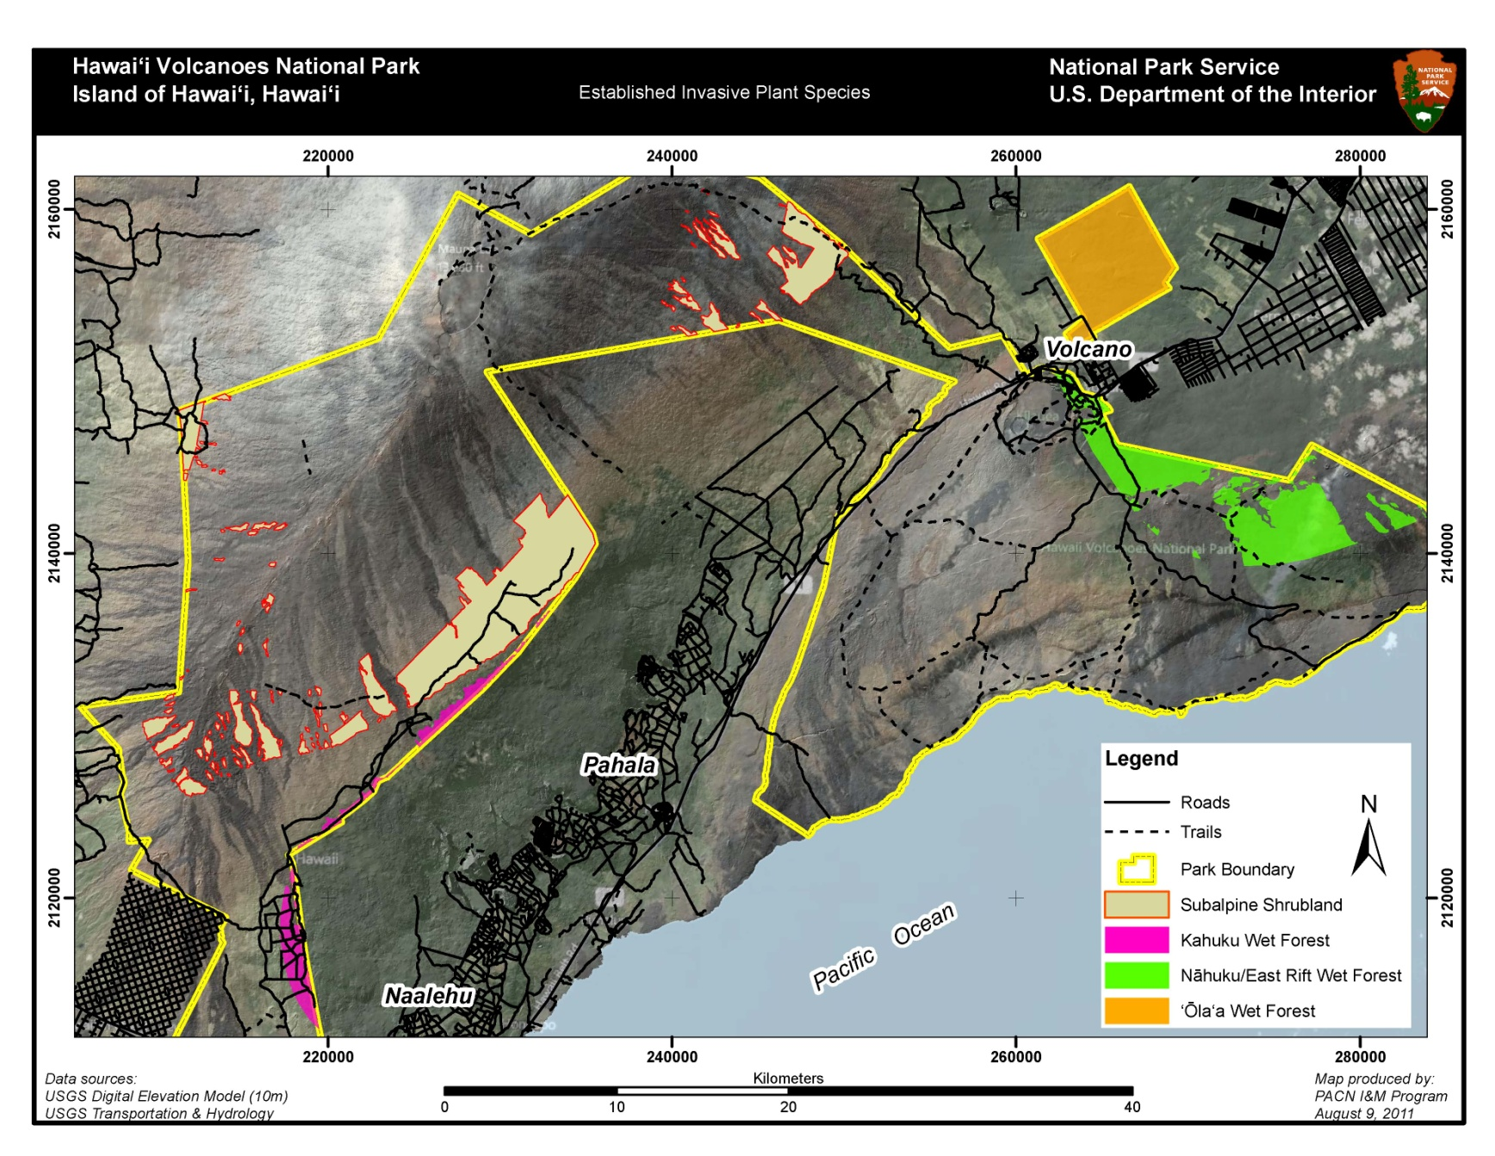

**Figure A.1.** Three wet forest and one subalpine shrubland sampling frames at HAVO.

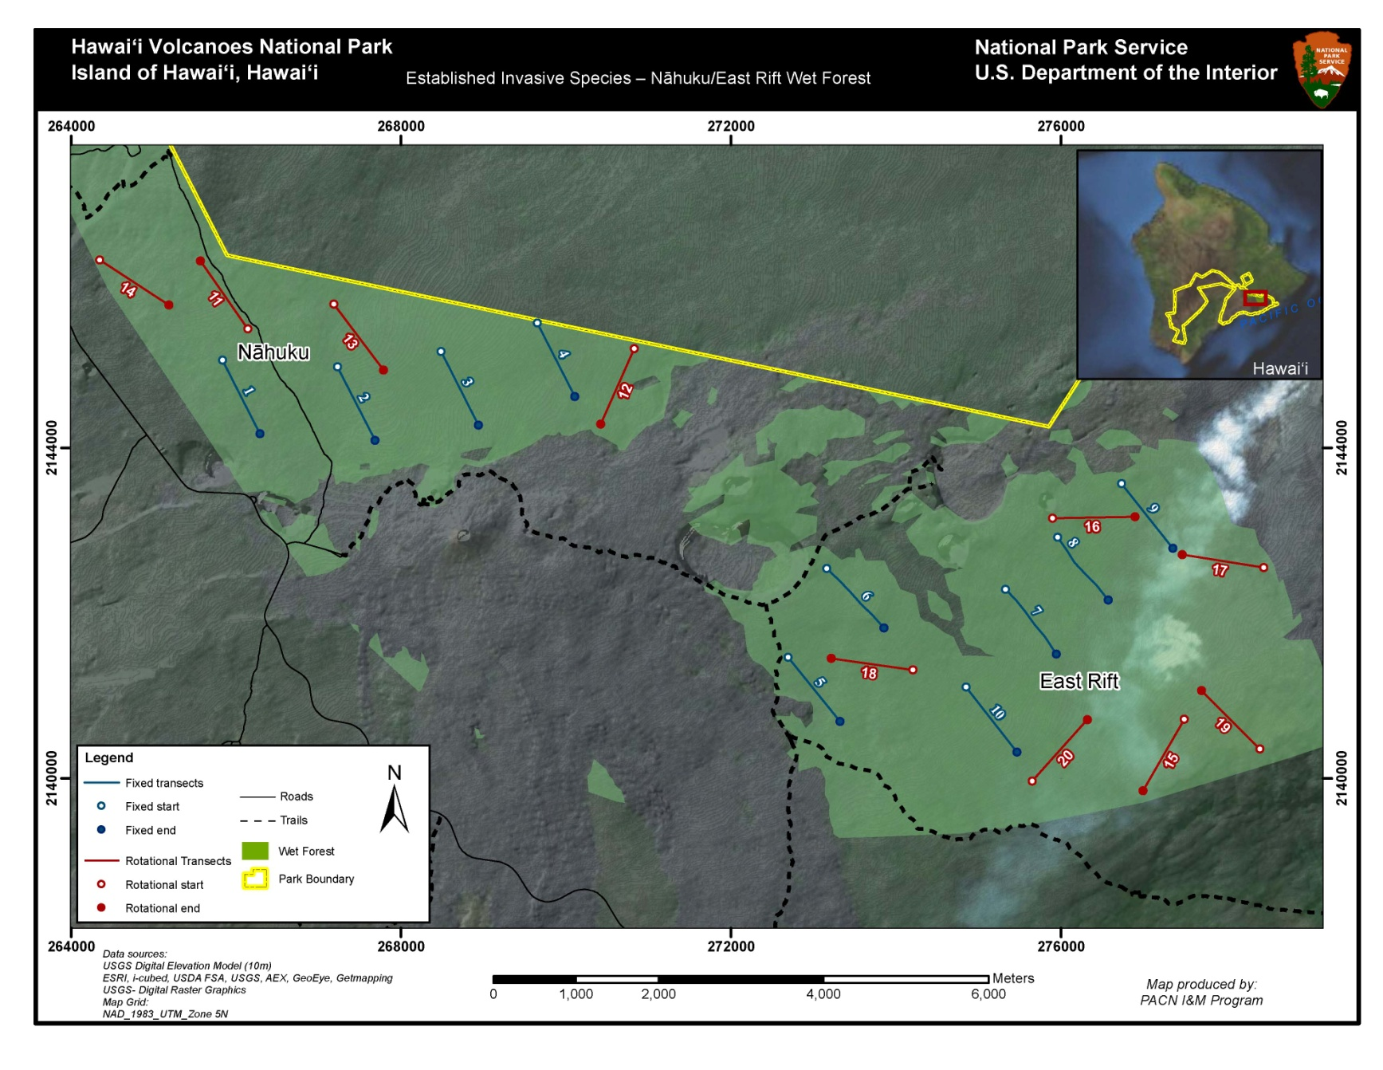

**Figure A.2.** Fixed and rotational transects for the Nāhuku/East Rift wet forest sampling frame at HAVO.

**Table A.2.** Fixed and rotational transect locations for the Nāhuku/East Rift wet forest sampling frame at HAVO. An asterisk (*) indicates that the transect falls along a legacy transect. Alternate locations are provided in case any of the rotational transects cannot be established and sampled. Coordinates are UTM, NAD83, zone 5N.

|  |  |  |  |  |  |  |  |
| --- | --- | --- | --- | --- | --- | --- | --- |
| **Transect Number** | **Length (m)** | **Azimuth** | **Start X** | **Start Y** | **End X** | **End Y** | **Panel** |
| 1 | 1000 | 153 | 265835 | 2145062 | 266062 | 2144617 | Fixed |
| 2 | 1000 | 153 | 267228 | 2144981 | 267455 | 2144536 | Fixed |
| 3 | 1000 | 153 | 268482 | 2145166 | 268709 | 2144721 | Fixed |
| 4 | 1000 | 153 | 269649 | 2145512 | 269876 | 2145067 | Fixed |
| 5 | 1000 | 139 | 272775 | 2143085 | 273103 | 2142708 | Fixed |
| 6 | 1000 | 167 | 272433 | 2141635 | 272545 | 2141148 | Fixed* |
| 7 | 1000 | 144 | 275784 | 2141601 | 276078 | 2141196 | Fixed* |
| 8 | 1000 | 143 | 277087 | 2141502 | 277388 | 2141102 | Fixed* |
| 9 | 1000 | 142 | 277114 | 2143076 | 277422 | 2142682 | Fixed |
| 10 | 1000 | 142 | 281950 | 2142605 | 282258 | 2142211 | Fixed |
| 11 | 1000 | 210 | 277491 | 2140715 | 277241 | 2140282 | Rotational |
| 12 | 1000 | 89 | 276057 | 2143153 | 276557 | 2143161 | Rotational |
| 13 | 1000 | 279 | 277963 | 2142628 | 277469 | 2142707 | Rotational |
| 14 | 1000 | 278 | 274203 | 2141312 | 273708 | 2141382 | Rotational |
| 15 | 1000 | 315 | 278408 | 2140355 | 278055 | 2140708 | Rotational |
| 16 | 1000 | 42 | 275648 | 2139966 | 275983 | 2140338 | Rotational |
| 17 | 1000 | 245 | 277513 | 2143747 | 277059 | 2143536 | Rotational |
| 18 | 1000 | 37 | 277925 | 2142444 | 278226 | 2142843 | Rotational |
| 19 | 1000 | 325 | 266131 | 2145456 | 265844 | 2145866 | Rotational |
| 20 | 1000 | 204 | 270767 | 2144623 | 270564 | 2144166 | Rotational |
| A1 | 1000 | 143 | 267183 | 2145740 | 267484 | 2145341 | Alternate |
| A2 | 1000 | 89 | 275255 | 2143139 | 275755 | 2143147 | Alternate |
| A3 | 1000 | 18 | 273997 | 2139749 | 274152 | 2140225 | Alternate |

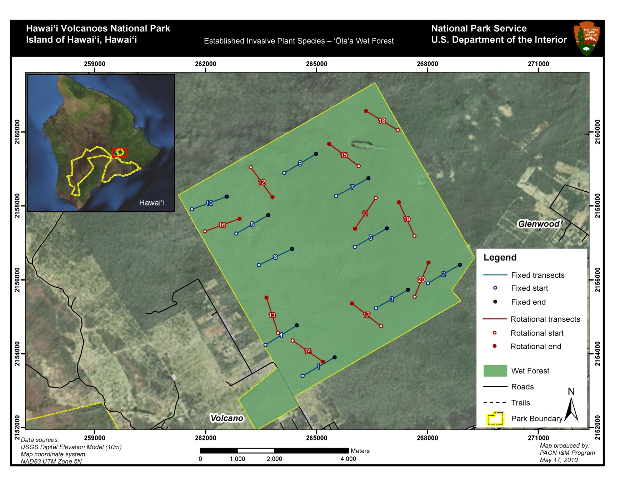

**Figure A.3.** Fixed and rotational transects for the ‘Ōla‘a wet forest sampling frame at HAVO.

**Table A.3.** Fixed and rotational transect locations for the ‘Ōla‘a wet forest sampling frame at HAVO. An asterisk (*) indicates that the transect falls along a legacy transect. Alternate locations are provided in case any of the rotational transects are rejected in the field. Coordinates are UTM, NAD83, zone 5N.

|  |  |  |  |  |  |  |  |  |
| --- | --- | --- | --- | --- | --- | --- | --- | --- |
| **Transect Number** | | **Length (m)** | **Azimuth** | **Start X** | **Start Y** | **End X** | **End Y** | **Panel** |
| 1 | 1000 | | 60 | 264624 | 2153405 | 265490 | 2153905 | Fixed* |
| 2 | 1000 | | 60 | 268012 | 2155908 | 268878 | 2156408 | Fixed* |
| 3 | 1000 | | 60 | 266608 | 2155231 | 267474 | 2155731 | Fixed* |
| 4 | 1000 | | 58 | 263620 | 2154240 | 264468 | 2154770 | Fixed* |
| 5 | 1000 | | 60 | 266036 | 2156892 | 266902. | 2157392 | Fixed* |
| 6 | 1000 | | 64 | 263442 | 2156401 | 264341 | 2156839 | Fixed* |
| 7 | 1000 | | 61 | 265531 | 2158263 | 266405 | 2158748 | Fixed* |
| 8 | 1000 | | 60 | 262831 | 2157253 | 263697 | 2157753 | Fixed* |
| 9 | 1000 | | 59 | 264131 | 2158892 | 264988 | 2159407 | Fixed* |
| 10 | 1000 | | 70 | 261633 | 2157910 | 262572 | 2158252 | Fixed* |
| 11 | 1000 | | 214 | 266602 | 2158215 | 266043 | 2157386 | Rotational |
| 12 | 1000 | | 144 | 263223 | 2159045 | 263811 | 2158236 | Rotational |
| 13 | 1000 | | 342 | 263958 | 2154571 | 263649 | 2155522 | Rotational |
| 14 | 1000 | | 125 | 264355 | 2154361 | 265174 | 2153787 | Rotational |
| 15 | 1000 | | 307 | 266141 | 2159075 | 265342 | 2159677 | Rotational |
| 16 | 1000 | | 70 | 261980 | 2157313 | 262920 | 2157655 | Rotational |
| 17 | 1000 | | 308 | 266746 | 2154747 | 265958. | 2155363 | Rotational |
| 18 | 1000 | | 301 | 267196 | 2160050 | 266338 | 2160565 | Rotational |
| 19 | 1000 | | 335 | 267649 | 2157192 | 267227 | 2158098 | Rotational |
| 20 | 1000 | | 22 | 267654 | 2155544 | 268028 | 2156471 | Rotational |
| A1 | 1000 | | 21 | 266149 | 2155350 | 266507. | 2156283. | Alternate |
| A2 | 1000 | | 1 | 263773 | 2155319 | 263791 | 2156318 | Alternate |
| A3 | 1000 | | 255 | 265103 | 2157422 | 264138 | 2157163 | Alternate |

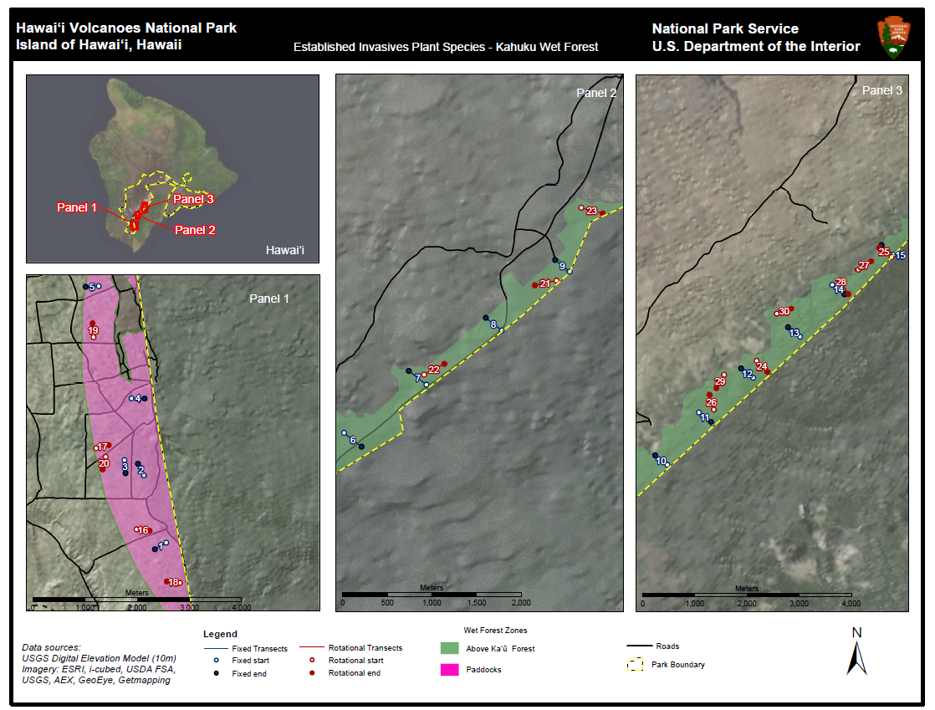

**Figure A.4.** Transect locations in the two zones of the Kahuku wet forest sampling frame at HAVO. Because this frame is narrow transect length is truncated to 250 m and the number of transects is increased to 15 per panel. The number of transects in each zone is proportional to the area of the zone.

**Table A.4.** Fixed and rotational transect locations for the Kahuku wet forest sampling frame at HAVO. An asterisk (*) indicates that the transect falls along a legacy transect. Alternate locations are provided in case any of the fixed or rotational transects are rejected in the field. Because the frame is narrow transect length is truncated to 250 m and the number of transects is increased to 15 per panel. Coordinates are UTM, NAD83, zone 5N.

|  |  |  |  |  |  |  |  |
| --- | --- | --- | --- | --- | --- | --- | --- |
| **Transect Number** | **Length (m)** | **Azimuth** | **Start X** | **Start Y** | **End X** | **End Y** | **Panel** |
| 1 | 250 | 240 | 218836 | 2114424 | 218620 | 2114299 | Fixed |
| 2 | 250 | 333 | 218409 | 2115719 | 218295 | 2115942 | Fixed |
| 3 | 250 | 175 | 218035 | 2116011 | 218057 | 2115762 | Fixed* |
| 4 | 250 | 91 | 218171 | 2117192 | 218421 | 2117188 | Fixed |
| 5 | 250 | 267 | 217541 | 2119331 | 217292 | 2119318 | Fixed |
| 6 | 250 | 128 | 220136 | 2124400 | 220333 | 2124246 | Fixed* |
| 7 | 250 | 308 | 221061 | 2124941 | 220864 | 2125095 | Fixed* |
| 8 | 230 | 308 | 221900 | 2125548 | 221719 | 2125689 | Fixed* |
| 9 | 210 | 308 | 222663 | 2126208 | 222498 | 2126337 | Fixed* |
| 10 | 250 | 308 | 226257 | 2129696 | 226060 | 2129850 | Fixed* |
| 11 | 250 | 128 | 226771 | 2130548 | 226969 | 2130394 | Fixed* |
| 12 | 250 | 308 | 227654 | 2131110 | 227457 | 2131263 | Fixed* |
| 13 | 250 | 308 | 228417 | 2131775 | 228220 | 2131929 | Fixed* |
| 14 | 250 | 128 | 228939 | 2132623 | 229137 | 2132470 | Fixed* |
| 15 | 250 | 308 | 229926 | 2133112 | 229729 | 2133266 | Fixed* |
| 16 | 250 | 96 | 218268 | 2114680 | 218516 | 2114654 | Rotational |
| 17 | 250 | 76 | 217492 | 2116239 | 217734 | 2116299 | Rotational |
| 18 | 250 | 276 | 219097 | 2113656 | 218848 | 2113682 | Rotational |
| 19 | 250 | 356 | 217442 | 2118369 | 217424 | 2118618 | Rotational |
| 20 | 250 | 194 | 217676 | 2116074 | 217616 | 2115832 | Rotational |
| 21 | 250 | 258 | 222514 | 2126106 | 222270 | 2126054 | Rotational |
| 22 | 250 | 61 | 221035 | 2125053 | 221254 | 2125174 | Rotational |
| 23 | 250 | 105 | 222792 | 2126921 | 223033 | 2126857 | Rotational |
| 24 | 250 | 136 | 227710 | 2131385 | 227884 | 2131205 | Rotational |
| 25 | 250 | 307 | 229891 | 2133072 | 229691 | 2133222 | Rotational |
| 26 | 250 | 344 | 227013 | 2130596 | 226944 | 2130836 | Rotational |
| 27 | 250 | 57 | 229350 | 2132868 | 229559 | 2133004 | Rotational |
| 28 | 250 | 148 | 229069 | 2132685 | 229201 | 2132473 | Rotational |
| 29 | 250 | 210 | 227181 | 2131159 | 227056 | 2130943 | Rotational |
| 30 | 250 | 70 | 228038 | 2132149 | 228273 | 2132234 | Rotational |
| A1 | 250 | 2 | 220064 | 2124310 | 220073 | 2124560 | Alternate |
| A2 | 250 | 80 | 225742 | 2129599 | 225989 | 2129643 | Alternate |
| A3 | 250 | 45 | 228584 | 2132149 | 228761 | 2132326 | Alternate |
| A4 | 250 | 275 | 218184 | 2115166 | 217934 | 2115188 | Alternate |
| A5 | 250 | 130 | 218019 | 2116931 | 218210 | 2116770 | Alternate |
| A6 | 250 | 343 | 218449 | 2113886 | 218376 | 2114125 | Alternate |

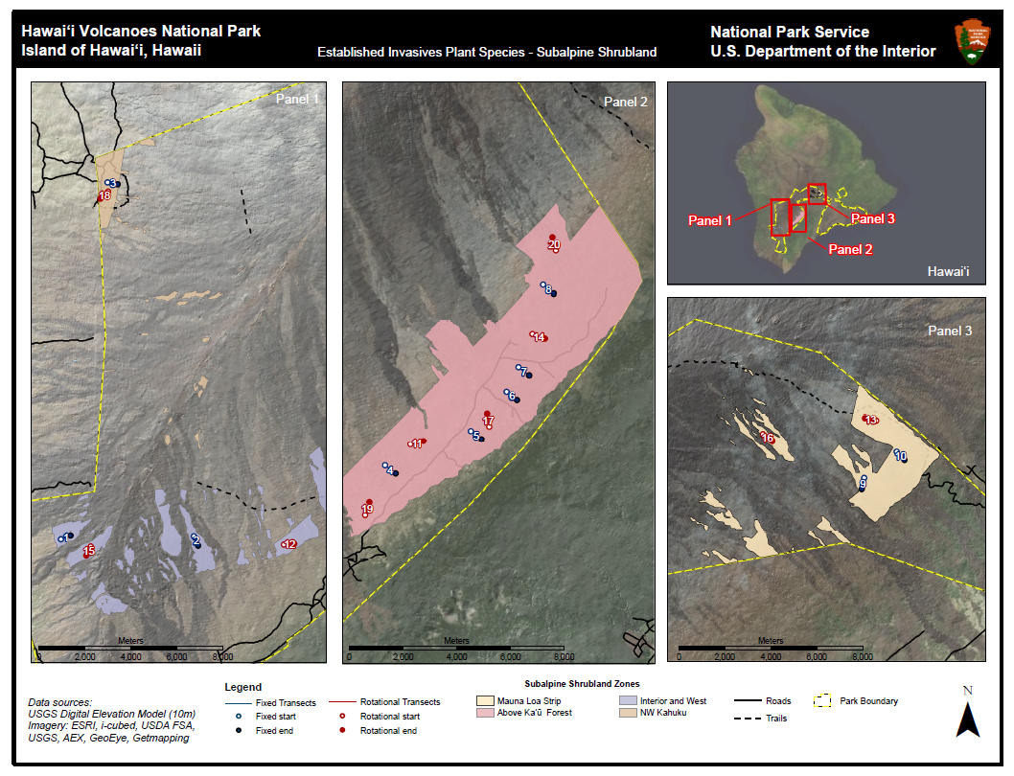

**Figure A.5.** Transect locations across the four zones in the subalpine shrubland sampling frame at HAVO. Zones represent disjointed geographic regions and were established to ensure well-interspersed transects across a geographically complex sampling frame. The number of sampling transects in each zone is proportional to the area of each zone.

**Table A.5.** Fixed and rotational transect locations for the subalpine shrubland sampling frame at HAVO. An asterisk (*) indicates that the transect falls along a legacy transect. Zones are indicated by the following abrieviations: MLS (Mauna Loa Strip), AKF (Above Ka‘ū Forest), IW (Interior and West), and NW (NW Kahuku). Alternate locations are provided in case any of the fixed or rotational transects are rejected in the field. Coordinates are UTM, NAD83, zone 5N.

|  |  |  |  |  |  |  |  |  |
| --- | --- | --- | --- | --- | --- | --- | --- | --- |
| **Transect Number** | **Length (m)** | **Azimuth** | **Start X** | **Start Y** | **End X** | **End Y** | **Panel** | **Zone** |
| 1 | 500 | 68 | 209671 | 2129642 | 210135 | 2129829 | Fixed | IW |
| 2 | 500 | 156 | 216191 | 2129791 | 216394 | 2129334 | Fixed | IW |
| 3 | 500 | 100 | 211955 | 2147127 | 212447 | 2147040 | Fixed* | NW |
| 4 | 500 | 128 | 225966 | 2133684 | 226360 | 2133376 | Fixed* | AKF |
| 5 | 500 | 128 | 229164 | 2134971 | 229558 | 2134663 | Fixed* | AKF |
| 6 | 500 | 128 | 230491 | 2136449 | 230885 | 2136141 | Fixed | AKF |
| 7 | 500 | 128 | 230939 | 2137355 | 231333 | 2137047 | Fixed* | AKF |
| 8 | 500 | 128 | 231856 | 2140422 | 232250 | 2140114 | Fixed* | AKF |
| 9 | 500 | 192 | 246983 | 2156385 | 246879 | 2155896 | Fixed | MLS |
| 10 | 500 | 137 | 248394 | 2157528 | 248735 | 2157163 | Fixed | MLS |
| 11 | 500 | 76 | 226913 | 2134473 | 227398 | 2134594 | Rotational | AKF |
| 12 | 500 | 85 | 220611 | 2129382 | 221109 | 2129425 | Rotational | IW |
| 13 | 500 | 283 | 247507 | 2158867 | 247020 | 2158980 | Rotational | MLS |
| 14 | 500 | 110 | 231456 | 2138589 | 231926 | 2138418 | Rotational | AKF |
| 15 | 500 | 208 | 211139 | 2129289 | 210904 | 2128848 | Rotational | IW |
| 16 | 500 | 126 | 242562 | 2158285 | 242966 | 2157992 | Rotational | MLS |
| 17 | 500 | 350 | 229853 | 2135139 | 229766 | 2135631 | Rotational | AKF |
| 18 | 500 | 228 | 211978 | 2146664 | 211606 | 2146330 | Rotational | NW |
| 19 | 500 | 19 | 225219 | 2131869 | 225382 | 2132342 | Rotational | AKF |
| 20 | 500 | 345 | 232331 | 2141698 | 232201 | 2142181 | Rotational | AKF |
| A1 | 500 | 159 | 211970 | 2148005 | 212149 | 2147538 | Alternate | NW |
| A2 | 500 | 88 | 248022 | 2156040 | 248522 | 2156057 | Alternate | MLS |
| A3 | 500 | 97 | 242383 | 2153426 | 242879 | 2153365 | Alternate | MLS |
| A4 | 500 | 332 | 215173 | 2129439 | 214938 | 2129881 | Alternate | IW |
| A5 | 500 | 118 | 231216 | 2139704 | 231658 | 2139469 | Alternate | AKF |

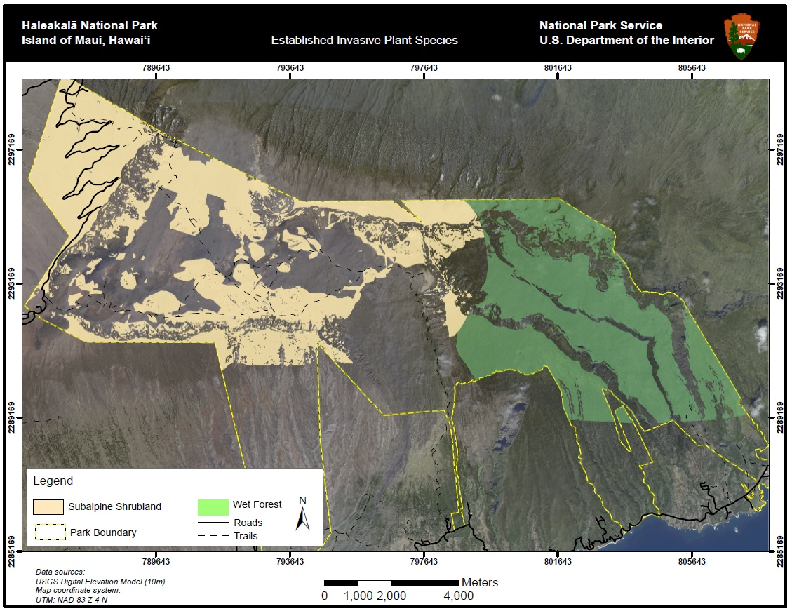

**Figure A.6.** Wet forest and subalpine shrubland sampling frames at HALE.

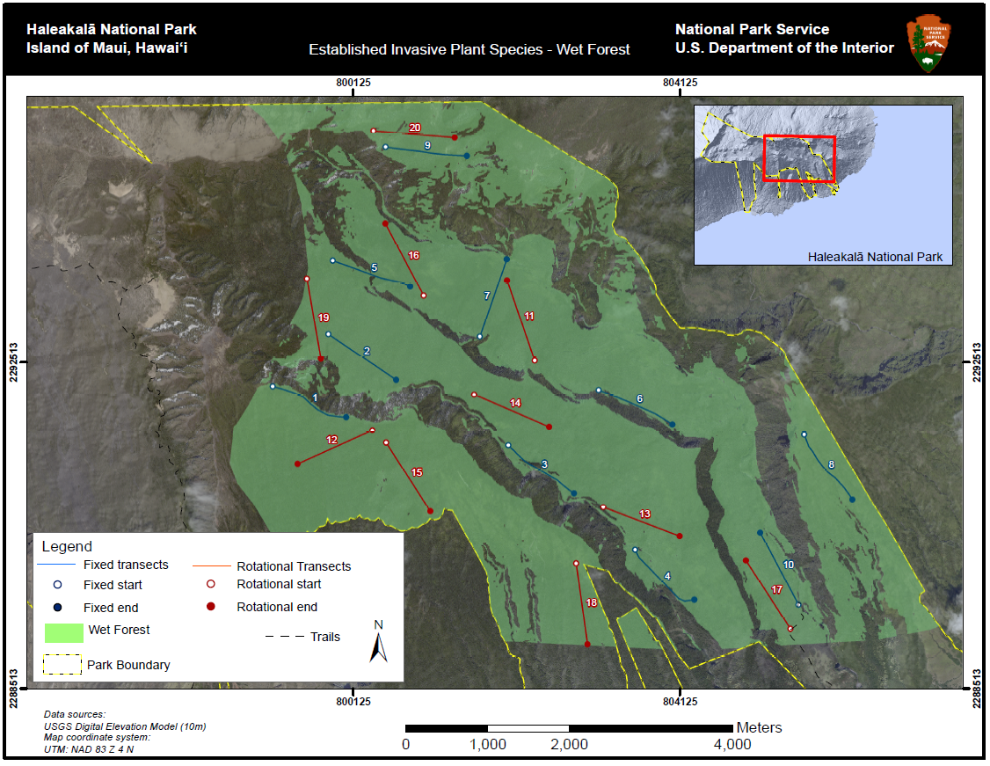

**Figure A.7.** Fixed and rotational transect locations for the wet forest sampling frame at HALE.

**Table A.6.** Fixed and rotational transect locations for the wet forest sampling frame at HALE. An asterisk (*) indicates that the transect falls along a legacy transect. Alternate locations are provided in case any of the transects are rejected in the field. Coordinates are UTM, NAD83, and zone 4N.

|  |  |  |  |  |  |  |  |
| --- | --- | --- | --- | --- | --- | --- | --- |
| **Transect Number** | **Length (m)** | **Azimuth** | **Start X** | **Start Y** | **End X** | **End Y** | **Panel** |
| 1 | 1000 | 113 | 799145 | 2292213 | 800046 | 2291835 | Fixed* |
| 2 | 1000 | 124 | 799827 | 2292851 | 800656 | 2292293 | Fixed* |
| 3 | 1000 | 126 | 802031 | 2291492 | 802834 | 2290905 | Fixed* |
| 4 | 1000 | 130 | 803585 | 2290208 | 804309 | 2289599 | Fixed* |
| 5 | 1000 | 109 | 799881 | 2293753 | 800827 | 2293435 | Fixed* |
| 6 | 1000 | 115 | 803138 | 2292168 | 804042 | 2291746 | Fixed* |
| 7 | 1000 | 19 | 801681 | 2292822 | 802009 | 2293767 | Fixed* |
| 8 | 1000 | 143 | 805655 | 2291619 | 806244 | 2290827 | Fixed* |
| 9 | 1000 | 96 | 800528 | 2295144 | 801522 | 2295037 | Fixed* |
| 10 | 1000 | 332 | 805586 | 2289540 | 805117 | 2290423 | Fixed |
| 11 | 1000 | 341 | 802340 | 2292566 | 802015 | 2293512 | Rotational |
| 12 | 1000 | 246 | 800364 | 2291673 | 799450 | 2291267 | Rotational |
| 13 | 1000 | 111 | 803194 | 2290733 | 804130 | 2290381 | Rotational |
| 14 | 1000 | 113 | 801610 | 2292111 | 802531 | 2291720 | Rotational |
| 15 | 1000 | 147 | 800532 | 2291522 | 801074 | 2290682 | Rotational |
| 16 | 1000 | 332 | 800994 | 2293323 | 800525 | 2294206 | Rotational |
| 17 | 1000 | 327 | 805486 | 2289241 | 804942 | 2290080 | Rotational |
| 18 | 1000 | 172 | 802862 | 2290045 | 802999 | 2289055 | Rotational |
| 19 | 1000 | 170 | 799563 | 2293534 | 799733 | 2292548 | Rotational |
| 20 | 1000 | 95 | 800377 | 2295344 | 801373 | 2295257 | Rotational |
| A1 | 1000 | 273 | 800711 | 2290876 | 799712 | 2290928 | Alternate |
| A2 | 1000 | 327 | 804421 | 2291599 | 803876 | 2292438 | Alternate |
| A3 | 1000 | 295 | 801301 | 2292415 | 800395 | 2292838 | Alternate |

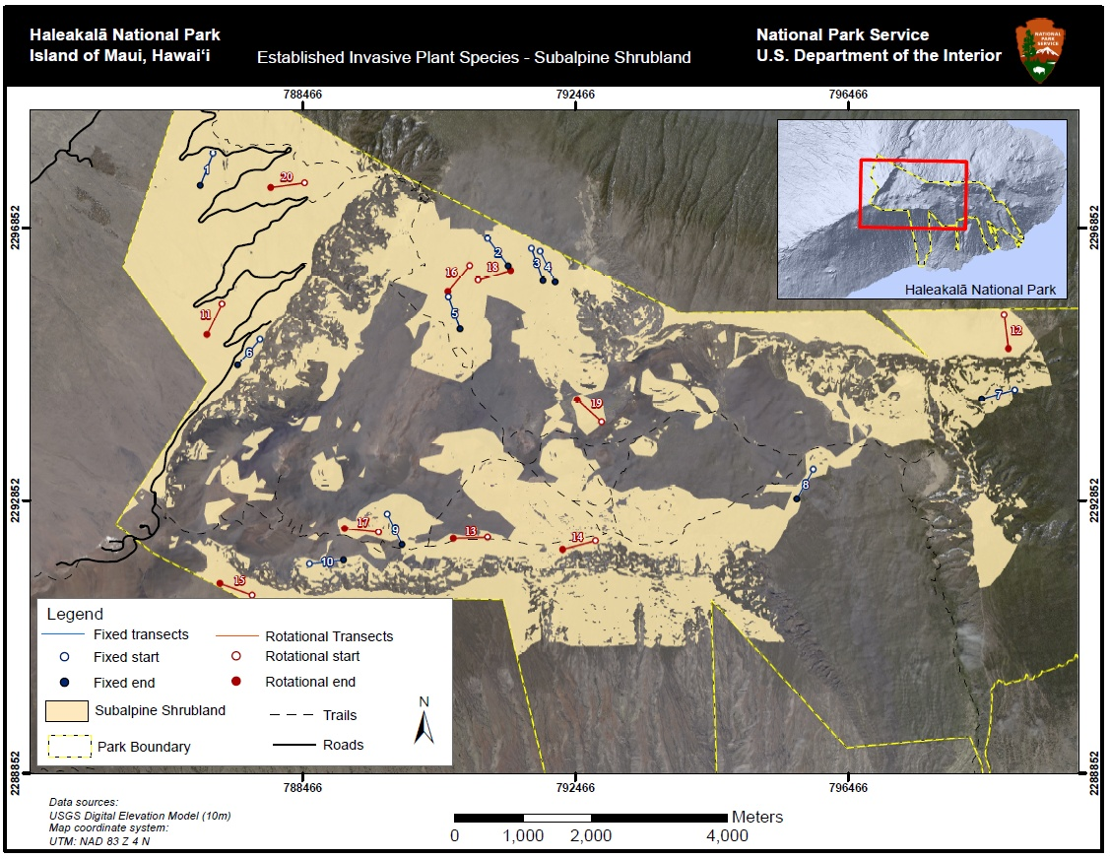

**Figure A.8.** Map of fixed and rotational transects for the subalpine shrubland sampling frame at HALE.

**Table A.7.** Fixed and rotational transect locations for the subalpine shrubland sampling frame at HALE. Alternate locations are provided in case any fixed or rotational transects are rejected in the field. No legacy transects were available in the subalpine shrubland for collocation of fixed transects. Coordinates are UTM, NAD83, and zone 4N.

|  |  |  |  |  |  |  |  |
| --- | --- | --- | --- | --- | --- | --- | --- |
| **Transect Number** | **Length (m)** | **Azimuth** | **Start X** | **Start Y** | **End X** | **End Y** | **Panel** |
| 1 | 500 | 202 | 787158 | 2297940 | 786970 | 2297476 | Fixed |
| 2 | 500 | 143 | 791187 | 2296692 | 791488 | 2296293 | Fixed |
| 3 | 500 | 160 | 791828 | 2296546 | 791999 | 2296077 | Fixed |
| 4 | 500 | 154 | 791958 | 2296503 | 792177 | 2296054 | Fixed |
| 5 | 500 | 160 | 790613 | 2295835 | 790784 | 2295365 | Fixed |
| 6 | 500 | 221 | 787848 | 2295215 | 787520 | 2294838 | Fixed |
| 7 | 500 | 255 | 798920 | 2294471 | 798437 | 2294342 | Fixed |
| 8 | 500 | 209 | 795967 | 2293311 | 795724 | 2292874 | Fixed |
| 9 | 500 | 154 | 789715 | 2292653 | 789934 | 2292203 | Fixed |
| 10 | 500 | 83 | 788577 | 2291926 | 789074 | 2291984 | Fixed |
| 11 | 500 | 206 | 787289 | 2295735 | 787070 | 2295286 | Rotational |
| 12 | 500 | 173 | 798765 | 2295577 | 798826 | 2295081 | Rotational |
| 13 | 500 | 268 | 791187 | 2292309 | 790687 | 2292293 | Rotational |
| 14 | 500 | 255 | 792772 | 2292260 | 792289 | 2292130 | Rotational |
| 15 | 500 | 290 | 787732 | 2291465 | 787262 | 2291636 | Rotational |
| 16 | 500 | 220 | 790924 | 2296295 | 790603 | 2295912 | Rotational |
| 17 | 500 | 276 | 789589 | 2292386 | 789092 | 2292438 | Rotational |
| 18 | 500 | 74 | 791047 | 2296086 | 791527 | 2296224 | Rotational |
| 19 | 500 | 312 | 792860 | 2294002 | 792500 | 2294328 | Rotational |
| 20 | 500 | 262 | 788502 | 2297514 | 788007 | 2297445 | Rotational |
| A1 | 500 | 221 | 789058 | 2296914 | 788728 | 2296539 | Alternate |
| A2 | 500 | 75 | 788820 | 2291815 | 789303 | 2291944 | Alternate |
| A3 | 500 | 98 | 788392 | 2295205 | 788888 | 2295135 | Alternate |
| A4 | 500 | 232 | 793156 | 2291184 | 792762 | 2290876 | Alternate |
| A5 | 500 | 257 | 788698 | 2291602 | 788211 | 2291489 | Alternate |
| A6 | 500 | 127 | 791043 | 2291800 | 791443 | 2291499 | Alternate |

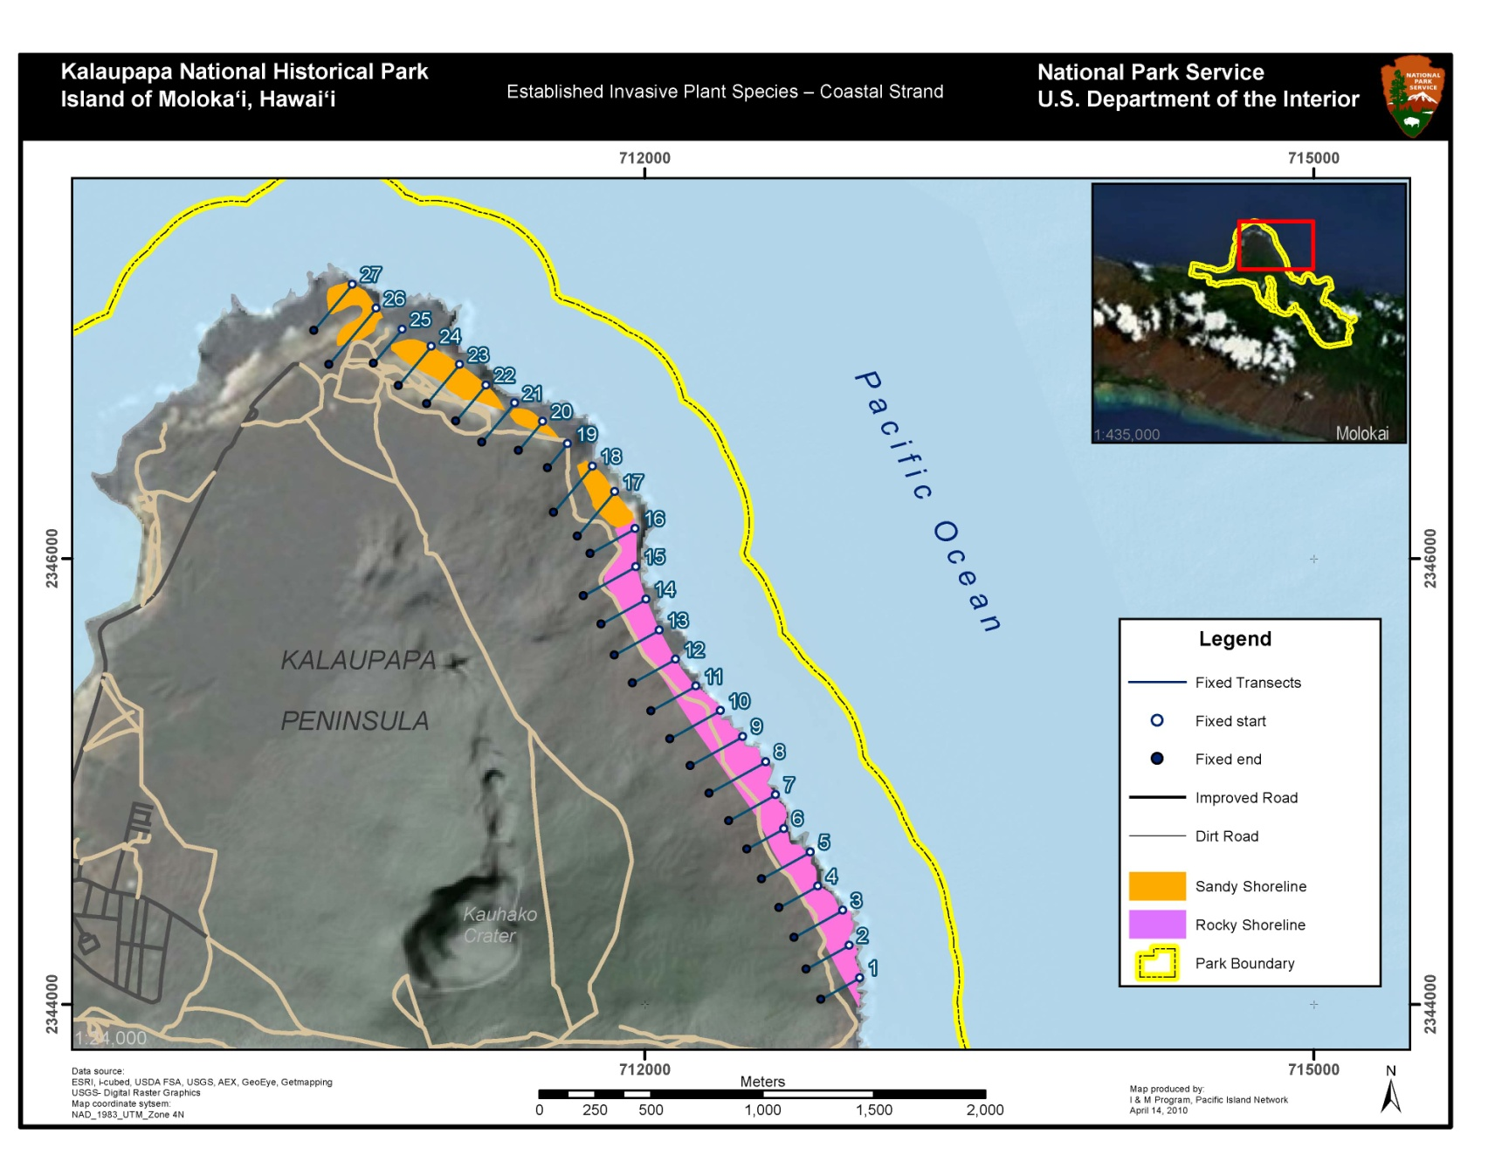

**Figure A.9.** Fixed transect locations within the two coastal strand sampling frames at KALA. Given the dimensions of the sampling frames and concerns regarding nonnative species invading from the adjacent buffer area fixed transects extend beyond the focal plant community frame boundaries. Substrate classifications are based on work done by Canfield (1990).

**Table A.8.** Fixed transect locations for the coastal strand sampling frames at KALA. No legacy transects were used at KALA. Due to small size of sampling frame and concern regarding invasive species introduction through monitoring, no rotational transects are used. Coordinates are UTM, NAD83, and zone 4N.

|  |  |  |  |  |  |  |  |  |
| --- | --- | --- | --- | --- | --- | --- | --- | --- |
| **Frame** | **Transect Number** | **Length (m)** | **Azimuth** | **Start X** | **Start Y** | **End X** | **End Y** | **Panel** |
| Rocky | 1 | 200 | 241 | 712965 | 2344119 | 712790 | 2344022 | Fixed |
| Rocky | 2 | 220 | 241 | 712917 | 2344264 | 712724 | 2344158 | Fixed |
| Rocky | 3 | 250 | 241 | 712889 | 2344421 | 712670 | 2344299 | Fixed |
| Rocky | 4 | 200 | 241 | 712777 | 2344530 | 712602 | 2344433 | Fixed |
| Rocky | 5 | 250 | 241 | 712743 | 2344682 | 712524 | 2344561 | Fixed |
| Rocky | 6 | 190 | 241 | 712624 | 2344788 | 712458 | 2344696 | Fixed |
| Rocky | 7 | 240 | 241 | 712588 | 2344939 | 712378 | 2344823 | Fixed |
| Rocky | 8 | 290 | 241 | 712543 | 2345088 | 712289 | 2344947 | Fixed |
| Rocky | 9 | 270 | 241 | 712440 | 2345201 | 712203 | 2345070 | Fixed |
| Rocky | 10 | 260 | 241 | 712340 | 2345317 | 712112 | 2345191 | Fixed |
| Rocky | 11 | 230 | 241 | 712230 | 2345427 | 712028 | 2345315 | Fixed |
| Rocky | 12 | 220 | 241 | 712137 | 2345547 | 711945 | 2345440 | Fixed |
| Rocky | 13 | 230 | 241 | 712064 | 2345678 | 711863 | 2345567 | Fixed |
| Rocky | 14 | 230 | 241 | 712006 | 2345817 | 711804 | 2345706 | Fixed |
| Rocky | 15 | 270 | 241 | 711960 | 2345963 | 711724 | 2345832 | Fixed |
| Rocky | 16 | 230 | 241 | 711957 | 2346134 | 711756 | 2346022 | Fixed |
| Sandy | 17 | 260 | 220 | 711865 | 2346299 | 711698 | 2346100 | Fixed |
| Sandy | 18 | 270 | 220 | 711765 | 2346413 | 711591 | 2346206 | Fixed |
| Sandy | 19 | 140 | 220 | 711654 | 2346514 | 711564 | 2346407 | Fixed |
| Sandy | 20 | 170 | 220 | 711543 | 2346615 | 711433 | 2346485 | Fixed |
| Sandy | 21 | 230 | 220 | 711416 | 2346697 | 711269 | 2346521 | Fixed |
| Sandy | 22 | 210 | 220 | 711288 | 2346778 | 711153 | 2346617 | Fixed |
| Sandy | 23 | 230 | 220 | 711170 | 2346870 | 711022 | 2346694 | Fixed |
| Sandy | 24 | 230 | 220 | 711043 | 2346952 | 710895 | 2346776 | Fixed |
| Sandy | 25 | 200 | 220 | 710912 | 2347029 | 710783 | 2346876 | Fixed |
| Sandy | 26 | 330 | 220 | 710795 | 2347123 | 710583 | 2346870 | Fixed |
| Sandy | 27 | 270 | 220 | 710689 | 2347230 | 710515 | 2347023 | Fixed |

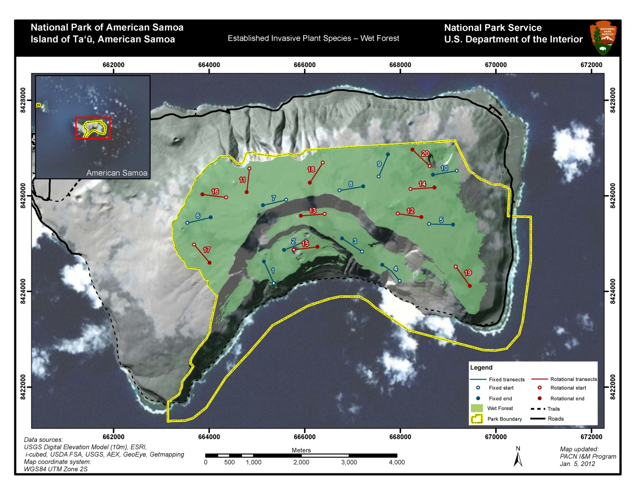

**Figure A.10.** Map of fixed and rotational transects for the Ta‘ū wet forest sampling frame at NPSA.

**Table A.9.** Fixed and rotational transect locations for the wet forest sampling frame on the island of Ta‘ū at NPSA. An asterisk (*) indicates that the transect falls along a legacy transect. Alternate locations are provided in case any of the transects are rejected in the field. Coordinates are UTM, WGS 84, zone 2S.

|  |  |  |  |  |  |  |  |
| --- | --- | --- | --- | --- | --- | --- | --- |
| **Transect Number** | **Length (m)** | **Azimuth** | **Start X** | **Start Y** | **End X** | **End Y** | **Panel** |
| 1 | 500 | 336 | 665355 | 8424168 | 665150 | 8424624 | Fixed* |
| 2 | 500 | 247 | 666031 | 8425058 | 665571 | 8424863 | Fixed* |
| 3 | 500 | 303 | 667205 | 8424830 | 666786 | 8425104 | Fixed* |
| 4 | 500 | 312 | 667990 | 8424218 | 667625 | 8424553 | Fixed* |
| 5 | 500 | 92 | 668605 | 8425409 | 669105 | 8425394 | Fixed* |
| 6 | 500 | 77 | 663549 | 8425431 | 664036 | 8425544 | Fixed* |
| 7 | 500 | 257 | 665616 | 8425912 | 665129 | 8425799 | Fixed* |
| 8 | 500 | 80 | 666733 | 8426109 | 667226 | 8426192 | Fixed* |
| 9 | 500 | 23 | 667552 | 8426400 | 667744 | 8426862 | Fixed |
| 10 | 500 | 260 | 669181 | 8426522 | 668688 | 8426439 | Fixed* |
| 11 | 500 | 187 | 664847 | 8426569 | 664788 | 8426072 | Rotational |
| 12 | 500 | 98 | 667950 | 8425626 | 668445 | 8425552 | Rotational |
| 13 | 500 | 265 | 666421 | 8425619 | 665923 | 8425579 | Rotational |
| 14 | 500 | 86 | 668218 | 8426140 | 668717 | 8426171 | Rotational |
| 15 | 500 | 83 | 665775 | 8424870 | 666271 | 8424929 | Rotational |
| 16 | 500 | 277 | 664360 | 8425964 | 663863 | 8426025 | Rotational |
| 17 | 500 | 140 | 663691 | 8424978 | 664013 | 8424596 | Rotational |
| 18 | 500 | 213 | 666381 | 8426692 | 666110 | 8426271 | Rotational |
| 19 | 500 | 144 | 669162 | 8424514 | 669457 | 8424111 | Rotational |
| 20 | 500 | 314 | 668619 | 8426618 | 668257 | 8426963 | Rotational |
| A1 | 500 | 229 | 664672 | 8425490 | 664296 | 8425161 | Alternate |
| A2 | 500 | 159 | 665315 | 8424830 | 665492 | 8424362 | Alternate |
| A3 | 500 | 17 | 669223 | 8425012 | 669372 | 8425489 | Alternate |

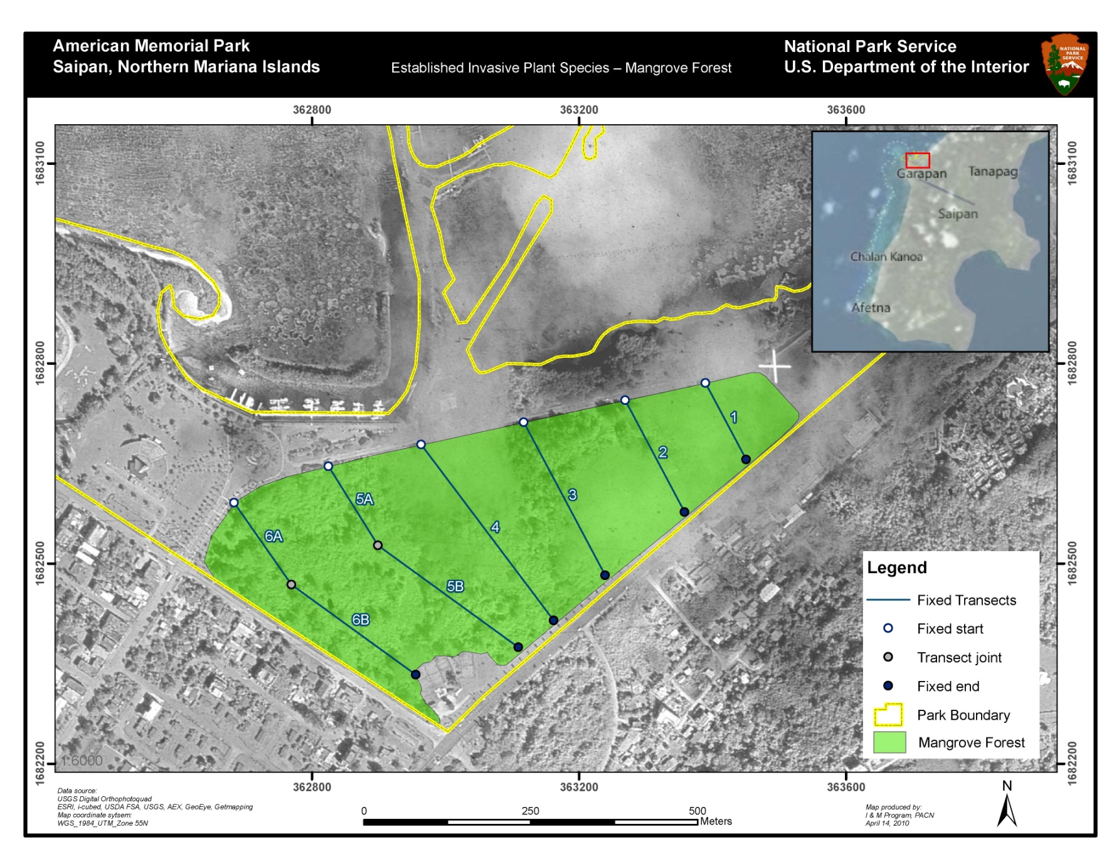

**Figure A.11.** Map of fixed transect locations in the mangrove forest sampling frame at AMME. Since the total area of fixed transects approaches 5% of the sampling frame area, rotational transects are not necessary in this frame.

**Table A.10.** Fixed transect locations for the mangrove forest sampling frame at AMME. An asterisk (*) indicates that the transect falls along a legacy transect. Since the total area of fixed transects approaches 5% of the sampling frame area, rotational transects are not necessary in this frame. Coordinates are UTM, WGS84, zone 55N.

|  |  |  |  |  |  |  |  |
| --- | --- | --- | --- | --- | --- | --- | --- |
| **Transect Number** | **Length (m)** | **Azimuth** | **Start X** | **Start Y** | **End X** | **End Y** | **Panel** |
| 1 | 130 | 152 | 363389 | 1682771 | 363450 | 1682656 | Fixed* |
| 2 | 190 | 152 | 363269 | 1682745 | 363358 | 1682577 | Fixed* |
| 3 | 260 | 152 | 363117 | 1682712 | 363239 | 1682482 | Fixed* |
| 4 | 330 | 143 | 362963 | 1682678 | 363162 | 1682415 | Fixed* |
| 5A | 140 | 148 | 362825 | 1682646 | 362899 | 1682527 | Fixed* |
| 5B | 260 | 126 | 362899 | 1682527 | 363109 | 1682374 | Fixed* |
| 6A | 150 | 145 | 362683 | 1682591 | 362769 | 1682468 | Fixed* |
| 6B | 230 | 126 | 362769 | 1682468 | 362955 | 1682333 | Fixed* |

Literature Cited

Canfield, J. E. 1990. Description and map of the plant communities of the northeast coastal spray zone of Kalaupapa National Historical Park. Technical Report 71. Pacific Cooperative Studies Unit, Honolulu, Hawaii.

Appendix B. Vegetation Monitoring in PACN Park Units

Each of the PACN parks has gained some baseline awareness of invasive plant species presence, either through data gathered for plant inventories, species checklists, or vegetation relevés. Although each park unit reported past or current efforts of nonnative plant control (with the exception of War in the Pacific and American Memorial National Historical Parks), Hawai‘i Volcanoes and Haleakalā National Parks are the only two which have completed studies focused on invasive nonnative plant species. The tables below document work conducted on invasive plant species monitoring as well as studies from which information on nonnative species can be drawn, and are listed by author and year of report or data collection, with a brief description. It is inferred that lists of nonnative species may be compiled from work done for vegetation maps.

Table B.1. Invasive plant species monitoring conducted in Pacific Island Network parks. Studies marked with (*) are unpublished.

|  |  |  |
| --- | --- | --- |
| **Park** | **Nonnative Plant Species Monitoring Project** | **Description** |
| *American Memorial National Historical Park (AMME)* | | |
|  | (Falanruw et al. 1989) | AMME vegetation map |
|  | (Raulerson and Rinehart 1989) | Wetland vegetation map |
| *Haleakalā National Park  (HALE)* | |  |
|  | (Yoshinaga 1977) | Monitoring changes following ungulate removal |
|  | (Yoshinaga 1980) | Upper Kipahulu Valley weed survey |
|  | (Jacobi 1981) | Ungulate damage and vegetation changes on Kalapawili Ridge |
|  | (Lamoureux 1967) | Distribution and spread of alien plants in Kipahulu Valley |
|  | (Loope 1992) | Alien plants in HALE and Maui Island |
|  | (Lamoureux and Stemmerman 1976) | Report on plant response to various herbicide applications |
| *Hawai‘i Volcanoes National Park (HAVO)* | |  |
|  | (Stone 1959) | Revision of Kipuka Puaulu Special Ecological Area (SEA) monitoring methods |
|  | (Doty and Mueller-Dombois 1966) | Revision of Nahuku SEA monitoring |
|  | (Tunison et al. 1984)* | Pre and post treatment monitoring of Nasturtium in Kipuka Puaulu |
|  | (Tunison 1987)* | Effects of alien grass removal on recruitment of native trees in Kipuka Puaulu Special Ecological Area |
|  | (Santos et al. 1992) | Herbicidal control of selected alien plant species in HAVO |
|  | (Tunison et al. 1992b) | The distribution of selected localized alien plant species in HAVO |
|  | (Tunison et al. 1992a)* | Kipuka Ki SEA: progress report on experimental management recommendations for management |
|  | (Tunison 1992) | Fountain grass control in HAVO: management considerations and strategies |
|  | (Tunison and Zimmer 1992) | Success in controlling localized alien plants in HAVO |
| Table B.1. Invasive plant species monitoring conducted in PACN parks. Studies marked with (*) are unpublished. (Continued) | | |
| **Park** | **Nonnative Plant Species Monitoring Project** | **Description** |
| *Hawai‘i Volcanoes National Park* (Con’t) | |  |
|  | (Loh 1994)* | Ōla’a vegetation inside and outside of pig exclosures in Koa Unit |
|  | (Loh 1997)* | Ōla’a vegetation monitoring in the Pu’u Unit |
|  | (Loh and Tunison 1998)* | Vegetation community change in response to ungulate removal in upper Mauna Loa |
|  | (Loh and Tunison 1999) | Ōla’a changes in vegetation following pig removal in Koa Unit |
|  | (Pratt et al. 1999) | East Rift vegetation above a feral pig barrier |
|  | (Fagerlund and Mitchell 1944) | Survey and control of Verbascum thapsis (mullein) |
| *Kaloko-Honokōhau National Historical Park (KAHO)* | | |
|  | (Canfield 1990b) | KAHO vegetation map |
|  | (Pratt and Abbott 1996a) | KAHO plant and weed inventory |
| *Kalaupapa National Park (KALA)* | |  |
|  | (Canfield 1990a) | Coastal spray zone plant inventory |
|  | (Kepler and Kepler 1981) | Baseline vegetation data pre and post ungulate removal at Ka’uhako Crater |
| *National Park of American Samoa (NPSA)* | |  |
|  | (Amerson et al. 1982) | Samoan plant inventory |
|  | (Cole et al. 1988) | US Forest Service plant inventory |
|  | (Whistler 1992a) | Tau vegetation map |
|  | (Whistler 1992b) | Samoan vegetation |
|  | (Whistler 1994) | Tutuila vegetation map |
|  | (Whistler 2002) | Samoan vegetation guide |
|  | (Whistler 2004) | Samoan rainforest trees |
| *Pu‘ukoholā Heiau National Historic Site (PUHE)* | | |
|  | (Macneil and Hemmes 1977) | PUHE plant inventory |
|  | (Pratt and Abbott 1996c) | PUHE plant inventory |
| *Pu‘uhonua o Hōnaunau National Historical Park (PUHO)* | | |
|  | (Leishmann 1986) | PUHO vegetation map |
|  | (Smith et al. 1986) | PUHO plant inventory |
|  | (Pratt and Abbott 1996b) | PUHO plant and weed inventory |
| *War in the Pacific National Historical Park (WAPA)* | | |
|  | (Rodda and Dean-Bradley 2001) | Guam reptile inventory and plants |
|  | (Donnegan et al. 2002) | Guam vegetation map |
|  | (Yoshioka 2005) | WAPA plant inventory |
|  | (Yoshioka 2008) | WAPA botanical survey |

References

Amerson, A. B., W. A. Whistler, and T. D. Schwaner. 1982. Accounts of flora and fauna. Pages 1-151*in* R.C. Banks (Editor), Wildlife and wildlife habitat of American Samoa II. United States Department of the Interior, Fish and Wildlife Service,.Washington D. C.

Canfield, J. E. 1990a. Description and map of the plant communities of the northeast coastal spray zone of Kalaupapa National Historical Park. Technical Report 71. Cooperative National Park Resources Studies Unit, University of Hawaii at Manoa, Honolulu, Hawaii.

Canfield, J. E. 1990b. Distribution and map of the plant communities of Kaloko-Honokohau National Historical Park. Technical Report 73. Cooperative National Park Resources Studies Unit, University of Hawaii at Manoa, Honolulu, Hawaii.

Cole, T. G., C. D. Whitesell, W. A. Whistler, N. McKay, and A. H. Ambacher. 1988. Vegetation survey and forest inventory, American Samoa. Resource Bulletin PSW-RB-25, USDA Forest Service, Berkeley, CA.

Donnegan, J. A., S. L. Butler, W. Grabowiecki, B. A. Hiserote, and D. Limtiaco. 2002. Guam's Forest Resources, 2000. Resource Bulletin PNW-RB-243. US Department of Agriculture Forest Service, Pacific Northwest Research Station, Portland, OR.

Doty, M. S. and D. Mueller-Dombois. 1966. Atlas for Bioecology Studies in Hawaii Volcanoes National Park. University of Hawaii, Hawaii Botanical Science Paper No. 2. Republished 1970 as College of Tropical Agriculture Hawaii Agricultural Experiment Station Miscellaneous Pub. No. 89.

Fagerlund, G. O. and A. L. Mitchell. 1944. A Checklist of Plants of Hawaii National Park, Kilauea-Mauna Loa Section. Natural History Bulletin 9. Hawaii National Park, Hawaii.

Falanruw, M. C., T. G. Cole, and A. H. Ambacher. 1989. Vegetation survey of Rota, Tinian, and Saipan, Commonwealth of the Northern Mariana Islands. Resource Bulletin PSW-27. Department of Agriculture, US Forest Service, Pacific Southwest Research Station, Berkeley, CA.

Jacobi, J. D. 1981. Vegetation changes in a subalpine grassland in Hawaii following disturbance by feral pigs. Technical Report 41. Cooperative National Park Resources Studies Unit. University of Hawaii at Manoa, Honolulu, Hawaii.

Kepler, C. and K. Kepler. 1981. Plant notes, including transects 26 and 27, USFWS Surveys, Kalaupapa Peninsula, Waikolu Valley. March 28-31, 1981.

Lamoureux, C. H. 1967. The vascular plants of Kipahulu Valley, Maui. *In* R. E. Warner, editor. Scientific report of the Kipahulu Valley Expedition: Maui, Hawaii, 2 August-31 August, 1967. The Nature Conservancy, San Francisco, CA.

Lamoureux, C. H. and L. Stemmerman. 1976. Report of the Kipahulu bicentennial expedition. Technical Report 11. Cooperative National Park Resources Studies Unit, University of Hawaii at Manoa, Honolulu, Hawaii.

Leishmann, J. 1986. Vegetation map of Puuhonua o Honaunau National Historical Park, Hawaii. Technical Report 57. Cooperative National Park Resources Studies Unit, University of Hawaii at Manoa, Honolulu, Hawaii.

Loh, R. K. 1994. Olaa vegetation inside and outside of pig exclosures in the Koa unit. Department of the Interior, National Park Service, Resource Mangement Division Unpublished Report, Hawaii National Park, Hawaii.

Loh, R. K. 1997. Olaa vegetation monitoring in the Puu unit. Department of the Interior, National Park Service, Resource Mangement Division Unpublished Report, Hawaii National Park, Hawaii.

Loh, R. K. and J. T. Tunison. 1998. Vegetation community change in response to ungulate removal in upper Mauna Loa. Department of the Interior, National Park Service, Resource Management Division Unpublished Report, Hawaii National Park, Hawaii.

Loh, R. K. and J. T. Tunison. 1999. Vegetation recovery following pig removal in Olaa-Koa rainforest unit, Hawaii Volcanoes National Park. Technical Report 123. Pacific Cooperative Studies Unit, Univeristy of Hawaii at Manoa, Honolulu, Hawaii.

Loope, L. L. 1992. Preventing establishmet of new alien species in Haleakala National Park and the island of Maui, Hawaii. The George Wright Forum 9:20-31.

Macneil, J. D. and D. E. Hemmes. 1977. Pu`ukohola Heiau National Historic Site plant survey. Technical Report 15. Cooperative National Park Resources Studies Unit, University of Hawaii at Manoa, Honolulu, Hawaii.

Pratt, L. W. and L. L. Abbott. 1996a. Distribution and abundance of alien and native plant species in Kaloko-Honokohau National Historical Park. Technical Report 103. Cooperative National Park Resources Studies Unit, University of Hawaii at Manoa, Honolulu, Hawaii.

Pratt, L. W. and L. L. Abbott. 1996b. Vascular plants of Pu'uhonua O Honaunau National Historical Park. Technical Report 105. Cooperative National Park Resources Studies Unit, University of Hawaii at Manoa, Honolulu, Hawaii.

Pratt, L. W. and L. L. Abbott. 1996c. Vascular plants of Pu'ukohola Heiau National Historic Site, Hawaii Island. Technical Report 101. Cooperative National Park Resources Studies Unit, University of Hawaii at Manoa, Honolulu, Hawaii.

Pratt, L. W., L. L. Abbott, and D. K. Palumbo. 1999. Vegetation above a feral pig barrier fence in rain forests of Kilauea's East Rift, Hawaii Volcanoes National Park. Technical Report 124. Cooperative National Park Resources Studies Unit, University of Hawaii at Manoa, Honolulu, Hawaii.

Raulerson, L. and A. Rinehart. 1989. Vegetation of American Memorial Park, Saipan, Mariana Islands. Technical Report 70. Cooperative National Park Resources Studies Unit, University of Hawaii at Manoa, Honolulu, Hawaii.

Rodda, G. H. and K. Dean-Bradley. 2001. Inventory of the reptiles of the War in the Pacific National Historic Park, Guam. Department of the Interior, US Geological Survey, Fort Collins, CO.

Santos, G. L., D. W. Kageler, D. E. Gardner, L. W. Cuddihy, and C. P. Stone. 1992. Herbicidal control of selected alien plant species in Hawaii Volcanoes National Park. *In* C. P. Stone, C. W. Smith, and J. T. Tunison, editors. Alien Plant Invasions in Native Ecosystems of Hawaii: Management and Research. Cooperative National Park Resources Studies Unit, University of Hawaii at Manoa, Honolulu, Hawaii.

Smith, C. W., L. Stemmerman, P. K. Higashino, and E. Funk. 1986. Vascular plants of Puuhonua O Honaunau National Historical Park, Hawaii. Technical Report 56. Cooperative National Park Resources Studies Unit, University of Hawaii at Manoa, Honolulu, Hawaii.

Stone, B. 1959. The Natural and Cultural History of the Kalapana Extension of the Hawaii National Park. B.P. Bishop Museum, Honolulu, Hawaii.

Tunison, J. T. 1987. Effects of alien grass removal on recruitment of native trees in Kipuka Puaulu Special Ecological Area. Department of the Interior, Hawaii Volcanoes National Park, Resources Management Unpublished Report, Hawaii National Park, Hawaii.

Tunison, J. T. 1992. Fountain grass control in Hawaii Volcanoes National Park: Management considerations and strategies. *In* C. P. Stone, C. W. Smith, and J. T. Tunison, editors. Alien Plant Invasions in Native Ecosystems of Hawaii: Management and Research. Cooperative National Park Resources Studies Unit, University of Hawaii at Manoa, Honolulu, Hawaii.

Tunison, J. T., D. W. Kageler, and L. W. Cuddihy. 1984. Pre and post treatment monitoring of nasturtium in Kipuka Puaulu. Hawaii Volcanoes National Park, Division of Resources Management Unpublished Report, Hawaii National Park, Hawaii.

Tunison, J. T., D. W. Kageler, and L. W. Cuddihy. 1992a. Kipuka Ki SEA: Progress report on experimental management recommendation for management. Department of the Interior, Hawaii Volcanoes National Park, Resources Management Unpublished Report, Hawaii National Park, Hawaii.

Tunison, J. T., L. D. Whiteaker, L. W. Cuddihy, A. M. La Rosa, D. W. Kageler, M. R. Gates, N. G. Zimmer, and L. Stemmermann. 1992b. The distribution of selected localized alien plant species in Hawaii Volcanoes National Park. Technical Report 84. Cooperative National Park Resources Studies Unit, University of Hawaii at Manoa, Honolulu, Hawaii.

Tunison, J. T. and N. G. Zimmer. 1992. Success in controlling localized alien plants in Hawaii Volcanoes National Park. *In* C. P. Stone, C. W. Smith, and J. T. Tunison, editors. Alien Plant Invasions in Native Ecosystems of Hawaii: Management and Research. Cooperative National Park Resources Studies Unit, University of Hawaii at Manoa, Honolulu, Hawaii.

Whistler, W. A. 1992a. Botanical inventory of the proposed Ta'u unit of the National Park of American Samoa. Technical Report 83. National Park Service project CA8034-2-0001. Honolulu, Hawaii.

Whistler, W. A. 1992b. Vegetation of Samoa and Tonga. Pacific Science 46:159-178.

Whistler, W. A. 1994. Botanical inventory of the proposed Tutuila and Ofu units of the National Park of American Samoa. Technical Report 87. National Park Service project CA8034-2-0001. Honolulu, Hawaii.

Whistler, W. A. 2002. The Samoan Rainforest: A Guide to the Vegetation of the Samoan Archipelago. Isle Botanica, Honolulu, Hawaii.

Whistler, W. A. 2004. Rainforest Trees of Samoa: A Guide to the Common Lowland and Foothill Forest Trees of the Samoan Archipelago. Isle Botanica, Honolulu, Hawaii.

Yoshinaga, A. Y. 1977. Montane rain forest vegetation of northeast Haleakala, Maui, Hawaii. Thesis. University of Wisconsin-Madison, Madison, WI.

Yoshinaga, A. Y. 1980. Upper Kipahulu Valley weed survey. Technical Report 33. Cooperative National Park Resources Studies Unit, University of Hawaii at Manoa, Honolulu, Hawaii.

Yoshioka, J. M. 2005. Vegetation of the War in the Pacific National Historical Park, Guam, Marianas Islands. Pacific Islands Network, USDI National Park Service, Hawaii National Park, Hawaii.

Yoshioka, J. M. 2008. Botanical survey of the War in the Pacific National Historical Park, Guam, Mariana Islands. Technical Report 161. Pacific Cooperative Studies Unit, University of Hawaii at Manoa, Honolulu, Hawaii.

Appendix C. Sample Size and Power

This appendix provides supplemental details and calculations for status estimators, sample size, and statistical power. These three entities are closely related to one another. Reduced confidence intervals around status estimates, which depend on sampling design and sample size, result in increased statistical power or an increased probability of detecting change. All things being equal, larger sample sizes can narrow confidence intervals which in turn increases statistical power. Ideally increases in power result from efficient sampling design (which concentrates variance within plots not between plots) rather than from increases in sample size. Sample size and power for this protocol are based in part on analyses and simulations performed on presence/ absence data from two pilot studies (Jacobi and Bio 2001, Ainsworth et al. 2008) which used methods similar to those in this protocol. After the first cycle of sampling status estimators, sample size and statistical power should be reevaluated using new data including abundance or cover class data.

Pilot Studies

The pilot study sites encompassed four areas of the ‘Ōla‘a-Kīlauea Management Area adjacent to the wet forests of Hawai‘i Volcanoes National Park. Data for Jacobi and Bio were collected in 1999, 2000, and 2001 in 3 x10 m plots in: Kīlauea Forest (KF), Mauna Loa Boys’ School (MLBS), and Pu‘u Kipu (PK). Data for Ainsworth et al. (2008) were collected in 2000 and 2008 in 5 x 50 m plots in Pu‘u Maka‘ala Natural Area Reserve. Presence/absence data of nonnative plant species were collected in a similar manner as in the Established Invasive Plant Species Monitoring Protocol by using contiguous plots along transects of varying lengths.

From the Jacobi and Bio study, we selected the following target species for examination: *Anthoxanthum odoratum* (ANTODO), *Ehrharta stipoides* (EHRSTI), *Holcus lanatus* (HOLLAN), and *Veronica serpyllifolia* (VERSER). In this study site ANTODO and EHRSTI were more common than HOLLAN and VERSER. From the Ainsworth et al. (2008) dataset, we selected the following five target invasive species: Psidium cattleianum (PSICAT), *Cyperus* *spp*. (CYPSPP), *Passiflora tarminiana* (PASTAR), *Rubus rosifolius* (RUBROS), and *Setaria palmifolia* (SETPAL). In this study CYPSPP and PSICAT were more common than PASTAR, RUBROS, and SETPAL.

Status Estimators

The sampling method in the Established Invasive Plant Species Monitoring Protocol is a split panel design consisting of permanent (fixed) and temporary (rotational) sampling units. For both types the primary sampling unit (PSU) is a transect and the secondary sampling unit is a plot within a transect. All plots along a transect are sampled; therefore, this is a one-stage design with possibly unequal cluster sizes (transect lengths). There are three types of variables for which annual status estimates are desired: nonnative plant species richness, frequency of a particular species, and cover of a particular species. In this case, nonnative plant species richness is the number of nonnative plant species, frequency is measured as the proportion of plots occupied by a particular species, and cover is estimated using modified cover classes.

There are two design-based estimators available for status variables, a ratio estimator and an unbiased estimator. Ratio estimates of the population average per plot are based on the ratio of the total of all the values for a variable in all plots in a sample and the total number of plots in that sample. Unbiased estimates of the population average per plot are based on the average for all transects sampled, where the observation is the average value per plot for a transect.

Ratio and unbiased status estimates were calculated for two nonnative plant pilot data sets in order to examine within and among transect variance for multiple potential transect lengths and different sample sizes (n = 10, n = 20). When using the following estimators, we assumed the sampling design is a one-stage cluster sample. Because we treated all transects in the pilot data as being the same length--although they were not--we refer to the unbiased estimator under our stated assumptions as the equally weighted estimator. Standard error estimates for the equally weighted estimator use the variance estimator assuming a simple random sample, ignoring the transect length. At the time of analysis, we did not know the area (km2) of the sampling frames for the pilot data, which means we did not know the number of primary or secondary sampling units in the population (*N* or *M*). Because of this, we technically should have used only the ratio estimator and not the unbiased estimator. To use the unbiased estimator, we made the above assumptions and used Equation 5 to estimate the variable of interest. Since the area of the sampling frames in the Established Invasive Plant Species Monitoring Protocol is known, Equation 3 could be used for those data in the future.

For the equations below, we used the following notation:

*N* = the number of primary sampling units (PSU = transect) in the sampling frame defining the total area of statistical inference

*n* = the number of PSU in the sample

*i* indexes the transect where *i* = 1,…,*N*

*Mi* = the number of secondary sampling units (SSU = plot) within the *i*th transect (PSU)

*j* indexes the plots within a transect where *j* = 1,…, *Mi*

*M* = 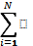*Mi* is the number of secondary sampling units in the population of primary sampling units

 = *Mi* /N is the mean number of secondary sampling units in the population of primary sampling units;

*yij* = the observation recorded in plot *j* in transect *i*; for our report this is either the plot invasive species richness or the presence or absence of a species within a plot

*yi* =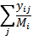 is either average invasive species richness per plot for transect *i*, or the proportion of plots occupied by a species in transect *i*.

Ratio Estimator

For a ratio estimator of the population average per plot (), we use (Lohr 2010)

= 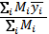 **Equation C.1**

The variance estimator is (Lohr 2010)

 = 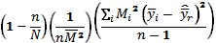 **Equation C.2**

Unbiased Estimator

If the area of the sample frame is known, the unbiased estimator for the population average per plot (Thompson 2002) is

 =  , **Equation C.3**

where

 = 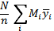 . **Equation C.4**

For the pilot data, the area of the sample frame is unknown, so we assumed that *Mi* = *Mo* where Mo is the size of the PSU and they are all equal. Therefore, *M* = *NMo*, and

 = 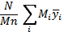 ,

= 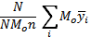 , **Equation C.5**

= 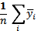 .

The variance estimator is (Thompson 2002)

 =  **Equation C.6**

where

 = 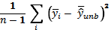. **Equation C.7**

Sample Size

Using empirical simulation and the estimators described above, we investigated the effect of length and number of transects on the variance estimate for status based on presence/absence data of a subset of nonnative species in the two pilot studies. For the simulation, we randomly sampled with replacement *n* transects for a given sample size (*n* =10 or *n* =20) from the pilot data sets. From the selected *n* transects, we randomly selected with replacement one segment of fixed length but no longer than the shortest transect. This procedure was repeated 100 times to generate 100 samples from the pilot data. Then for each sample the variance estimate based on an equally weighted unbiased estimator (one-stage cluster sample with equal cluster sizes) was calculated yielding 100 variance estimates. For this simulation we assumed transects were of equal length and were randomly selected using simple random sampling (SRS), therefore we can use the unbiased variance estimate (Equation C. 6). Use of this variance estimate is appropriate because a proportion is calculated for each transect as the number of plots with presences divided by the total number of plots sampled along that transect.

The major assumption in simulations is that pilot data are representative of variability within a population of established nonnative species in wet forest at Hawai‘i Volcanoes National Park and elsewhere.

Ainsworth et al. Simulation

The frequency estimates for the five target species in 2000 and 2008 from Ainsworth et al. (2008) are presented in Table C.1. Results from the simulation described above are summarized in Figures C.1 and C.2. In those figures, the equally weighted unbiased variance estimate (SRS variance estimator) of the estimated mean frequency is presented for each target species for either 10 or 20 transects of three lengths (100, 250, and 500 m).

For all five species, the mean and quartile width of variance estimations are reduced by sampling 20 transects as compared to 10 (figs. C.1 and C.2). Therefore we recommend a sample size of 20 transects. Increasing transect length from 100 to 500 m does provide some reduction in mean estimated variance for 20 transects, but this gain is not as large as the gain by increasing sample size to 20 transects. For this study site, there does not appear to be much additional gain by increasing transect length from 250 to 500 m. Since all estimated variances for various lengths are quite small in terms of a proportion (y-axis range), the decision on what length of transect to sample should be based on the trade-off in cost associated with surveying longer transects versus a minimal reduction in estimated variances. Assuming that variability in these data is representative of what occurs within a park, sufficient status estimates could be obtained by sampling an increased number of shorter transects.

**Table C.1.** Mean frequency or the proportion of area occupied estimates (population average per plot) for five target species from Ainsworth et al. (2008) pilot data with standard error in parentheses.

|  |  |  |  |  |  |  |
| --- | --- | --- | --- | --- | --- | --- |
| **Species Name** | **Species Code** | **2000 Frequency** | |  | **2008 Frequency** | |
| **Ratio** | **Equally Weighted** |  | **Ratio** | **Equally Weighted** |
| *Cyperus* spp. | CYPSPP | 0.28 (0.094) | 0.28 (0.089) |  | 0.27 (0.069) | 0.26 (0.065) |
| *Passiflora tarminiana* | PASTAR | 0.01 (0.012) | 0.01 (0.012) |  | 0.10 (0.082) | 0.09 (0.08) |
| *Psidium* *cattleianum* | PSICAT | 0.12 (0.077) | 0.12 (0.074) |  | 0.38 (0.16) | 0.39 (0.15) |
| *Rubus rosifolius* | RUBROS | 0.10 (0.046) | 0.09 (0.046) |  | 0.13 (0.052) | 0.12 (0.052) |
| *Setaria palmifolia* | SETPAL | 0.06 (0.061) | 0.06 (0.059) |  | 0.12 (0.080) | 0.12 (0.076) |

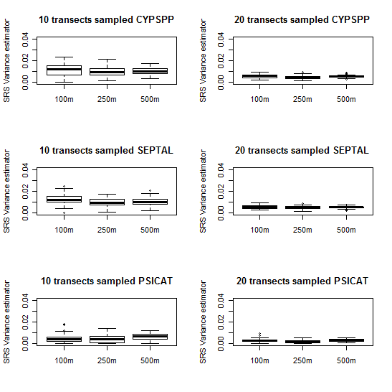

**Figure C.1.** Estimated variance of mean frequency for each simulation run (n = 100) based on re-sampling the 2000 data from Ainsworth et al. (2008) for *Cyperus* spp. (CYPSPP, top row) and *Setaria palmifolia* (SETPAL, middle row), and *Psidium cattleianum* (PSICAT, bottom row), given sample size of 10 or 20 transects of varying length between 100 m to 500 m.

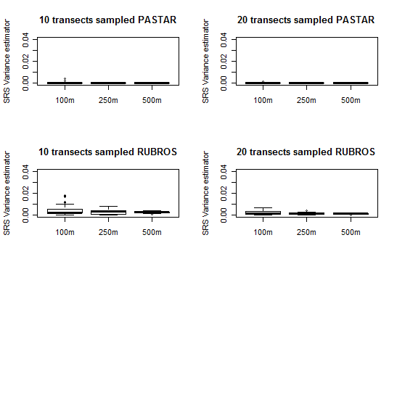

**Figure C.2.** Estimated variance of mean frequency for each simulation run (n = 100) based on re-sampling the 2000 data from Ainsworth et al. (2008) for *Passiflora tarminiana* (PASTAR, top row), and *Rubus rosifolius* (RUBROS, bottom row) given sample size of 10 or 20 transects of varying length between 100 m to 500 m.

Jacobi and Bio Simulation

The Jacobi and Bio (2001) dataset contains longer transects than the Ainsworth et al. (2008) dataset; therefore, we were able to investigate a wider range of transect lengths. Because there was very little change in frequency along each transect of any given species from 1999 to 2001 (table C.2), we pooled the three years of data for the simulation in order to investigate number of transects and length of transects effects on variance estimates for frequency of a species.

For each combination of number and lengths of transects, the variance estimator values are presented by species at Mauna Loa Boys’ School (MLBS) and Kīlauea Forest (KF) in Figures C.3- 6. MLBS represents a site where nonnative plant species are more common whereas KF represents a site with less common nonnative species. As in the Ainsworth et al. (2008) data, there was a larger reduction in the mean and quartile widths of estimated variance by increasing sampling size than by increasing transect length. It appears that the higher the estimated variance, the greater the reduction attained by increasing sample size. We recommend sampling 20 transects and selecting a transect length that balances the cost of sampling with the minimal reductions in estimated variance.

**Table C.2.** Mean frequency or the proportion of area occupied estimates (population average per plot) for four target species from Jacobi and Bio (2001) pilot data with standard error in parentheses.

|  |  |  |  |  |  |  |  |
| --- | --- | --- | --- | --- | --- | --- | --- |
| **Species** | **Year** | **Kīlauea Forest** | | **Mauna Loa Boys’ School** | | **Pu‘u Kipu** | |
| **Ratio** | **Equally Weighted** | **Ratio** | **Equally Weighted** | **Ratio** | **Equally Weighted** |
| *Anthoxanthum odoratum* | | |  |  |  |  |  |
|  | 1999 | 0.01 (0.004) | 0.02 (0.01) | 0.66 (0.119) | 0.71 (0.1) | 0.15 (0.028) | 0.14 (0.029) |
|  | 2000 | 0.01 (0.005) | 0.02 (0.013) | 0.63 (0.126) | 0.69 (0.106) | 0.15 (0.028) | 0.14 (0.028) |
|  | 2001 | 0.004 (0.002) | 0.01 (0.003) | 0.6 (0.135) | 0.66 (0.116) | 0.1 (0.022) | 0.09 (0.027) |
| *Ehrharta stipoides* | | |  |  |  |  |  |
|  | 1999 | 0.1 (0.012) | 0.13 (0.021) | 0.07 (0.032) | 0.08 (0.033) | 0.18 (0.047) | 0.18 (0.04) |
|  | 2000 | 0.11 (0.013) | 0.14 (0.031) | 0.07 (0.031) | 0.08 (0.033) | 0.2 (0.043) | 0.21 (0.036) |
|  | 2001 | 0.09 (0.01) | 0.11 (0.019) | 0.07 (0.035) | 0.09 (0.038) | 0.17 (0.038) | 0.18 (0.034) |
| *Holcus lanatus* | | |  |  |  |  |  |
|  | 1999 | 0.01 (0.007) | 0.03 (0.019) | 0.12 (0.057) | 0.15 (0.054) | 0.02 (0.011) | 0.02 (0.011) |
|  | 2000 | 0.02 (0.008) | 0.03 (0.023) | 0.12 (0.052) | 0.14 (0.051) | 0.02 (0.009) | 0.02 (0.008) |
|  | 2001 | 0.01 (0.006) | 0.02 (0.017) | 0.12 (0.053) | 0.14 (0.052) | 0.02 (0.009) | 0.01 (0.008) |
| *Veronica serpyllifolia* | | |  |  |  |  |  |
|  | 1999 | 0.01 (0.005) | 0.02 (0.015) | 0.09 (0.052) | 0.1 (0.056) | 0.05 (0.017) | 0.04 (0.016) |
|  | 2000 | 0.01 (0.007) | 0.03 (0.015) | 0.08 (0.052) | 0.09 (0.056) | 0.04 (0.012) | 0.04 (0.012) |
|  | 2001 | 0.01 (0.005) | 0.02 (0.013) | 0.07 (0.044) | 0.08 (0.047) | 0.04 (0.014) | 0.03 (0.013) |

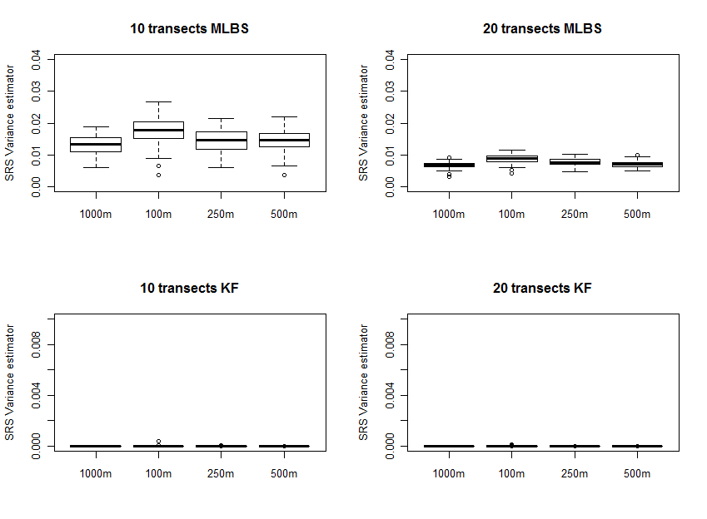

**Figure C.3.** Variance estimates based on re-sampling the pooled data from Jacobi and Bio (2001) using 10 versus 20 transects of varying lengths for *Anthoxanthum odoratum* (ANTODO) in Mauna Loa Boys’ School (MLBS, top row) and Kīlauea Forest (KF, bottom row). ANTODO is the most common species in the dataset. Note the transect lengths along the x-axis are not in ascending order.

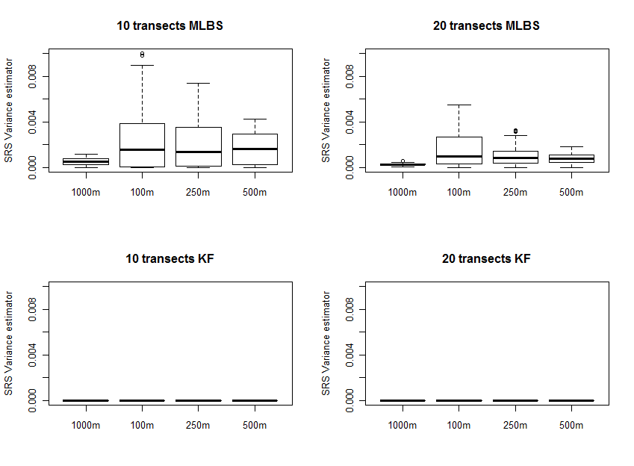

**Figure C.4.**Variance estimates based on re-sampling the pooled data from Jacobi and Bio (2001) using10 versus 20 transects of varying lengths for *Ehrharta stipoides* (EHRSTI) in Mauna Loa Boys’ School (MLBS, top row) and Kīlauea Forest (KF, bottom row). Note the transect lengths along the x-axis are not in ascending order.

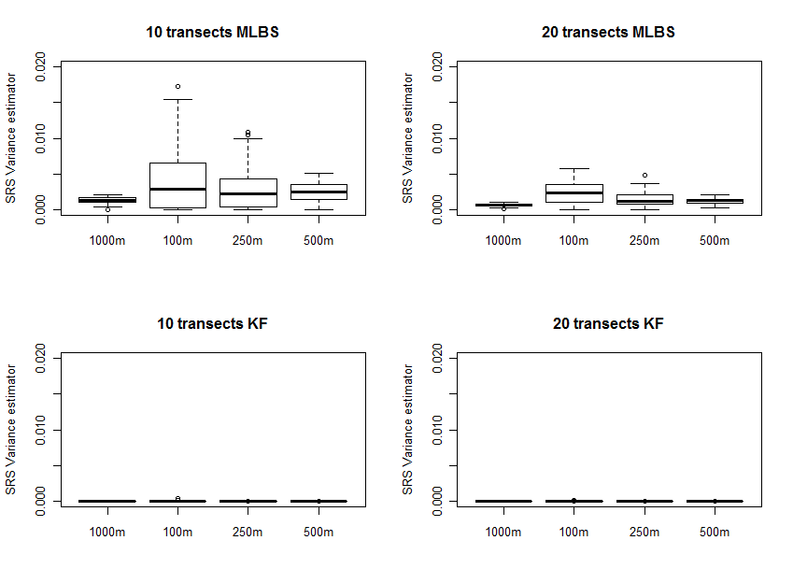

**Figure C.5.** Variance estimates based on re-sampling the pooled data from Jacobi and Bio (2001) using 10 versus 20 transects of varying lengths for *Holcus lanatus* (HOLLAN) in Mauna Loa Boys’ School (MLBS, top row) and Kīlauea Forest (KF, bottom row). Note the transect lengths along the x-axis are not in ascending order.

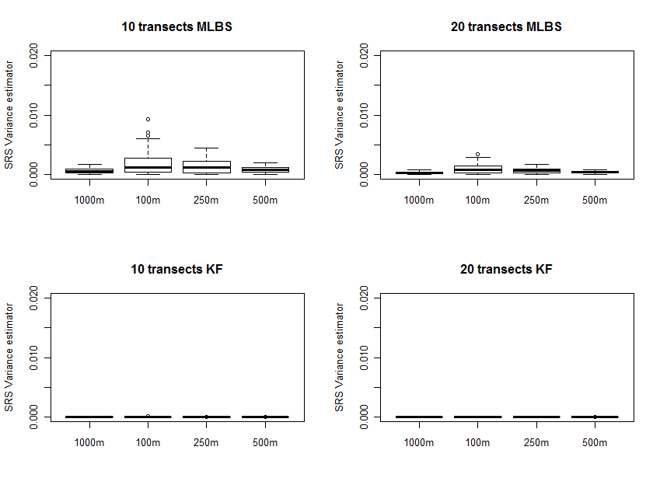 **Figure C.6.** Variance estimates based on re-sampling the pooled data from Jacobi and Bio (2001 ) using10 versus 20 transects of varying lengths for *Veronica serpyllifolia* (VERSER) in Mauna Loa Boys’ School (MLBS, top row) and Kīlauea Forest (KF, bottom row). Note the transect lengths along the x-axis are not in ascending order.

Margin of Error for Species Richness Status Estimates

Because the frequency data simulation above indicates a sample size of 20 transects is necessary, we examined the margin of error in species richness values for 20 transects as well. Using the data from Jacobi and Bio (2001), we also calculated two estimates for species richness (ratio and equally weighted). In order to use an equally weighted estimator we make the same assumptions about sampling design as previously described in the frequency simulation section. If we knew how many primary sampling units are in a population for the pilot data we could re-calculate the equally weighted estimator for mean species richness per plot to be that of the unbiased estimator stated in most sampling textbooks. The trade-off between a ratio estimator and an unbiased estimator is typically a function of whether or not species richness increases with transect length.

To assess the margin of error associated with a sample size of 20 transects, we calculated the number of transects necessary for a 90% confidence interval with varying interval half-widths. For the MLBS, where mean species richness was highest (table C.3), the margin of error associated with 20 transects is ±0.6 species for both richness estimates (table C.4). At KF, where species richness was the lowest (table C.3), this sample size yielded a margin of error of ±0.06 species for the ratio estimate and ±0.15 species for the equally weighted estimate (table C.5). Finally, at PK, where species richness was only moderately higher than at KF (table C.3), the margin of error for both estimates was ±0.10 to 0.15 (table C.5).

These margins of error are sufficiently low and support employing a sample size of 20 transects. However, these calculations assume that estimated variance from the pilot data is a good indicator of variability across all sampling frames of wet forest within and between different parks. If there is more spatial heterogeneity of plants within a sampling frame or a park, these could be under-estimates of the needed sample sizes for status of species richness.

**Table C.3**. Ratio and equally weighted estimates of mean species richness per plot by year for each study area with standard error in parentheses (Jacobi and Bio 2001).

|  |  |  |  |
| --- | --- | --- | --- |
| **Area** | **Year** | **Mean Species Richness (SE)** | |
| **Ratio Estimate** | **Equally Weighted Estimate** |
| Mauna Loa Boys’ School | 1999 | 2.679 (0.797) | 3.020 (0.704) |
| 2000 | 2.634 (0.815) | 2.985 (0.720) |
| 2001 | 2.662 (0.876) | 3.039 (0.776) |
| Kīlauea Forest | 1999 | 0.243 (0.058) | 0.375 (0.147) |
| 2000 | 0.264 (0.070) | 0.423 (0.187) |
| 2001 | 0.219 (0.048) | 0.321 (0.112) |
| Pu‘u Kipu | 1999 | 0.692 (0.159) | 0.641 (0.155) |
| 2000 | 0.687 (0.133) | 0.647 (0.129) |
| 2001 | 0.542 (0.114) | 0.503 (0.111) |

**Table C.4.** Transect sample size estimates for 90% confidence intervals (CI) for given interval half-widths for Mauna Loa Boys’ School (MLBS) for data pooled across years (Jacobi and Bio 2001). Bolded values are for the recommended sample size of 20 transects based analysis of frequency data.

|  |  |  |
| --- | --- | --- |
| **CI ½ Width**  **(# species per plot)** | **No. of MLBS Transects** | |
| **Ratio** | **Equally Weighted** |
| 0.20 | 232 | 182 |
| 0.25 | 149 | 116 |
| 0.40 | 58 | 45 |
| 0.45 | 46 | 36 |
| 0.50 | 37 | 29 |
| 0.55 | 31 | 24 |
| **0.6** | **26** | **20** |
| 0.75 | 17 | 13 |
| 1.00 | 9 | 7 |
| 1.50 | 4 | 3 |

**Table C.5.** Transect sample size estimates for 90% confidence intervals (CI) for given interval half-widths for Kīlauea Forest (KF) and Pu‘u Kipu (PK) for data pooled across years (Jacobi and Bio 2001). Bolded values are for the recommended sample size of 20 transects based analysis of frequency data.

|  |  |  |  |  |  |
| --- | --- | --- | --- | --- | --- |
| **CI ½ Width**  **(# species per plot)** | **No. of KF Transects** | |  | **No. of PK Transects** | |
| **Ratio** | **Equally Weighted** | **Ratio** | **Equally Weighted** |
| 0.010 | 723 | 4744 |  | 2919 | 2767 |
| 0.020 | 181 | 1186 |  | 730 | 692 |
| 0.025 | 116 | 759 |  | 467 | 443 |
| 0.040 | 45 | 297 |  | 182 | 173 |
| 0.045 | 36 | 234 |  | 144 | 137 |
| 0.050 | 29 | 190 |  | 117 | 111 |
| 0.055 | 24 | 157 |  | 96 | 91 |
| **0.060** | **20** | 132 |  | 81 | 77 |
| 0.075 | 13 | 84 |  | 52 | 49 |
| **0.100** | 7 | 47 |  | **29** | **28** |
| **0.150** | 3 | **21** |  | 13 | 12 |
| 0.200 | 2 | 12 |  | 7 | 7 |

Sample Size Recommendations

The simulation results indicate that a sample size of 20 transects yields lower estimated variances for frequency or proportion than 10 transects. For species richness estimates a sample size of 20 transects would provide a margin of error of no greater than 0.6 species, an acceptable range. Although increasing transect length in the simulations only provided small reductions in estimated variance, we recommend 1000m transects where possible to increase potential to detect rare or new nonnative species. Longer transects are logistically less challenging than adding new short transects to cover the same amount of area. An additional consideration when selecting transect length should be the scale at which frequency is monitored for trends. For example, with 20 m long contiguous plots, a species’ frequency along a 500 m transect would have 26 possible values between 0-100% while a 1000 m transect would have 51 values, providing a finer scale at which to detect trends. For these reasons, we will sample 20-1000 m transects in larger sampling frames or where possible.

Power Analysis

High values of statistical power correspond to a high probability of detecting change and low risk of missed-change (Type II) errors (Elzinga et al. 2001). In general, statistical power can be increased by reducing standard deviation or increasing precision through efficient sampling designs or through increased sample size. Power analyses were conducted on individual target nonnative species frequency and combined nonnative species richness using pilot data in order to examine the probability of detecting a 50% change over a 10 year period.

Power is a function of: sample size (n), trend effect size, values of the means (*µ*) and variances, and probability of a Type I error (). For these analyses, we set =0.10, n = 20 or 30, and the number of years of monitoring (*T*) equal to 10. Note that we define a given effect size (or net trend) as a function of the 10-year monitoring period length. Equivalent net trend for a longer monitoring period would result in lower power for trend detection because the annual trend would be smaller. We specified the effect size as a multiple () of mean response in 2008 for frequency = 1, 1.25,…, 2.00 and for richness =1, 1.05,…, 1.25. Values for means and variances were calculated based on the two available pilot data sets (Jacobi and Bio 2001 and Ainsworth et al. 2008) using models described below (eqs. C.8 – 18).

Power was approximated for frequency and richness using Monte Carlo simulations. For each of the 1000 iterations, we performed the following steps: (1) generated n transect effects by sampling at random with replacement from the range of values in the sample, (2) starting with year 0, increased the mean values so that after 10 years, the mean would be times what they were at the beginning, (3) generated average mean values (*µij*), by adding random error (*eij*), and (4) ran the mixed model analysis below. Note that if *µ*ij is negative, it was set to 0. Then we estimated power as the proportion of times the hypothesis  was rejected at level . The resulting power curves are presented in Figures C.7 and C.8.

Frequency

To address non-normality of the data due to many values close to zero, we used a zero-inflated beta (0-beta) distribution (Opsina and Ferrari, 2010) which is a mixture of a point mass at zero and a beta random variable with range 0<p<1. The parameters of this distribution include *p0*, the proportion of zeros, and the parameters of the beta distribution. We took the beta parameters to be its mean, *μ*, and scale parameter, . We then used “PROC” NLMIXED in SAS software (2008) to fit this model using a logit model for *p0* and *µ*. That is, we assumed that

 Equation C.8

where γ0 is the intercept; *tri* is the random effect of the *i*-th transect, and γj is the effect of year *j*.

Also,

 **Equation C.9**

that is, the mean of p>0 has a logit-linear model in transect and year effects.

Under these two models, our null hypothesis is

 **Equation C.10**

where *T* is the number of years sampled.

The null hypothesis states that year does not affect the proportion of zeros or the mean of nonzeros. Alternatively, if we are interested in a linear increase or decrease over years, we would use the models

 **Equation C.11**

and

 **Equation C.12**

where *t* denotes year.

The null hypothesis states that there is no linear increase or decrease in proportion of plots with a given nonnative plant species

H0: γ1=0 and β1=0 **Equation C.13**

while the alternative hypothesis is that there is a linear trend in either or both the proportion of zero plots and the mean proportion among nonzero plots

H1: γ1≠0 and/or β1≠0. **Equation C.14**

To combine data from multiple areas or sampling frames, we must account for these areas in the model. To do this, we added a term to Equations C.8 and C.9 to get

 **Equation C.15**

and

. **Equation C.16**

Note that multiplicative change is simulated over time; therefore change on the logit scale will be linear. We acknowledge that not all trends are linear. However, we agree that a changing population will exhibit a directional, non-cyclic component of change that may be explained by a linear relationship (Urquhart and Kincaid, 1999).

Ainsworth et al. Frequency Power Simulation

For the Ainsworth et al. (2008) data set (table C.1), transect term was dropped from the models in Equations C.8 and C.9 because ten observations (five transects in 2000 and 2008) were not enough to estimate all parameters in the model. Although reduced, the model fit does allow us to estimate parameters required for power analysis (p0ij, μij, and ). Results of the Monte Carlo simulation for five selected species are presented in Figure C.7. For the desired level of 80% power in detecting change, the mean over 10 years must increase by at least 50% for the more common species (CYPSPP, PSICAT, RUBROS). For those species that are rare (PASTAR, SETPAL) the mean cover over ten years must more than double for detection with 80% power. These values are below our stated objective of detecting a 50% change with 80% power over a 10 year period. While increasing the number of transects from 20 to 30 did lower the level of change detected at a similar power, it may not be substantial enough to counteract costs incurred by sampling additional transects. Since there are only ten observation points available for each species, this power analysis should be revisited when more data are available.

Jacobi and Bio Frequency Power Simulation

Because the study data for Jacobi and Bio (2001) came from separate areas, we used data from KF and PK (table C.2) and Equations C.15 and C.16 for the power analysis. Results of the power analysis for four select species along 20 or 30 transects are presented in Figure C.8. Overall, a 50% increase in proportions leads to power of approximately 80%, even for relatively rare species (HOLLAN and VERSER). Because Jacobi and Bio pilot data were more abundant and had less zero-values, the power curves are somewhat better than those for Ainsworth et al. (2008). Rare species in Jacobi and Bio data such as HOLLAN and VERSER achieve approximately 80% power for detecting a 50% change in mean while similarly rare species in the Ainsworth et al. data do not reach 80% power until the means have at least doubled. There does not appear to be enough of an increase in power to justify sampling 30 transects at each location.

Frequency Power Estimation

Based on power analysis results from Jacobi and Bio (2001) data, we should be able to detect a 50% change in mean transect frequency over 10 years with 80% power and 10% Type I error using 20 transects per sampling frame. The level of change and power of detection achieved for most species gives us confidence that our sampling scheme will meet our goal. Additionally, statistical power for this monitoring protocol is expected to be higher than the values calculated above because sample size (n = 20) will be larger than in the above studies. This power analysis should be rerun when more data become available.

One complication in detecting 50% change in frequency in this data set was that for species present at low mean frequency (<5% of the transect), standard errors (SE) were more than 50% of the mean (tables C.1, C.2, C.3). For example, initial frequencies and SE for HOLLAN were 0.03± 0.019 in KF and 0.02±0.011 in PK (Jacobi and Bio 2001). In this case, the detected 50% increase over ten years translates to less than 5% of transect containing the species. For rare individual species such as these, anything less than a 50% increase or decrease may be difficult to detect and more importantly may not be an appropriate trigger for management. Conversely, for species present at moderate initial proportions, small increases or decreases such as 25% or less are important for prioritizing management and assessing past management efficacy. Given that little or no data are available for most of the target species, the project lead along with park managers should refine desired detection levels to meet each park’s needs and realities as data become available after the first sampling cycles.

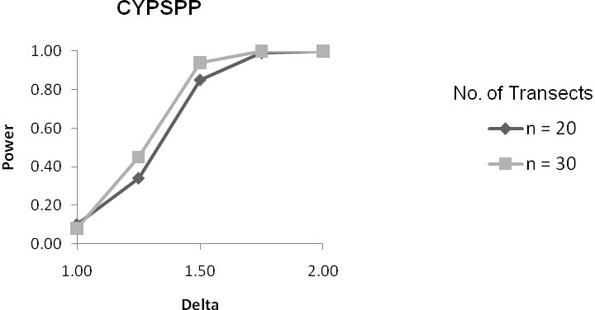

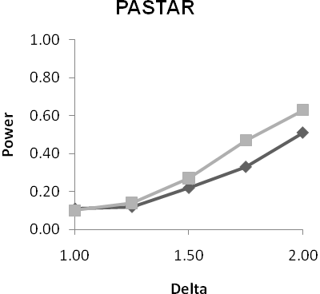 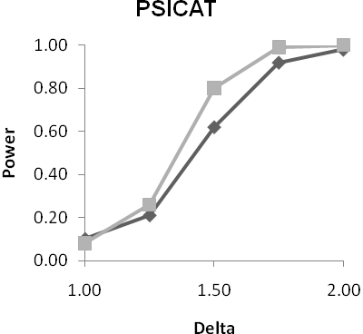

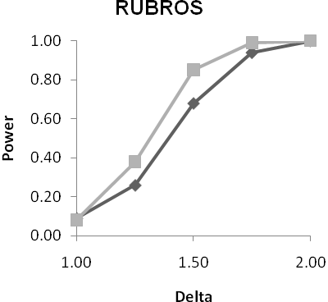 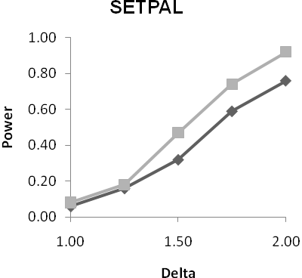

**Figure C.7.** Power estimates detecting 10-year change in mean (Delta) for simulation data of five selected species along 20 or 30 transects based on Ainsworth et al. (2008). Data are from Monte Carlo simulations with 1000 iterations and 10% Type I error for a monitoring period of 10 years.

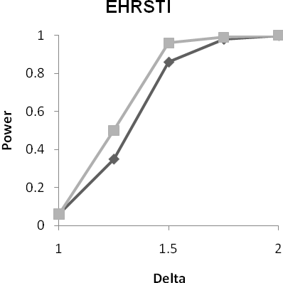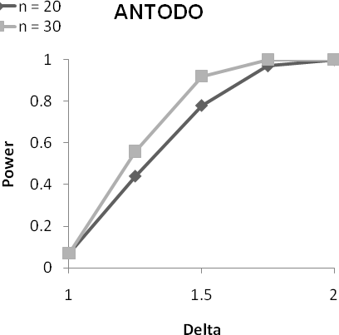 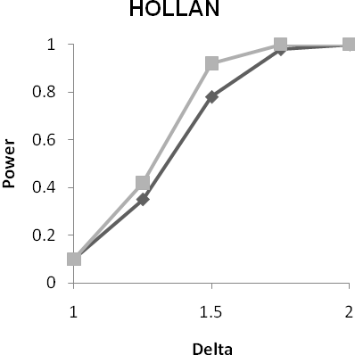

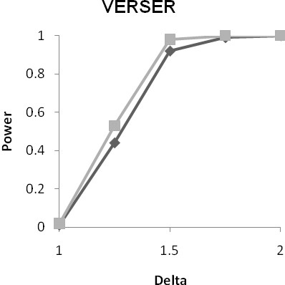**Figure C.8.** Power estimates detecting 10-year change in mean (Delta) for simulation data of four selected species along 20 or 30 transects based on data for Kīlauea Forest and Pu‘u Kipu from Jacobi and Bio (2001). Data are from Monte Carlo simulations with 1,000 iterations and 10% Type I error for a monitoring period of 10 years.

Invasive Species Richness

We averaged the plot invasive plant species richness values for each transect. Since we are looking at average species richness, the central limit theorem implies that transect average richnesses will be approximately normal. Mixed model analysis of variance (ANOVA) can be used to test for differences over years with transects being random and years being fixed. The underlying model is

 **Equation C.17**

where is the average richness in year *j* for transect *i*,

*µ* is the overall mean,

*Tri* is the effect of the *i*-th randomly selected transect,

*γj* is the effect of the *j*-th year, and

*eij* is residual error.

Note that and .

The hypotheses of interest are 

Where transects were located in distinct areas, we included a blocking (stratification) term for this effect in the model.

 **Equation C.18**

where *i* is the blocking effect of the *i*-th area and

the subscript *j(i)* indicates that transects are nested within areas.

Ainsworth et al. Richness Power Simulation

The power curve based on the Monte Carlo simulation described above using Equation C.17 as the model is presented in Figure C.9. For 20 transects, power reaches 80% when mean richness after 10 years increased by slightly less than 20% ( = 1.20). For 30 transects, power is 80% with a mean increase of 15% ( = 1.15). The reduction of at 80% power achieved by sampling 30 transects is minimal and does not justify the increased sampling costs.

Jacobi and Bio Richness Power Simulation

As in the frequency power analysis above, data from all areas of the Jacobi and Bio (2001) study were combined for analysis (table C.3). Accordingly, we used Equation C.18 as the model for the simulation. The power curve is presented in Figure C.10. With 20 transects, we achieve 80% power between = 1.15 and 1.20 while with 30, we reached it at =1.13. The reduction of at 80% power achieved by sampling 30 transects is minimal; therefore sampling 30 transects is not justified given the increased sampling costs.

Invasive Species Richness Power Estimation

For both datasets analyzed above, the change in mean over 10 years that is necessary to be detected at 80% power with 10% Type I error is less than 20% (=1.20) whether 20 or 30 transects were used. The small declines in when sampling 30 transects do not justify the added costs of sampling 10 more transects. Therefore we recommend sampling 20 transects.

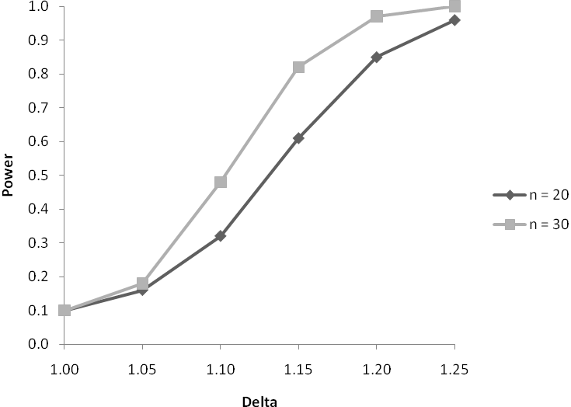

**Figure C.9.** Power curve from Monte Carlo simulation (B = 1000) of invasive species richness over 10 years based on data from Ainsworth et al. (2008).

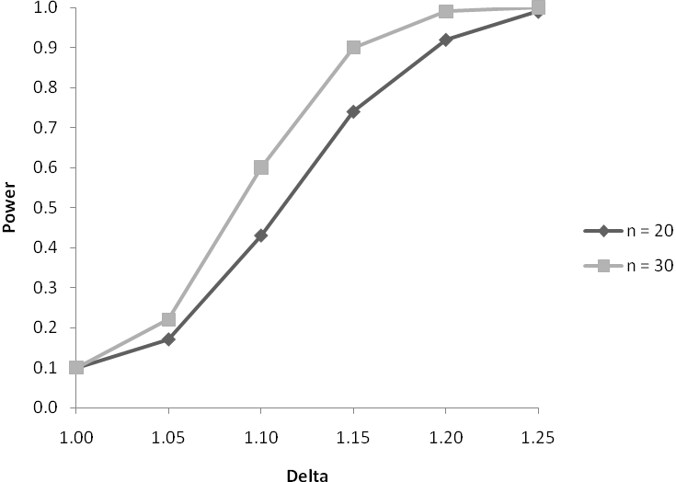

**Figure C.10.** Power curve from Monte Carlo simulation (B = 1000) of invasive species richness over 10 years based on data from Jacobi and Bio (2001). Data from three sampling areas were included in the simulation.

Literature Cited

Ainsworth, A., B. Stevens, L. Hadway, N. Agorastos, I. Cole, and C. M. Litton. 2008. Vegetation response to eight years of feral pig (*Sus scrofa*) removal in Pu‘u Maka‘ala Natural Area Reserve, Hawai‘i. State of Hawaii, Division of Forestry and Wildlife Unpublished Report, Hilo, Hawaii.

Elzinga, C. L., D. W. Salzer, J. W. Willoughby, and J. P. Gibbs. 2001. Monitoring Plant and Animal Populations. Blackwell Science, Malden, Massachusetts.

Jacobi, J. D. and K. Bio. 2001. Invasive plant species surveys, Olaa-Kilauea Management Area. Department of the Interior, US Geological Survey, Biological Resources Division, Kilauea Field Station Unpublished Report, Hawaii National Park, Hawaii.

Lohr, S. L. 2010. Sampling: Design and Analysis. Brooks/Cole, Cengate Learning, Boston, Massachusetts.

Opsina, R. and S.L.P. Ferrari (2010). Inflated beta distributions. *Statistical Papers* 51: 111-126.

SAS software, Version 9.2 of the SAS System for Windows XP. Copyright © 2008 SAS Institute Inc. SAS and all other SAS Institute Inc. product or service names are registered trademarks or trademarks of SAS Institute Inc., Cary, North Carolina.

Thompson, S. K. 2002. Sampling. John Wiley and Sons, New York, New York.

Urquhart, N.S. and T.M. Kincaid (1999). Designs for detecting trend from repeated surveys of ecological resources. *Journal of Agricultural, Biological, and Environmental Statistics* 4:404-414.

Appendix D. Allocation of Sampling Units to Panel Members

This monitoring effort samples for both status and trends, with a tradeoff existing between the ability to detect spatial (i.e., status) and temporal (i.e., trends) changes. The split panel design selected for this protocol uses rotational (temporary) plots to increase spatial replication, while using permanent plots to increase statistical power to detect temporal trends (McDonald 2003). The optimal proportion of fixed to rotating panels can be estimated from correlation (r) between years within sites with the equation D.1 (p. 347 in Cochran 1977):

Proportion of fixed to rotating panels =  **Equation D.1**

With greater correlation between sampling years, fewer fixed panels are needed and more sites can be allocated to the rotating panel. Past data from repeated sampling events was available for one section of ‘Ōla‘a wet forest at Hawai‘i Volcanoes National Park (HAVO), surveyed for invasive plant species in 1992 and 1998 (Loh 1998), and for the adjacent ‘Ōla‘a-Kīlauea Management Area surveyed in 1999 and 2001 (Jacobi and Bio 2001). Some vegetation parameters are highly correlated (r >0.80) between sampling events (e.g., species richness in the ‘Ōla‘a-Kīlauea Management Area), resulting in a fixed to rotating panel ratio of approximately 35 % (table D.1). However, most percent values by species have lower inter-sampling correlations (r <0.40) resulting in a proportion of fixed to random sites between 45% and 50% (Loh 1998). In general, the more correlated parameters come from data measured two years apart (i.e., the ‘Ōla‘a-Kīlauea data); thus over longer time periods we anticipate lower correlations and higher proportions of fixed panels. Therefore a conservative design (which does not require high correlation values between years) has been selected in which 50% of the panels are fixed and 50% are rotating, i.e., visited only once before replacement. Equal allocation of effort among fixed and rotating panels when both status and trends are of interest is considered a reasonable compromise (McDonald 2003). There are obvious limitations to applying these correlations to other park units; however, this design serves as a starting point until further data are available.

**Table D.1.** Correlation values (r) of invasive plant species parameters between years in the ‘Ōla‘a wet forest unit at HAVO (Loh 1998) and the adjacent ‘Ōla‘a-Kīlauea Management area (Jacobi and Bio 2001).



Literature Cited

Cochran, W. G. 1977. Sampling Techniques, Wiley & Sons, New York, New York.

Jacobi, J. D. and K. Bio. 2001. Invasive plant species surveys, Olaa-Kilauea Management Area. Department of the Interior, US Geological Survey, Biological Resources Division, Kilauea Field Station Unpublished Report, Hawaii National Park, Hawaii.

Loh, R. K. 1998. Percent Cover of Alien Species, Olaa Puu Unit. Department of the Interior, National Park Service, Hawaii Volcanoes National Park, Resource Management Division Unpublished Report, Hawaii National Park, Hawaii.

McDonald, T. L. 2003. Review of environmental monitoring methods: survey designs. Environmental Monitoring and Assessment 85:277-292.

Appendix E. Forms for Recording Field Data

This appendix contains all the data forms required to record data for the Established Invasive Plant Species Monitoring Protocol. Field staff can record data in whatever order is most efficient. The data forms appear in the following order:

1. Transect location
2. Photographic record
3. Transect data: Species cover

If data will be collected using laptops or other digital devices, these sample forms can be used to develop the data dictionaries and user interface for collecting information.

|  |  |  |  |  |  |  |  |  |
| --- | --- | --- | --- | --- | --- | --- | --- | --- |
| **Form 1. Version 1.0. Revised 28 April 2010.** | | | |  |  |  |  |  |
| **Established Invasive Plant Species Protocol** | | | |  |  |  |  |  |
| **Transect Location** | |  |  |  |  |  |  |  |
|  |  |  |  |  |  |  |  |  |
|  |  |  |  |  |  |  |  |
| **Observers / Date** | |  |  | **Transect #** | |  |  |  |
|  |  |  |  | **Transect: Fixed Rotational** | | | |
| **PACN Park** | |  |  |  |  |  |  |  |
|  |  |  |  |  |  |  |  |
| **Community Name /Sampling Frame** |  |  |  | **GPS Unit Make / Model** | |  |  |  |
|  |  |  |  |  |  |  |  |
| Datum: WGS 84 NAD 83 | | | UTM Zone: | |  |  |  |  |
| (X,Y) Coordinates of Transect Origin ---> | | | UTME (X): UTMN (Y): | | | |  |  |
| Transect Azimuth: | |  | GPS Unit Error (m): | |  |  |  |  |
| Elevation: |  |  |  |  |  |  |  |  |
|  |  |  |  |  |  |  |  |
| 1. Road and trail used to travel to the transect origin (i.e., the point where monitoring begins): | | | | | | | |  |
|  |  |  |  |  |  |  |  |  |
|  |  |  |  |  |  |  |  |  |
| 2. Location where field crew leaves access road/trail & azimuth to transect origin: | | | | | | |  |  |
|  |  |  |  |  |  |  |  |  |
|  |  |  |  |  |  |  |  |  |
|  |  |  |  |  |  |  |  |  |
| 3. Describe route to the transect origin including hand drawn maps, transect layout and reference features. | | | | | | | |
| Also describe exit route from transect endpoint if different than access route. | | | | | | |  |  |
|  |  |  |  |  |  |  |  |  |
|  |  |  |  |  |  |  |  |  |
|  |  |  |  |  |  |  |  |  |
|  |  |  |  |  |  |  |  |  |
|  |  |  |  |  |  |  |  |  |
|  |  |  |  |  |  |  |  |  |
|  |  |  |  |  |  |  |  |  |
|  |  |  |  |  |  |  |  |  |
| 4. Check box if map attached □. | | |  |  |  |  |  |  |
| 5. Date of most recent map revision: | | | | | |  |  |  |
| 6. Map last revised by: | | |  |  |  |  |  |  |
| 7. Problems encountered, changes, comments: | | | |  |  |  |  |  |
|  |  |  |  |  |  |  |  |  |
|  |  |  |  |  |  |  |  |  |



Appendix F. Established Invasive Plant Monitoring Database Documentation

The database for this project consists of four types of tables: core tables describing the “who, where, and when” of data collection, project-specific tables, lookup tables that contain domain constraints for other tables, and cross reference tables that link lookup tables with data tables. Figure F.1 illustrates the relationships between the database tables. Although core tables are based on Pacific Island Network (PACN) standards, they may contain fields, domains or descriptions that have been added or altered to meet project objectives.

The database includes the following standard tables:

tbl_Sites Sample sites – individual parks

tbl_Locations Sample locations – area where monitoring is being conducted

tbl_Events Data collection event for a given location

tbl_Images Images associated with transect segments

tbl_Db_Meta Database description and links to Inventory and Monitoring Program (I&M) metadata tools

tbl_Db_Revisions Database revision history data

tbl_QA_Results Data validation results from using the quality review tool

The following are project-specific data tables:

tbl_Transects Transect location information

tbl_Segments Transect segments

tbl_Image_Points Transect image points

The following are a few of the more prominent, standard cross-reference tables:

xref_Event_Contacts Cross-reference table for event contacts

xref_Cover_Class_Species Cross-reference table for segments and species

xref_Park_Species_Nativity Cross-reference table for species and park nativity

The following are a few of the more prominent, standard lookup tables:

tlu_Contacts Contact data from project-related personnel

tlu_Enumerations Enumerated lookup table

tlu_Species Species taxon table for sampling events

tlu_Segment_Points Lookup table for segments

tlu_Points_Images Lookup table for image points

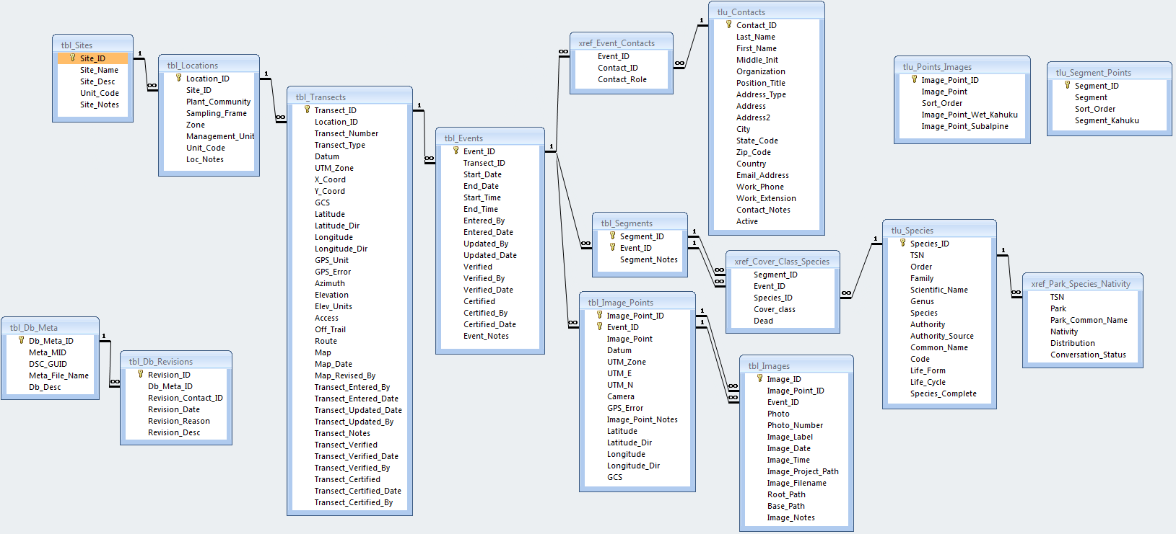

**Figure F.1.** Data model for the PACN Established Invasive Plant Species Monitoring database.

Database Tables

**tbl_ Sites: Sample sites – individual parks**

|  |  |  |  |  |
| --- | --- | --- | --- | --- |
| ***Field*** | ***Primary?*** | ***Data Type*** | ***Size*** | ***Description*** |

Site_ID Yes Text 50 Unique identifier for site records (Parks)

Unit_Code No Text 5 Park, monument or network code

Site_Name No Text 100 Unique name or code for a site

Site_Desc No Text 255 Description for a site

Site_Notes No Memo - General notes on the site

**tbl_ Locations: Sample locations – area where monitoring is being conducted**

|  |  |  |  |  |
| --- | --- | --- | --- | --- |
| ***Field*** | ***Primary?*** | ***Data Type*** | ***Size*** | ***Description*** |

Location_ID Yes Text 50 Unique identifier for sample location records

Site_ID No Text 50 Link to tbl_Sites

Unit_Code No Text 5 Park, monument or network code

Community No Text 50 Community name (wet forest, subalpine shrubland,  
 coastal strand, mangrove forest)

Sampling_Frame No Text 50 Subset of community

Zone No Text 50 Zone

Management_Unit No Text 50 Resource management unit

Loc_Notes No Memo - Other notes about the sample location

**tbl_ Transects: Transect location information**

|  |  |  |  |  |
| --- | --- | --- | --- | --- |
| ***Field*** | ***Primary?*** | ***Data Type*** | ***Size*** | ***Description*** |

Transect_ID Yes Text 50 Unique identifier for transect records

Location_ID No Text 50 Link to tbl_Locations

Transect_Number No Number Lng Int Transect number

Transect_Type No Text 20 Indicates the type of transect (fixed or rotational)

GPS_Unit No Text 50 What GPS unit was used to collect the plot coordinates

Datum No Text 50 Datum of mapping ellipsoid

UTM_Zone No Text 10 UTM Zone

X_Coord No Text 10 X coordinate

Y_Coord No Text 10 Y coordinate

GCS No Text 255 Geographic Coordinate System

Latitude No Number Double Latitude

Latitude_Dir No Text 50 Latitude direction

Longitude No Number Double Longitude

Longitude_Dir No Text 50 Longitude direction

Elevation No Number Double Elevation of the location

Elev_Units No Text 20 Elevation units (meters or feet)

Azimuth No Number Double Angle of reference direction

GPS_Error No Number Lng Int GPS unit error (meters)

Access No Memo - Road and trail used to travel to the transect

origin (i.e., the point where monitoring begins)

Off_Trail No Memo - Location where field crew leaves access

road/trail & azimuth to transect origin

Route No Memo - Describes route to the transect origin including

hand drawn maps, transect layout, and

reference features. Also describe exit route

from the transect endpoint if different than

Map No Boolean - Is a map available?

Map_Date No Date/Time - Date of most recent map revision

Map_Revised_By No Text 50 Person who made the map revision

Transect_Entered_By No Text 50 Person who created this record

Transect_Entered_Date No Date/Time - Time stamp for record creation

Transect_Updated_By No Text 50 Person who made the most recent edits

Transect_Updated_Date No Date/Time - Date of the last update to this record

Transect_Verified No Boolean - Has the record been verified

Transect_Verified_Date No Date/Time - Date the record was verified

Transect_Verified_By No Text 50 Person who verified the record

Transect_Certified No Boolean - Has the record been certified

Transect_Certified_Date No Date/Time - Date the record was certified

Transect_Certified_By No Text 50 Person who certified the record

Transect_Notes No Memo - Other notes about the transect

**tbl_ Events: Data collection event for a given location**

|  |  |  |  |  |
| --- | --- | --- | --- | --- |
| ***Field*** | ***Primary?*** | ***Data Type*** | ***Size*** | ***Description*** |

Event_ID Yes Text 50 Unique identifier for event records

Transect_ID No Text 50 Link to tbl_Transects

Start_Date No Date/Time - Starting date for the event

End_Date No Date/Time - Ending date for the event

Start_Time No Date/Time - Starting time for the event

End_Time No Date/Time - Ending time for the event

Entered_By No Text 50 Person who entered the data for this event

Entered_Date No Date/Time - Date on which data entry occurred

Updated_By No Text 50 Person who made the most recent updates

Updated_Date No Date/Time - Date of the most recent edits

Verified No Boolean - Has the data has been verified

Verified_By No Text 50 Person who verified accurate data transcription

Verified_Date No Date/Time - Date on which data were verified

Certified_By No Text 50 Person who certified data for accuracy and  
 completeness

Certified_Date No Date/Time - Data on which data were certified

Event_Notes No Memo - General notes on the event

**tbl_ Images: Images associated with transect segments**

|  |  |  |  |  |
| --- | --- | --- | --- | --- |
| ***Field*** | ***Primary?*** | ***Data Type*** | ***Size*** | ***Description*** |

Image_ID Yes Text 50 Unique identifier for image records

Image_Point_ID No Text 50 Link to tbl_Image_Points

Event_ID No Text 50 Link to tbl_Events

Photo No Text 50 Photo number taken

Photo_Number No Text 50 Camera photo identification number

Image_Label No Text 100 Image caption or label

Image_Date No Date/Time - Date on which the image was created, if

different from the sampling event date

Image_Time No Date/Time - Time image was taken

Image_Project_Path No Text 255 Location of the image from the main project

folder or image library

Image_Filename No Text 100 Name of the image including extention (.jpg)

but without the image path

Root_Path No Text 255 The root path for the linked image file. This will change   
 upon re-linking of database

Base_Path No Text 255 The base file path for the linked image file. This will stay  
 the same no matter where the root folder is

Image_Notes No Memo - General notes about the image

**tbl_ Segments: Transect segments**

|  |  |  |  |  |
| --- | --- | --- | --- | --- |
| ***Field*** | ***Primary?*** | ***Data Type*** | ***Size*** | ***Description*** |

Segment_ID Yes Text 50 Link to tlu_Segment_Points

Event_ID Yes Text 50 Link to tbl_Events

Segment_Notes No Memo - Comments or notes about the segment

**tbl_ Image_Points: Transect image points**

|  |  |  |  |  |
| --- | --- | --- | --- | --- |
| ***Field*** | ***Primary?*** | ***Data Type*** | ***Size*** | ***Description*** |

Image_Point_ID Yes Text 50 Unique identifier for transect segment records

Event_ID Yes Text 50 Link to tbl_Events

Image_Point No Text 50 Image point identification

Datum No Text 50 Datum of mapping ellipsoid

UTM_Zone No Text 10 UTM Zone

UTM_E No Text 10 UTM East (X coordinate)

UTM_N No Text 10 UTM North (Y coordinate)

Camera No Text 100 Camera used to take the image

Error No Text 25 GPS error (meters)

GCS No Text 255 Geographoc coordinate system

Latitude No Number Double Latitude

Latitude_Dir No Text 50 Latitude direction

Longitude No Number Double Longitude

Longitude_Dir No Text 50 Longitude direction

Image_Point_Notes No Memo - General notes about the image point

**tbl_ QA_Results: Data validation results from using the quality review tool**

|  |  |  |  |  |
| --- | --- | --- | --- | --- |
| ***Field*** | ***Primary?*** | ***Data Type*** | ***Size*** | ***Description*** |

Query_Name No Text 100 Name of query

Data_Scope No Number Byte Scope of data

Time_Frame No Text 30 Time frame of data records

Query_Type No Text 20 Type of query

Query_Result No Text 50 The number of records returned by the query

Query_Run_Time No Date/Time - Most recent run time of the query

Query_Description No Memo - Query description

Query_Expression No Memo - Expression used to run query

Remedy_Desc No Memo - Action taken to fix error

Remedy_Date No Date/Time - Remedy date

QA_User No Text 50 Remedy by

Is_Done No Boolean - Was the query checked

**tbl_ Db_Meta: Database description and links to I&M metadata tools**

|  |  |  |  |  |
| --- | --- | --- | --- | --- |
| ***Field*** | ***Primary?*** | ***Data Type*** | ***Size*** | ***Description*** |

Db_Meta_ID Yes Text 50 Unique local primary key

Meta_MID No Text 255 Link to NPS Data Store

Db_Desc No Memo - Description of the database purpose

DSC_GUID No Text 50 Link to I&M Dataset Catalog desktop

metadata tool

Meta_File_Name No Text 50 Name of the metadata file that describes

this Natural Resources Database Template data file (must be in the same directory as this data file)

**tbl_ Db_Revisions: Database revision history data**

|  |  |  |  |  |
| --- | --- | --- | --- | --- |
| ***Field*** | ***Primary?*** | ***Data Type*** | ***Size*** | ***Description*** |

Revision_ID Yes Text 50 Unique database revision (version) number or code

Db_Meta_ID No Text 50 Link to tbl_DB_Meta

Revision_Contact_ID No Text 50 Link to tlu_Contacts

Revision_Date No Date/Time - Database revision date

Revision_Reason No Memo - Reason for the database revision

Revision_Desc No Memo - Revision description

**xref_ Event_Contacts: Cross-reference table for event contacts**

|  |  |  |  |  |
| --- | --- | --- | --- | --- |
| ***Field*** | ***Primary?*** | ***Data Type*** | ***Size*** | ***Description*** |

Contact_ID No Text 50 Link to tlu_Contacts

Event_ID No Text 50 Link to tb_Events

Contact_Role No Text 50 The contact’s role in the protocol

**xref_ Cover_Class_Species: Cross-reference table for segments and species**

|  |  |  |  |  |
| --- | --- | --- | --- | --- |
| ***Field*** | ***Primary?*** | ***Data Type*** | ***Size*** | ***Description*** |

Segment_ID No Text 50 Together with Event_ID, a link to tbl_Segments

Event_ID No Text 50 Together with Segment_ID, a link to tbl_Segments

Species_ID No Text 50 Link to tlu_Species

Cover_Class No Text 50 Cover class

Dead No Boolean - Is the species dead?

**xref_ Park_Species_Nativity: Cross-reference table for species and park nativity**

|  |  |  |  |  |
| --- | --- | --- | --- | --- |
| ***Field*** | ***Primary?*** | ***Data Type*** | ***Size*** | ***Description*** |

TSN No Number Double TSN number

Nativity No Text 255 Species nativity

Park_Common_Name No Text 255 Species common name in park

Distribution No Text 50 Species distribution

Conservation_Status No Text 10 Species conservation status

Park No Text 255 Park unit code

**tlu_ Contacts: Contact data for project-related personnel**

|  |  |  |  |  |
| --- | --- | --- | --- | --- |
| ***Field*** | ***Primary?*** | ***Data Type*** | ***Size*** | ***Description*** |

Contact_ID Yes Text 50 Unique record identifier for each contact

Address No Text 50 Street address (cntaddr)

Address_Type No Text 50 Address (mailing, physical, both) type

Address2 No Text 50 Address line 2, suite, apartment number

City No Text 50 City or town

Contact_Notes No Memo - Contact notes

Country No Text 50 Country

Email_Address No Text 50 E-mail address

First_Name No Text 50 First name

Last_Name No Text 50 Last name

Middle_Int No Text 4 Middle initial

Organization No Text 50 Organization or employer

Position_Title No Text 50 Title or position description

State_Code No Text 8 State or province

Work_Extension No Text 50 Phone extension

Work_Phone No Text 50 Phone number

Active No Boolean - Is the contact active

Zip_Code No Text 50 Zip code

**tlu_ Enumerations: Enumerated lookup table**

|  |  |  |  |  |
| --- | --- | --- | --- | --- |
| ***Field*** | ***Primary?*** | ***Data Type*** | ***Size*** | ***Description*** |

Enum_Group Yes Text 50 Category for lookup value

Enum_Code No Text 50 Code for lookup values

Enum_Description No Memo - Lookup value description

Sort_Order No Number Integer Order in which to sort lookup values

**tlu_ Species: Species taxon table for sampling event**

|  |  |  |  |  |
| --- | --- | --- | --- | --- |
| ***Field*** | ***Primary?*** | ***Data Type*** | ***Size*** | ***Description*** |

Species_ID Yes Text 50 Unique identifier for species records

TSN No Number Double The TSN of target species

Family No Text 255 Family of target species

Order No Text 255 Order of target species

Scientific_Name No Text 255 Scientific name of plant species, includes  
 genus, species and variety

Common_Name No Text 255 Common name of the target species

Genus No Text 255 Genus of target species

Species No Text 255 Species name

Authority No Text 255 Authority for the species

Authority_Source No Text 255 Source for the species’ authority

Species_Complete No Text 25 Has this species been checked by the PACN for  
 authority, preferred common name, and life form?

Code No Text 255 6 letter code to identify the plant species. First 3  
 letters of the genus and the first 3 letters of the species

Life_Form No Text 50 The life form of the species

Life_Cycle No Text 25 The life cycle of the species, i.e., annual or perrenial

Appendix G. Yearly Project Task List

This appendix presents a table that identifies tasks by project stage, indicates who is responsible for the task, and establishes the timing for execution.

| **Table G.1.** Yearly Project Task List for Established Invasive Plant Species Monitoring Protocol. | | | |
| --- | --- | --- | --- |
| **Project Stage** | **Task Description** | **Responsibility** | **Timing** |
| Preparation | Notify data manager and/or GIS specialist of needs (field maps, Global Positioning System [GPS] support, training) | Project Lead, Field Leader | ASAP,  by Feb 1 |
| Ensure that project workspace is ready for use and GPS download software is loaded at each park | Project Lead, Data Manager and GIS Specialist | by Apr 1 |
| Implement working database copy | Data Manager | by Apr 1 |
| Prepare and print field maps | GIS Specialist | by Apr 1 |
| Update and load data dictionary, background maps, and target coordinates into GPS units | GIS Specialist | by Apr 1 |
| Provide database/GPS training as needed | Data Manager and GIS Specialist | by Apr 1 |
| Train field crew in safety, species identification, equipment usage, and field sampling protocols | Field Leader, Project Lead, Park Botanists | by Apr 1 |
| Verification of field observer qualifications | Field Leader | by Apr 1 |
| Data acquisition | Collect monitoring data and GPS data in the field | Field Leader, Field Technicians | Apr-Oct (varies by park) |
| Review data forms after each day and identify any unknown species | Field Leader, Field Technicians | daily |
| Regular review of field forms for completeness and accuracy | Field Leader | bi-weekly |
| Data entry & processing  (Continued) | Download GPS data and email files to GIS specialist for correction | Field Leader, GIS Specialist | ASAP, after each tour |
| Enter data into working copy of the database | Field Leader, Field Technicians | ASAP, after each tour |
| Verification of accurate transcription as data are entered | Field Leader, Field Technicians | ASAP, after each tour |
| GPS data correction | GIS Specialist | ASAP, after each tour |
| Periodic review of GPS location data and database entries for completeness and accuracy | Field Leader | bi-weekly |
| Upload processed and verified coordinates to database | GIS Specialist | Oct |
| Product development | Complete field season report | Field Leader | Nov 30 |
| Product delivery | Send field season report to project lead and data manager | Field Leader | by Dec 1 |
| Quality review | Quality review and data validation using database tools | Project Lead | Dec |
| Prepare coordinate summaries and/or GIS layers and data sets as needed for spatial data review | GIS Specialist | by Nov 15 |
| Joint quality review of GIS data | Project Lead and GIS Specialist | Nov-Dec |
| Metadata | Identify any sensitive information contained in the data set | Project Lead | Oct-Dec |
| Update project metadata records | Project Lead | Oct-Dec |
| Data certification | Certify the season’s data and complete the certification report | Project Lead | Dec |
| Data delivery | Deliver certification report, certified data, and updated metadata to data manager | Project Lead | by Dec 31 |
| Upload certified data into master project database, store data files in PACN Digital Library 1 | Data Manager | Jan |
| Notify project lead of uploaded data ready for analysis and reporting | Data Manager | by Jan 31 |
| Update project GIS data sets, layers and associated metadata records | GIS Specialist | Jan-Feb |
| Finalize and parse metadata records, store in PACN Digital Library 1 | Data Manager and GIS Specialist | Jan |
| Data analysis | Export data required for analysis from database | Data Manager and Project Lead | Feb |
| Compute annual summary statistics for status report | Project Lead | Feb |
| Run trend analysis after 2 or more years of data is available for a park | Project Lead and Statistician (as consultant only) | Feb |
| Export analysis results into database | Project Lead | Feb |
| Product development | Export automated reports from database | Project Lead | Feb |
| Produce park-wide and area-specific maps for archives | GIS Specialist | Jan-Feb |
| Generate quality maps for reports | GIS Specialist | Jan-Feb |
| Acquire the proper report template from the [NPS website](http://www.nature.nps.gov/publications/NRPM/index.cfm), create annual report | Project Lead | Mar-Apr |
| Screen all reports and data products for sensitive information | Project Lead | Mar-Apr |
| Product delivery | Submit draft report to network coordinator for review | Project Lead | by Apr 30 |
| Review report for formatting and completeness, notify project lead of approval or need for changes | Network Coordinator | May |
| Upload completed report to PACN Digital Library 1 submissions folder, notify data manager | Project Lead | upon approval |
| Deliver other products according to the delivery schedule and instructions | Project Lead | upon completion |
| Product check-in | Data Manager | upon receipt |
| Posting & distribution  (Continued) | Submit metadata to References service within IRMA2 | Data Manager | by Mar 15 |
| Create and post a record for reports in References service within IRMA2 | Data Manager | upon receipt |
| Update species records in Biology service within IRMA2 | Data Manager | Dec-Mar |
| Submit certified data and GIS data sets to IRMA2 | Data Manager | by June of the second year |
| Archival & records management | Store finished products in PACN Digital Library1 | Data Manager | upon receipt |
| Review, clean up and store and/or dispose of project files according to NPS Director’s Order #193 | Project Lead | Jan |
| Season close-out | Meet to discuss the recent field season, and document any needed changes to field sampling protocols or the working database | Project Lead, Data Manager, GIS Specialist, Field Leader | by Dec 30 of the same year |
| Discuss and document needed changes to analysis and reporting procedures | Project Lead, Data Manager and GIS Specialist | by Apr 30 of second year |

1 The PACN Digital Library is a hierarchical digital filing system stored on the PACN file servers. Network users have read-only access to these files, except where information sensitivity may preclude general access.

2 The Integrated Resource Management Applications (IRMA) Portal (NPS 2011) is the National Park Service’s clearinghouse for natural resource data, metadata, bibliographic records, and park species information. Only non-sensitive information is posted to IRMA. Refer to the protocol section on sensitive information for details.

3 NPS Director’s Order 19 (NPS 2001) provides a schedule indicating the amount of time that the various kinds of records should be retained.

References

National Park Service (NPS). 2001. Director's Orders and Related Documents. Department of the Interior, National Park Service, Office of Policy. Available at <http://home.nps.gov/applications/npspolicy/DOrders.cfm> (accessed 1 Oct 2007).

National Park Service (NPS). 2011. Integrated Resource Management Applications (IRMA) Portal website. https://irma.nps.gov/App/Portal/Home (accessed on 27 Feb 2012).

Appendix H. Target Invasive Plant Species List

This appendix presents a list of nonnative plant species found in each park as of February 2010 (table H.1). Nomenclature follows that of Wagner et al. (1999) for flowering plants and Palmer (2003) for ferns and fern allies. This list is strictly a guide, all nonnative plant species found along transects will be recorded for presence even if they are not on this list. Before each field season, the project lead will coordinate a review with park managers of the species in order to identify which species will also be assigned ocular cover class estimates for each contiguous subplot. Table H.1 provides additional taxonomic details for each plant species including family name and common name for Haleakalā National Park (HALE), Hawai‘i Volcanoes National Park (HAVO), Kalaupapa National Park (KALA), and National Park of American Samoa (NPSA). The target list for American Memorial National Park (AMME) will be generated prior to sampling in year five.

| **Table H.1.** List of 238 nonnative plant species. A checked box indicates presence of species in the respective park as of February 2010. Field crew members need to obtain an updated list prior to each field season. HAVO-K indicates the Kahuku parcel of HAVO. | | | | | | | | | |
| --- | --- | --- | --- | --- | --- | --- | --- | --- | --- |
| **SpCode** | **Target Species** | **Family** | **Common Name** | **HALE** | **HAVO** | **HAVO-K** | **KALA** | **NPSA** | **No. of Parks** |
| AbrPre | Abrus precatorius | Fabaceae | rosarypea |  | X |  |  |  | 1 |
| AcaCon | Acacia confusa | Fabaceae | Formosan koa |  | X | X |  |  | 2 |
| AcaMea | Acacia mearnsii | Fabaceae | black wattle | X | X |  |  |  | 2 |
| AcaMel | Acacia melanoxylon | Fabaceae | Australian blackwood | X | X |  |  |  | 2 |
| AgaAme | Agave americana | Asparagaceae | century plant |  | X |  |  |  | 1 |
| AgaSis | Agave sisalana | Asparagaceae | sisal |  | X | X |  |  | 2 |
| AgeAde | Ageratina adenophora | Asteraceae | Maui pamakani | X | X |  |  |  | 2 |
| AgeRip | Ageratina riparia | Asteraceae | Hamakua pamakani |  | X | X |  |  | 2 |
| AgrRep | Agropyron repens | Poaceae | wheatgrass | X |  |  |  |  | 1 |
| AndVir | Andropogon virginicus | Poaceae | broomsedge | X | X | X |  |  | 3 |
| AneHup | Anemone hupehensis var. japonica | Ranunculaceae | Japanese anemone |  | X | X |  |  | 2 |
| AngEve | Angiopteris evecta | Marattiaceae | mule's foot fern | X | X |  |  | X | 3 |
| AntOdo | Anthoxanthum odoratum | Poaceae | sweet vernal grass | X | X | X |  |  | 3 |
| ArcAle | Archontophoenix alexandrae | Arecaceae | date palm |  | X | X |  |  | 2 |
| ArdCri | Ardisia crispa | Primulaceae | Hilo holly |  | X |  |  |  | 1 |
| ArdEll | Ardisia elliptica | Primulaceae | shoebutton ardisia | X | X |  |  |  | 2 |
| ArgMex | Argemone mexicana | Papaveraceae | yellow poppy, Mexican poppy, Mexican prickly poppy |  |  |  | X |  | 1 |
| ArtCil | Arthrostema ciliatum | Melastomataceae | arthrostema |  | X |  |  |  | 1 |
| AruGra | Arundina graminifolia | Orchidaceae | Chinese bamboo orchid |  | X | X  (Continued) |  |  | 2 |
| AscPhy | Asclepias physocarpa | Apocynaceae | butterfly flower, milkweed, balloon plant | X | X | X |  |  | 3 |
| AxoCom | Axonopus compressus | Poaceae | broad-leaved carpetgrass | X |  |  |  |  | 1 |
| AxoFis | Axonopus fissifolius | Poaceae | narrow-leaved carpetgrass | X | X | X |  | X | 4 |
| BamVul | Bambusa vulgaris | Poaceae | common bamboo, golden stem bamboo |  | X |  |  |  | 1 |
| BanInt | Banksia integrifolia | Thymelaeaceae | coast banksia | X | X |  |  |  | 2 |
| BenHis | Benincasa hispida | Cucurbitaceae | Chinese melon |  | X |  |  |  | 1 |
| BidAlb | Bidens alba var. radiata | Asteraceae | beggar's tick | X |  |  |  |  | 1 |
| BocFru | Bocconia frutescens | Papaveraceae | bocconia, plume poppy, tree poppy | X | X | X |  |  | 3 |
| BraMut | Brachiaria mutica | Poaceae | California grass |  | X |  |  | X | 2 |
| BroTec | Bromus tectorum | Poaceae | cheat grass | X |  |  |  |  | 1 |
| BruCan | Brugmansia candida | Solanaceae | bella donna |  | X | X |  |  | 2 |
| BudAsi | Buddleia asiatica | Scrophulariaceae | dogtail, huelo 'ilio | X | X | X |  |  | 3 |
| BudDav | Buddleia davidii | Scrophulariaceae | butterfly bush | X | X |  |  |  | 2 |
| BudMad | Buddleia madagascariensis | Scrophulariaceae | smoke bush | X | X | X |  |  | 3 |
| CarLon | Carex longii | Cyperaceae | Long's sedge | X |  |  |  |  | 1 |
| CasEla | Castilla elastica | Moraceae | Mexican rubber tree; Panama rubber tree |  |  |  |  | X | 1 |
| CasEqu | Casuarina equisetifolia | Casuarinaceae | ironwood |  | X | X |  |  | 2 |
| CecObt | Cecropia obtusifolia | Urticaceae | trumpet tree |  | X |  |  |  | 1 |
| CenEch | Cenchrus echinatus | Poaceae | common sandbur |  | X |  |  | X | 2 |
| CesNoc | Cestrum nocturnum | Solanaceae | night cestrum |  | X | X |  |  | 2 |
| ChlCom | Chlorophytum comosum | Agavaceae | spider plant |  | X |  |  |  | 1 |
| CinBur | Cinnamomum burmanni | Lauraceae | padang cassia |  | X |  |  |  | 1 |
| CirVul | Cirsium vulgare | Asteraceae | bull-thistle, pua kala | X | X | X |  |  | 3 |
| CitCau | Citharexylum caudatum | Verbenaceae | fiddlewood |  | X |  |  |  | 1 |
| CitSpi | Citharexylum spinosum | Verbenaceae | fiddlewood |  | X |  |  |  | 1 |
| CliHir | Clidemia hirta var. hirta | Melastomataceae | Koster's curse | X | X | X |  | X | 4 |
| CocGra | Coccinia grandis | Cucurbitaceae | ivy gourd | X | X |  |  |  | 2 |
| CofAra | Coffea arabica | Rubiaceae | Arabian coffee | X |  |  |  |  | 1 |
| CoiLac | Coix lacryma-jobi | Poaceae | Job's tears, kukae-kolea | X |  | (Continued) |  |  | 1 |
| ComDif | Commelina diffusa | Commelinaceae | honohono grass | X | X | X |  |  | 3 |
| ConBon | Conyza bonariensis | Asteraceae | hairy horseweed | X | X | X |  |  | 3 |
| CorLan | Coreopsis lanceolata | Asteraceae | tickseed |  | X |  |  |  | 1 |
| CorJub | Cortaderia jubata | Poaceae | Andean pampas grass | X | X |  |  |  | 2 |
| CorSel | Cortaderia selloana | Poaceae | pampas grass |  | X |  |  |  | 1 |
| CotPan | Cotoneaster pannosa | Rosaceae | cotoneaster | X | X |  |  | X | 3 |
| CypRot | Cyperus rotundus | Cyperaceae | nut grass |  | X |  |  | X | 2 |
| CytPal | Cytisus palmensis | Fabaceae | tagasaste | X |  |  |  |  | 1 |
| DacGlo | Dactylis glomerata | Poaceae | cocksfoot |  | X | X |  |  | 2 |
| DelOdo | Delairea odorata | Asteraceae | Cape ivy, German ivy | X | X | X |  |  | 3 |
| DesCaj | Desmodium cajanifolium | Fabaceae | tree desmodium |  | X |  |  |  | 1 |
| DicFib | Dicksonia fibrosa | Dicksoniaceae | New Zealand tree fern |  | X |  |  |  | 1 |
| DigCil | Digitaria ciliaris | Poaceae | Henry's crabgrass, southern crabgrass | X |  | X | X |  | 3 |
| DigEri | Digitaria eriantha | Poaceae | pangola grass | X |  | X |  |  | 2 |
| EhrCal | Ehrharta calycina | Poaceae | veldt grass |  | X |  |  |  | 1 |
| EhrSti | Ehrharta stipoides | Poaceae | meadow ricegrass | X | X | X |  |  | 3 |
| ElaUmb | Elaeagnus umbellata | Elaeagnaceae | Autumn olive |  | X |  |  |  | 1 |
| EraBro | Eragrostis brownei | Poaceae | Brown's lovegrass | X |  | X |  |  | 2 |
| EriKar | Erigeron karvinskianus | Asteraceae | daisy fleabane |  | X |  |  |  | 1 |
| EriJap | Eriobotrya japonica | Rosaceae | loquat | X | X |  |  |  | 2 |
| EscCal | Eschscholzia californica | Papaveraceae | California poppy |  | X |  |  |  | 1 |
| EucGlo | Eucalyptus globulus | Myrtaceae | Tasmanian blue gum, southern blue gum, blue gum | X |  |  |  |  | 1 |
| EucRob | Eucalyptus robusta | Myrtaceae | swamp mahogany | X | X | X |  |  | 3 |
| EucSpp | Eucalyptus spp. | Myrtaceae | eucalyptus |  |  | X |  |  | 1 |
| EugUni | Eugenia uniflora | Myrtaceae | Surinam cherry, Brazilian cherry, Cayenne cherry |  |  |  | X |  | 1 |
| FalMol | Falcataria moluccana | Fabaceae | albizzia | X | X | X |  | X | 4 |
| FeiSel | Feijoa sellowiana | Myrtaceae | pineapple guava, guavasteen |  | X |  |  |  | 1 |
| FicCar | Ficus carica | Moraceae | common fig |  | X |  |  |  | 1 |
| FicMac | Ficus macrophylla | Moraceae | Moreton Bay fig | X | X |  |  |  | 2 |
| FicMic | Ficus microcarpa | Moraceae | Chinese banyan | X | X | (Continued) | X |  | 3 |
| FicPum | Ficus pumila | Moraceae | climbing fig |  | X |  |  |  | 1 |
| FraUhd | Fraxinus uhdei | Oleaceae | tropical ash |  | X | X |  |  | 2 |
| FucPan | Fuchsia paniculata | Onagraceae | Fuchsia |  | X |  |  |  | 1 |
| GreBan | Grevillea banksii | Proteaceae | bottlebrush |  | X | X |  |  | 2 |
| GreRob | Grevillea robusta | Proteaceae | silk oak, silver oak | X | X | X |  |  | 3 |
| HedHel | Hedera helix | Araliaceae | English ivy |  | X | X |  |  | 2 |
| HedCor | Hedychium coronarium | Zingiberaceae | white ginger, 'awapuhi-ke'oke'o | X | X | X | X |  | 4 |
| HedFla | Hedychium flavescens | Zingiberaceae | yellow ginger, 'awapuhi-melemele | X | X |  |  |  | 2 |
| HedGar | Hedychium gardnerianum | Zingiberaceae | kahili ginger | X | X | X |  |  | 3 |
| HelFoe | Helichrysum foetidum | Asteraceae | stinking everlast; stinking strawflower |  |  | X |  |  | 1 |
| HetSub | Heterocentron subtriplinervium | Melastomataceae | pearl flower |  | X | X |  |  | 2 |
| HetGra | Heterotheca grandiflora | Asteraceae | telegraph weed | X | X |  |  |  | 2 |
| HolLan | Holcus lanatus | Poaceae | velvetgrass, Yorkshire fog | X | X | X |  |  | 3 |
| HypRuf | Hyparrhenia rufa | Poaceae | thatching grass, jaragua | X | X | X |  |  | 3 |
| HypCan | Hypericum canariense | Hypericaceae | St. John's wort | X |  |  |  |  | 1 |
| HypKou | Hypericum kouytchense | Hypericaceae | St. John's wort |  | X |  |  |  | 1 |
| HypPec | Hyptis pectinata | Lamiaceae | comb hyptis | X | X | X |  | X | 3 |
| IleAqu | Ilex aquifolium | Aquifoliaceae | English holly |  | X |  |  |  | 1 |
| ImpSod | Impatiens sodenii | Balsaminaceae | impatiens |  | X |  |  |  | 1 |
| IpoTri | Ipomoea triloba | Convolvulaceae | little bell |  | X |  |  |  | 1 |
| JacMim | Jacaranda mimosifolia | Bignoniaceae | jacaranda |  | X | X |  |  | 2 |
| JasFlu | Jasminum fluminense | Oleaceae | jasmine |  | X |  |  |  | 1 |
| JunBuf | Juncus bufonius | Juncaceae | common toad rush | X |  | X |  |  | 2 |
| JunEff | Juncus effusus | Juncaceae | Japanese mat rush | X | X | X | X |  | 4 |
| JunEns | Juncus ensifolius | Juncaceae | swordleaf rush | X |  | X |  |  | 2 |
| JunPla | Juncus planifolius | Juncaceae | broadleaf rush | X |  |  |  |  | 1 |
| JunTen | Juncus tenuis | Juncaceae | slender rush, path rush | X |  | X |  |  | 2 |
| JusBet | Justicia betonica | Acanthaceae | white shrimp plant, squirrels tail |  | X |  |  |  | 1 |
| KalPin | Kalanchoe pinnata | Crassulaceae | air plant | X | X | X |  | X | 4 |
| LanCam | Lantana camara | Verbenaceae | lantana | X | X | X  (Continued) | X |  | 4 |
| LatOdo | Lathyrus odoratus | Fabaceae | sweet pea |  | X |  |  |  | 1 |
| LigLuc | Ligustrum lucidum | Oleaceae | glossy privit |  | X |  |  |  | 1 |
| LigOva | Ligustrum ovalifolium | Oleaceae | California privet |  | X | X |  |  | 2 |
| LigSin | Ligustrum sinense | Oleaceae | Chinese privit |  | X | X |  |  | 2 |
| LigVul | Ligustrum vulgare | Oleaceae | privet |  | X |  |  |  | 1 |
| LonJap | Lonicera japonica | Caprifoliaceae | Japanese honeysuckle |  | X | X |  |  | 2 |
| LopEru | Lophospermum erubescens | Plantaginaceae | roving sailor |  | X | X |  |  | 2 |
| LucGra | Luculia gratissima | Rubiaceae | luculia |  | X |  |  |  | 1 |
| LupHyb | Lupinus hybridus | Fabaceae | lupine |  | X |  |  |  | 1 |
| MacMap | Macaranga mappa | Euphorbiaceae | bingabing |  | X |  |  |  | 1 |
| MacTan | Macaranga tanarius | Euphorbiaceae | bingabing |  | X |  |  |  | 1 |
| ManGla | Manihot glaziovii | Euphorbiaceae | ceara rubber tree |  | X |  |  |  | 1 |
| MarVul | Marrubium vulgare | Lamiaceae | common horehound |  | X | X |  |  | 2 |
| MedMag | Medinilla magnifica | Melastomataceae | magnificent Medinilla, kapa-kapa |  | X |  |  |  | 1 |
| MelQui | Melaleuca quinquenervia | Myrtaceae | paperbark tree |  | X |  |  |  | 1 |
| MelCan | Melastoma candidum | Melastomataceae | Malabar melastome, Indian rhododendron |  | X |  |  |  | 1 |
| MelAze | Melia azedarach | Meliaceae | pride of India, Chinaberry | X |  |  |  |  | 1 |
| MelMin | Melinis minutiflora | Poaceae | molasses grass | X | X | X | X | X | 5 |
| MelRep | Melinis repens | Poaceae | natal redtop | X | X | X |  |  | 3 |
| MelUmb | Melochia umbellata | Sterculiaceae | melochia |  | X | X |  |  | 2 |
| MerTub | Merremia tuberosa | Convolvulaceae | wood rose | X | X |  |  |  | 2 |
| MicCal | Miconia calvescens | Melastomataceae | velvet tree, Miconia | X | X | X |  |  | 3 |
| MikMic | Mikania micrantha | Asteraceae | mile-a-minute weed, climbing hempweed |  |  |  |  | X | 1 |
| MimDip | Mimosa diplotricha | Fabaceae | giant sensitive plant |  |  |  |  | X | 1 |
| MonHib | Montanoa hibiscifolia | Asteraceae | tree daisy |  | X |  |  |  | 1 |
| MorFay | Morella faya | Myricaceae | firetree | X | X | X |  |  | 3 |
| MueAxi | Muehlenbeckia axillaris | Polygonaceae | wire vine |  | X |  |  |  | 1 |
| MyrCau | Myrciaria cauliflora | Myrtaceae | jaboticaba |  | X | X |  |  | 2 |
| NeoWig | Neonotonia wightii | Fabaceae | tinaroo, glycine, perennial soybean | X | X | X  (Continued) |  |  | 3 |
| NepFal | Nephrolepis falcata | Nephrolepidaceae | fishtail fern | X | X |  |  |  | 2 |
| NepMul | Nephrolepis multiflora | Nephrolepidaceae | swordfern | X | X | X |  |  | 3 |
| NorEma | Noronhia emarginata | Oleaceae | Madagascar olive | X |  |  |  |  | 1 |
| OchTho | Ochna thomasiana | Ochnaceae | mickey-mouse plant | X |  |  |  |  | 1 |
| OleEur | Olea europaea | Oleaceae | Russian olive |  | X | X |  |  | 2 |
| OpeVen | Operculina ventricosa | Convolvulaceae | paper rose |  |  |  |  | X | 1 |
| OplHir | Oplismenus hirtellus | Poaceae | basket grass | X | X | X |  | X | 4 |
| OpuFic | Opuntia ficus-indica | Cactaceae | prickly pear, panini | X | X | X |  |  | 3 |
| PaeFoe | Paederia foetida | Rubiaceae | maile pilau |  | X |  |  |  | 1 |
| PanMax | Panicum maximum | Poaceae | Guinea grass | X | X | X |  |  | 3 |
| PanRep | Panicum repens | Poaceae | panic grass |  | X |  |  |  | 1 |
| PasCon | Paspalum conjugatum | Poaceae | Hilo grass | X | X | X | X | X | 5 |
| PasDil | Paspalum dilatatum | Poaceae | dallisgrass | X | X | X |  | X | 4 |
| PasPan | Paspalum paniculatum | Poaceae | angel grass, galmarra grass |  | X |  |  | X | 2 |
| PasScr | Paspalum scrobiculatum | Poaceae | ricegrass, mau'u-laiki | X | X |  |  |  | 2 |
| PasUrv | Paspalum urvillei | Poaceae | vasey grass | X | X | X |  | X | 4 |
| PasEdu | Passiflora edulis | Passifloraceae | passion fruit |  | X | X |  | X | 3 |
| PasLau | Passiflora laurifolia | Passifloraceae | yellow granadilla, bell apple |  | X |  |  |  | 1 |
| PasLig | Passiflora ligularis | Passifloraceae | sweet grandilla |  | X | X |  |  | 2 |
| PasSub | Passiflora suberosa | Passifloraceae | corky passionflower, indigo berry |  | X |  |  |  | 1 |
| PasTar | Passiflora tarminiana | Passifloraceae | banana poka | X | X | X |  |  | 3 |
| PenCla | Pennisetum clandestinum | Poaceae | kikuyu grass | X | X | X | X |  | 4 |
| PenPol | Pennisetum polystachion | Poaceae | feather pennisetum, mission grass |  |  | X |  |  | 1 |
| PenPur | Pennisetum purpureum | Poaceae | napier grass,elephant grass | X | X |  |  | X | 3 |
| PenSet | Pennisetum setaceum | Poaceae | fountain grass | X | X | X |  |  | 3 |
| PerAme | Persea americana | Lauraceae | avocado | X | X | X |  |  | 3 |
| PerCap | Persicaria capitata | Polygonaceae | pinkhead knotweed, pinkhead smartweed |  | X | X |  |  | 2 |
| PhiSpp | Philodendron spp. | Araceae | philodendron |  | X | X |  |  | 2 |
| PhoTen | Phormium tenax | Agavaceae | New Zealand flax |  | X | (Continued) |  |  | 1 |
| PhyNig | Phyllostachys nigra | Poaceae | black bamboo | X | X |  |  |  | 2 |
| PinPat | Pinus patula | Pinaceae | Mexican weeping pine | X |  |  |  |  | 1 |
| PinPin | Pinus pinaster | Pinaceae | maritime pine | X |  |  |  |  | 1 |
| PinRad | Pinus radiata | Pinaceae | Monterey pine | X |  | X |  |  | 2 |
| PinSpp | Pinus spp. | Pinaceae | pine | X | X | X |  |  | 3 |
| PitUnd | Pittosporum undulatum | Pittosporaceae | victorian box, orange pittosporum | X | X |  |  |  | 2 |
| PitVir | Pittosporum viridiflorum | Pittosporaceae | cape pittosporum |  | X |  |  |  | 1 |
| PitAus | Pityrogramma austroamericana | Pteridaceae | golden fern |  | X | X |  |  | 2 |
| PluCar | Pluchea carolinensis | Asteraceae | sour bush | X | X | X | X |  | 4 |
| PluInd | Pluchea indica | Asteraceae | Indian camphorweed, Indian fleabane |  | X |  | X | X | 3 |
| PluAur | Plumbago auriculata | Plumbaginaceae | ua huka, plumbago |  | X |  |  |  | 1 |
| PruCer | Prunus cerasifera | Rosaceae | methley plum | X |  | X |  |  | 2 |
| PruPer | Prunus persica | Rosaceae | peach | X |  | X |  |  | 2 |
| PsiCat | Psidium cattleianum | Myrtaceae | strawberry guava, waiawi | X | X | X | X |  | 4 |
| PsiGua | Psidium guajava | Myrtaceae | common guava | X | X | X | X | X | 5 |
| PteGlo | Pterolepis glomerata | Melastomataceae | false meadowbeauty |  | X |  |  |  | 1 |
| PueMon | Pueraria montana var. lobata | Fabaceae | kudzu |  | X |  |  |  | 1 |
| PyrAng | Pyracantha angustifolia | Rosaceae | firethorn | X | X |  |  |  | 2 |
| PyrCre | Pyracantha crenatoserrata | Rosaceae | Chinese firethorn, Graber's firethorn |  | X |  |  |  | 1 |
| PyrKoi | Pyracantha koidzumii | Rosaceae | Formosa firethorn |  |  | X |  |  | 1 |
| PyrMal | Pyrus malus | Rosaceae | apple | X |  |  |  |  | 1 |
| RhoTom | Rhodomyrtus tomentosa | Myrtaceae | downy rose myrtle |  | X |  |  |  | 1 |
| RhyCad | Rhynchospora caduca | Cyperaceae | angelstem breaksedge | X |  |  |  |  | 1 |
| RicCom | Ricinus communis | Euphorbiaceae | castor bean | X | X | X |  | X | 4 |
| RubArg | Rubus argutus | Rosaceae | Florida prickly blackberry | X | X | X | X |  | 4 |
| RubEll | Rubus ellipticus var. obcordatus | Rosaceae | yellow Himalayan raspberry | X | X | X |  |  | 3 |
| RubGla | Rubus glaucus | Rosaceae | Andean raspberry |  | X |  |  |  | 1 |
| RubNiv | Rubus niveus | Rosaceae | hill raspberry, Mysore raspberry |  | X | X |  |  | 2 |
| RubRos | Rubus rosifolius | Rosaceae | thimbleberry |  | X | X |  |  | 2 |
| SacInd | Sacciolepis indica | Poaceae | Glenwood grass | X | X | X  (Continued) |  |  | 3 |
| SalTra | Salsola tragus | Chenopodiaceae | Russian thistle, tumbleweed | X | X |  |  |  | 2 |
| SamMex | Sambucus mexicana | Caprifoliaceae | Mexican elderberry |  | X |  |  |  | 1 |
| SchAct | Schefflera actinophylla | Araliaceae | octopus tree | X | X | X |  |  | 3 |
| SchArb | Schefflera arboricola | Araliaceae | dwarf octopus tree |  | X | X |  |  | 2 |
| SchMol | Schinus molle | Anacardiaceae | pepper tree, California pepper |  | X | X |  |  | 2 |
| SchTer | Schinus terebinthifolius | Anacardiaceae | Christmasberry, Brazilian peppertree | X | X | X | X | X | 5 |
| SchCon | Schizachyrium condensatum | Poaceae | beardgrass | X | X | X |  |  | 3 |
| SecEdu | Sechium edule | Cucurbitaceae | pipinola, chayote | X | X |  |  |  | 2 |
| SenMad | Senecio madagascariensis | Asteraceae | fireweed | X | X | X |  |  | 3 |
| SenOcc | Senna occidentalis | Fabaceae | coffee senna, 'auko'i, miki palalo | X |  |  |  |  | 1 |
| SenPen | Senna pendula var. advena | Fabaceae | golder shower ,valamuerto, | X |  |  |  |  | 1 |
| SenSep | Senna septemtrionalis | Fabaceae | arsenic bush, buttercup bush, dooleyweed | X |  | X |  |  | 2 |
| SenSur | Senna surattensis | Fabaceae | kolomona | X |  |  |  |  | 1 |
| SetPal | Setaria palmifolia | Poaceae | palm grass | X | X | X |  |  | 3 |
| SolLin | Solanum linnaeanum | Solanaceae | apple of Sodom |  | X | X |  |  | 2 |
| SolPse | Solanum pseudocapsicum | Solanaceae | Jerusalem cherry |  | X | X |  |  | 2 |
| SolSes | Soliva sessilis | Asteraceae | soliva |  | X |  |  |  | 1 |
| SpaCam | Spathodea campanulata | Bignoniaceae | African tulip tree | X | X |  | X | X | 4 |
| SpeAss | Spermacoce assurgens | Rubiaceae | buttonweed | X |  |  |  |  | 1 |
| SphCoo | Sphaeropteris cooperi | Cyatheaceae | Australian tree fern | X | X | X |  |  | 3 |
| SphTri | Sphagneticola trilobata | Asteraceae | wedelia, Bay Biscayne creeping-oxeye | X | X |  |  | X | 3 |
| SpiCan | Spiraea cantoniensis | Rosaceae | spirea |  | X |  |  |  | 1 |
| SpoAfr | Sporobolus africanus | Poaceae | African dropseed, rattail grass | X |  | X |  |  | 2 |
| StiCer | Stipa cernua | Poaceae | needlegrass |  | X |  |  |  | 1 |
| SyzCum | Syzygium cumini | Myrtaceae | Java plum | X | X |  | X |  | 3 |
| SyzJam | Syzygium jambos | Myrtaceae | rose apple | X | X | X |  |  | 3 |
| TecSta | Tecoma stans | Bignoniaceae | trumpet bush, yellow bells | X |  |  |  |  | 1 |
| TerCat | Terminalia catappa | Combretaceae | tropical almond, false kamani |  | X | (Continued) |  | X | 2 |
| TetBic | Tetrazygia bicolor | Melastomataceae | Florida clover ash |  | X |  |  |  | 1 |
| TheVil | Themeda villosa | Poaceae | Lyon's grass |  | X |  |  |  | 1 |
| ThePer | Thevetia peruviana | Apocynaceae | yellow oleander | X | X |  |  |  | 2 |
| ThuAla | Thunbergia alata | Acanthaceae | black-eyed susan vine |  | X |  |  |  | 1 |
| TibHer | Tibouchina herbacea | Melastomataceae | cane tibouchina | X | X | X |  |  | 3 |
| TibLon | Tibouchina longifolia | Melastomataceae | white flower tibouchina, longleaf glorytree |  | X |  |  |  | 1 |
| TibUrv | Tibouchina urvilleana var. urvilleana | Melastomataceae | glory bush, princess flower |  | X |  |  |  | 1 |
| TitDiv | Tithonia diversifolia | Asteraceae | tree marigold |  | X |  |  |  | 1 |
| TreOri | Trema orientalis | Ulmaceae | gunpowder tree |  | X | X |  |  | 2 |
| TriArv | Trifolium arvense var. arvense | Fabaceae | rabbit-foot clover | X |  |  |  |  | 1 |
| TroMaj | Tropaeolum majus | Tropaeolaceae | nasturtium |  | X | X |  |  | 2 |
| UleEur | Ulex europaeus | Fabaceae | gorse | X | X |  |  |  | 2 |
| VerTha | Verbascum thapsus | Scrophulariaceae | mullein |  | X | X |  |  | 2 |
| VerEnc | Verbesina encelioides | Asteraceae | golden crown-beard | X | X |  | X |  | 3 |
| **Total No. of Species** | |  |  | **122** | **192** | **105** | **19** | **29** |  |

Standard Operating Procedure (SOP) #1

Before the Field Season

Version 1.01 (July 27, 2012)

Change History

|  |  |  |  |  |
| --- | --- | --- | --- | --- |
| **Version #** | **Date** | **Revised by** | **Changes** | **Justification** |
| 1.1 | 7/12/2012 | Alison Ainsworth | Added PACN Safety Plan for required reading | Safety |
|  |  |  |  |  |
|  |  |  |  |  |
|  |  |  |  |  |
|  |  |  |  |  |

Only changes in this specific SOP will be logged here. Version numbers will be incremented by a whole number (e.g., Version 1.3 to Version 2.0) when a change is made that significantly affects requirements or procedures. Version numbers will be incremented by decimals (e.g., Version 1.6 to Version 1.7) when there are minor modifications that do not affect requirements or procedures for publication in the series.

Purpose

This SOP outlines the steps to prepare for a Pacific Island Network (PACN) Inventory and Monitoring Program (I&M) field season and ensures that the proper equipment is available prior to the start of monitoring.

Procedures

Prior to surveying all observers should review the entire monitoring protocol, including SOPs, and the PACN Safety Plan. Review of invasive plant species identification is particularly important as misidentification of a species is one of the most serious errors crew members can make during monitoring. This SOP also gives a brief description of how invasive plant species monitoring should be scheduled at PACN park units. Preseason planning facilitates the completion of scheduled work. All of the equipment and supplies listed in this SOP should be organized and made ready for the field season, and copies of the field data forms in Appendix E “Forms for Recording Field Data” should be made. All field data forms should be copied to waterproof paper. As a precaution some data forms should be taken into the field even if data will be collected electronically. If the field crew will collect data on laptops, then the database tables and forms need to be installed prior to the field season.

General Preparation and Review

Notebooks

Notebooks and reports from previous monitoring efforts should be reviewed if available to identify any unique events that may be encountered. A field notebook for the survey year should be prepared with pages for entry of sampling schedules, observer names, field hours and unique happenings that may influence how the data are reported.

Compile Species Lists

Prior knowledge of the invasive plant species most likely to be encountered will aid observers in preparing for the monitoring season. Field crew members should familiarize themselves with park resources management invasive species lists, the results of monitoring efforts from previous years, as well as species lists from adjacent regions. Crew members should become familiar with threatening invasive species not previously recorded but which have some probability of being found in the upcoming monitoring efforts. Copies of the species lists with photos of seedlings and mature plants should be carried into the field as quick references in helping to identify unknown plants.

Load Waypoints

The field leader should consult the Geographic Information System (GIS) specialist to download all needed waypoints for the field season. Waypoints for each transect (transect start and end points, plus every 100 m if possible) must be loaded onto the Global Positioning System (GPS) unit prior to the start of field work. Waypoints consist of the X and Y coordinates that can be used to navigate to locations being surveyed. SOP #5 “Transect Generation” contains information on locating transects and preparing maps. SOP #6 “Using GPS to Navigate to and Mark Waypoints” describes how to use GPS units, including uploading and navigating to waypoints. Copies of waypoint lists should be carried into the field to ensure that the location of each station is known in the event of a GPS malfunction. This is especially important for fixed transects.

Scheduling Field Work

Sampling Dates

Invasive plant species sampling (in combination with the I&M focal terrestrial plant communities sampling) will begin in April and end approximately 6 months later depending upon the park, number of transects being surveyed, and other logistical issues. This allows for approximately 180 days (or 130 weekdays) in a typical field season. Inclement weather and personnel workloads will preclude the scheduling of sampling events to specific annual dates. Sampling dates should be scheduled and logistics organized prior to the start of each field season.

Crew

Monitoring for invasive species along transects within each PACN park will require a two-person field crew. In general, one or both crew members will survey for invasive species while one of the crew members records data on the data forms or laptop.

Timing and Collection

The amount of time required to survey transects will vary greatly depending upon the park, terrain, vegetation type, and transect location. In steep, densely vegetated wet forest, crew members may survey as little as one or part of one transect <1000 m per day, while on open subalpine transects surveyors may cover up to four transects 2000 m in a day. Access issues and logistics will play a major role in scheduling and timing, as helicopter support (e.g., HAVO and HALE most likely) and coordination with PACN landbird and focal terrestrial plant community monitoring efforts may be required. Some areas will require multiple-day field trips in order to complete the work efficiently and cost effectively. Transects separated by the least amount of distance will be scheduled together when possible.

Organizing Supplies and Equipment

Review Equipment Lists

An equipment list should be compiled, and equipment organized and made ready prior to the field season. Time to make needed repairs and order equipment should be allocated before fieldwork starts; we suggest at least two months in advance.

Equipment Required to Establish and Survey One Transect

The following list presents the field equipment required to survey transects.

1. Two small stakes (used to anchor the start of each transect segment)
2. One 20 m cord (marked and labeled every 10 m) or tape
3. One 2.5 m lightweight folding pole (e.g., old tent pole cut to length)
4. Aluminum tags (to mark and label transect markers)
5. Arctic flagging (heavy duty)
6. Digital camera and associated equipment (charger, cables for uploading, batteries, etc.)
7. Two compasses
8. One GPS units and extra batteries
9. Waterproof data forms, multiple pencils, clipboards
10. One laptop, waterproof casing, two flash drives, extra batteries (if data will be collected digitally)
11. Invasive plant species lists and reference books
12. Hand lens for identifying invasive plant species.
13. Maps of the survey area and transects

Miscellaneous Equipment

1. One 4-Wheel-Drive vehicle
2. Personal protective equipment when traveling by helicopter (flight suits, helmet, etc.)
3. First aid kit
4. Sunscreen
5. Folding pocket knife
6. Duct tape
7. Protective clothing (e.g., warm and waterproof layers for montane wet forest)
8. Sturdy boots
9. Wrist watch
10. Gallon storage bags (to keep data forms dry)
11. Field radios and/or cell phones (see SOP #3 “Safety”)
12. Materials for collecting and vouchering (see SOP #8 “Collecting and Vouchering”)

*Field Data Forms*

Copies of the field data forms should be made on waterproof paper (e.g., Rite-in-the-Rain waterproof paper). Field data forms can be found in Appendix E “Forms for Recording Field Data.”

Standard Operating Procedure (SOP) #2

Training Observers

Version 1.01 (July 27, 2012)

Change History

|  |  |  |  |  |
| --- | --- | --- | --- | --- |
| **Version #** | **Date** | **Revised by** | **Changes** | **Justification** |
| 1.01 | 7/27/2012 | Alison Ainsworth | Added PACN Safety Plan as required reading | Safety |
|  |  |  |  |  |
|  |  |  |  |  |
|  |  |  |  |  |
|  |  |  |  |  |

Only changes in this specific SOP will be logged here. Version numbers will be incremented by a whole number (e.g., Version 1.3 to Version 2.0) when a change is made that significantly affects requirements or procedures. Version numbers will be incremented by decimals (e.g., Version 1.6 to Version 1.7) when there are minor modifications that do not affect requirements or procedures for publication in the series.

Purpose

This SOP outlines the steps to train observers to identify nonnative plant species within the Pacific Island Network (PACN) parks and to become familiar with methods used to collect field data along transects. Skill in plant identification is particularly important as misidentification of a species is one of the most serious errors crew members can make during invasive species monitoring.

Procedures

Prior to initiating monitoring all field crew members will review the entire monitoring protocol, including SOPs, and the PACN Safety Plan. Formal safety (detailed in SOP #3 “Safety”) and other trainings (e.g., computer security, defensive driving) will be provided. Additionally, time will be spent learning or reviewing field identification characteristics for plant species that may be observed during the field season as well as practicing field collection methods and calibrating observers for percent cover estimation.

Species Identification

The ability to identify both native and nonnative plant species is essential to the collection of credible, high-quality invasive species data. Recognizing that a species is unknown and collecting a voucher specimen is equally as crucial. It is important that each member of the field crew has a basic understanding of field botany as well as plant anatomy. The field leader will have a more advanced understanding of field botany and ability to identify plant species; however, there will be times when an unknown plant is encountered and cannot be identified to the desired taxonomic level. In these cases, a voucher specimen must be collected and assigned a temporary name to be recorded in the field records until a proper determination can be made for that specimen (see SOP #8 “Collecting and Vouchering”).

Species identification training (or refresher training) will be conducted prior to the initiation of data collection in the field. Training will involve reviewing lists of invasive species for each sampling area as well as other known locations, and becoming proficient with field identification of most of the species that could be encountered. In order to become familiar with the flora of an intended sampling frame, field crew members will examine books, reports, journal publications, websites, photographs, and herbarium collections that contain examples of all plant species expected to be encountered during the monitoring effort that coming year. A list of references is provided in the “Suggested Reading” section of this SOP. Copies of most of these resources should be available at each park so they can be used to assist with field identifications as needed.

Field Sampling Methodology

A detailed description of the methods used to monitor for invasive species is provided in SOP #7 “Sampling Invasive Plant Species.” Additional procedures used during monitoring are described in SOP #6 “Using GPS to Navigate to and Mark Waypoints.” These techniques are based on standard vegetation sampling procedures that are described in several of the references listed in the Suggested Reading. During the training period prior to each field season, the entire crew should establish at least one practice sampling plot for transect monitoring and review all data collection and recording procedures that will be required in the field. The field crew leader and field crew members will calibrate their Braun-Blanquet cover estimates by practicing and comparing estimates with each other. Each individual will independently take data for multiple sampling plots, and compare their data to those of others in the group. This will elucidate any tendencies toward over- or under-estimation. The group will discuss the process of how each person arrived at a cover estimate for a given species to build consistency among field crew members. Post-processing procedures should also be reviewed at this time.

Suggested Reading

Field Sampling Methods

Elzinga, C. L., D. W. Salzer, J. W. Willoughby and J. Gibbs. 2001. Monitoring Plant and Animal Populations. Blackwell Science Ltd., Denver, CO.

Mueller-Dombois, D. and H. Ellenberg. 1974. Aims and Methods of Vegetation Ecology. John Wiley and Sons, New York, NY.

Species Identification

Bohm, B. A. 2004. Hawai‘i's Native Plants. Mutual Publishing, Honolulu, Hawaii.

Craig, P. 2010. National Park of American Samoa: Nature and Science. Department of the Interior, National Park Service. Available at <http://www.nps.gov/npsa/naturescience/index.htm> (accessed 17 Apr 2010).

Craig, P., editor. 2009. Natural History Guide to American Samoa (3rd edition). National Park of American Samoa, American Samoa Department of Marine and Wildlife Resources, and American Samoa Community College: Community and Natural Resources Division, Pago Pago, American Samoa. Available at http://www.botany.hawaii.edu/basch/uhnpscesu/pdfs/NatHistGuideAS09op.pdf (accessed 27 Apr 2010).

Hawai‘i Ecosystems at Risk Project. 1997-2010. Hawai‘i Ecosystems at Risk Project: Invasive Species Information for Hawaii and the Pacific. Hawai‘i Ecosystems at Risk Project. Available at <http://www.hear.org> (accessed 27 Apr 2010).

Merlin, M. 1999. Hawaiian Coastal Plants. Pacific Guide Books, Honolulu, Hawaii.

Moore, P. H. and P. McMakin. 2005. I Tinanom Guahan Siha - Plants of Guam. University of Guam. Available at <http://university.uog.edu/cals/people/POG/POGHome.html> (accessed 27 Apr 2010).

Palmer, D. D. 2002. Hawai‘i's Ferns and Fern Allies. University of Hawai‘i Press, Honolulu, Hawaii.

Raulerson, L. and A. Reinhart. 1991. Trees and Shrubs of the Northern Mariana Islands. Coastal Resource Management, Commonwealth of the Northern Mariana Islands.

Staples, G. W. and D. R. Herbst. 2005. A Tropical Garden Flora: Plants Cultivated in the Hawaiian Islands and Other Tropical Places. Bishop Museum Press, Honolulu, Hawaii..

Vogt, S. R. and L. L. Williams. 2004. Common Flora and Fauna of the Mariana Islands. WinGuide Saipan, Mariana Islands.

Wagner, W. L., D. R. Herbst and S. H. Sohmer. 1990. Manual of the Flowering Plants of Hawai‘i. University of Hawai‘i Press and Bishop Museum Press, Honolulu, Hawaii..

Wagner, W. L., D. R. Herbst, and D. H. Lorence. 2005-2010. Flora of the Hawaiian Islands. Available at <http://botany.si.edu/pacificislandbiodiversity/hawaiianflora/index.htm> (accessed on 27 April 2010).

Walter, M. 2004. A Guide to Hawai‘i`s Coastal Plants. Mutual Publishing, Honolulu, Hawaii..

Whistler, A. 2004. Rainforest Trees of Samoa: A guide to the common lowland and foothill forest trees of the Samoan Archipelago. Isle Botanica, Honolulu, Hawaii..

Yoshioka, J. M. 2008. Botanical survey of the War in the Pacific National Historical Park, Guam, Mariana Islands. Technical Report 161. Pacific Cooperative Studies Unit, University of Hawaii at Manoa, Honolulu, Hawaii..

Plant Communities and Species Lists

Cuddihy, L. and C. P. Stone. 1990. Alteration of Native Hawaiian Vegetation: Effects of humans, their activities and introductions. Cooperative National Park Resources Studies Unit, University of Hawai'i at Manoa, Honolulu, Hawaii..

Mueller-Dombois, D. and F. R. Fosberg. 1998. Vegetation of the Tropical Pacific Islands. Springer Ecological Studies 132. Springer-Verlag, New York, New York.

Obha, T. 1994. Flora and Vegetation of the Northern Mariana Islands. Natural History Museum and Institute, Chiba, Japan.

Ragone, D. and D. H. Lorence. 2003. Botanical and Ethnobotanical Inventories of the National Park of American Samoa. Department of the Interior, National Park Service Unpublished Report, Pago Pago, AS.

Space, J. D. and T. Flynn. 2000. Reports on Invasive Species on Pacific Islands. Pacific Island Ecosystems at Risk (PIER). Available at <http://www.hear.org/pier/reports.htm> (accessed 27 Apr 2010).

Staples, G. W. and R. H. Cowie, Eds. 2001. Hawai‘i's Invasive Species: A guide to invasive plants and animals in the Hawaiian Islands. Mutual Publishing and the Bishop Museum Press, Honolulu, Hawaii..

Stone, C. P., C. W. Smith and J. T. Tunison, Eds. 1992. Alien Plant Invasions in Native Ecosystems of Hawai‘i: Management and Research. Cooperative National Park Resources Studies Unit, University of Hawai‘i at Manoa, Honolulu, Hawaii..

Whistler, A. 2002. The Samoan Rainforest: A Guide to the Vegetation of the Samoan Archipelago. Isle Botanica, Honolulu, Hawaii..

Ziegler, A. C. 2002. Hawaiian Natural History, Ecology and Evolution. University of Hawai‘i Press, Honolulu, Hawaii..

Standard Operating Procedure (SOP) #3

Safety

Version 1.01 (July 27, 2012)

Change History

|  |  |  |  |  |
| --- | --- | --- | --- | --- |
| **Version #** | **Date** | **Revised by** | **Changes** | **Justification** |
| 1.01 | 7/27/2012 | Alison Ainsworth | Edits based on protocol readiness review | Safety |
|  |  |  |  |  |
|  |  |  |  |  |
|  |  |  |  |  |
|  |  |  |  |  |

Only changes in this specific SOP will be logged here. Version numbers will be incremented by a whole number (e.g., Version 1.3 to Version 2.0) when a change is made that significantly affects requirements or procedures. Version numbers will be incremented by decimals (e.g., Version 1.6 to Version 1.7) when there are minor modifications that do not affect requirements or procedures for publication in the series.

Purpose

This Standard Operating Procedure (SOP) explains safety procedures that all field crew members should follow to ensure optimum safety when working in the field at Pacific Island Network (PACN) parks. Importantly, this SOP regularly refers to the PACN I&M Safety Plan which will be updated more frequently than this SOP and must be reviewed by field crews. In addition to the I&M Safety Plan, this SOP includes information from PACN park safety plans, park job hazard analyses (JHAs), and the Pacific Cooperative Studies Unit (PCSU) field operation SOPs (PCSU 2010).

**Safe Fieldwork Overview**

Safety is our most important priority. It is essential that field crew members are both technically proficient in vegetation monitoring and function as an effective team focused on reducing the probability for human error. Recent NPS accident statistics show that human error continues to be the most significant cause of accidents in parks with many of the error-caused mishaps due to poor judgment, inattention, and ineffective supervision. Field accidents often happen when staff members are tired or distracted. Field staff must be mindful of this and stay focused and aware of their surroundings. Personal safety is everyone’s responsibility. If one does not feel safe in performing some aspect of their job, the activity should be stopped and a supervisor should be notified. If one feels that a co-worker is not performing safely, the activity should be reported to a supervisor. If the supervisor does not correct the safety issue, the Program Manager is to be notified. Any employee who knowingly commits an unsafe act, creates an unsafe condition, disregards the safety policy, or is a repeated safety offender, will be disciplined.

Rules and Regulations

All Inventory and Monitoring (I&M) field crews (staff and volunteers) are required to read and be familiar with the I&M Safety Plan. Additionally, all staff must be familiar with any park specific guidance on safety for the park they will be working in. Documented park safety plans range from nonexistent (WAPA) to very thorough (HAVO). Existing plans can be found for HAVO at: I: Administration/Safety/PACN parks safety/HAVO/HAVO General Safety Policy 8.03.09  and all other parks at I: Administration/ Safety/PACN_Parks_Safety. Because park safety plans are living documents, field crews must contact the parks prior to conducting field work to ensure they have the most updated park specific safety and communication guidance. Park specific contact numbers and other details are available at the end of the PACN I&M Safety Plan document.

Only staff, cooperators, and approved volunteers are allowed to assist with field work. Friends, pets and children are prohibited from accompanying field teams. Researchers or colleagues from other organizations are not allowed to accompany field teams without prior permission. The project lead should always be consulted if there are uncertainties regarding someone’s eligibility to accompany the field crew.

When conducting field work, a crew must have at least two members with current Standard First Aid and CPR certification. All crew members will attend NPS Operational Leadership Training (OLT) during the field season. OLT training focuses on reducing the probability for human error by increasing individual and team effectiveness. Field crews will always have a designated leader and in areas concerning safety, the on-site leader’s decision is final. However, an individual still may refuse to engage in what they believe is an unsafe operation.

Any time field crews are in the field they must have and be familiar with their **Emergency Action Plan (EAP**). It is essential that the EAP identify a contact person, crew return date and time, check-in procedures, and actions to be taken in the event that the crew fails to return or check-in. The contact person is responsible for notifying the park’s staff and the Safety Officer if a field person is injured. Any injury incurred on the job must be reported to the supervisor IMMEDIATELY. Failure to report injury may result in the denial of workers compensation claims and/or disciplinary action. The EAP example provided below should be modified for local circumstances, however it is important that supervisors and field crew clearly understand emergency and communication procedures for their specific location. For overnight trips or day trips in restricted areas in Hawaii parks, crews are also required to submit a backcountry camping permit (Backcountry_Permit_Form.pdf) to the park’s “dispatch” or Pacific Area Communications Center (808-985-6170).

*Emergency Action Plan*

1. The contact person is responsible for making sure that an emergency alert and/or process is initiated if field personnel do not return when scheduled or no radio or cell phone contact is received from the field at the expected call-in time.
2. Thirty minutes (30) after call-in time, an alert is issued. The contact person or another person should stay near the phone in case field personnel call.
3. One hour from call-in time, search procedures should begin.
4. One person should remain near the phone, and one person familiar with the field area should begin tracking the scheduled route with a partner.
5. The tracking person should have a radio and/or cell phone and call back to the office every 20 minutes to see if field personnel have made contact.
6. Tracking continues until the person is found or word is received that the field personnel are safe.

*Emergency Response Plan*

“*Call, Contact, Care*” describes the required immediate response to an emergency. *Always call*

911 first if the situation warrants. Be sure to give the following information: name, location of emergency, type of emergency and type of help required. *Contact* colleagues in the field, supervisor, and park staff (Dispatch) to alert them to the incident and any relevant danger.Field crews are required to carry lists of emergency contact phone numbers as a backup to those programmed into project cell phones.*Care* for injuries by giving and getting prompt medical treatment. All injuries that warrant compensation require paperwork. Report all incidents of any type to your supervisor immediately.

Communication

Field work will be planned ahead of departure, discussed with a supervisor, and the appropriate information including a clear communication plan will be documented on the EAP (e.g., contact, sample site locations, return time). Communication is essential for safe field work and for all PACN parks the portable radio should be the primary form. In Hawaii parks, the Pacific Area Communications Center (808-985-6170) is the central radio dispatch and is physically located at HAVO. Radio communications for the outer island parks run through the park superintendents or resource chiefs. Cell phones can also be effective tools in parks that can receive cell phone reception.

*Communication Training*

All crew members will receive training on the operation of park radios, cellular phones, and other communication devices (e.g., Geopro) prior to beginning field work. Training will cover appropriate use of communication devices, site specific communication issues (i.e., known park radio/cell phone dead zones), and review of what to do in an emergency.

*Portable Radios*

Portable radios are the primary communication tool to ensure staff safety in the field when working in PACN parks. At least one park radio (preferably two) and charger(s) will be assigned per crew. Portable radios keep field crews abreast of park emergency situations (e.g., wildfires), allow other staff in the park to know the location and status of crew members particularly in the case of an emergency, and are a means of communicating locally between separated field crew members.

Before entering the field in a park, field crews must ensure that their radios are correctly programmed including all park repeaters or, if necessary, borrow park preprogrammed radios. Because some radio and emergency procedures differ among parks, it is essential that field staff discuss current radio and emergency SOPs with park personnel prior to field work.

General radio guidelines:

1. Read and review the radio user guide ( I:\administration\Safety\ Radio_User_Guide_Icom_2008.pdf).
2. Identify the appropriate park channels and keep a copy of those channels and park radio call numbers with the radio.
3. Ask park staff if the crew members should be assigned call numbers or just use a general name such as “I&M vegetation crew” on the radio.
4. Protect radios from moisture, dust and hard impacts.
5. Bring an extra battery.
6. Radios must be loud enough to hear at all times in the field.
7. Always scan all park channels.
8. Communicate between separated team members using the park’s appropriate line of sight channel.
9. When hiking along a trail, if team members spread out along the trail the last team member must have a radio.
10. Avoid accidentally activating the radio key. This can happen in a backpack or wearing a belt harness while using the seatbelt in a vehicle. Everyone in the park will hear your conversation and having the radio key activated will keep the system out of use for other traffic, including emergencies.
11. Turn off and charge radios whenever out of the field.
12. Communicating with the radio:
    1. Check that your radio is on with a charged battery (green LED light illuminated).
    2. Think about what needs to be relayed before calling on the radio. Be brief and concise to keep the airwaves clear and save battery power.
    3. State the call number of the person you are trying to reach or “Dispatch”, followed by your own call number if assigned or name. For example, state: “Dispatch, 720.” And the dispatcher will respond with, “720, this is dispatch.”
    4. After firmly pressing the push-to-talk button (PTT) on the radio (red LED light illuminated), wait a second before speaking to prevent the start of the radio communication from being cut off. Speak clearly and face the wind when talking into the radio to prevent the wind from directly hitting the microphone and causing static. If your transmission is longer than 30 seconds, you must break your transmission to allow other emergency radio traffic. Say “break”, take a breath, listen for any other traffic and then resume your transmission if there is no other traffic.
    5. During park emergencies, dispatch will “SECURE THE RADIO FREQUENCY.” All traffic on the radio should relate to the ongoing incident until the original incident is done and the dispatchers “RELEASE THE FREQUENCY TO NORMAL TRAFFIC.” If there is another emergency during the initial incident then the frequency should be interrupted to call for assistance.

*Cellular Phones*

Cellular phones are valuable communication devices that field teams will carry when working in parks with reception (HAVO, HALE, and KALA). Note that not all areas of these parks have reception and crews will receive updated cellular phone coverage maps or verbal information from park staff during the communication training. All PACN cellular phones will need to have their roaming coverage updated and park’s emergency contacts, park primary point of contact, and PACN staff home and work numbers programmed prior to each field season. Field crews will also take a hard copy of the contact list for use with personal cellular phones in the event of a work phone malfunction. Field crews will take chargers for multi-day trips with access to electricity or a vehicle.

Field Work

Daily tailgate safety briefings are required prior to any field work. Briefings are conducted in the field before hiking to the work site and include: objectives for the day, communication, maps, and safety hazards. Any relevant Job Hazard Analyses (JHAs) should be reviewed during these tailgate safety sessions. JHAs identify existing and potential hazards and recommend corrective measures for basic job steps or activities such as hiking in backcountry. These are intended to be quick references and should be reviewed and updated regularly. At the end of each field day, the vegetation crew will have a debriefing in which near misses are identified and any general concerns addressed.

Field personnel safety is the highest priority when collecting vegetation monitoring data. No data is worth the risk of injury or death. Worker injuries, in addition to causing physical harm, directly impact productivity by reducing personnel and funds available for monitoring vegetation. Although most workers possess a reasonable degree of wilderness hiking knowledge and experience, the hazards of wilderness hiking or backpacking should not be taken for granted. A large number of injuries result from slips, trips, and falls while hiking. Just like any other work activity, hazards must be identified, safe procedures and techniques must be developed, and workers must be trained to perform tasks safely.

Below are some of the risks and concerns associated with PACN vegetation monitoring. See the attached JHAs and the PACN I&M Safety Plan (2011) for further safety guidelines.

*Weather and Gear*

Field personnel need to be aware of weather forecasts, changes in the weather, and be prepared to alter field work and clothing accordingly. The following are required field safety equipment and clothing needed for every trip into the backcountry.

1. Communication equipment (see Field Communication for Backcountry Travel). At least one portable radio (with back-up battery) and a cellular phone where appropriate.
2. Water and food to sustain you for the duration of the field work. Not drinking enough water is a common and potentially life-threatening problem during field work.
3. First aid kit, flashlight, matches (waterproof or in a zip-lock bag), whistle, sunscreen, hat, insect repellent, and sun/safety glasses. For a safety kit example, go to I:/Administration/Safety/SP_F1_Safety_Kits.
4. Sturdy boots that provide ankle support and traction. Boots that are at least ankle high with Vibram® soles will help prevent slips, falls, and ankle sprains. Depending on park and terrain, alternate footwear may be worn if approved by a supervisor (e.g., Tabis in and around water, rugby shoes in steep forested terrain of NPSA).
5. Rain gear/outerwear at all times to keep the field worker warm and dry. Rain gear typically includes rain pants and a rain jacket. The combination of clothing must be adequate to keep the worker warm and dry during an unplanned stay overnight with no shelter.
6. Tents and sleeping bags for overnight stays during field work. Tents must be serviceable and in good condition to withstand most wind and rain, and sleeping bags must be sufficient to keep staff warm.
7. Respirator when working in high SO2 areas of HAVO. Medical clearance and fit testing/training are necessary for operation.
8. SO2 detector (Gas Badge) when working in high SO2 areas of HAVO. The badge should remain “ON” through the duration of the field work including overnight during camping trips. Gas badge must be “bumped” or “calibrated” prior to departing for the field.

*Hiking and Backpacking*

Hiking and backpacking hazards will be addressed during the daily tailgate safety briefings. Relevant hiking JHAs should be reviewed during these sessions and crew members should properly stretch during this time prior to hiking to any field sites. Much of PACN vegetation monitoring takes place in remote locations and requires backcountry hiking and backpacking for access. Field personnel need to be aware of the hazards associated with backcountry travel, including hiking over rugged or steep terrain, and long distance travel off-trail.

Field crew members should avoid working alone and never traverse difficult terrain without another crew member. If you do become separated and lost or disoriented it is important that you STAY WHERE YOU ARE. You may be overcome by panic. Sit down and quietly organize your thoughts on where you are. A few moments of recollection may clarify your situation. If not, find a comfortable place to rest. Use your whistle or other means to attract the attention of anyone around you. Do not try to leave the area if there are no signs of where to go. Do not follow a stream downhill, as it will almost certainly go over a waterfall at some time. Do not travel at night.

Though efforts have been made to reduce field personnel exposure to unsafe areas, some travel over rough or steep terrain may still be required. Field crews must use extreme caution and take the time to continue safe practices. When traveling over rough or steep terrain, conservative decision making is required and the safest route is to be chosen, even if it results in increased travel time. Rerouting to avoid risky terrain may result in fewer sites monitored. The NPS realizes this tradeoff and still places safety as a higher priority than productivity. Attached to the end of this SOP are the PACN I&M Vegetation Monitoring JHAs which contain more information on risks, including travel over rough and steep terrain, and mitigation methods during vegetation monitoring in the backcountry. These analyses were compiled from a number of HAVO JHAs and other I&M networks (KLMN, PINN, PWR, SFAN) monitoring protocols.

Travel in Vehicles

Vehicles must be operated safely and all staff must complete the DOI Learn defensive driving course.

Follow the guidelines below for vehicle use:

1. You must have a valid driver’s license before driving any vehicle whether on the road or off-road.
2. Persons not experienced in 4-wheel driving may require training in off-road driving.
3. Always carry emergency equipment (i.e., first aid and basic survival kit and car jack).
4. Always be sure someone in the park knows where you are going and when you are expected to return.
5. On private land the owners and their workers have the right of way. Drive slowly so as not to kick up dust.
6. Any vehicle being used to reach sampling sites should have fluid levels checked weekly.
7. Vehicles should be cleaned prior to entering new sections of the park to prevent inadvertent invasive seed transport.
8. Report any vehicle problem immediately to the supervisor and maintenance.
9. Report accidents to your supervisor immediately.
10. Use common sense.
11. Obey the rules of the road even when driving off-road.
12. Driving safety policies are listed in NPS Reference Manual 50B, Section 6.0 Motor Vehicles

Travel in Helicopters and on Commercial Flights

Field staff that fly in helicopters for work related activities, are required to take the Office of Aircraft Service’s Basic Aviation Safety Training (B3). If you will be flying on commercial airlines, you are not permitted to take any fuel for cook stoves or have it packed in your luggage. All fuel must be purchased at your destination. It is also prohibited to fly commercially with any fuel containers (even if they are empty) or stoves using fuel containers that have previously contained fuel. You can be fined and/or arrested for attempting to bring these items on commercial airlines. For a listing of what is not allowed on commercial airlines, visit the Federal Aviation Administration (FAA 2010) or the Transportation Security Administration (TSA 2010) websites.

Health Concerns

It is the employee’s responsibility to notify the supervisor regarding any health problems that might put the employee at additional risk of injury in the field. Such problems include fever, aches, fatigue, colds or other ill health, as well as allergies and other long-term and chronic health concerns.

An open cut may become infected easily under field conditions; therefore all scratches and cuts should be given appropriate attention, such as disinfecting and bandaging, and any injury should be monitored. Antibacterial cream may be applied to reduce the chances of infection. Persons with serious injuries should seek professional medical attention as soon as possible.

Leptospirosis

There is a known risk of contracting leptospirosis in Hawaii and American Samoa. This is a disease caused by bacteria (*Leptospira interrogans*) that are transmitted between mammals. The bacteria can survive long periods of time in fresh water and mud and can enter the body through the eyes, nose, mouth and broken skin. It is inadvisable to drink or swim in potentially contaminated water (i.e., streams and ponds). The last outbreak in American Samoa was reported in 2004, which appeared to be related to contamination of streams from pig farms (Goldberg 2010). Avoid entering freshwater if you have breaks in the skin.

If 2 to 20 days after working in or around a stream, you experience flu-like symptoms that persist for more than two days, consult a physician and inform him/her that you may have been exposed to *L. interrogans* bacteria. If you come down with any severe fever or disease, ask your doctor to consider whether there are any unusual diagnoses that should be considered because of your fieldwork.

Literature Cited

Federal Aviation Administration (FAA). 2010. Hazardous Materials Information for Passengers. Available at <http://www.faa.gov/about/office_org/headquarters_offices/ash/ash_programs/hazmat/passenger_info/> (accessed 27 Apr 2010).

Goldberg, D. 2010. MD Travel Health: American Samoa. MDTravelHealth.com. Available at <http://www.mdtravelhealth.com/destinations/oceania/american_samoa.html> (accessed 27 Apr 2010)

Pacific Cooperative Studies Unit (PCSU). 2010. Standard Operating Procedures (SOPs) for PCSU Employees. Pacific Cooperative Studies Unit, University of Hawaii at Manoa, Honolulu, Hawaii.. Available at <http://www.botany.hawaii.edu/faculty/duffy/safety.htm> (accessed 27 Apr 2010)

Transportation Security Administration (TSA). 2010. For Travelers. Available at <http://www.tsa.gov/travelers/index.shtm> (accessed 27 Apr 2010)

Job Hazard Analysis - Hiking in backcountry

|  |  |  |
| --- | --- | --- |
| **Basic Job Steps/Activity** | **Existing and Potential Hazards** | **Recommended Corrective Measures** |
| Hiking in backcountry | Physical injury | Always be prepared for the day's tasks, mentally, physically, and with the proper equipment. At a minimum, all field crews should have first aid kits, field maps, a compass, cell phone, radio, raingear, lunches, and water. Conduct safety briefings on hiking hazards and STRETCH prior to hikes. Know how to initiate rescue via radio. |
|  |  | Stay physically fit. |
|  |  | Know your limits! Forcing yourself to go beyond your limits may increase the chance of an accident. |
|  | Losing footing, | Wear gloves and long pants when on a’a lava. |
|  | falling on jagged, | Move with cautious, sure footing. |
|  | sharp lava | Try not to place your whole body weight on each step taken. - - Be ready to react if necessary. |
|  |  | Look nearby for footing. |
|  |  | Take your time ascending and descending. |
|  | Losing footing, falling on shelly/ unstable lava | Develop an awareness of the lava type you are encountering. If it appears brittle, avoid it. Look and listen. |
|  | Unstable/uneven footing, tripping | Wear high cut boots with good ankle support. Check soles of boots periodically to ensure adequate thickness. |
|  |  | Mentally pick a path through the flow then focus on rocks or features that you will be stepping on. |
|  |  | Always anticipate that the rock will move underfoot. Try not to place your whole body weight on each step taken. Be ready to react if necessary. |
|  |  | When stepping off small ledges, land on the balls of your feet rather than heels. Be especially wary when carrying heavy tools or equipment. |
|  |  | Make sure your pack is balanced with a good center of gravity. |
|  |  | Do not rush. No project is worth an injury. |
|  |  | Pay particular attention to traveling on steep slopes, unstable terrain, through dense vegetation, and in foggy conditions. Practice fall-arrest techniques (roll on stomach, dig elbow, feet and knees in). |
|  |  | If you are not participating in a sweep, travel single file and step only where the previous person has stepped. |
|  |  | In heavy undergrowth, lift your knees high to clear obstacles. Slow down and exaggerate steps in the area of exposed roots to keep from catching your toes. |
|  |  | Always be aware of your surroundings. Conversations on trails could distract you from avoiding cracks/crevasses or other obstacles on the ground. |

PACN updated 2/15/2012

Job Hazard Analysis - Hiking in backcountry (continued)

|  |  |  |
| --- | --- | --- |
| **Basic Job Steps/Activity** | **Existing and Potential Hazards** | **Recommended Corrective Measures** |
| Hiking in | Losing footing, | Stay focused and anticipate changes in ground level. |
| backcountry | falling on | Use trekking poles if appropriate to help maintain balance and ease strain on knees. |
|  | steep slopes | Maintain safe walking and working distance between people (10-foot minimum). Stagger spacing when on slopes such that people are not directly below other personnel higher on the slope. Be sure other workers in the vicinity know where you are. If something comes loose from a slope, warn others by yelling "ROCK!!!" |
|  |  | When contouring a steep slope, do not lean into the hill. This tends to loosen footing. Erect posture, or slightly leaning out gives more secure footing. |
|  |  | When moving uphill or in sandy soils, lean slightly forward, turn feet outward, shorten stride, and use as much of the inside of the foot as possible. Another technique is to toe into the slope by kicking your toe in and creating a step. |
|  |  | On slippery, loose ground, or going downhill, keep most of your weight on your heels. Shorten your stride, keep knees bent, and lean slightly backward. Make sure of secure footing and safe working positions. Walk - never run down slopes. |
|  |  | Rocky slopes, especially loose rock and steep country, are treacherous. Have one hand free, preferably the uphill side, for protection against falls. Always carry tools on your downhill side. |
|  |  | When slipping, lean into the slope and grasp for things to help arrest your decent. Use trees and solid rocks for handholds when they are available. Check footholds before using them. Do not lean out away from the slope, as this may result in a head-over-heels tumble. |
|  |  | If you feel yourself slipping, pick a landing spot. Even before this, as you traverse a steep area, survey the area and look for good landing spots. |
|  |  | Carry webbing for use when hiking or working in steep environments. Be conservative when deciding to use webbing. Remember, it’s always easier to go up, than down. |
|  |  | "Curse your fall." This means shout out an exclamation as you fall. This ensures you exhale as you land releasing air from your lungs. This can help minimize damage to your internal organs. |
|  |  | Do not stick your arms out to break a fall. Keep your arms slightly bent in front of your head. Protect your head and back. |
|  | Falling in areas with | Identify areas near fault zones or craters that are known to have an abundance of earth cracks. |
|  | hidden earth cracks | Walk slowly and test footing. Uluhe, a native fern, is very effective at concealing holes and cracks, so be especially careful when walking in areas covered by uluhe. |

PACN updated 2/15/2012

Job Hazard Analysis - Hiking in backcountry (continued)

|  |  |  |
| --- | --- | --- |
| **Basic Job Steps/Activity** | **Existing and Potential Hazards** | **Recommended Corrective Measures** |
| Hiking in backcountry | Tripping while walking, hiking after dark or before light | Carry and use good quality, strong flashlight. Carry extra batteries, bulb and back-up light. Allow additional time; walk with extra caution when darkness falls (no pun intended.) |
|  | Falling due to wind | Be extra alert as wind gusts can affect balance. |
|  | Losing footing due to wet, rainy conditions | Slow down, use extra caution on the often slippery surfaces, especially on sloping terrain. |
|  | Losing footing near cliffs and cracks | Stay away from cliffs and cracks when possible. Watch footing near edges - or cracks - as they can easily break off. |
|  |  | When you need to walk near cliffs use extra caution, especially when conditions are dark, wet, windy, or produce limited visibility. |
|  |  | If working near the sea cliff, wear a Personal Flotation Device (PFD). Watch for high surf. |
|  | Ankle sprains and blisters | Keep boot laces tight, treat hotspots immediately with moleskin. |
|  | Fatigue | Take breaks when needed, eat snacks to keep blood sugar level high. |
|  | Eye injury | Be aware of ground hazards as well as above-ground hazards. Watch for fallen branches, bare twigs, etc. If needed, wear safety glasses and a still brim hat. |
|  | Branches and trees, other dangerous | Do not jump off trees. |
|  | obstacles | Examine for the safest way around. |
|  | Getting lost | Work in pairs and check on each other frequently enough so your general location is known to your partner at all times. |
|  |  | High-visibility bright colored clothing should be worn for all field operations to more readily locate workers in the wilderness. |
|  |  | Carry map of area to be visited and a compass. |
|  |  | Carry radio and cell phone with enough batteries to last the whole trip. |
|  |  | Obtain weather report to be aware of expected conditions. |
|  |  | Let someone know where it is you are visiting prior to departure. |
|  |  | Report to the office every morning with phone. |
|  |  | Ensure all personnel are knowledgeable with map and compass as well as GPS usage. |
|  |  | Keep track of current position and location prominent landmarks with frequent map updates. |
|  |  | Whenever possible, stick to established trails. |

PACN updated 2/15/2012

Job Hazard Analysis - Hiking in backcountry (continued)

|  |  |  |
| --- | --- | --- |
| **Basic Job Steps/Activity** | **Existing and Potential Hazards** | **Recommended Corrective Measures** |
| Hiking in | Dehydration, | Carry and drink at least 3 liters of water daily. Apply sunscreen 20 minutes prior to exposure. |
| backcountry | over-exposure to sun. | Wear sunglasses. Remember to reapply sunscreen if working in sun for extended periods. Cover skin surfaces as much as is comfortable (e.g. wear long-sleeve shirts and wide-brim hat if possible). Take an umbrella into the field to provide shade if none is found nearby. |
|  | Hypothermia | Practice prevention: stay dry; wear appropriate clothing; cotton kills; wear layers, shed layers as needed (don’t overheat as sweat can cause hypothermia); watch or listen to the weather forecast (see Radio SOP), and plan accordingly; stay hydrated, cover head with warm clothing, stay active. |
|  |  | Be aware of the role that wind-chill can play in hypothermia; under certain conditions, hypothermia can occur without any rain or being wet. |
|  | Electrical Storms – | Watch the sky for signs of thunderstorms and seek shelter before the weather deteriorates. |
|  | lightning | Do not use telephones. |
|  |  | If outside with no shelter, do not congregate. In case of lightning strike, someone must be able to begin revival techniques (e.g., CPR). |
|  |  | Do not use metal objects. |
|  |  | Avoid standing near isolated trees. |
|  |  | Seek lower elevations such as valleys or canyons; avoid being on peaks and trees. |
|  |  | If you feel your hair standing on end and your skin tingling, this is a sign that lightning might be about to strike – crouch immediately (feet together, hands on knees). |
|  | Altitude sickness | Know and recognize signs of “acute mountain sickness:” headaches; lightheadedness; unable to catch your breath; nausea; vomiting. |
|  |  | Practice prevention: acclimate to high elevations slowly and stay hydrated. |
|  |  | If symptoms progress: difficulty breathing, chest pain, confusion, decreased consciousness or loss of balance, descend to lower elevations immediately and seek medical attention. |
|  | Giardia | Treat, filter, or boil all drinking water. Do not drink untreated water from streams, lakes, or springs. |
|  | Bees and wasps | Be aware of bee/wasp activity around the area by listening and watching. Avoid areas with high activity. Inform supervisor and fellow crew members of allergies ahead of time. |
|  |  | Carry Benadryl, epi-pen or other anti-histamine if you have known allergic reactions. |
|  | Scorpions | Inspect items left lying on the ground, e.g. clothing, prior to putting them on, especially camping. |
|  | Mosquitoes | Wear bug repellent and long sleeve shirt to prevent bites; be aware of dengue symptoms. |
|  | Encounters with strangers | Report uncomfortable encounters with strangers in park to a supervisor as soon as possible; report apparent illegal activity to a park ranger, do not get into a confrontation with a visitor in the park. |

PACN updated 2/15/2012

Job Hazard Analysis - Hiking to work areas on beaches and across streams

|  |  |  |
| --- | --- | --- |
| **Basic Job Steps/Activity** | **Existing and Potential Hazards** | **Recommended Corrective Measures** |
| Hiking to work | Exposure to high | Check tide tables before going out and plan travel accordingly. |
| areas on beaches and | tides on beach, routes cut off | If caught on beach on a rising tide, move as high up the cliff as possible, but in an area that you can be seen from above. |
| across |  | Use alternate land routes if possible for one leg of the trip. |
| streams |  | Be careful on slippery logs, intertidal areas covered in algae, and watch footing on either side of stream or channel crossings. Adjust pace and footing to allow you sure footing as you move through the tidal zone. Don't allow incoming waves to rush you. |
|  | Crossing streams | Scout the area to determine a safe spot to ford the stream. Avoid crossing where the water is knee high or higher. Do not cross on logs that span the stream. Do not attempt crossing during heavy rainfall or if upslope thunder has been noted. |
|  |  | Walk slowly and deliberately to allow for proper evaluation of upcoming terrain in order to avoid any potentially dangerous obstacles. Place your feet carefully in firm footholds. Avoid loose rocks, high water flow, slippery rocks, and overly steep or muddy terrain. |
|  |  | When climbing rocks or crossing rocky areas attempt to have three points of contact at all times and keep your center of gravity low. A wading pole is required to aid in the balance and exploring for drop offs. |
|  |  | Appropriate footwear with traction (tabies, or shoes with a felt or nylon sole, lace-on oversoles, or bonded carpeting sole) should be used for stream work. If wearing a non-quick release backpack, slip off the upstream shoulder strap so the pack can be discarded in an emergency situation. |
|  |  | Prior to leaving for the field, reliable weather reports should be obtained for areas influencing streams or river beds where work will be conducted. Avoid working in flooded areas or where water is moving swiftly. Cancel work activities during or following weather changes, especially upslope of stream sites (excessive rain, although it may be sunny at the site). Be alert and listen for signs of a flash flood and move to higher ground immediately. Any sudden increase of debris, muddy water, or a low roar of thunder are indicators of a possible flash flood which can arrive very quickly. Leave yourself with exit routes in the event of flash flooding. |

PACN updated 2/15/2012

Job Hazard Analysis – Backpacking with heavy loads; General heavy lifting; Communication; Working near volcanic fumes

|  |  |  |
| --- | --- | --- |
| **Basic Job Steps/Activity** | **Existing and Potential Hazards** | **Recommended Corrective Measures** |
| Backpacking with heavy | Load instability | Make sure your pack properly fits. Adjust the hip-belt and sternum strap correctly. Use both straps to carry pack. |
| loads |  | Carry no more than 1/3 of your body weight while traveling in the backcountry. When carrying heavy loads, pack the gear so that heavy equipment is carried low on your back to increase stability. Consider using hiking poles. DO NOT OVERESTIMATE YOUR LOAD CAPACITY. |
|  | Muscular pain and soreness | Start slowly to ensure muscle groups are given adequate time to warm up. Use stretching exercises before starting. |
|  | Back strain | Lift loads with your legs to avoid back injuries. |
| General heavy lifting | Strained back, arms and/or shoulders, | Before lifting, check intended route and point of placement for load. If the load is too heavy for you to safely lift, call for assistance immediately. |
|  | hands, hernia, damaged fingers | Test the weight of the load. When testing load weight, do not attempt to lift item more than 3 inches. During lifting test, keep your hands and fingers on the sides of the item whenever possible |
|  | and/or toes, tripping, | Note the locations of your fingers, hands and feet in relation to the location of the load at all times |
|  | falling, and/or slipping | Stand close to load with feet apart. Bend knees, keep back as straight as possible (although not necessarily vertical) |
|  |  | Lift with legs, arms and shoulders – NOT WITH BACK AND STOMACH MUSCLES. Avoid quick, jerky motions. Keep back as straight and the load as close to the body as possible. |
| Communication | Unable to reach | Make sure radio is charged and on the correct channel. |
|  | a radio repeater in | Try to raise someone on the radio to inform them of your predicament. |
|  | a remote location | If you are unable to reach a repeater from your location, climb up a slope toward a knoll ridgetop and try again. Try at regular intervals, just meandering around may help in getting a signal. |
|  | Loss of contact with field partner(s)/ | Establish regular contact/meeting times where failure to contact triggers emergency procedures. Clearly establish triggers for emergency procedures, avoid false alarms. |
|  | team member(s) | Make sure members of the team are aware of location, and can find route out. |
|  |  | Arrange meeting places and times -- all crewmembers must wear a watch. |
|  |  | Have a travel plan for each day and make sure it is understood by all crewmembers. |
| Working near volcanic fumes | Physical irritations - headache, sore throat, coughing, and nausea | Follow guidelines found in the “Effective Respirator Use” section (see HAVO safety section). If respirator use does not eliminate symptoms, you may be especially sensitive to the fumes. Talk to your supervisor about possible relocation to an area with better air quality. |

PACN updated 2/15/2012

Standard Operating Procedure (SOP) #4

Sanitation

Version 1.0 (April 27, 2010)

Change History

|  |  |  |  |  |
| --- | --- | --- | --- | --- |
| **Version #** | **Date** | **Revised by** | **Changes** | **Justification** |
|  |  |  |  |  |
|  |  |  |  |  |
|  |  |  |  |  |
|  |  |  |  |  |
|  |  |  |  |  |

Only changes in this specific SOP will be logged here. Version numbers will be incremented by a whole number (e.g., Version 1.3 to Version 2.0) when a change is made that significantly affects requirements or procedures. Version numbers will be incremented by decimals (e.g., Version 1.6 to Version 1.7) when there are minor modifications that do not affect requirements or procedures for publication in the series.

Purpose

This SOP explains the sanitation procedures that all Pacific Island Network (PACN) Inventory and Monitoring Program (I&M) field crews should implement to ensure that invasive plant and animal species are not spread by field crews working near, in, and around invasive species populations or in areas that are native-dominated. Sanitation, in this context, is best defined as the removal and destruction of invasive species, plant parts or propagules through the decontamination of vehicles, tools, equipment, supplies, clothes, and hands to prevent the spread of invasive plants, animals, or pathogens. The required sanitation procedures should be implemented by all agencies and organizations that work in natural areas of high ecological value, as one of the major dispersal mechanisms of invasive species into these areas is through human actions (i.e., on field staff, vehicles, helicopters, pack animals, equipment and supplies). Before working in any park, review all sanitation guidelines for that park, and then implement whichever sanitation protocol (this protocol or the park protocol) is more stringent. In all cases, field crews are responsible for understanding and implementing sanitation guidelines before, during, and after monitoring events.

Pre-survey Procedures

Field Clothes and Gear

* Use only clean gear and clothes for field work. Launder clothes prior to field work and preferably dry clothes in high heat.
* Scrub shoes, packs, and pack contents and inspect them for any hitchhiking seeds, organisms, and soil. Take special care to check boot tongues and tread, pack, seams, pockets, radio harnesses, etc. A small brush should be used to clean boots, equipment and gear.
* Use designated, specially marked clothing, shoes, and gear when working in areas with highly dispersible invasive species. Use this set of clothes and gear exclusively for work with specific invasive plants. Keep this set of clothes separate from personal, non-work clothes or field clothes used for native natural areas.
* Suggestion: Pack extra clothes to change into to prevent transport of invasive species.

Equipment and Supplies

* Wash all equipment and supplies prior to field work to ensure all soil, plant parts, and organisms are removed.
* Treat monitoring supplies (e.g., PVC poles, stakes) and transport equipment (e.g., helicopter sling nets) that have been stored outside or in unmonitored storage areas with a mild bleach or appropriate cleaning solution to kill hitchhiking organisms such as spiders, slugs, ants, cockroaches, and other species.
* If work is planned in a pristine natural area, inspect all gear and supplies before packing them. Store the gear and supplies in a pest free environment before taking them into the field (e.g., indoors or in plastic trash bags). It may be necessary to freeze gear overnight (or at least 12 hrs) at or below 26°F and pack camp food in covered plastic buckets or action-packers toprevent accidental introductions of unwanted pests and to make freezing and cleaning easier. Refer to the park guidelines for more details on these procedures.

Vehicles

* Clean vehicle exteriors (especially wheel wells, bumpers, grill, fenders, and underneath) by washing with soap and strong spray, preferably using a high pressure hose.
* Use a vacuum to clean vehicle interiors and remove soil, invasive plants, and plant parts. Use an air compressor to blow the insides clean, if needed.
* Do not allow vehicles to move from one area to another without first being cleaned and inspected.

Survey Procedures

* If possible, strategically plan field work to move from weed-free areas to weedy areas. If working over long distances, this often means walking from higher elevation sites that tend to be more pristine to lower elevation sites that tend to be weedier. If possible, limit field work to times when invasive plants of concern are not seeding.
* Pack out everything. Food scraps including orange peels and apple cores potentially introduce new organisms, and are food for rats and other animals. Seeds of fruit may germinate in the field as well. All field crews should adopt a “leave no trace” policy.
* If possible, camp or arrange breaks in plant or animal pest-free sites to prevent transporting invasive species.
* When surveying along transects or clearing trails, limit the amount of ground disturbance and foliage removal, which may create suitable substrate and light conditions for weeds to become established.
* Report sightings of invasive species populations observed in the course of field work. Use the example form provided below (fig. 1). Reporting incipient populations allows managers to eradicate populations before they become widespread.
* Inspect clothes and gear and take a few moments to clean them before heading to a new work area or leaving the field.
* Refrain from eating certain fruit to avoid becoming a dispersal agent. Eating the fruit of invasive species while in the field (e.g., blackberry) or eating fruit while at home (e.g., tomatoes) has resulted in their introduction to remote sites. If these items are eaten, bury waste at least 12 inches.

Post-survey Procedures

* Clean gear and vehicles promptly with the understanding that transported frogs, insects, and plant seeds do not remain in one place for very long.
* Dispose of invasive plant seeds and plant parts that are removed from clothing. Appropriate disposal techniques include microwaving the seeds, grinding them in a food processor, using a pestle and mortar, or incinerating them. Often, it is not appropriate to throw them in the trash, which could result in their establishment at the refuse dump.
* Clean gear in a designated site at home or office so that the area can be continually monitored for invasive species.

Sample Invasive Plant Reporting Form

Figure 1 illustrates a generalized version of the invasive species report form used by Resource Management at HALE. A similar form may be adapted for other agencies and organizations utilizing this protocol. Ensure the codes for each field are provided with the form, preferably copied to the back of each form.

Park-Specific Sanitation Protocols

Most parks have their own protocols for biological sanitation. Field crews should always review these park-specific protocols before any monitoring occurs. For instance, in HAVO no pack animals may be used in upper elevation Kahuku (i.e., above the cattle pastures) until protocols for preventing movement of weeds by pack animals are developed. HAVO also has coqui frog and ant sanitation protocols. All vehicles going above the 5,000 foot elevation level in Kahuku must be sanitized for ants to prevent ants from getting established above the Kā‘u Forest Reserve. After reviewing park-specific sanitation guidelines, field crews should implement whichever protocol is most rigorous for that area.



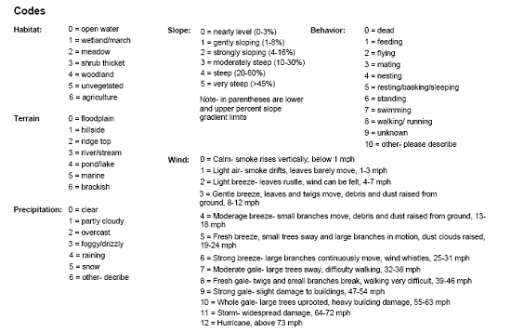

Figure 1. Sample form for observations of invasive plant species.

Standard Operating Procedure (SOP) #5

Transect Generation

Version 1.0 (June 9, 2010)

Change History

|  |  |  |  |  |
| --- | --- | --- | --- | --- |
| **Version #** | **Date** | **Revised by** | **Changes** | **Justification** |
|  |  |  |  |  |
|  |  |  |  |  |
|  |  |  |  |  |
|  |  |  |  |  |
|  |  |  |  |  |

Only changes in this specific SOP will be logged here. Version numbers will be incremented by a whole number (e.g., Version 1.3 to Version 2.0) when a change is made that significantly affects requirements or procedures. Version numbers will be incremented by decimals (e.g., Version 1.6 to Version 1.7) when there are minor modifications that do not affect requirements or procedures for publication in the series.

Partially based on: Camp, R. J. 2006. Standard Operating Procedure (SOP) #3 “Preparing Maps, Images, and Sampling Point Location Tables From GIS,” Version 1.00. In Camp, R. J., T. K. Pratt, C. Bailey, and D. Hu. 2011. Landbirds vital sign monitoring protocol – Pacific Island Network. Natural Resources Report NPS/PACN/NRR—2011/402. National Park Service, Fort Collins, Colorado.

Purpose

This SOP explains how to generate fixed and rotational transects using ArcGISTM for the Pacific Island Network (PACN) Established Invasive Plant Species Monitoring Protocol. For the first sampling cycle, fixed and rotational transect locations have been generated following these procedures and are presented in Appendix A “Target Populations and Sampling Frames.” For subsequent sampling cycles, this procedure must be performed to generate new rotational and alternate transects for each sampling frame; fixed transects are sampled every cycle and therefore should not need to be generated in the future. As transect locations will be shared between this protocol, PACN Landbirds Protocol (Camp et al. 2011), and Focal Terrestrial Plant Communities Protocol (Ainsworth et al. 2011), guidelines for all three protocols should be considered when generating transects. This SOP is based on available extensions for ArcGISTM used by the GIS specialist and represents one of many ways to accomplish these tasks. Once transects have been generated, SOP #7 “Sampling Invasive Plant Species” describes how to install contiguous plots along each transect.

Procedures

Fixed transects are established along available legacy transects. Subsections of the legacy transects are selected as fixed transects using the “Random Point on Polylines” feature of the ET GeoWizard extension for ArcGISTM. As most areas do not have a sufficient number of legacy transects, the remaining fixed transects are randomly generated in the same fashion as the rotational transects. Rotational transects are generated in ArcMap® 9.3 using the “Random Point Generation” tool within Hawth’s Tools. Generating new transects follows a two-step procedure: (1) generate buffers and screen hazards and (2) generate transects. The GIS specialist has the necessary ArcMap® documents and base layers (park boundaries, streams, roads, etc.) to generate the required rotational transects for subsequent sampling cycles, as described below. To the greatest extent possible, this protocol will share transects with the PACN Landbirds (Camp et al. 2011) and Focal Terrestrial Plant Communities (Ainsworth et al. 2011) protocols. Table 1 lists the required number of each type of transect for each frame.

Table 1. Guidelines for transect generation for each sampling frame. At least three alternative transects should also be generated for each sampling frame in case a new location is rejected in the field.

|  |  |  |  |  |  |  |  |
| --- | --- | --- | --- | --- | --- | --- | --- |
| **Park** | **Focal Community** | **Sampling Frame** | **Fixed Transects** | **Rotational Transects** | **Transect Length (m)** | **Plot Dimensions (m)** | **Legacy Available?** |
|
| HAVO | Wet Forest | Nāhuku/ East Rift | 10 | 10 | 1000 | 5 x 20 | Yes |
| HAVO | Wet Forest | ‘Ōla‘a | 10 | 10 | 1000 | 5 x 20 | Yes |
| HAVO | Wet Forest | Kahuku | 15 | 15 | 250 | 5 x 10 | Yes |
| HAVO | Subalpine shrubland | Subalpine shrubland | 10 | 10 | 500 | 5 x 20 | No |
| HALE | Wet Forest | Wet forest | 10 | 10 | 1000 | 5 x 20 | Yes |
| HALE | Subalpine shrubland | Subalpine shrubland | 10 | 10 | 500 | 5 x 20 | No |
| KALA | Rocky Shoreline | Coastal Strand | 16 | 0 | Variable | 5 x 10 | No |
| KALA | Sandy Shoreline | Coastal Strand | 11 | 0 | Variable | 5 x 10 | No |
| NPSA | Wet Forest | Ta‘ū | 10 | 10 | 500 | 5 x 20 | Yes |
| AMME | Mangrove Forest | Mangrove Forest | 6 | 0 | Variable | 5 x 10 | Yes |

Generating Fixed Transects along Legacy Transects

Where possible, fixed transects are randomly established along legacy transects. If not all of the fixed transects can be placed along legacy transects, new transects as well as alternatives in case of rejection in the field should be generated following the same procedures as for rotational transects. In most sampling frames, no more than one fixed transect was randomly placed along each legacy transect. Because legacy transects in NPSA and HALE are few in number but very long, more than one fixed transect may be randomly placed along a legacy transect with a minimum 500 m buffer between fixed transects in those wet forest sampling frames. To generate a fixed transect along an existing legacy transect:

1. Using the “Random Points on Polylines” feature of the ET GeoWizards extension for ArcGIS (fig. 1), generate a point along the selected legacy transect.
2. From the point, extend the fixed transect the appropriate length (table 1) along the legacy transect in a randomly chosen direction.
   * If the legacy transect is too short to fit the entire fixed length in the first direction, extend the fixed transect in the opposite direction.
   * If the length of the fixed transect still does not fit after trying both directions and the legacy transect is long enough to accommodate the entire length, adjust the point the appropriate distance so as to accommodate the length in the first direction.
   * If a legacy transect is too short to contain the entire length of a fixed transect, extend the fixed length past end of the legacy transect in the first direction.
   * Once established, orient the sample transect in the same direction as the legacy.
3. Assign transect numbers and X and Y Universal Transverse Mercator (UTM) coordinates for the start and end points of each transect.

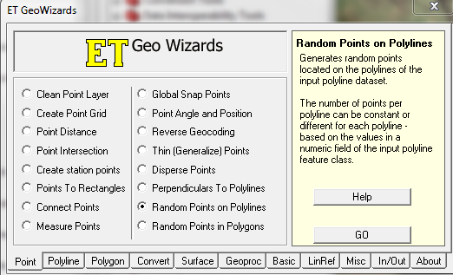

Figure 1. Dialogue box for the “Random Points on Polylines” feature of the ET GeoWizards extension for ArcGIS.

Park Special Considerations: Exceptions to the guidelines above occur. Given the small size of the mangrove forest sampling frame, the entire length of all legacy transects are used at AMME, and no rotational transects are used. At KALA, the shape and size of the coastal strand sampling frame as well as management concerns regarding spread of invasives lead to the exclusion of rotational transects and a stratified array of fixed transects. Fixed transects at KALA start 16 m in from the inland edge of the sampling frame and extend to within 16 m of the coastline. They are spaced every 200 m and, for those over the same substrate type, are parallel to one another. Given the difficulty of the terrain in HALE wet forest, all transects must have an endpoint near or must cross existing access points such as roads, trails, or existing legacy transects.

Buffers and Hazard Screening for New Transects

The first step in generating new transect locations is to screen for hazards and generate buffers around all major unrepresentative features such as paved roads, boundaries, trails, etc. These buffer zones represent areas that cannot contain transect lines (Technical note: procedurally it may be easier to combine all unrepresentative features into one layer before generating buffers). Buffers are created on the following criteria:

* greater than 3 m from roads, trails, streams, coastlines, cultural features or other unrepresentative features.
* greater than 50 m from existing fixed sampling transects.
* in a location with a slope less than 70% (35°).

If a buffer around unrepresentative features cannot be easily generated, individual points may be evaluated after generation by performing the following steps:

1. Based on the highest resolution digital elevation model (DEM) available, create a slope raster using the “Surface Tools” in Spatial Analyst. If a DEM already exists in the I&M GIS database, this step may be skipped.
2. Run the “Extract Values to Points” tool located within the “Extraction” subfolder of the Spatial Analyst Toolset. This tool uses the slope raster to compute slope for each point.
3. Based on the interpolated slope values, discard all points that do not meet the slope criteria. Furthermore, if a plot location lies next to dangerous slopes that could fall within or on the edge of plot boundaries, eliminate this point as well. In general, only the wet forests of KALA, NPSA, and HALE have large areas with slopes greater than 70%. In the other sampling frames, extreme slopes are distributed more sparsely (if at all) across the frame.

An alternative strategy to buffering unrepresentative features is to generate points throughout the sampling frame and then manually exclude any infeasible points at the end. This approach works reasonably well in the larger sampling frames with few unrepresentative areas/features but will be more time-consuming in smaller, more restricted sampling frames.

New Transect Generation

Once buffers have been established and hazards screened, transects are generated randomly using Hawth’s Analysis Tools for ArcGISTM. At least three additional points should be generated for use as alternative transects in the event that a location is rejected in the field. The criteria for transect establishment is similar to the PACN Landbirds Protocol (Camp et al. 2011) and Focal Terrestrial Plant Community Protocol (Ainsworth et al. 2011), enabling the GIS specialist to create one set of transects for all protocols where applicable. The procedure to create new transects is as follows:

1. Using Hawth’s Analysis Tools for ArcGISTM (fig. 2), generate the appropriate number of random points (table 1) for each sampling frame, excluding buffered areas for use as potential transect starting points.
2. Beginning with the first random point, assign a random azimuth (either by computer or using the random number table in SOP #7). Draw transect of appropriate length (table 1) in the direction of that azimuth. If the transect reaches a buffered feature, passes through an area with a slope more than 70% (35°), or crosses another rotational transect from the same sample cycle before the full length is drawn, discard the transect.
3. Continue generating transects from each random starting point until the appropriate number of transects per sampling frame including alternatives (table 1) have been selected. To ensure compatibility with PACN Landbirds Protocol (Camp et al. 2011) and Focal Terrestrial Plant Community Protocol (Ainsworth et al. 2011), consult with the respective project leads to verify that the new transects meet their protocol requirements.
4. Assign transect numbers as well as X and Y UTM coordinates for the start and end points of each transect.

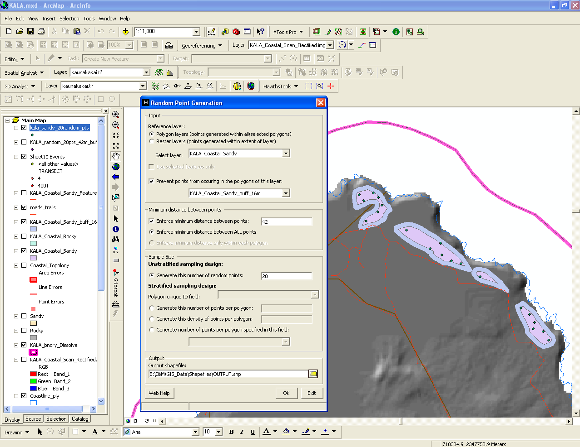

Figure 2. Dialog box for the “Random Point Generation” tool in Hawth’s Analysis Tools. Note relevant options to prevent points from occurring in selected polygons and to enforce minimum distances between points.

Preparing Field Materials

Once all of the transects for a sampling cycle are generated, the GIS specialist should assist in preparing the location information for use by the field crew. This includes:

1. Print out X and Y UTM coordinates and azimuths for all transects.
2. Provide information on the proximity of transects to each other and nearby access points as well as the recommended order of sampling to maximize efficiency in the field.
3. Develop and print field maps displaying each transect’s location relative to the others’ and any landmarks that may aid field navigation.
4. Enter the X and Y UTM coordinates and unique transect numbers into GPS units (see SOP #6 “Using GPS to Navigate to and Mark Waypoints”) along with any landmarks (roads, trails, streams, etc.) that may aid field navigation.

Literature Cited

Ainsworth, A., P. Berkowitz, J. D. Jacobi, R. K. Loh, and K. Kozar. 2011. Focal terrestrial plant communities monitoring protocol: Pacific Island Network. Natural Resource Report NPS/PACN/NRR—2011/410. National Park Service, Fort Collins, Colorado.

Camp, R. J., T. K. Pratt, C. Bailey, and D. Hu. 2011. Landbirds vital sign monitoring protocol – Pacific Island Network. Natural Resources Report NPS/PACN/NRR—2011/402. National Park Service, Fort Collins, Colorado.

Standard Operating Procedure (SOP) #6

Using GPS to Navigate to and Mark Waypoints

Version 1.0 (April 27, 2010)

Change History

|  |  |  |  |  |
| --- | --- | --- | --- | --- |
| **Version #** | **Date** | **Revised by** | **Changes** | **Justification** |
|  |  |  |  |  |
|  |  |  |  |  |
|  |  |  |  |  |
|  |  |  |  |  |
|  |  |  |  |  |

Only changes in this specific SOP will be logged here. Version numbers will be incremented by a whole number (e.g., Version 1.3 to Version 2.0) when a change is made that significantly affects requirements or procedures. Version numbers will be incremented by decimals (e.g., Version 1.6 to Version 1.7) when there are minor modifications that do not affect requirements or procedures for publication in the series.

Based on: Camp, R.J. 2006. Standard Operating Procedure (SOP) #4 “Using GPS to Navigate and Mark Waypoints,” Version 1.00. *in* Camp, R. J., T. K. Pratt, C. Bailey, and D. Hu. 2011. Landbirds vital sign monitoring protocol – Pacific Island Network. Natural Resources Report NPS/PACN/NRR—2011/402. National Park Service, Fort Collins, Colorado.

Purpose

This SOP explains how to use an autonomous, non-differential Garmin Global Positioning System (GPS) receiver and GPS transfer software within Pacific Island Network (PACN) parks. This protocol may be used for any Garmin GPS that can average a waypoint and store tracklogs. The GPS transfer process uses DNRGarmin Version 5.1.1 and Geographic Information System (GIS) software. DNRGarmin software can be updated for free via the State of Minnesota Department of Natural Resources website (MN-DNR 2010).

Pre-Field Preparation

Garmin GPS Preparation

1. Load fresh batteries and have extra, charged sets available. Extra batteries should be placed in a water tight “dry bag” or a re-sealable plastic bag.
2. Initialize and download a fresh almanac into a Garmin™ if more than one week has passed since last collection or if the GPS unit has moved more than a straight-line distance of 150 miles. Downloading the almanac takes roughly 20 minutes in open areas - away from buildings, canopy, and obstructions.
3. Delete old waypoints and tracks from memory (download and save data elsewhere if appropriate).
4. Turn off active tracklog. Set “Tracklog” to the preferred collection method (“Time” is recommended) and an appropriate logging rate for the data collection (“five seconds” is recommended for most walking collection, but keep in mind the total storage capacity of the GPS).
5. Ensure Simulator Mode is not ON when collecting data.
6. If necessary, transfer data (e.g. background maps) to the GPS unit using DNRGarmin software. See below for DNRGarmin instructions.
7. Set Time and Date on the GPS Unit (note that no Pacific Island Network [PACN] parks use daylight savings time, rather the entire PACN is always in ‘standard’ time).
8. Make sure that “Interface Protocol” is set to Garmin.
9. Make sure that Wide Area Augmentation System (WAAS) is enabled.
10. Set the Coordinate System (UTM or LAT/LONG) and Datum to ensure compatibility with any written coordinates needed for navigation or mapping. Recommended settings are:

* State of Hawai‘i: NAD83 UTM
* Guam, Saipan, and American Samoa: WGS84 UTM

1. Set Heading to Magnetic, and make sure your compass is set the same way. Setting your GPS and compass inconsistently will make accurate navigation unnecessarily challenging at best.
2. If needed, use Trimble Planning Software (Trimble Navigation Limited 2010) to ensure best time of day for GPS data collection.
3. Prior to fieldwork, ensure the GPS has been placed in a “dry bag” with a desiccant pack.

GPS Transfer Software for DNRGarmin

1. Uninstall any previous versions of DNRGarmin
2. Download and install the latest version to any computer that will receive GPS data from the Garmin. DNRGarmin can be downloaded from the State of Minnesota Department of Natural Resources website (MN-DNR 2010).
3. In DNRGarmin, set projection to ensure compatibility with data stored in GIS.

* Hawai‘i Island: ESRI (or EPSG) POSC code of 26905 (NAD83 UTM zone_5N).
* Maui Island: ESRI (or EPSG) POSC code of 26904 (NAD83 UTM zone_4N).
* Molokai Island: ESRI (or EPSG) POSC code of 26904 (NAD83 UTM zone_4N).
* Saipan: ESRI (or EPSG) POSC code of 32602 (WGS 84 UTM zone_55N).
* American Samoa: ESRI (or EPSG) POSC code of 32775 (WGS 84 UTM zone_2S).

1. In ArcMap®, ensure that Data Frames are set to the appropriate projection.

* State of Hawai‘i: UTM, NAD83
* Guam: UTM, WGS84
* Saipan: UTM, WGS84
* American Samoa: UTM, WGS84

GPS Field Procedures

Data Collection

Data is collected for all transects.

1. Hold GPS unit or antenna at or above your head. Use an external antenna to free hands.
2. Electronically store all data (waypoints and tracks). Write down positions on the data forms for backup.
3. Note that a Garmin™ will collect data no matter what the GPS positioning quality is, so it will be necessary to monitor the GPS Satellite Page continuously for anomalies and accuracy. Collect only when “3D GPS” or “3D Differential” is shown. Do not collect data in 2D unless absolutely necessary. 2D Differential should not be used either.
4. Waypoints:

* Collect all waypoints in “Averaged Position” mode if you are standing still. Obtain a minimum of 10 position points per site, or record for a maximum of 5 minutes at that site. Somewhere in between is enough to generate a quality position in most cases.
* Collect instantaneous waypoints only when moving.
* Name each point along the transect including codes for the sampling frame, “TR”+ transect number, location on transect. For example, 200m along fixed Kahuku wet forest transect 5 at HAVO would be recorded as: KUTR05200M

1. TrackLogs:

* Use “Stop when Full” or “Fill” Record Mode to prevent overwriting TrackLog points when Active TrackLog becomes full.
* Begin collecting Active TrackLog once the desired destination is known and immediately begin moving when TrackLog begins collecting.
* Stop Active TrackLog when stopped.
* Always stop Active TrackLog when nearing the beginning point of a polygon area you want closed. A line between the last track point and the initial point will automatically be generated in order to close the polygon.
* Always turn Active TrackLog to OFF when finished collecting. If TrackLogs are turned ON when you are in the office, ugly data will result.
* NEVER ‘store’ or ‘save’ an active Tracklog unless you need to save space, rather choose to ‘stop’ an active TrackLog. Garmin III+ receivers remove the Active TrackLog, while modern Garmins merely make a copy of the Active TrackLog. In any case, saved tracklogs degrade original data, whereas a ‘stopped’ TrackLog retains data quality.
* Name TrackLogs with community, sampling frame, transect number (or destination), year/month/day. For example, the TrackLog generated walking to the start of wet forest Kahuku unit transect five on August 3, 2011 would be recorded as: KUTR520110803

Back in the Office

1. Connect GPS to PC with cable and place GPS in Simulator Mode.
2. Check that TrackLog is OFF! Again, do not save Track!
3. Open DNRGarmin from the desktop (for ArcGIS™ users) or from within ArcView® by loading the extension.
4. Check Projection in DNRGarmin one more time. This will define the projection the GPS file will be stored in.
5. Download Waypoints and Tracks and save to Shapefile (if in ArcGIS™) or if saving a shapefile from the desktop DNRGarmin, save to projected shapefile. Use naming conventions as below.

* For waypoints, the file-naming convention is to include protocol abrieviation, community, sampling frame, transect type, number, and meter mark all separated by underscores (_). For example, the waypoint (WFTR05200M) labeled in the field in Kahuku wet forest at 200 m along established invasive fixed transect 5 is renamed on the computer as: EI_W_KU_F_05_200M
* For TrackLogs, the file-naming convention is to include protocol abrieviation, community, sampling frame, transect or destination, and year/month/day all separated by underscores (_). For example, the Track (WKUTR520110803) labeled in the field for the route to Kahuku wet forest transect 5 on August 3, 2011 is renamed on the computer as: EI_W_KU_F_05_20110803
* If additional notes about GPS collection exist, such as data collected in ‘2D’ mode; create a simple *text* file with an identical filename in the same location which contains this information, with a .text filename extension.

1. Delete all Waypoints and Tracks for the next mapping mission.
2. Turn off the GPS and disconnect cables, returning equipment to its proper storage location.
3. Recharge batteries if appropriate.

Options to Consider

* External antennae, with long cable and pole in order to extend the antennae above a thick vegetated canopy.
* An external beacon, such as the Thales Mobile Mapper Beacon®, for DGPS (Differential GPS). This will improve the accuracy of your GPS location.
* Averaging will improve your GPS locations, if and only if, the satellite geometry improves during point collection. Otherwise, averaging can sometimes result in a less accurate position.

Literature Cited

Minnesota Department of Natural Resources (MN-DNR). 2010. DNR Garmin Application. Minnesota Department of Natural Resources. Available at <http://www.dnr.state.mn.us/mis/gis/tools/arcview/extensions/DNRGarmin/DNR> Garmin.html (accessed 14 Jun 2010).

Trimble Navigation Limited. 2010. Trimble Planning Software Download. Trimble Navigation Limited. Available at <http://www.trimble.com/planningsoftware_ts.asp?Nav=Collection-8425> (accessed on 14 June 2010).

Standard Operating Procedure (SOP) #7

Sampling Invasive Plant Species

Version 1.0 (May 6, 2010)

Change History

|  |  |  |  |  |
| --- | --- | --- | --- | --- |
| **Version #** | **Date** | **Revised by** | **Changes** | **Justification** |
|  |  |  |  |  |
|  |  |  |  |  |
|  |  |  |  |  |
|  |  |  |  |  |
|  |  |  |  |  |

Only changes in this specific SOP will be logged here. Version numbers will be incremented by a whole number (e.g., Version 1.3 to Version 2.0) when a change is made that significantly affects requirements or procedures. Version numbers will be incremented by decimals (e.g., Version 1.6 to Version 1.7) when there are minor modifications that do not affect requirements or procedures for publication in the series.

Purpose

This SOP describes how to establish transects and collect field data for monitoring change in nonnative plant species richness, frequency proportion, distribution and, for target invaders, cover within focal plant communities of Pacific Island Network (PACN) parks. Invasive species are defined as species known to, or with the potential to cause significant ecological or economic harm (Daehler et al. 2004, Daehler 2009). Within PACN parks, managers have been working to control and monitor the state of their invasive species problem. This protocol is designed to provide systematically gathered long-term data for nonnative plant species monitoring utilizing fixed and rotational transects established within major plant communities at each park.

Transect monitoring will be conducted within four focal terrestrial plant community types: wet forest, subalpine shrubland, mangrove forest, and coastal strand. Fixed and rotational transects will be read for nonnative species presence and target invasive species cover in contiguous plots. In subalpine shrubland and most wet forest communities contiguous plots are 5 x 20 m along 500 or 1000 m transects. In mangrove forest and coastal strand communities only fixed transects of varying lengths are sampled within 5 x 10 m contiguous plots. Monitoring along transects will allow for a general assessment of the status and changes in overall nonnative species populations within major plant communities of each park. A description of transects to be sampled in the first sampling cycle at each park can be found in Appendix A “Target Populations and Sampling Frames.” In subsequent sampling cycles, new rotational plots will have to be generated as outlined in SOP #5 “Transect Generation.”

A master equipment list for the entire Established Invasive Plant Species Monitoring Protocol can be found in SOP #1 “Before the Field Season.” The master equipment list should be updated as needed if this SOP is revised. Data forms for recording field observations are located in Appendix E “Forms for Recording Field Data.”

Establishing Transects and Plots

To establish the start of a transect, the field crew must first navigate to the start (0 m) of a fixed or rotational transect. Procedures for navigating using a Global Positioning System (GPS) unit are provided in SOP #6 “Using GPS to Navigate to and Mark Waypoints.” Prior to navigating to a transect, sanitation procedures outlined in SOP #4 “Sanitation” must be followed. While navigating to a transect, any cutting or clearing to ease access should be kept to a minimum to allow quick recovery of the vegetation and minimize disturbance. Once at a transect, no cutting or clearing of vegetation should occur except when necessary for safe navigation; then it should be minimal.

Upon arrival at the transect origin, the field crew leader or designated “acting” leader will evaluate the location for crew safety. When safety concerns cannot be addressed as outlined in the following section, the transect is discarded and an alternate location is used. If deemed safe, the field crew should record the Universal Transverse Mercator (UTM) coordinates along with a detailed description of: 1) any roads or trails used to reach the transect start, 2) the point at which the field crew left road/trail access to reach the transect start, 3) the route used to reach the transect, 4) a hand drawn map with transect layout and reference features, and 5) the exit route used if different from the access route. Any problems navigating to the transect, changes, or concerns will also be noted.

After recording details about the transect origin, the field crew may begin to establish plots. A plot is oriented such that the length of a plot is established along the transect. The plot width is centered on the transect with the plot extending 2.5 m on each side of the transect (fig. 1). This effectively makes the transect the centerline of the plot. Plots will be measured by having one field crew member stand at the start of the plot and the other measure to the end, either 20 m or 10 m along the transect. Width boundaries of the plot do not need to be marked but distance from the centerline should be measured using a lightweight 2.5 m pole, as needed.

Addressing Obstacles

Although major landscape barriers can be avoided using certain Geographic Information System tools, it is expected that the field crew will still come across some physical impediments to reading a plot. Legacy transects should not have obstacles as those transects have already been established. For obstacles that are safe to navigate around, the field crew should first attempt to monitor the plot by looking into the plot from a safe location. If the plot is not walkable and there is no good vantage point from which to monitor, the plot may be moved 10 m to the right, and if still not acceptable, left of the transect when standing at the 0 m end. The start of the offset plot should be measured at a 90° angle away from the bottom corner of the previous plot (to have the plot completely clear the transect as well). Once cleared, the field crew should attempt to re-align with the original transect. If it is not possible to sample 10 m to either side of the transect but the obstacle is navigable, a note should be made on the data form and the field crew should continue sampling on the original transect. The distance skipped to clear the obstacle should be added to the end of the transect so that the area sampled is maintained. When obstacles that would be best

a)

40 m

Plot 20-40

Plot 40-60

Transect Line

20 m

Plot 0-20

Permanent Marker

0 m

2.5 m

5 m

b)

20 m

Plot 10-20

Plot 20-30

Transect Line

10 m

Plot 0-10

Permanent Marker

0 m

2.5 m

5 m

Figure 1. Diagram of sampling plots established along transects. In subalpine shrubland and wet forest communities, plots are 5 x 20 m (a) while in mangrove forest, coastal strand, and wet forest at HAVO-Kahuku plots are 5 x 10 m (b).

addressed by shifting 10 m to either side are visible at the start of a new transect, then the whole transect may be shifted.

Any obstacles too large to safely navigate around warrant truncation of the original transect. If the truncated transect is from the rotational panel and is less than half the intended length of the transect, then an alternate rotational transect will be sampled. However, the data collected prior to discontinuation may still be used for status estimates. If from the fixed panel, then the truncated transect is only worth including in the network of fixed transects if its length exceeds half the intended transect length (e.g., 500 m for a 1000 m transect in the wet forest). Fixed transects less than half the intended length are not worth resampling logistically nor do they permit co-location with the PACN Landbirds (Camp et al. 2011) and Focal Terrestrial Plant Community (Ainsworth et al. 2011) Protocols. All deviations from the original transect should be recorded including information on distances, compass directions, and other pertinent information.

Permanently Marking Fixed Transects and Plots

Fixed transects will be permanently marked at the beginning and end of each transect. Plots along fixed transects must be marked precisely as possible since trend analysis relies on these same plots being resampled in the future. The transect path will be marked using blue flagging as necessary and every plot start will be marked using heavy duty red and blue flagging in dense community types (e.g., wet forest) to ensure that future field crews will follow the exact same path. Transect number and meter mark will be written on the red and blue flagging with a felt tip permanent marker. Additionally, six permanent markers described below will be established at the transect end points and equally spaced along each fixed transect. For fixed transects that are 1000 m, permanent markers will be installed every 200 m (or at the start of every 10th 5 x 20 m plot) while 500 m long transects will be marked every 100 m (or at the start of every 5th 5 x 20 m plot). Fixed transects shorter than 500 m will be marked every 50 m (or at the start of every 5th 5 x 10 m plot). Photographs and GPS coordinates will be recorded at each permanent marker along the transect. Although rotational transects and plots do not receive any permanent markers or flagging, the same criteria will be used for taking photographs and recording GPS locations.

Permanent markers consist of 0.01 m x 0.5 m stainless steel rods covered with PVC pipe and marked with pin flags and flagging. The rods are buried with at least 0.3 m (1 ft) of the rod above ground. In rocky substrates, setting the rod may require a 5 lb sledgehammer and a fast-setting two-part epoxy (e.g., Power-Fast™) to keep the marker vertical. Alternatively, rods may be buried a measured distance beyond or before the actual point and appropriately noted on the data form. White PVC pipe (inner diameter of 0.01 m) is slid over the stainless steel threaded rod and secured with epoxy to increase marker visibility. Labeled aluminum tags are attached to the rods and will contain Inventory and Monitoring program identifier (I&MVeg), transect number, appropriate meter mark (e.g., 0 m, 20 m, 50 m) on the centerline, year and month of plot installation (YYYYMM), and transect azimuth (fig. 2). Location information is also written on the PVC post with a permanent felt tip marker.

I&M Veg- TR 02

Est Inv 0m

201008 29º

Figure 2. Example label for marking transects and plots. Label should include: Inventory and Monitoring vegetation program identifier, transect number, appropriate meter mark, year and month of plot installation, and transect azimuth.

Note that some areas (e.g., KALA coastal strand community, HAVO and HALE subalpine shurblands) may have sensitive archaeological features present within the sampling frame. It is the responsibility of the project lead to protect these resources and ensure compliance with the National Historic Preservation Act. Burying of stainless steel rods may be prohibited under some circumstances, and field crew workers should do their best at all times to avoid negative impacts to any known or suspected cultural resource sites. The project lead will consult with local park staff regarding cultural resources issues prior to monitoring. If detailed archeological surveys exist, then culturally sensitive sites can be buffered and excluded from the sampling frame to ensure that no sampling plots coincide with important cultural resources (SOP #5 “Transect Generation”).

Inclement weather in the field may prohibit transect marking and data collection. A small umbrella may help keep data forms drier and a hankerchief may be necessary to dry the flagging in order to write on it with a permanent marker. If environmental conditions warrant leaving the field prior to completing a transect, the field crew will mark where they have stopped on the data forms and in the field. In these instances it may be necessary to wait for the weather to clear or return to the transect and continue another day.

Collecting GPS Points

A GPS location point is recorded at transect endpoints and every 200 m, 100 m, or 50 m depending on transect length. For 1000 m transects, GPS locations are recorded every 200 m (or every 10-5 x 20 m plots), for 500 m transects GPS locations are recorded every 100 m (or every 5-5 x 20 m plots), and for transects shorter than 500 m GPS locations are recorded every 50 m (or every 5-5 x 10 m plots). Location data will be recorded in UTM coordinates with the zone appropriate for that area (HAVO – zone 5, HALE – zone 4, NPSA – zone 2, AMME – zone 55, KALA – zone 4). Datum base should be NAD83 in Hawai‘i and WGS84 elsewhere, which will also be recorded. The field crew will record the model of GPS unit used as well as the error margin for each point taken. A minimum of 30 position points must be captured by the GPS prior to recording a point. If GPS satellite coverage is poor and a point cannot be collected, then the field crew will note the lack of coordinates and must attempt to collect a point at the start of the next 10 or 20 m long plot. GPS points are named using a coded naming convention which identifies the sampling frame, transect number, and meter mark along the transect (e.g., OTR04200M identifies the location of the point in the ‘Ōla‘a sampling frame along transect 4 that is 200 m along the transect). After downloading, points are renamed to include the protocol identifier, community type, and underscores (e.g., EI_WF_O_F04_200M).

GPS track logs are recorded if the route to the transect is difficult (e.g., dense vegetation) to aid in relocation. This is particularly important if a transect is not completed in one day. Following the same path to enter and exit an area increases staff safety, field efficiency, and reduces the overall impact to the forest. More information on procedures for collecting and naming GPS data is provided in SOP #6 “Using GPS to Navigate to and Mark Waypoints.”

Photographing Transects and Plots

Photographs will be taken everywhere that GPS coordinates are recorded (transect endpoints and every 200 m, 100 m, or 50 m depending on the length of the transect). For a fixed transect, a minimum of three photographs will be taken at each location (fig. 3). The first photograph will be taken along the transect, looking toward the end while standing at the marker. The second photograph will be taken along the transect looking toward the start while standing at the marker. The last photograph will be taken of the plot marker from a distance capturing any landmarks that may assist in relocating the marker in the future. The field crew will note the direction and distance to the marker from where the photo was taken. Rotational transects require only the first two types of photographs.The type of camera used as well as photograph numbers (obtained from the “review” option on the camera used) should be recorded on the data form; this includes photos of unknown species and other helpful reference photos. For cameras that are not equipped with memo ability carefully recording the photo number and reference on the dataform is particularly important. Once a transect is completed in the field, a photograph is taken of the completed “UTMs and Photographic Record” data form marking the end of the transect on the camera. This photo will aid in organization once all photographs are transferred to the computer.

C

Start of Selected Plot

Previous Plot

Next Plot

Transect

Selected Plot

A

B

Figure 3. Schematic of photographs taken along the transect. For the first photo (A), the photographer stands on the transect line at the designated meter mark and captures the view toward the next plot or toward the end of the transect. For the second photo (B), the photographer will capture the view along the previous plot or toward the beginning of the transect. For fixed plots, the third photo (C) is taken of the marker to aid in relocating the point for future sampling.

Collecting Invasive Species Data

All nonnative plant species encountered within each plot along the transect are recorded. For target invasive plant species or target invasive groups of species (e.g., pasture grasses, sedges, rushes) the aerial cover is also recorded using modified Braun-Blanquet cover classes (table 1)(Mueller-Dombois and Ellenberg 1974). Aerial vegetated cover is the estimated vegetation cover as seen by a bird’s-eye view of the vegetation. These cover classes are designed to be easy to learn and relatively quick to estimate. It is useful to have a pre-defined idea of what a given percentage of the area of a plot would look like. For example, a 5 x 20 m plot such as those in the wet forest and subalpine shrubland communities has an area of 100 m2 and therefore a single percent is 1 m2. For the coastal and mangrove communities (5 x 10 m plots) a single percent is 0.5 m2. Only one pass through the plot should be made while looking for species and estimating cover. Fruit or leaf litter on the ground is sometimes the only indicator of vine presence in the canopy above. Each species present is recorded on the data form by its six-letter code (first three letters of the genus followed by the first three letters of the species). A species is considered to be in the plot if any foliage or stem material—live or dead— within the plot boundary is connected to a live individual. Dead nonnative plant species that are not present as live in the plot are recorded as “dead and present” by adding “-D” after the six-letter code. Notes on conditions that may explain why the species is dead (e.g., drought, seasonality, or herbicide treatment) are included. Invasive species of particular interest to park resource managers located outside of the designated plot are noted on the data form with “out” written in the space for cover class. Opportunistic invasive species sighted outside of the belt transect are recorded if they have not been previously observed along the transect. These data are useful for detecting new invaders to the community.

Table 1. Modified Braun-Blanquet cover classes and ranges of cover (Mueller-Dombois and Ellenberg 1974) recorded for each target invasive plant species.

|  |  |
| --- | --- |
| **Cover Class** | **Range of Cover** |
| 1 | < 1% |
| 2 | 1% - <5% |
| 3 | 5% - <10% |
| 4 | 10% - <25% |
| 5 | 25% - <50% |
| 6 | 50% - <75% |
| 7 | 75% - 100% |

Literature Cited

Ainsworth, A., P. Berkowitz, J. D. Jacobi, R. K. Loh, and K. Kozar. 2011. Focal terrestrial plant communities monitoring protocol: Pacific Island Network. Natural Resource Report NPS/PACN/NRR—2011/410. National Park Service, Fort Collins, Colorado.

Camp, R. J., T. K. Pratt, C. Bailey, and D. Hu. 2011. Landbirds vital sign monitoring protocol – Pacific Island Network. Natural Resources Report NPS/PACN/NRR—2011/402. National Park Service, Fort Collins, Colorado.

Daehler, C. C. 2009. Weed Risk Assessments for Hawaii and Pacific Islands. University of Hawaii at Manoa, Honolulu, Hawaii. Available at <http://www.botany.hawaii.edu/faculty/daehler/wra/default2.htm> (accessed 14 January 2010).

Daehler, C. C., J. S. Denslow, S. Ansari, and H. Kuo. 2004. A risk assessment system for screening out invasive pest plants from Hawai'i and other Pacific Islands. Conservation Biology 18:360-368.

Mueller-Dombois, D. and H. Ellenberg. 1974. Aims and Methods of Vegetation Ecology. John Wiley & Sons, New York, NY.

Standard Operating Procedure (SOP) #8

Collecting and Vouchering

Version 1.0 (May 5, 2011)

Change History

|  |  |  |  |  |
| --- | --- | --- | --- | --- |
| **Version #** | **Date** | **Revised by** | **Changes** | **Justification** |
|  |  |  |  |  |
|  |  |  |  |  |
|  |  |  |  |  |
|  |  |  |  |  |
|  |  |  |  |  |

Only changes in this specific SOP will be logged here. Version numbers will be incremented by a whole number (e.g., Version 1.3 to Version 2.0) when a change is made that significantly affects requirements or procedures. Version numbers will be incremented by decimals (e.g., Version 1.6 to Version 1.7) when there are minor modifications that do not affect requirements or procedures for publication in the series.

Based on:

Williams, A., S. O’Neil, E. Speith, and J. Rodgers. 2007. Standard Operating Procedure (SOP)

#4 “Plant Collecting and Vouchering,” Version 1.0. *In* Early Detection Monitoring of Invasive Plant Species in the San Francisco Bay Area Network:A Volunteer-Based Approach. U.S. Department of the Interior, National Park Service, Pacific West Regional Office, Oakland, California.

***Only local PARK STAFF are allowed to collect without a permit.***

Purpose

This SOP describes how to collect and document a physical voucher of a plant within Pacific Island Network (PACN) parks.

Having a physical voucher of a plant, especially a potentially new park record, is still the preferred method of proving an observation. Specimens, even nonnatives, should not be collected by non-staff unless the individual has the proper Scientific Research and Collecting Permit. Volunteers and inexperienced field crew members should only take photographic vouchers of any unknown species. More experienced staff may field-key or choose to voucher for expert identification, or to record a new species for the park plant list or significant range expansion for an invasive species (e.g., the first record in the county), but should also photograph the plant *in situ* to capture characteristics that may be lost during pressing. Contact park vegetation staff for a list of plants that lack voucher evidence of their presence in the park.

Collecting In the Field

Collecting Ethics and Regulations

Only collect native individuals if the plant population will not be seriously affected by the taking: generally, if there are over 20 individuals in the vicinity. If the population is small, consider photo-vouchering first, but if you must collect, take only enough to key without destroying the plant (e.g., a flower and stem without roots). If native plants are, or are suspected to be, rare, consider carefully whether or not to collect. Hawaii Plant Extinction Prevention program (State of Hawaii 2011), State and Federally listed species should not be collected without consultation with the park supervisory botanist and the appropriate permits. Nonnative individuals can be collected regardless of population size, but if there is any uncertainty as to whether a rare individual is native or not it should not be collected.

Collecting Tips

Plants are best keyed fresh, so field-key when possible. Tiny-flowered plants are especially difficult to key when wilted or pressed. If field-keying is unsuccessful, press some of the plant and store the rest in a plastic bag. Blow the bag up with air and keep the plant moist (a small piece of wet paper in the bag helps); refrigeration will help keep the specimen fresh. Label the bagged and the pressed plants! A plastic sandwich container works well for delicate structures.

If you decide to collect with the intent of creating a pressed and mounted specimen:

* Collect a representative example of the species, not the largest or smallest. Try to capture any phenotypic variation.
* Collect enough of the plant to make pressing worthwhile. If the plants are tiny, collect enough to fill about half an herbarium sheet. Take enough to make a good voucher, plus a little extra for keying if necessary.
* Collect as much of the individual plant as possible, including roots (or a portion if rhizomatous), bulbs, vegetative and flowering/fruiting matter.
* Collect as many phenological stages as possible (flowering and fruiting), since many keys use characteristics of fruit and flower. If necessary, snip flowers or fruits off an additional plant to complete the collection.
* Press carefully; the standard plant press is the same size as a standard herbarium sheet (11”x17”). How you place the plant in the press will generally be how it will look mounted. If a plant is large, fold it or cut it to fit, keeping branchings and general form intact. Note original dimensions and photograph if possible. Plants may occasionally require more than one sheet for proper representation.
* Take copious notes, including the following information (see example collection label in Figure 1 or field descriptions from NPSpecies in Table 1): date; collector; exact location in Lat/Long or UTM (if Global Positioning System [GPS] is used, specify datum such as NAD83); descriptive location (e.g*.* Wolf Ridge, Marin Headlands; do not use “local” nicknames not on any map!); habitat description (dominant species); associated species; characteristics that may be lost in pressing (smells, flower color, habit, etc.); study name and number/plot number if applicable. Some information (elevation, sensitivity) may be filled in at the office. Many specimens are eventually discarded due to a lack of collection information.

|  |  |  |  |  |  |  |
| --- | --- | --- | --- | --- | --- | --- |
| Date: | 03/31/03 | Collector: | Andrea Williams |  | Collection #: | AW-03-03 |
| Binomial: | *Allium triquetrum* | | Authority: | L. |  |  |
| Family: | Liliaceae |  | Common Name: | threecorner leek | |  |
| Distinctive Features: | | Onion odor, triangular stem, sl succulent, bracted umbel of 5-15 | | | | |
| 6-tepalled fls; perianth white with grn midvein | | | |  |  |  |
| Habitat: | disturbed areas | |  |  |  |  |
| Assoc sp.: | *Rubus discolor, Achillea millefolia* | | | plus weedy grasses | |  |
| Location Description: | | Freshwater Lagoon Spit | |  |  |  |
| Numeric Location: | | Orick Quad, T10N R1E S6 | |  |  |  |
| Slope: | 0% | Aspect: | N/A | Elevation: | ~30 ft |  |
| Comments: | New to list; weedy and a potential problem | | | |  |  |

**Figure 1.** Sample collection label.

**Table 1.** NPSpecies field descriptions.

|  |  |
| --- | --- |
| **Field Name** | **Description** |
| ParkCode | 4-Character park code (Hawai‘i Volcanoes National Park = HAVO) |
| LatinName | Accepted scientific name of specimen. |
| ParkAdminUnit | Administrative Unit for park (i.e. Alcatraz Island, Mori Point) |
| Sensitivity | Security level: 0=sensitive; 1=park only; 2=NPS only; 3=public |
| DocLatinName | Documented scientific name of species in the original records when it was observed |
| Date | Date of observation or collection (mm/dd/yy) |
| EndDate | Companion to Date; allows date ranges (mm/dd/yy) |
| Time | Time of observation or collection (24-hour clock, hh:mm) |
| Observer | Name of observer or collector |
| ObserverNumber | Field collection number provided by collector, if available. |
| Habitat | Concise description of habitat where observation or collection was made |
| Elevation | Estimated elevation in feet or meters where observation or collection was made |
| ElevationUnits | Units for elevation (feet or meters) |
| SpecimenID | Repository identification number of voucher specimen. |
| SpecimenLocation | Acronym, name and address of herbarium, museum or other location of specimen |
| Location | Concise description of collection site within the park or location from specimen label |
| LocalLocCode | An optional code for a permanently recognized local location. |
| Latitude | Latitude in decimal degrees |
| Longitude | Longitude in decimal degrees |
| UtmX | UTM X coordinate (northing) |
| UtmY | UTM Y coordinate (easting) |
| UtmZone | UTM zone |
| Datum | DATUM for location (e.g., NAD27, NAD83) |
| LocationError | Estimated location error in meters. How close are the coordinates to the true location? |
| DataSource | Source of voucher data (e.g. database name, file name, etc.) |
| Comments | Comments |
| FromPark | Collected within park boundary - yes or no. |
| VoucherType | Specimen, audio recording, image, or other. |
| VoucherTypeDetails | Concise description of voucher type. |

* Wash as much dirt as possible from the roots and pat dry before pressing.
* If flowers are large enough, cut one or two open and press flat so the interior/cross-section can be seen. Do the same for fruits. Turn over at least one leaf so the underside will be visible in the final mounting.

Post-Collection Processing

Identify the Specimen

Do your best to identify the plant to species level; it may be a good idea to confirm this identification by asking a local expert and comparing to an existing herbarium specimen or online photo.

Determining Formal Accession of Specimen into the Herbarium Collection

If the specimen meets any of the following criteria, you should consider accessioning it, if it does not then you may consider adding it to a field collection (an informal notebook or set of specimens that can be used in the field for reference) or you may discard it once you are finished identifying it for whatever purpose you had.

* Is the species under-represented (less than five specimens) in the herbarium?
* Does the specimen display a unique feature?
* Is this a unique voucher associated with a study or monitoring project?
* Is the specimen exceptional in some other way?
* Is there complete collection information associated with the specimen? Plants that lack location, habitat, collector and/or identifier information should not be accessioned.

Independent Verification

If plants will be verified, do not accession until they are returned. This makes loan paperwork unnecessary. A receipt for property is sufficient.

Whether or not to verify: If the specimen is to be formally accessioned, independent verification of the identity of the specimen should be considered when one or more of the following conditions are met:

* There are no preexisting specimens of the same species in the collection;
* The collection represents a new species to the park;
* Designated park staff are unable to confirm its identification with certainty;
* The specimen is otherwise unique or problematic.

Where to get them verified: If independent verification is desired for a quantity of specimens, the herbarium manager or curator should arrange for a contract through a recognized herbarium; current options include informal assistance from the Bishop Museum in Honolulu or Smithsonian Institute in Washington DC. Independent verification can pose a problem, because many herbaria want to keep specimens or duplicate specimens after identification, but National Park Service (NPS) property guidelines will only allow for “permanent loans” which may not suffice in the eyes of some herbaria. Be sure to discuss with local or regional NPS curation staff who have experience with natural resource collections.

Documenting and packing specimens for shipping: Include proper documentation including a spreadsheet listing the specimens with collection numbers. Place a label with each specimen. See Figure 2 below for an example of a label that can be used.

Dry and press, but do not mount them. This facilitates identification.

Place them in folded, numbered sheets of newsprint, occasionally layered between cardboard, and tie the entire bundle with string to facilitate removal from the box.

Pack the box tightly to prevent anything from moving around within it.

Send it via a reputable carrier (FedEx, UPS, USPS), insured. If feasible, hand carry.

|  |  |
| --- | --- |
| Date Collector Collection #  Binomial Authority  Family Common name  *Please do not make notations in this space, as these labels will not be included with the specimens once cataloged. You can make additional notations on the reverse of this temporary label, or on separate archival paper, with the collection number noted.* | *Please make all of your notations anywhere in this space. This portion will be cut off and affixed to the actual herbarium sheet, with the official label.*  Det: Margriet Wetherwax  Date: |

Figure 2. Temporary label to be attached to specimens sent off for verification.

Accessioning the Specimen into the Formal Herbarium Collection

A collection of dried plants to be added to the parks’ herbarium needs an accession number, as a group, and individual catalog numbers for each specimen. Obtain these from the Museum Curator. Specimens collected as part of a study should be accessioned together, clearly indicating relevant study information. Researchers who have collected specimens under a Scientific Research and Collecting Permit must provide cataloging data in the form specified by the Museum Curator in the permit. Catalogued specimens must be entered into the ANCS+ database. Contact the Herbarium Manager or Museum Curator for procedures and permit requirements if applicable. Remember that in entering the specimen you should be preserving the process as well as the final identification, so original identifications and identifiers should be recorded even if incorrect. Information needed for ANCS+ includes the data from the sheet above, as well as the date of any subsequent identifications and the name of the person identifying (verifying) the specimen.

Adding the Specimen into NPSpecies

Currently, some duplication of data exists between park herbaria and NPSpecies. Researchers who have collected specimens under a Scientific Research and Collecting Permit under Inventory and Monitoring Program (I&M) must also provide data in electronic format suitable for upload into NPSpecies. Updates to the park species list and to NPSpecies need to be accompanied by a voucher specimen and coordinated through an NPSpecies “gatekeeper.” The current coordinator for data updates is the data manager. The data manager can provide you with the template with which you can record your collection information.

***SPECIMENS MUST INCLUDE LOCATION, HABITAT AND COLLECTION DATA TO BE ACCESSIONED AND INCLUDED IN NPSPECIES.***

Mounting the Specimen

Once specimens are identified and verified, they may be mounted. Mounting can take place before or after accessioning. Not all pressed material must (or should) be mounted: only the most complete plants, plus additional fertile material or leaf variations, should be adhered to a sheet—enough to show the characteristics of the plant but not so much as to crowd the page. Split into “a” and “b” sheets if necessary, and be sure to leave room for label information. If you are inexperienced at mounting, consult I&M or local experts and/or look into one of the references listed at the end of this document.

Glossary

*Accession number*: The number assigned to an object or group of objects to be added to the parks’ collection.

*Authority*: The original publishing author for a scientific name.

*Binomial*: The genus and species of a scientific name. Taken here in the broad sense to include subspecies.

*NPSpecies*: The National Park Service catalog for natural resource inventory data.

*Phenotypic*: The outward expression of genetic; flowers of Scotch broom show phenotypic variation in that some are all yellow and some have red wings.

*UTM*: Universal Transverse Mercator (or latitude/longitude) in pinpointing a location.

*Voucher*: A physical representation of a plant observation; the pressed, mounted plant “vouching” that a plant was found in a given location.

Suggested Reading

Bridson, D. and Forman, L., editors. 1992. The Herbarium Handbook, rev. ed. Kew, Royal Botanic Gardens.

United States Department of Agriculture, Agricultural Research Service. 1971. *Preparing Herbarium Specimens of Vascular Plants*. U.S. Government Printing Office. Washington, D.C.

Literature Cited

State of Hawaii. 2011. Plant Extinction Prevention Program website. http://hawaii.gov/dlnr/dofaw/rpc/pep-program (accessed 5 May 2011).

Standard Operating Procedure (SOP) #9

After the Field Season

Version 1.0 (April 27, 2010)

Change History

|  |  |  |  |  |
| --- | --- | --- | --- | --- |
| **Version #** | **Date** | **Revised by** | **Changes** | **Justification** |
|  |  |  |  |  |
|  |  |  |  |  |
|  |  |  |  |  |
|  |  |  |  |  |
|  |  |  |  |  |

Only changes in this specific SOP will be logged here. Version numbers will be incremented by a whole number (e.g., Version 1.3 to Version 2.0) when a change is made that significantly affects requirements or procedures. Version numbers will be incremented by decimals (e.g., Version 1.6 to Version 1.7) when there are minor modifications that do not affect requirements or procedures for publication in the series.

Purpose

This SOP explains procedures that all for Pacific Island Network (PACN) field crew members should be familiar with and follow after the field season is completed.

Procedures

The following list summarizes the procedures to follow after the field season.

1. Clean, inspect and repair all equipment prior to returning them to their proper storage areas at PACN Inventory and Monitoring Program (I&M) facilities. All field equipment should also be decontaminated according to SOP #4 “Sanitation.” All references manuals should be re-shelved on their appropriate bookshelf. Other reference materials and extra data forms need to be filed in their appropriate filing cabinet. Clean the insides and outsides of all vehicles used in the field.
2. Remove the memory card from the camera and store with the camera. Remove the camera power supply and place it in the camera battery charger. Put the camera in its case and place in cool, dry, secure storage. After the power supply is recharged, place it in the case with the camera.
3. Prepare a maintenance log that clearly identifies each piece of gear, the date serviced, and the type of maintenance performed.
4. Organize field data forms and check that they have been filled out completely. As a rule, all data forms need to be reviewed for completeness before the crew leaves the field. However, because of the number of field days and crew members, some deficiencies in data recording may not be identified until all data forms have been organized and reviewed as a group.
5. At the earliest practicable time, the field leader and crew members should enter data into the working database, validate it, and file the field season report. Conducting these tasks in a timely manner increases the odds of identifying and correcting data discrepancies and inconsistencies. The field leader is responsible for filing all field reports.
6. Identify and obtain ancillary data. It is of critical importance that these data be incorporated into established invasive species monitoring efforts. First and foremost, knowledge of park management efforts for that year (e.g. ungulate control) may be used to assess the effects of these efforts on the terrestrial plant communities. Secondly, data collected by other PACN Vital Signs (e.g., habitat and vegetation data from the PACN Landbirds Protocol [Camp et al. 2011], and climate data from the Climate Vital Sign) may provide additional information about the status and trends of established invasives plant species monitored in this protocol.

Literature Cited

Camp, R. J., T. K. Pratt, C. Bailey, and D. Hu. 2011. Landbirds vital sign monitoring protocol – Pacific Island Network. Natural Resources Report NPS/PACN/NRR—2011/402. National Park Service, Fort Collins, Colorado.

Standard Operating Procedure (SOP) #10

Workspace Setup and Project Records Management

Version 1.0 (April 27, 2010)

Change History

|  |  |  |  |  |
| --- | --- | --- | --- | --- |
| **Version #** | **Date** | **Revised by** | **Changes** | **Justification** |
|  |  |  |  |  |
|  |  |  |  |  |
|  |  |  |  |  |
|  |  |  |  |  |
|  |  |  |  |  |

Only changes in this specific SOP will be logged here. Version numbers will be incremented by a whole number (e.g., Version 1.3 to Version 2.0) when a change is made that significantly affects requirements or procedures. Version numbers will be incremented by decimals (e.g., Version 1.6 to Version 1.7) when there are minor modifications that do not affect requirements or procedures for publication in the series.

Purpose

This SOP document describes how to set up a project workspace on one’s computer, and describes the for Pacific Island Network (PACN) Digital Library which is used for archival of finished Established Invasive Plant Species Monitoring products.

Set up project workspace

A section of the networked PACN file server is reserved for this project, and access permissions are established so that project staff members have access to needed files within this workspace. Prior to each season, the project lead should make sure that network accounts are established for each new staff member, and that the data manager is notified to ensure access to project workspace and databases. If network connections are too slow for efficient data entry and processing, individual staff members may set up a workspace on their own workstation, with periodic data transfer to the PACN server. Daily backups of the workstation to an external hard drive will ensure that no data are lost.

The recommended file structure within this workspace is shown in Figure 1. Certain folders – especially those for Global Positioning System (GPS) data and images – should be retained in separate folders for each calendar year as shown in Figure 1. This will make it easier to identify and move these files to the project archives at the end of each season (see Chapter 4: Season Close-out).

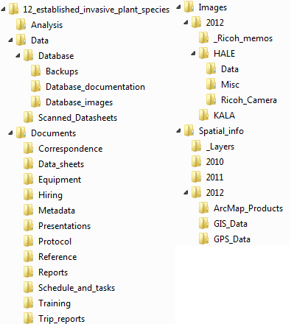

**Figure 1.** Recommended file structure for the Established Invasive Plant Species project workspace.

Images that are to be linked to the database must be placed within the proper folder structure as designated in Figure 2. This will insure that when the images and database are moved, the links to these files will be updated in the database. The database must be in the database folder for the links to work.

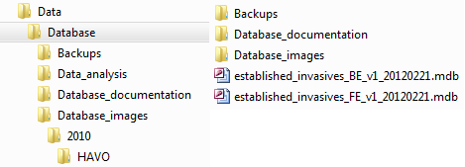

**Figure 2.** Required file structure for images linked to the Established Invasive Plant Species database.

Within the Database folder there should be a folder called “Database_images”. This folder contains a folder for the current monitoring year with subfolders for each park sampled that year. Images that are to be linked to the database should be organized in individual folders by location and date of sampling event, and placed appropriately. All other images should go into the “Images” folder in the main directory.

Following these steps will ensure that the files will be re-linked to the database upon moving as long as the structure is maintained.

Each major subfolder is described as follows:

* Analysis – Contains working files associated with data analysis.
* Data – Contains subfolders to categorize project data and the working database file for the season. The master database for the project is stored in the PACN Digital Library.
* Documents – Contains subfolders to categorize documents as needed for various stages of project implementation.
* Images – For storing images associated with the project (refer to **S**OP #12 “Managing Photographic Images”). Note that this folder contains subfolders to arrange files by year.
* Spatial info – Contains subfolders that arrange files by year and park. Yearly folders organized by park contain the following subfolders.
  + ArcMap_Products – Map products.
  + GIS_Data – New working shapefiles and geodatabases specific to the project.
  + GPS_Data – Contains GPS data dictionaries, and raw and processed GPS data files.

Naming Conventions

Folder Naming Standards

In all cases, folder names should follow these guidelines:

* No spaces or special characters in the folder name.
* Use the underbar (“_”) character to separate words in folder names.
* Try to limit folder names to 20 characters or fewer.
* Dates should be formatted as YYYYMMDD.

File Naming Standards

In all cases, file names should follow these guidelines:

* No spaces or special characters in the file name.
* Use the underbar (“_”) character to separate file name components.
* Try to limit file names to 30 characters or fewer, up to a maximum of 50 characters.
* Dates should be formatted as YYYYMMDD.
* Correspondence files should be named as YYYYMMDD_AuthorName_subject.ext.

Archival and records management

All project files should be reviewed, cleaned up and organized by the project lead on a regular basis (e.g., annually in January). Decisions on what to retain and what to destroy should be made following guidelines stipulated in NPS Director’s Order 19 (NPS 2001), which provides a schedule indicating the amount of time that the various kinds of records should be retained. Although many of the files for this project may be scheduled for permanent retention, it is important to isolate and protect these important files and not lose them in the midst of a large, disordered array of miscellaneous project files. Because this is a long-term monitoring project, good records management practices are critical for ensuring the continuity of project information. Files will be more useful to others if they are well organized, well named, and stored in a common format. In addition, it is important that files containing sensitive information be stored in a manner that will enable quick identification. Refer to SOP #16 (“Sensitive Information”) for more information. Hard copies of field data forms should be stored in the designated filing cabinet for three years as specified by NPS Director’s Order 19.

To help ensure safe and organized electronic file management, PACN has implemented a system called the PACN Digital Library, which is a hierarchical digital filing system stored on the PACN file servers. The typical arrangement is by project, then by year to facilitate easy access. Network users have read-only access to these files, except where information sensitivity may preclude general access. Submission of certified products occurs in the PACN Digital Library by uploading the certified products in the “Submissions” folder and notifying the data manager.

As digital products are delivered for long-term storage according to SOP #17 “Product Delivery Specifications and Schedule” they will be catalogued in the PACN project tracking database and filed within the PACN Digital Library by the data manager. The master versions of all digital files relating to the Established Invasive Plant Species Monitoring Protocol are stored within the PACN Digital Library, with regular file back-ups accomplished automatically. Presently, the master protocol files include the protocol narrative, the SOPs, and the Established Invasive Plant Species database files. Analog (non-digital) materials are to be handled according to current practices of the individual park collections.

Archived Data Maintenance

Any editing of archived data is accomplished jointly by the project lead or designee and PACN data manager. Prior to any major changes of a dataset, a copy is stored with the appropriate version number to allow for tracking of changes over time. Likewise, any time a revision of the protocol requires a revision to the database, a complete copy of the database will be made and stored in an archive directory. In addition to this copy in its native database format, all tables will be archived in a comma-delimited ASCII format that is platform-independent by using the Access_to_ascii.mdb utility developed by the Northern Colorado Plateau Network.

Versioning of archived datasets is handled by adding a three digit number to the file name, with the first version being numbered 001 (e.g., establish_invasive_plants_be_2010_validated_v001, for the first version of a back-end data file validated by the project lead and data manager at the end of the 2008 field season). The two text files generated by the Access_to_ascii.mdb utility, FieldDef.txt and TableDef.txt, will be stored in a similarly named folder (e.g. establish_invasive_plants_be_2010_validated_v001_text). Each additional version is assigned a sequentially higher number. Frequent users of the data are notified of the updates, and provided with a copy of the most recently archived version.

Every change must be documented in the edit log and accompanied by an explanation that includes pre- and post-edit data descriptions. All data collected using this protocol are subject to the following three caveats:

* Only make changes that improve or update the data while maintaining data integrity.
* Once archived, document any changes made to the dataset through an edit log. At end of each fiscal year, the database manager will update the central database and will post read-only versions.
* Mistakes can be made during editing so updates must be compared with the original data form prior to validating the data.

Literature Cited

National Park Service (NPS). 2001. Director's Orders and Related Documents website. <http://home.nps.gov/applications/npspolicy/DOrders.cfm> (accessed 1 Oct 2007).

Standard Operating Procedure (SOP) #11

Field Data Form Handling

Version 1.0 (April 27, 2010)

Change History

|  |  |  |  |  |
| --- | --- | --- | --- | --- |
| **Version #** | **Date** | **Revised by** | **Changes** | **Justification** |
|  |  |  |  |  |
|  |  |  |  |  |
|  |  |  |  |  |
|  |  |  |  |  |
|  |  |  |  |  |

Only changes in this specific SOP will be logged here. Version numbers will be incremented by a whole number (e.g., Version 1.3 to Version 2.0) when a change is made that significantly affects requirements or procedures. Version numbers will be incremented by decimals (e.g., Version 1.6 to Version 1.7) when there are minor modifications that do not affect requirements or procedures for publication in the series.

Purpose

This SOP describes how to process Pacific Island Network (PACN) Inventory and Monitoring Program (I&M) field data forms.

Field Data Form Handling Procedures

As the field data forms are part of the permanent record for project data, they should be handled in a way that preserves their future interpretability and information content. Data sets collected on laptops or other digital devices should be printed and treated in the same way as other field data forms (in addition to being stored and backed up electronically). If changes to data on the forms need to be made either during or after field data acquisition, the original values should not be erased or otherwise rendered illegible. Instead, changes should be made as follows:

* Draw a horizontal line through the original value, and write the new value adjacent to the original value with the date and initials of the person making the change.
* All corrections should be accompanied by a written explanation in the appropriate notes section on the field data form. These notes should also be dated and initialed.
* If possible, edits and revisions should be made in a different color ink to make it easier for subsequent viewers to be able to retrace the edit history.
* Edits should be made on the original field data forms and on any photocopied forms.

These procedures should be followed throughout data entry and data revision. After each tour, data forms are to be scanned as PDF documents and placed in the project workspace folder assigned to data forms. See SOP #10 “Workspace Setup and Project Records Management” for more details. These digital files will be archived with the certified data according to SOP #17 “Project Delivery Specifications and Schedule.” The PDF files may then serve as a convenient digital reference of the original if needed.

Standard Operating Procedure (SOP) #12

Managing Photographic Images

Version 1.0 (February 24, 2012)

Change History

|  |  |  |  |  |
| --- | --- | --- | --- | --- |
| **Version #** | **Date** | **Revised by** | **Changes** | **Justification** |
|  |  |  |  |  |
|  |  |  |  |  |
|  |  |  |  |  |
|  |  |  |  |  |
|  |  |  |  |  |

Only changes in this specific SOP will be logged here. Version numbers will be incremented by a whole number (e.g., Version 1.3 to Version 2.0) when a change is made that significantly affects requirements or procedures. Version numbers will be incremented by decimals (e.g., Version 1.6 to Version 1.7) when there are minor modifications that do not affect requirements or procedures for publication in the series.

Purpose

This Standard Operating Procedure document describes how to download and process photographic images collected by project staff or volunteers during the course of conducting project-related activities. Images that are acquired by other means – e.g., downloaded from a website or those taken by a cooperating researcher – are not project records and should be handled separately.

The standards described herein pertain specifically to all digital photographs related to established invasive plant species monitoring. In this SOP, digital photographrefers to any photo in electronic format regardless of acquisition by scanner or digital camera. Most photos acquired and used by I&M personnel should fit into one of the general categories.

1. *Library Photos*: These photos are final products that have been edited, documented, reviewed and added to the photo archive in the PACN Digital Library. Metadata for these photos is created and stored using ThumbsPlus7software. The standard operation procedure for using ThumbsPlus gives detailed instructions on how to use the metadata database (PACN 2008). These photos are representative, unique and instructive and can be used for multiple purposes by a variety of staff.
2. *Working photos*: Photos in this category are “works in progress”. Working photos are documented, edited, cataloged with project data in the photo archive of the PACN Digital Library, or are deleted. **Metadata for working photos does not exist but is in progress**. Working photos for all vegetation protocols are stored in the Protocol_Processing folder located in the vegetation folder.
3. *Data Photos*: Data photos are photos collected as data. Care should be taken to distinguish data photos from incidental or opportunistic photos taken by project staff. Data photos are those taken for at least one of the following reasons:

* to document a particular feature or perspective for the purpose of site relocation
* to capture site habitat characteristics and possibly to indicate gross structural changes over time
* to document a species detection that is also recorded in the data

Data photos may be linked to specific records within the database, and are stored in a manner that permits the preservation of those database links. Other photos – e.g., of field crew members at work, or photos showing the morphology or behavior of certain bird species – may also be retained but are not necessarily linked with database records.

Image Management Workflow

Effectively managing hundreds of photographic images requires a consistent method for downloading, naming, editing, and documenting. The general process for managing photos proceeds as follows:

1. File structure setup
2. Image acquisition
3. Download files
4. Rename the image files according to convention
5. Review and edit or delete the photos
6. Move into appropriate folders for storage
7. Establish database links
8. Document the photos
9. Final storage

File Structure Setup

Prior to data collection for any given year, project staff will need to set up new folders under the Images folder in the established invasive plant species monitoring project workspace and the Protocol_Processing folder in the vegetation folder. Folder structures should be set up as follows:

**Images**

[Year] The appropriate year – 2011, 2012, etc.

_Ricoh_memos Memos to be loaded onto the Ricoh GPS camera

[Park code] Arrange files by park – HAVO, NPSA, etc.

Data Data images arranged by sampling locations and date

Miscellaneous Non-data images taken by project staff and arranged by  
 sampling locations and dates

Ricoh_Camera Arranged by sampling locations and date

**vegetation**

[Protocol_Processing]

Images

[Park code] Arrange files by park – HAVO, NPSA, etc.

Originals Unedited image files

Ricoh Unedited ricoh camera image files

This folder structure permits data images to be stored and managed separately from non-record and miscellaneous images collected during the course of the project. It also provides a separate work space for image processing. Note: For additional information about the project workspace, refer to the SOP Workspace Setup and Project Records Management (PACN 2007a).

Folder Naming Standards

In all cases, folder names should follow these guidelines:

* No spaces or special characters in the folder name
* Use the underscore (“_”) character to separate words in folder names
* Try to limit folder names to 20 characters or fewer
* Dates within folder names should be formatted as YYYYMMDD (for better sorting)

Individual transect folders should be named to distinguish between protocol, sampling frame, plant community, transect type, and number. Additionally, the date the transect was sampled is added to the end.

Examples:

* EI_W_KU_F08_20110604 (Established Invasive, Wet Forest, Kahuku)
* EI_C_CS_R14_20110720 (Established Invasive, Coastal Strand, Coastal Strand)

The following naming conventions and abbreviations should be used when creating a transect folder (applies to both the Images folder in the established invasive plant species project monitoring workspace and the Protocol_Processing folder in the vegetation folders):

1. Protocols
   1. EI Established Invasive Plant Species
2. Plant Community
   1. W Wet Forest
   2. S Subalpine Shrubland
   3. C Coastal Strand
   4. M Mangrove Forest
3. Sampling Frame
   1. OL ‘Ola’a
   2. ER East Rift/Nahaku
   3. KU Kuhuku
   4. TA Tau
   5. TT Tutuila
   6. SS Sandy Substrate
   7. RS Rocky Substrate
   8. WF Wet Forest
   9. SA Subalpine Shrubland
   10. MF Mangrove Forest
4. Plot Type
   1. F Fixed
   2. R Rotational

Image Acquisition

Digital photographs should be captured at a resolution and quality setting appropriate for the highest detail intended use. As a general rule, images destined for printing or publication should be of a higher quality and resolution than images that will be used for email or internet use. If the camera will allow, the resolution should be set at 1760 x 1168 or higher. The quality should be set for “super fine” or “high”. Uncompressed TIFF files retain the greatest amount of image information, but the trade-off for the highest image quality is that these image files are large, and fewer images can be saved to any single memory card.

Publication quality photos should be taken at a minimum of 5 megapixels. Because the destination of a photo is unknown at the time it is taken, all photos should be taken with this resolution, or for lower resolution cameras, the highest resolution possible. Any resizing or file compression should be done during post processing using image editing software.

Though most digital cameras can digitally imprint the date and time directly onto the photo image, this feature usually should not be used. Date and time data are automatically recorded in the EXIF metadata by most digital cameras. If the image is being cataloged and documented it has value – imprinting the image reduces the image quality and hence the image value.

Different brands of digital cameras name photos differently. Some cameras will have several file naming options that may include:

• Sequential numbering which resets each time a memory card is formatted or a new card is put in.

• Sequential numbering which loops from 0001 to 9999.

• Numbering based on date-photo sequence.

As a general rule, the most useful setting is a date-photo sequence, then the 0001-9999 loop and the least useful the card based sequence. Projects must carefully review the naming options of the project cameras for the most useful convention. Projects must also ensure the same convention is used by all cameras collecting data photos. Photos will be renamed later following the naming conventions described below.

Download Images

When returning from the field, images must be downloaded from the camera and placed in the appropriate folder as soon as possible (vegetation/Protocol_Processing/Images/Park/Originals). In the “Originals” folder, new folders should be created with the date the images were downloaded, camera type and camera number, and the initials of the person who did the downloading (ex: 20110818_CANNON9518_jg).

Images from the Ricoh camera should also be downloaded and placed in the correct folder as soon as possible (vegetation/Protocol_Processing/Images/Park/Ricoh). In the “Ricoh” folder, new folders should be created with just the image download date (ex: 20110818). At this point, contact the data management team and they will process the Ricoh camera images (the Ricoh camera utilizes special software that enables images to be watermarked with text). After images have been downloaded, don’t forget to delete them from the camera.

Rename Images

Rename the images according to protocol convention (see section below). If image file names were noted on the field data forms, be sure to update these to reflect the new image file name prior to data entry. See the SOP on Field Form Handling Procedures (PACN 2007b). Images that belong to a specific plot or transect can be located by using the following resources:

1. “date taken” information associated with the image files
2. Picture of the Photo Record datasheet
3. Scanned or hard-copy datasheets
4. Rain log book

In cases where there are small quantities of photos it is practical to individually rename these files. However, for larger numbers it may be useful to rename files in batches. This may be done in ThumbsPlus, Extensis Portfolio or a similar image software package. A somewhat less sophisticated alternative is to batch rename files in Windows Explorer, by first selecting the files to be renamed and then selecting File > Rename. The edits made to one file will be made to all others, although with the unpleasant side effect of often adding spaces and special characters (e.g., parentheses) which will then need to be removed manually.

Renaming photos may be most efficient as a two part event – one step performed as a batch process which inserts the date and transect number at the beginning of the photo name, and a second step in which a descriptive component is manually added to each file name.

Begin by renaming the image of the Photo Record datasheet (image below). The Photo Record datasheet will tell you which transect you are working with as well as the photo ID of each of the images taken. If there is no image of this datasheet you will have to check the hardcopy datasheets or the scanned datasheets in I:\vital_signs\12_established_invasive_plant_species\Data\Scanned_Datasheets. The image names that were recorded on the datasheet should match the names of the images downloaded from the camera.

Use the following naming conventions based on the example of Transect 6 in Subalpine Shrubland on April 6, 2011 (Figure 12.1). Your image name should be written as, 20110406_TR06_Photorec for the photo record sheet. Once this is done, open the now renamed photo record and use it as your guide to renaming the rest of the transect images. You should have 2-3 images per meter mark depending on if it was a fixed or rotational transect. At the end of the name an “E” will be used for images taken facing toward the end of the transect, “S” for photos taken facing toward the start of the transect, and “P” for fixed plot posts. Rotational plots do not have post photos. A “T” may be used instead of an E, S, or P when a plot tag has been photographed. Using the example above, the photo#100-1591 (shutter count on camera) at 0M, X-End will be renamed as “20110406_S_TR06_0ME.”



Figure 12.1. Example data form used for naming photographic images.

Following the naming convention, images will be renamed as follows (for rotational plots, the “F” will be replaced by “R”). Any images taken of the same view (perhaps just another perspective) will be named similar to the first one, only with a “(2)” added, and so on; the first image name will remain the same.

20110406_F06_Photorec

20110406_F06_0mEnd

20110406_F06_0mStart

20110406_F06_0mPost

20110406_F06_0mTag

20110406_F06_100mEnd

20110406_F06_100mStart

20110406_F06_100mPost

20110406_F06_100mTag

20110406_F06_200mEnd

20110406_F06_200mStart

20110406_F06_200mPost

20110406_F06_200mTag

20110406_F06_300mEnd

20110406_F06_300mStart

20110406_F06_300mPost

20110406_F06_300mTag

20110406_F06_400mEnd  
20110406_F06_400mStart

20110406_F06_400mPost

20110406_F06_400mTag

20110406_F06_500mEnd

20110406_F06_500mStart

20110406_F06_500mPost

20110406_F06_500mTag

20110406_F06_Staff

20110406_F06_Unkspp

20110406_F06_Other

Review and Edit Images

Delete any poor quality photos, repeats, blurred or otherwise unnecessary photos. Low quality photos might be retained if the subject is highly unique, or the photo is an irreplaceable data photo. Edit the photos by doing any of the following if needed.

* + Rotate the image to make the horizon level.
  + Photos of people should have ‘red eye’ glare removed.
  + Photos should be cropped to remove edge areas that grossly distract from the subject.

Organize Images

Once images have been renamed and reviewed/edited, copy and paste the transect folder from the “Originals” folder (I:\vegetation\Protocol_Processing\Images\Park\Originals) into the established invasive plant species protocol folder. Images should be left in the “Originals” folder for the duration of the field season and will get deleted once data has been certified.

Data images should be moved to the “Data” folder (I:\vital_signs\12_established_invasive_plant_species\Images\Year\Park\Data) and any other miscellaneous images moved to the “Misc” folder (I:\vital_signs\12_established_invasive_plant_species\Images\Year\Park\Misc). Images that are to be linked to the database will need to go into the database images folder. Copy transect folders to the database images folder and then delete any images that will not be linked to the database (I:\vital_signs\12_established_invasive_plant_species\Data\Database\Database_images\Year\Park).

Since Ricoh camera images will be processed by the data management team, project staff will be notified when images are completed and have been moved to the “Data” folder (I:\vital_signs\12_established_invasive_plant_species\Images\Year\Park\Data). Unlike other images, the software used to process Ricoh camera images (GPS-Photolink) automatically creates various subfolders with duplicate images. These subfolders are necessary however, and cannot be changed or deleted until the end of the field season. Once the Ricoh camera images have been processed, all images from the “Output” folder (I:\vital_signs\12_established_invasive_plant_species\Images\Year\Park\Ricoh_Camera\Output) will be moved into the “Data” folder (I:\vital_signs\12_established_invasive_plant_species\Images\Year\Park\Data). It is up to the project staff to decide which of these images need to be linked to the database and moved to the appropriate database images folder. Images ending in “tag” are the photos that have been watermarked. These will typically be the images that need to be copied and pasted into the database images folder. Images will be left in the “Ricoh_Camera” folder (I:\vital_signs\12_established_invasive_plant_species\Images\Year\Park\Ricoh_Camera) for the duration of the field season, but will be deleted once data has been certified.

Photos of interest to a greater audience should be copied to the PACN Digital Library\Photo Archive folder. Generally these images are high quality, high resolution, but lower quality images may be included if the subject matter has broad appeal and is special, rare, or unique. Metadata associated with the image should be entered into the ThumbsPlus application. The standard operation procedure for using ThumbsPlus gives detailed instructions on how to use the metadata database (PACN 2008).

Establish Database Links

Images for the established invasive plant species monitoring protocol can be directly linked to the data in the database. During data entry and processing, the database application will provide the functionality required to establish a link between each database record and the appropriate image file(s). To establish the link, the database prompts the user to indicate the root project workspace directory path, the specific image folder within the project workspace, and the specific file name. This way, the entire workspace may be later moved to a different directory (i.e., the PACN Digital Library) and the links will still be valid after changing only the root path. Refer to the SOP for Workspace Setup and Project Records Management (PACN 2007) for additional details on setting up the database images structure and establishing these links.

Note: It is important that the files keep the same name and relative organization once these database links have been established. Users should not rename or reorganize the directory structure for linked image files without first consulting with the Data Manager.

Image Documentation and Cataloging

Images stored in the PACN Digital Library should be documented and cataloged. Documentation, or metadata, provides the minimum information a user will need to appropriately use the photo. Cataloging provides a collective means for searching, finding, and retrieving photos. A variety of software is available to facilitate this process; the software the PACN uses is ThumbsPlus version 7. The standard operation procedure for using ThumbsPlus gives detailed instructions on how to use the metadata database (PACN 2008).

The NPS has published the Digital Photo Metadata Standard for all images (NPS 2006). This standard identifies the full scope of metadata elements that a project in the NPS might use to describe, manage, and preserve digital images. The Digital Photo Metadata Standard specifies that seven metadata elements are considered mandatory. It was determined that these are the minimum number of elements required to enable an NPS project to access, interpret, and manage an image. All photos should be documented with these minimal metadata attributes:

* Date/Time
* Title
* Location
* Park Code
* Metadata/Access Control
* Constraints Information
* Contact Information

Projects should store data photo metadata attributes in the appropriate relational tables of the project database. Project databases should contain at least the minimum metadata requirements listed above.

Final Storage

At the end of the season, and once the year’s data are certified, data images for the year may be delivered along with the working copy of the database (if images are linked to the database) to the Data Manager on a CD or DVD. To do this, simply copy the folder for the appropriate year(s) and all associated subfolders and images onto the disk. If the project images are on the network server, simply inform the Data Manager that the images are ready to be archived. These files will be loaded into the established invasive plant species monitoring project section of the PACN Digital Library, and the database links to data images will be updated accordingly. In addition, to help reduce the number of duplicate images stored on the network server, images in the “Protocol_Processing” folder (I:\vegetation\Protocol_Processing) and the “Ricoh_Camera” folder (I:\vital_signs\12_established_invasive_plant_species\Images\Year\Park\Ricoh_Camera) will be deleted.

Standard Operating Procedure (SOP) #13

Data Entry and Verification

Version 1.0 (May 14, 2010)

Change History

|  |  |  |  |  |
| --- | --- | --- | --- | --- |
| **Version #** | **Date** | **Revised by** | **Changes** | **Justification** |
|  |  |  |  |  |
|  |  |  |  |  |
|  |  |  |  |  |
|  |  |  |  |  |
|  |  |  |  |  |

Only changes in this specific SOP will be logged here. Version numbers will be incremented by a whole number (e.g., Version 1.3 to Version 2.0) when a change is made that significantly affects requirements or procedures. Version numbers will be incremented by decimals (e.g., Version 1.6 to Version 1.7) when there are minor modifications that do not affect requirements or procedures for publication in the series.

Purpose

This SOP document describes the general procedures for entry and verification of field data in the working project database. Refer to Established Invasive Plant Species Monitoring Protocol sections “Overview of Database Design” and “Data Entry and Processing” for related guidance and clarification of the distinction between the working database and the master database.

Data Entry

The following are general guidelines to keep in mind:

1. Data entry will be conducted by field staff and overseen by the field leader at their duty station.
2. Data entry should occur as soon after data collection as possible so that the field leader keeps current with data entry tasks, and catch any errors or problems as close to the time of data collection as possible.
3. The working database application will be found in the project workspace. The project workspace may be on the user’s computer if the connection to the networked server is too slow (see SOP # 10 “Workspace Setup and Project Records Management”) with periodic uploads to the network server. If the workspace resides on the networked server, it is recommended that users copy the front-end database onto their workstation hard drives and open it there for enhanced performance. This front-end copy may be considered “disposable” because it does not contain any data, but rather acts as an interface with data residing in the back-end working database.
4. Each data entry form is patterned after the layout of the field data form, and has built-in quality assurance components such as pick lists and validation rules to test for missing data or illogical combinations. Although the database permits users to view the raw data tables and other database objects, users are strongly encouraged only to use the pre-built forms as a way of ensuring the maximum level of quality assurance.
5. As data are being entered, the person entering the data should visually review each data form to make sure that the data on screen match the field forms. This should be done for each record prior to moving to the next form for data entry.
6. After each data entry session, the field leader should upload the working copy of the database onto the networked server if the database has been stored on their computer.

Data Verification

Data verificationchecks that the digitized data match the source data. The following guidelines regarding data verification should be followed:

1. Project leaders are responsible for specifying in the project protocol one or more of the data verification methods available and ensuring proper execution. At the discretion of the project leader, additional verification methods may be applied.
2. Data verification is carried out by staff thoroughly familiar with data collection and entry.
3. All records (100%) should be verified against original source data using the method below.
   1. Visually review or proof all data after data entry: Upon completion of data entry, all records are compared with original values from the hard copy. Errors are clearly marked and corrected in the database as soon after data entry as possible. Reliability increases if someone other than the person keying the data performs the review. Alternatively, two technicians (one reading from the original data and one checking the entered data) can perform this review.
4. A subset of randomly selected records (20%) should be reviewed after initial verification by the project lead. If errors are found, the entire data set should be verified again.
5. A record of the verification process for each data set, including number of iterations and results, will be prepared by the project leader as part of formal metadata generation.
6. Spatial data collected as part of the project will be viewed in a Geographic Information System and visually inspected for accuracy (e.g., points located outside park boundaries, upland locations occurring in water).

Database Instructions

The first action to be taken is to make sure the data entry workspace is set up properly on a networked drive or the user’s computer if networked server connections are too slow for efficient data entry. If you are unclear about where this should be, contact the data manager (see SOP #10 “Workspace Setup and Project Records Management” for more information).

* Store the back-end database file in the database folder in the project workspace. The back-end file has “_be_” as part of its name.
* The user’s copy of the front-end database may also be stored in the same folder.
* If it does not already exist, also create a folder in the same network folder named “backups” or “backup_copies” for storing daily backups of the back-end database file.
* Open the front-end database. The first thing it will do is to ask to update the links to the back-end database file. This will only need to be done once for each new issue of the front-end database.

Important Reminders for Daily Database Use

* A copy of the front-end must be copied to your workstation if the project workspace is set up on the networked server. *Do not open and use the front-end on the network* as this ‘bloats’ the database file and makes it run more slowly.
* Backups should be made consistently at some point every day that data entry occurs. Normally the front-end application will automatically prompt you to make a backup either upon initially opening or upon exiting the application. Backups can also be made on demand by hitting the “Back up data” button on the main menu and storing the backup file in the “backups” folder.
* To save drive space and network resources, backup files should be compacted by right-clicking on the backup file in Windows Explorer and selecting the option: “Add to Zip file”. Older files may be deleted at the discretion of the field leader.
* New issues of the front-end application may be released as needed through the course of the field season. If this happens, there should be no need to move or alter the back-end file. Instead, the front-end file may be deleted and replaced with the new version, which will be named in a manner reflecting the update (e.g., establish_invasive_plants_2010_v2.mdb).
* If the front-end database gets bigger and slower, compact it periodically by selecting Tools > Database Utilities > Compact and Repair Database.

Working Database Functions

The working front-end application has the following functional components, which are accessed from the main application switchboard form that opens automatically when the application starts:

Data Entry and Review

1. Data entry/edit: After verifying default settings (e.g., park, coordinate datum) the data gateway form will open. From here, data for a particular sampling date and location can be reviewed and edited if necessary. By choosing the option “Add a New Record” the data entry form will open and new data may be entered.
2. Quality assurance tools – opens a form that shows the results of pre-built queries that check for data integrity, missing data, and illogical values, and allows the user to fix these problems and document the fixes. See SOP #14 “Data Quality Review and Certification”.

Other Functions

1. Manage lookups – opens a tool for managing the lookup values for the project data set (e.g., species list, list of project personnel, etc.).
2. View database window – allows the user to view the database objects (tables, queries and forms).
3. Back up data – creates a date-stamped copy of the back-end database file
4. Connect back-end database – Verifies the connection to the back-end working database file, and provides the option to redirect or update that connection.
5. Set system defaults – user name, declination, current park, coordinate datum.
6. View release history – opens a form describing known bugs and changes made to the front-end database since its first release.

Standard Operating Procedure (SOP) #14

Data Quality Review and Certification

Version 1.0 (April 26, 2011)

Change History

|  |  |  |  |  |
| --- | --- | --- | --- | --- |
| **Version #** | **Date** | **Revised by** | **Changes** | **Justification** |
|  |  |  |  |  |
|  |  |  |  |  |
|  |  |  |  |  |
|  |  |  |  |  |
|  |  |  |  |  |

Only changes in this specific SOP will be logged here. Version numbers will be incremented by a whole number (e.g., Version 1.3 to Version 2.0) when a change is made that significantly affects requirements or procedures. Version numbers will be incremented by decimals (e.g., Version 1.6 to Version 1.7) when there are minor modifications that do not affect requirements or procedures for publication in the series.

Purpose

This SOP document describes the procedures for validation and certification of data in the working project database. Refer also to protocol sections in Chapter 4 (Overview of Database Design, Quality Review, and Data Certification and Delivery) for related guidance and a clarification of the distinction between the working database and the master database.

After the season’s field data have been entered, verified, and processed, they need to be reviewed and certified by the project lead for quality, completeness and logical consistency. Data validation is the process of checking data for completeness, logical consistency, and structural integrity. The working database application facilitates this process by showing the results of pre-built queries that check for data integrity, data outliers and missing values, and illogical values. The project lead may then fix these problems and document the fixes. Following this process, the project lead certifies the data.

Data Quality Review

At the end of each field season, the project lead and the PACN data management staff are collectively responsible for finalizing a validated dataset for that field season. The project lead will ensure that all data is validated. Some validation (ensuring that the data make sense) methods have been incorporated into the Established Invasive Plant Species Monitoring Protocol database. Other, more specific validation routines will be worked out with the project lead and/or staff and incorporated into the database as appropriate. These modifications will be described in the edit log and the functionality of the validation routines will be explained in detail in the Established Invasive Plant Species Monitoring Protocol Database User Guide.

Completing Data Certification

Data certification is a benchmark in the project information management process that indicates: (1) the data are complete for the period of record, (2) the data have undergone and passed the quality assurance checks, and (3) that the data are appropriately documented and in a condition for archiving, posting and distribution as appropriate. Certification is not intended to imply that the data are completely free of errors or inconsistencies which may or may not have been detected during quality assurance reviews.

To ensure that only quality data are included in reports and other project deliverables, the data certification step is an annual requirement for all tabular and spatial data. Once the data have been through the validation process and metadata have been developed for them, they are to be certified by completing the PACN *Project Data Certification Form* (NPS 2010). The project lead is primarily responsible for completing this form. The completed form, certified data, and updated metadata may then be delivered to the data manager according to the timeline in Appendix G “Yearly Project Task List.” Refer to SOP #17 “Product Delivery Specifications and Schedule” for delivery instructions.

Literature Cited

National Park Service (NPS). 2010. Pacific Island Network: Data Management Guidance Documents website. <http://science.nature.nps.gov/im/units/pacn/data/data_sop.cfm> (accessed on 26 April 2011).

Standard Operating Procedure (SOP) #15

Metadata Development

Version 1.0 (April 26, 2011)

Change History

|  |  |  |  |  |
| --- | --- | --- | --- | --- |
| **Version #** | **Date** | **Revised by** | **Changes** | **Justification** |
|  |  |  |  |  |
|  |  |  |  |  |
|  |  |  |  |  |
|  |  |  |  |  |
|  |  |  |  |  |

Only changes in this specific SOP will be logged here. Version numbers will be incremented by a whole number (e.g., Version 1.3 to Version 2.0) when a change is made that significantly affects requirements or procedures. Version numbers will be incremented by decimals (e.g., Version 1.6 to Version 1.7) when there are minor modifications that do not affect requirements or procedures for publication in the series.

Purpose

This SOP document describes the guidelines for documenting data and how it should be accomplished.

Metadata Documentation

Data documentation is a critical step toward ensuring that data sets are usable for their intended purposes well into the future. This involves the development of metadata, which can be defined as structured information about the content, quality, condition and other characteristics of a given data set. Additionally, metadata provide the means to catalog and search among data sets, thus making them available to a broad range of potential data users. Metadata for all PACN monitoring data will conform to Federal Geographic Data Committee (FGDC) guidelines and will contain all components of supporting information such that the data may be confidently manipulated, analyzed and synthesized.

Updated metadata is a required deliverable that should accompany the certified data from each season. For long-term projects such as this one, metadata creation is most time consuming the first time it is developed – after which most information remains static from one year to the next. Metadata records in subsequent years then only need to be updated to reflect changes in contact information and taxonomic conventions, to include recent publications, to update data disposition and quality descriptions, and to describe any changes in collection methods, analysis approaches or quality assurance for the project.

Specific procedures for creating, parsing, and posting the metadata record are found in *PACN* *Metadata Guidelines* (NPS 2010). The general flow is as follows:

1. After the annual data quality review has been performed and the data are ready for certification, the project lead (or a designee) updates the [*PACN Metadata Interview Form*](http://science.nature.nps.gov/im/units/pacn/data/data_sop/PACN_Metadata_Interview_Form.doc)(NPS 2010).
2. The *Metadata Interview Form* greatly facilitates metadata creation by structuring the required information into a logical arrangement of 15 main questions, many with additional sub-questions.
3. The first year, a new copy of the *Metadata Interview Form* should be downloaded. Otherwise the form from the previous year can be used as a starting point, in which case the track changes tool in Microsoft Word should be activated in order to make edits obvious to the person who will be updating the XML record.
4. Complete the *Metadata Interview Form* and maintain it in the project workspace. Much of the interview form can be filled out by cutting and pasting material from other documents (e.g., reports, protocol narrative sections, and SOPs).
5. The data manager can help answer questions about the *Metadata Interview Form.*
6. Deliver the completed interview form to the data manager according to SOP #17 “Product Delivery Specifications and Schedule.”
7. The data manager (or Geographic Information System specialist for spatial data) will then extract the information from the interview form and use it to create and update an FGDC- and NPS-compliant metadata record in XML format. Specific guidance for creating the XML record is contained in *PACN* [*Metadata Guidelines*](http://science.nature.nps.gov/im/units/pacn/data/data_sop/PACN_Metadata_Guidelines.pdf)
8. The data manager will post the record and the certified data to the Integrated Resource Management Applications (IRMA) Portal and maintain a local copy of the XML file for subsequent updates.
9. The project lead should update the metadata interview content as changes to the protocol are made, and each year as additional data are accumulated.

Identifying sensitive information

Part of metadata development includes determining whether or not the data include any sensitive information, which is partly defined as the specific locations of rare, threatened or endangered species. Prior to completing the metadata interview form, the project lead should identify any sensitive information in the data after first consulting SOP #16 “Sensitive Information.” Their findings may be documented and communicated to the data manager through the metadata interview form.

Literature Cited

National Park Service (NPS). 2010. Pacific Island Network: Data Management Guidance Documents website. <http://science.nature.nps.gov/im/units/pacn/data/data_sop.cfm> (accessed on 26 April 2011).

Standard Operating Procedure (SOP) #16

Sensitive Information

Version 1.0 (April 26, 2011)

Change History

|  |  |  |  |  |
| --- | --- | --- | --- | --- |
| **Version #** | **Date** | **Revised by** | **Changes** | **Justification** |
|  |  |  |  |  |
|  |  |  |  |  |
|  |  |  |  |  |
|  |  |  |  |  |
|  |  |  |  |  |

Only changes in this specific SOP will be logged here. Version numbers will be incremented by a whole number (e.g., Version 1.3 to Version 2.0) when a change is made that significantly affects requirements or procedures. Version numbers will be incremented by decimals (e.g., Version 1.6 to Version 1.7) when there are minor modifications that do not affect requirements or procedures for publication in the series.

Purpose

Although it is the general National Park Service (NPS) policy to share information widely, the NPS also realizes that providing information about the location of park resources may sometimes place those resources at risk of harm, theft, or destruction. This can occur, for example, with regard to caves, archeological sites, tribal information, and rare plant and animal species. Therefore, information will be withheld when the NPS foresees that disclosure would be harmful to an interest protected by an exemption under the Freedom of Information Act (FOIA). The National Parks Omnibus Management Act, Section 207, 16 U.S.C. 5937, is interpreted to prohibit the release of information regarding the “nature or specific location” of certain cultural and natural resources in the national park system. Additional details and information about the legal basis for this policy can be found in the NPS Management Policies (NPS 2006), and in Director’s Order #66 (NPS 2001).

These guidelines apply to all Pacific Island Network (PACN) staff, cooperators, contractors, and other partners who are likely to obtain or have access to information about protected NPS resources. The project lead has primary responsibility for ensuring adequate protection of sensitive information related to this project.

The following are highlights of our strategy for protecting this information:

* *Protected resources*, in the context of the PACN Inventory and Monitoring Program, include species that have State- or Federally-listed status, and other species deemed rare or sensitive by local park taxa experts.
* *Sensitive information* is defined as information about protected resources which may reveal the “nature or specific location” of protected resources. Such information must not be shared outside the National Park Service, unless a signed confidentiality agreement is in place.
* In general, if information is withheld from one requesting party, it must be withheld from anyone else who requests it, and if information is provided to one requesting party without a confidentiality agreement, it must be provided to anyone else who requests it.
* To share information as broadly as legally possible, and to provide a consistent, tractable approach for handling sensitive information, the following shall apply if a project is likely to collect and store sensitive information:
  + Random coordinate offsets of up to 2 km for data collection locations, and
  + Removal of data fields from the released copy that are likely to contain sensitive information.

What Kinds of Information Can and Cannot Be Shared?

Do not share

Project staff and cooperators should not share any information that reveals details about the “nature or specific location” of protected resources, unless requested by NPS staff with valid reasoning or outside of the NPS a confidentiality agreement is in place. Specifically, the following information should be omitted from shared copies of all data, presentations, reports, or other published forms of information.

* *Exact coordinates* – Instead, public coordinates are to be generated that include a random offset azimuth and distance. These offset coordinates can be shared freely.
* *Other descriptive location data* – Examples may include travel descriptions, location descriptions, or other fields that contain information which may reveal the specific location of the protected resource(s).
* *Protected resource observations at disclosed locations* – If specific location information has already been made publicly available, the occurrence of protected resources at that location cannot be shared outside NPS without a confidentiality agreement. For example, if the exact coordinates for a monitoring station location are posted to a website or put into a publication, then at a later point in time an endangered plant is observed at that monitoring station, that plant cannot be mentioned or referred to in any report, presentation, data set, or publication that will be shared outside NPS.

Do share

All other information about the protected resource(s) may be freely shared, so long as the information does not reveal details about the “nature or specific location” of the protected resource(s) that are not already readily available to the general public in some form (e.g., other published material). Species tallies and other types of data presentations that do not disclose the precise locations of protected resources may be shared, unless by indicating the presence of the species the specific location is also revealed (i.e., in the case of a small park).

Details for Specific Products

Whenever products such as databases and reports are being generated, handled and stored, they should be created explicitly for one of the following purposes:

1. *Public or general-use* – Intended for general distribution, sharing with cooperators, or posting to public websites. They may be derived from products that contain sensitive information so long as the sensitive information is either removed or otherwise rendered in a manner consistent with other guidance in this document.
2. *Internal NPS use* – These are products that contain sensitive information and should be stored and distributed only in a manner that ensures their continued protection. These products should clearly indicate that they are solely for internal NPS use by containing the phrase: “Internal NPS Use Only – Not for Release.” These products can only be shared within NPS or in cases where a confidentiality agreement is in place. They do not need to be revised in a way that conceals the location of protected resources.

Data Sets

To create a copy of a data set that will be posted or shared outside NPS:

1. Make sure the public offset coordinates have been populated for each sample or observation location in tbl_Locations.
2. Delete any database objects that may contain specific, identifying information about locations of protected resources.

The local, master copy of the database contains the exact coordinates and all data fields. The data manager and/or Geographic Information System (GIS) Specialist can provide technical assistance as needed to apply coordinate offsets or otherwise edit data products for sensitive information.

Maps and Other GIS Output

General use maps and other geographic representations of observation data that will be released or shared outside NPS should be rendered using offset coordinates, and should only be rendered at a scale that does not reveal their exact position (e.g., 1:100,000 maximum scale).

If a large-scale, close-up map is to be created using exact coordinates (e.g., for field crew navigation, etc.), the map should be clearly marked with the following phrase: “Internal NPS Use Only – Not For Release.”

The data manager and/or GIS specialist can provide technical assistance as needed to apply coordinate offsets or otherwise edit data products for sensitive information.

Presentations and Reports

Public or general-use reports and presentations should adhere to the following guidelines:

1. Do not list exact coordinates or specific location information in any text, figure, table, or graphic in the report or presentation. If a list of coordinates is necessary, use only offset coordinates and clearly indicate that coordinates have been purposely offset to protect the resource(s) as required by law and NPS policy.
2. Use only general use maps as specified in the section on maps and other GIS output.

If a report is intended for internal use only, these restrictions do not apply. However, each page of the report should be clearly marked with the following phrase: “Internal NPS Use Only – Not for Release.”

Voucher Specimens

Specimens of protected taxa should only be collected as allowed by law. Labels for specimens should be clearly labeled as containing sensitive information by containing the following phrase: “Internal NPS Use Only – Not for Release.” These specimens should be stored separately from other specimens to prevent unintended access by visitors. As with any sensitive information, a confidentiality agreement should be in place prior to sending these specimens to another non-NPS cooperator or collection.

Procedures for Coordinate Offsets

1. Process Global Positioning System (GPS) data, upload into the database, and finalize coordinate data records.
2. Set the minimum and maximum offset distances (project-specific, typically up to 2 km).
3. Apply a random offset and random azimuth to each unique set of coordinates.
4. Coordinates may then be either rounded or truncated so the UTM values end in zeros to give a visual cue that the values are not actual coordinates.
5. Do not apply independent offsets to clustered or otherwise linked sample locations (e.g., multiple sample points along a transect). Instead, either apply a single offset to the cluster so they all remain clustered after the offset is applied, or apply an offset to only one of the points in the cluster (e.g., the transect origin) and store the result in the public coordinates for each point in that cluster.
6. These “public” coordinates are then the only ones to be shared outside NPS – including all published maps, reports, publications, presentations, and distribution copies of the data set – in the absence of a confidentiality agreement.

The following components can be used to create individual offsets rounded to the nearest 100 meters in MS Excel:

* Angle = rand() * 359
* Distance = ((Max_offset – Min_offset) * rand() + Min_offset)
* Public_UTME = Round(UTME_final + (Distance * Cos(Radians(Angle – 90))), -2)
* Public_UTMN = Round(UTMN_final + (Distance * Sin(Radians(Angle + 90))), -2)

Sharing Sensitive Information

Refer to SOP #18 “Product Posting and Distribution” for a more complete description of how to post and distribute products and to keep a log of data requests.

No sensitive information (e.g., information about the specific nature or location of protected resources) may be posted to the Integrated Resource Management Applications (IRMA) Portal (NPS 2011) or another publicly-accessible website, or otherwise shared or distributed outside NPS without a confidentiality agreement between NPS and the agency, organization, or person(s) with whom the sensitive information is to be shared. Only products that are intended for public/general-use may be posted to public websites and clearinghouses – these may not contain sensitive information.

Responding to Data Requests

If requests for distribution of products containing sensitive information are initiated by the NPS, by another federal agency, or by another partner organization (e.g., a research scientist at a university), the unedited product (e.g., the full data set that includes sensitive information) may only be shared after a confidentiality agreement is established between NPS and the agency, organization, or person(s) with whom the sensitive information is to be shared. All data requests will be tracked according to procedures in SOP #18 “Product Posting and Distribution.”

Once a confidentiality agreement is in place, products containing sensitive information may be shared following these guidelines:

* Always clearly indicate in accompanying correspondence that the products contain sensitive information, and specify which products contain sensitive information.
* Indicate in all correspondence that products containing sensitive information should be stored and maintained separately from non-sensitive information, and protected from accidental release or re-distribution.
* Indicate that NPS retains all distribution rights; copies of the data should not be redistributed by anyone but NPS.
* Include the following standard disclaimer in a text file with all digital media upon distribution: “The following files contain protected information. This information was provided by the National Park Service under a confidentiality agreement. It is not to be published, handled, re-distributed or used in a manner inconsistent with that agreement.” The text file should also specify the file(s) containing sensitive information.
* If the products are being sent on physical media (e.g., CD or DVD), the media should be marked in such a way that clearly indicates that media contains sensitive information provided by the National Park Service.

Confidentiality Agreements

Confidentiality agreements may be created between NPS and another organization or individual to ensure that protected information is not inadvertently released. When contracts or other agreements with a non-federal partner do not include a specific provision to prevent the release of protected information, the written document must include the following standard Confidentiality Agreement:

**Confidentiality Agreement** - I agree to keep confidential any protected information that I may develop or otherwise acquire as part of my work with the National Park Service. I understand that with regard to protected information, I am an agent of the National Park Service and must not release that information. I also understand that by law I may not share protected information with anyone through any means except as specifically authorized by the National Park Service. I understand that protected information concerns the nature and specific location of endangered, threatened, rare, commercially valuable, mineral, paleontologic, or cultural patrimony resources such as threatened or endangered species, rare features, archeological sites, museum collections, caves, fossil sites, gemstones, and sacred ceremonial sites. Lastly, I understand that protected information must not be inadvertently disclosed through any means including websites, maps, scientific articles, presentation, and speeches.

Freedom of Information Act Requests

All official FOIA requests will be handled according to NPS policy. The project lead will work with the data manager and the park FOIA representative(s) of the park(s) for which the request applies.

Literature Cited

National Park Service (NPS). 2001. Director's Orders and Related Documents website. http://home.nps.gov/applications/npspolicy/DOrders.cfm (accessed 1 Oct 2007).

National Park Service (NPS). 2006. Management Policies website. [http://www.nps.gov/policy/mp/policies.htm](http://www.nps.gov/policy/mp/policies.html) (accessed 6 February, 2007).

National Park Service (NPS). 2011. Integrated Natural Resource Applications (IRMA) Portal website. https://irma.nps.gov/App/Portal/Home (accessed on 27 Feb 2012).

Standard Operating Procedure (SOP) #17

Product Delivery Specifications and Schedule

Version 1.0 (April 26, 2011)

Change History

|  |  |  |  |  |
| --- | --- | --- | --- | --- |
| **Version #** | **Date** | **Revised by** | **Changes** | **Justification** |
|  |  |  |  |  |
|  |  |  |  |  |
|  |  |  |  |  |
|  |  |  |  |  |
|  |  |  |  |  |

Only changes in this specific SOP will be logged here. Version numbers will be incremented by a whole number (e.g., Version 1.3 to Version 2.0) when a change is made that significantly affects requirements or procedures. Version numbers will be incremented by decimals (e.g., Version 1.6 to Version 1.7) when there are minor modifications that do not affect requirements or procedures for publication in the series.

Purpose

This SOP document provides details on the process of submitting completed data sets, reports and other project deliverables. Prior to submitting digital products, files should be named according to the naming conventions appropriate to each product type (see below for general naming conventions).

All digital file submissions that are sent by email should be accompanied by a [*Product Submissions Form*](http://science.nature.nps.gov/im/units/pacn/data/data_sop/PACN_Product_Submissions_Form.doc) (NPS 2010), which briefly captures the following information about the products:

* Submission date
* Name of the person submitting the product(s)
* Name and file format of each product
* Indication of whether or not each product contains sensitive information (see SOP #16 “Sensitive Information” for more detail).

The [*Product Submissions Form*](http://science.nature.nps.gov/im/units/pacn/data/data_sop/PACN_Product_Submissions_Form.doc) can be obtained from the data manager or from the PACN website (NPS 2010). Upon notification and/or receipt of the completed products, the data manager or Geographic Information System (GIS) Specialist will check them into the PACN project tracking application.

**Table 1.** Product Delivery Schedule for the Established Invasive Plant Species Monitoring Protocol.

| **Deliverable Product** | **Primary Responsibility** | **Target Date** | **Instructions** |
| --- | --- | --- | --- |
| Field season report | Field Leader | October 30 of the same year | Upload digital file in MS Word format to the PACN Digital Library1 submissions folder. |
| Raw Global Positioning System (GPS) data files | Field Leader | October 31 of the same year | Zip and send all digital files to the GIS specialist. |
| Processed GPS data files | GIS Specialist | December 31 of the same year | Zip and upload raw and processed files to the PACN Digital Library1. |
| Digital photographs | Project Lead | December 31 of the same year | Organize, name and maintain photographic images in the project workspace according to SOP #12. Upload to the PACN Digital Library1. |
| Certified working database | Project Lead | December 31 of the same year | Refer to the following section on delivering certified data and related materials. Data will be uploaded to the Integrated Resource Management Applications (IRMA) Portal2, and stored in the PACN Digital Library12. |
| Certified geospatial data | Project Lead with GIS Specialist |
| Data certification report | Project Lead |
| Metadata interview form | Project Lead |
| Full metadata (parsed XML) | Data Manager and GIS Specialist | March 15 of the following year | Upload the parsed XML record to the Reference service within IRMA2, and store in the PACN Digital Library1. |
| Annual Inventory I&M report | Project Lead | April 30 of the following year | Refer to the following section on reports and publications. Final reports will be entered in IRMA2, and stored in the PACN Digital Library1. |
| 5-year analysis report | Project Lead | Every 5 years by April 30 |
| Other publications | Project Lead, and possibly others | As completed |
| Field data forms | Project Lead | Scan after every filed tour, upload by April 30 of the following year | Scan original, marked-up field forms as PDF files and upload these to the PACN Digital Library1 submissions folder. Originals go to Park Curator. |
| Other records | Project Lead | Review for retention every January | Organize and send analog files to Park Curator for archival. Digital files that are slated for permanent retention should be uploaded to the PACN Digital Library1. Retain or dispose of records following [NPS Director’s Order #19](http://data2.itc.nps.gov/npspolicy/DOrders.cfm)3. |

1 The PACN Digital Library is a hierarchical digital filing system stored on the PACN file servers. Network users have read-only access to these files, except where information sensitivity may preclude general access.

2 The Integrated Resource Management Application (IRMA) Poral (NPS 2011a) is the National Park Service’s clearinghouse for natural resource data, metadata, bibliographic records, and park species information. Only non-sensitive information is posted to IRMA. Refer to the protocol section on sensitive information for details.

3 NPS Director’s Order 19 (NPS 2001) provides a schedule indicating the amount of time that the various kinds of records should be retained.

Delivering Certified Data and Related Materials

Data certification is a benchmark in the project information management process that indicates that: (1) the data are complete for the period of record; (2) they have undergone and passed the quality assurance checks; and (3) that they are appropriately documented and in a condition for archiving, posting and distribution as appropriate. To ensure that only quality data are included in reports and other project deliverables, the data certification step is an annual requirement for all tabular and spatial data. For more information refer to SOP #14 “Data Quality Review and Certification.”

The following deliverables should be delivered as a package:

* *Certified working database* – Database in MS Access format containing data for the current season that has been through the quality assurance checks documented in SOP #14 “Data Quality Review and Certification.”
* *Certified geospatial data* – GIS themes in Environmental Systems Research Institute (ESRI) geodatabase format.
* *Project Data Certification Form* – A brief questionnaire in MS Word that describes the certified data product(s) being submitted. A template form is available on the PACN website (NPS 2010).
* *Metadata Interview Form* – The metadata interview form is an MS Word questionnaire that greatly facilitates metadata creation. This form is available on the PACN website (NPS 2010). For more details, refer to SOP #15 “Metadata Development.”

After the quality review is completed, the project lead should package the certification materials for delivery as follows:

1. Open the certified back-end database file and compact it (in Microsoft [MS] Access, Tools > Database Utilities > Compact and Repair Database). This will make the file size much smaller. Back-end files are typically indicated with the letters “_be” in the name (e.g., Established_Invasives_be_2010.mdb).
2. Rename the certified back-end file with the project name (“Established_Invasives”), the year or span of years for the data being certified, and the word “certified”. For example: Established_Invasives_2010_certified.mdb.
3. Create a compressed file (using WinZip® or similar software) and add the back-end database file to that file. Note: The front-end application does not contain project data and as such should not be included in the delivery file.
4. Add the completed *Metadata Interview Form* and the *Project Data Certification Form* to the compressed file. Both files should be named in a manner consistent with the naming conventions described elsewhere in this document.
5. Add any geospatial data files that are not already in the possession of the GIS specialist. Geospatial data files should be developed and named according to PACN GIS Naming Conventions.
6. Upload the compressed file containing all certification materials to the submissions folder of the PACN Digital Library. If the project lead does not have access to the PACN Digital Library, then certification materials should be delivered as follows:
   1. If the compressed file is under 5 mb in size, it may be delivered directly to the data manager by email.
   2. If the compressed file is larger than 5 mb, it should be copied to a CD or DVD and delivered in this manner. Under no circumstances should products containing sensitive information be posted to an FTP site or other unsecured web portal (refer to SOP #16 “Sensitive Information” for more information).
7. Notify the data manager by email that the certification materials have been uploaded or otherwise sent.

Upon receiving the certification materials, the data manager will:

1. Review them for completeness and work with the project lead if there are any questions.
2. Notify the GIS specialist if any geospatial data are submitted. The GIS specialist will then review the data, and update any project GIS data sets and metadata accordingly.
3. Check in the delivered products using the PACN project tracking application.
4. Store the certified products together in the PACN Digital Library.
5. Upload the certified data to the master project database.
6. Notify the project lead that data from that year have been uploaded and processed successfully. The project lead may then proceed with data summarization, analysis and reporting.
7. Develop, parse and post the XML metadata record to IRMA.
8. After a holding period of two years, the data manager will upload the certified data to IRMA. This holding period is to protect professional authorship priority and to provide sufficient time to catch any undetected quality assurance problems. See SOP #18 “Product Posting and Distribution.”

Reports and Publications

Annual reports and trend analysis reports will use the NPS Natural Resource Publications template, a pre-formatted Microsoft Word template document based on current NPS formatting standards. Annual reports will use the Natural Resource Report (NRR) template or the Natural Resource Data Series (NRDS) template, and trend analysis and other peer-reviewed technical reports will use the Natural Resource Technical Report (NRTR) template. Templates and specific instructions for acquiring a series number and other information about NPS publication standards can be found at the NPS Natural Resources Publications website (NPS 2011b). A summary of the process for publishing in the NRR, NRTR, and NRDS series, which is described more fully in the *Instructions to Authors* (NPS 2011b), is as follows:

1. Project lead prepares draft manuscript following style/formatting guidelines outlined in the *Instructions to Authors* (NPS 2011b) and makes initial determination to which series material is most appropriate. Project lead submits draft manuscript to the program manager.
2. Program manager reviews manuscript and obtains additional peer reviewers if necessary and then returns manuscript to project lead for revisions.
3. Project lead revises manuscript and resubmits draft manuscript and the *Manuscript Submittal Form and Checklist* (NPS 2011b) to the program manager.
4. Program manager submits approved draft manuscript and the *Manuscript Submittal Form and Checklist* via email to the regional Inventory and Monitoring Program (I&M) coordinator.
5. The regional I&M coordinator assigns a Peer Review Manager (selected PWR program manager from a different network than the project lead) who then contacts the author and schedules a time for review.
6. The Peer Review Manager reviews the manuscript for content, the quality of the initial reviews, and for compliance with formatting and organization. The Peer Review Manager may determine that additional content peer review is needed and or a Management Review.
7. Once the Peer Review Manager is satisfied that reviewer comments have been adequately incorporated and the report meets the minimum standards for the series, the report is approved for publication in one of the series. The project lead or program manager then requests report numbers from the Natural Resources Program Center (NRPC) office in Fort Collins.
8. Once the report numbers are added the project lead produces a PDF (portable document format) version of the publication, uploads the file to the PACN Digital Library submissions folder, and sends a printout to each park curator.
9. The data manager or a designee creates a bibliographic record and uploads the PDF document to IRMA according to document sensitivity.

File naming conventions

In all cases, digital file names should follow these guidelines:

* No spaces or special characters in the file name
* Use the underscore (“_”) character to separate file name components
* Try to limit file names to 30 characters or fewer, up to a maximum of 50 characters
* As appropriate, include the project name (e.g., “Established_Invasive_Plants”), network code (“PACN”) or park code, and year in the file name.

*Example:*

* PACN_Established_Invasive_Plants_2011_Annual_report.pdf

Literature Cited

National Park Service (NPS). 2001. Director's Orders and Related Documents. http://home.nps.gov/applications/npspolicy/DOrders.cfm (accessed 1 Oct 2007).

National Park Service (NPS). 2010. Pacific Island Network: Data Management Guidance Documents website. <http://science.nature.nps.gov/im/units/pacn/data/data_sop.cfm> (accessed on 26 April 2011).

National Park Service (NPS). 2011a. Integrated Resource Management Applications (IRMA) Portal website. https://irma.nps.gov/App/Portal/Home (accessed on 27 Feb 2012).

National Park Service (NPS). 2011b. Natural Resource Publication Management website. <http://www.nature.nps.gov/publications/NRPM/> (accessed on 26 April 2011).

Standard Operating Procedure (SOP) #18

Product Posting and Distribution

Version 1.0 (April 26, 2011)

Change History

|  |  |  |  |  |
| --- | --- | --- | --- | --- |
| **Version #** | **Date** | **Revised by** | **Changes** | **Justification** |
|  |  |  |  |  |
|  |  |  |  |  |
|  |  |  |  |  |
|  |  |  |  |  |
|  |  |  |  |  |

Only changes in this specific SOP will be logged here. Version numbers will be incremented by a whole number (e.g., Version 1.3 to Version 2.0) when a change is made that significantly affects requirements or procedures. Version numbers will be incremented by decimals (e.g., Version 1.6 to Version 1.7) when there are minor modifications that do not affect requirements or procedures for publication in the series.

Purpose

This SOP document provides details on the process of posting and otherwise distributing finalized data, reports and other project deliverables for the Pacific Island Network (PACN) Inventory and Monitoring Program (I&M). For a complete list of project deliverables, refer to SOP #17 “Product Delivery Specifications and Schedule.”

Product posting and distribution

Once digital products have been delivered and processed, the data manager will post the products to the Integrated Resource Management Applications (IRMA) Portal (NPS 2011). IRMA is the NPS clearinghouse for natural resource products that are available to the public. The following sets of products are available in IRMA:

1. Full metadata records and datasets will be posted to the References service within IRMA and made available to the public.
2. A record for reports and other publications will be created in the Reference service. The digital report file in PDF format will then be uploaded and linked to the reference record.
3. Species observations will be extracted from the database and entered into the Biology service which is the NPS database and application for maintaining park-specific species lists and observation data.

IRMA serves as the primary mechanism for sharing reports, data, and other project deliverables with other agencies, organizations, and the general public.

Holding period for project data

To protect professional authorship priority and to provide sufficient time to complete quality assurance measures, there is a 2-year holding period before posting or otherwise distributing finalized data. This means that certified data sets are first posted to publicly-accessible websites (i.e. IRMA) approximately 24 months after they are collected (e.g. data collected in June 2011 becomes generally available through IRMA in June 2013). In certain circumstances, and at the discretion of the project lead and park biologists, data may be shared before a full two years have elapsed.

Note: This hold only applies to raw data; all metadata, reports or other products are to be posted to IRMA in a timely manner as they are received and processed.

Responding to Data Requests

Occasionally, a park or project staff member may be contacted directly regarding a specific data request from another agency, organization, scientist, or from a member of the general public. The following points are considered when responding to data requests:

* NPS is the originator and steward of the data, and the NPS Inventory and Monitoring Program should be acknowledged in any professional publication using the data.
* NPS retains distribution rights; copies of the data should not be redistributed by anyone but NPS.
* The data that project staff members and cooperators collect using public funds are public records and as such cannot be considered personal or professional intellectual property.
* No sensitive information (e.g., information about the specific nature or location of protected resources) may be posted to IRMA or another publicly-accessible website, or otherwise shared or distributed outside NPS without a confidentiality agreement between NPS and the agency, organization, or person(s) with whom the sensitive information is to be shared. Refer to the section in this document about sensitive information and also to websiteSOP #16 “Sensitive Information.”
* For quality assurance, only the certified, finalized versions of data sets should be shared with others.

The project lead will handle all data requests as follows:

1. Discuss the request with other park biologists as necessary to make those with a need to know aware of the request and, if necessary, to work together on a response.
2. Notify the data manager of the request if s/he is needed to facilitate fulfilling the request in some manner.
3. Respond to the request in an official email or memo.
4. In the response, refer the requestor to IRMA, so they may download the necessary data and/or metadata. If the request cannot be fulfilled in that manner – either because the data products have not been posted yet, or because the requested data include sensitive information – work with the data manager to discuss options for fulfilling the request directly (e.g., burning data to CD or DVD). Ordinarily, only certified data sets should be shared outside NPS.
5. If the request is for a document, it is recommended that documents be converted to PDF format prior to distributing it.
6. If the request is for data that may reveal the location of protected resources, refer to the section in this document about sensitive information and also to SOP #16 “Sensitive Information.”
7. After responding, provide the following information to the data manager, who will maintain a log of all requests in the PACN Project Tracking database:
   1. Name and affiliation of requestor
   2. Request date
   3. Nature of request
   4. Responder
   5. Response date
   6. Nature of response
   7. List of specific data sets and products sent (if any)

All official Freedom of Information Act (FOIA) requests will be handled according to NPS policy. The project lead will work with the data manager and the park FOIA representative(s) of the park(s) for which the request applies.

Special procedures for sensitive information

Products that have been identified upon delivery by the project lead as containing sensitive information will either be revised into a form that does not disclose the locations of sensitive resources, or withheld from posting and distribution. When requests for distribution of the unedited version of products are initiated by the NPS, by another federal agency, or by another partner organization (e.g., a research scientist at a university), the unedited product (e.g., the full data set that includes protected information) may only be shared after a confidentiality agreement is established between NPS and the other organization. Refer to SOP #16 “Sensitive Information” for more information.

Literature Cited

National Park Service (NPS). 2011. The Integrated Resource Management Applications (IRMA) Portal website. https://irma.nps.gov/App/Portal/Home (accessed on 27 Feb 2012).

Standard Operating Procedure (SOP) #19

Statistical Data Analysis

Version 1.0 (June 25, 2010)

Change History

|  |  |  |  |  |
| --- | --- | --- | --- | --- |
| **Version #** | **Date** | **Revised by** | **Changes** | **Justification** |
|  |  |  |  |  |
|  |  |  |  |  |
|  |  |  |  |  |
|  |  |  |  |  |
|  |  |  |  |  |

Only changes in this specific SOP will be logged here. Version numbers will be incremented by a whole number (e.g., Version 1.3 to Version 2.0) when a change is made that significantly affects requirements or procedures. Version numbers will be incremented by decimals (e.g., Version 1.6 to Version 1.7) when there are minor modifications that do not affect requirements or procedures for publication in the series.

Purpose

This SOP describes how to analyze established nonnative plant species monitoring data for both status and trends for Pacific Island Network (PACN) parks. Status is described primarily with summary statistics including means and variances, while trends are evaluated using paired t-tests, repeated measures analysis of variance (ANOVA), generalized linear models, zero-inflated generalized models, proportional odds models, or likelihood ratio tests depending on the type of data and its distribution. A list of recommended summary and trend statistics based on the data collected is provided in Table 1.

Note that a Type I error level of 0.10 is assumed. Testing at this level may be conservative for long-term monitoring. Since a Type I error occurs when we erroneously find a trend that is not real, the consequences are to take management action to conserve the resource for which the trend was detected. The consequences of a Type II error may be more severe if nonnative plant richness, frequency and/or cover are increasing without detection. The relative cost of each error make the use of a large Type I error rate reasonable for monitoring (Buhl-Mortensen 1996; Gibbs et al. 1998; Mapstone 1995).

**Table 1.** List of recommended summary statistics and trend analysis methods for each vegetation attribute.

|  |  |  |
| --- | --- | --- |
| **Vegetation Attribute** | **Summary Statistics (Means & Var)** | **Trend Analysis** |
| Nonnative Species Richness | Count of nonnative species per plot | Paired t-test  Generalized Linear Model  Repeated Measures ANOVA |
| Frequency | No. or % of plots with presence of species, life forms, or other groupings | Paired t-test  Zero-Inflated Generalized Model  Likelihood Ratio Test |
| Cover Class | No. or % of plots with a particular cover class for a species | Proportional Odds Model (Ordered Logit)  Likelihood Ratio Test |

Status

Based on the certified presence/absence data, descriptive statistics (means, variances, confidence intervals, etc.) can be computed for nonnative species richness and nonnative species frequency with the transect as the sample unit. Nonnative species richness per transect is calculated as the average count (or number) of different species found in each contiguous plot along the transect. The sampling design is a one-stage cluster sample, where the primary sampling unit is a transect and the secondary sampling unit is a plot. Species frequency is calculated as the proportion of sampled plots along a transect where a species or specific group of species are found.

Cover class data are also used to compute descriptive statistics at the transect level. A separate status estimate is reported for each cover class for each species with their associated error. Because these data are collected categorically in classes of differing sizes it is not appropriate to use cover midpoints as though these were collected as continuous data. However, cover classes can be combined to increase within-class observation and subsequently the power to detect differences among sampling frames or zones. Depending on the attribute, these statistics are aggregated across all species, grouped by life form (i.e., tree, shrub, fern, herbaceous), and/or individual species.

There are two design-based estimators available for status summary with a one-stage cluster sample with unequal transect lengths (primary sampling unit size varies), a ratio estimator and an unbiased estimator. Ratio estimates of the population average per plot are based on the ratio of the total of all the values for the variable in all the plots in the sample and the total number of plots in the sample. Unbiased estimates of the population average per plot are based on the average for all transects sampled, where the observation is the average value per plot for a transect, and can better address transects of differing lengths. If the transects are all of equal length, the ratio and unbiased estimator are equivalent; however, if the transect lengths vary and the number of plots with a species is proportional to the length of the transect the ratio estimator will be more efficient (smaller variance). In other words, in the situation that longer transects have more plots with presences recorded, the ratio estimator would be preferred.

For the equations below, we used the following notation:

*N* = the number of primary sampling units (PSU = transect) in the sampling frame defining the total area of statistical inference;

*n* = the number of PSU in the sample;

*i* indexes the transect where *i* = 1,…,*N*;

*Mi* = the number of secondary sampling units (SSU = plot) within the *i*th transect (PSU);

*j* indexes the plots within a transect where *j* = 1,…, *Mi*;

*M* = *Mi* is the number of secondary sampling units in the population of primary sampling units;

 = *Mi* /N is the mean number of secondary sampling units in the population of primary sampling units;

*yij* = the observation recorded in plot *j* in transect *i*; for our report this is either the plot invasive species richness or the presence or absence of a species within a plot;

*yi* = is either average invasive species richness per plot for transect *i*, or the proportion of plots occupied by a species in transect *i*.

Ratio Estimator

For a ratio estimator of the population average per plot (), we use (Lohr 2010)

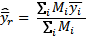 Equation 1

The variance estimator is (Lohr 2010)

 =  Equation 2

Unbiased Estimator

If the area of the sample frame is known, the unbiased estimator for the population average per plot (Thompson 2002) is

 =  , Equation 3

where

 =  . Equation 4

The variance estimator is (Thompson 2002)

 =  Equation 5

where

 = . Equation 6

Aggregating Data

For areas or communities with more than one sampling frame (e.g., the wet forest of HAVO and NPSA), we may want to aggregate the data for the entire area, not just a particular sampling frame. In this case, the standard formulas for stratified random sampling apply where each sampling frame represents a different stratum within the plant community. Following from Skalski (2005), the formula to estimate the overall population mean from strata (or analogously, the invasive species mean from multiple sampling frames) is:

 Equation 7

where  = estimate of the *g*th strata (mean species richness or frequency [sample proportion])

 = area of the *g*th stratum,

*L* = number of strata in the sampling frame, and

 =  = weight of the *g*th stratum.

The variance of  is

 Equation 8

Trends

For nonnative plant species richness, parametric paired t-tests are used to assess changes between the first two sampling periods if data meet the standard assumptions of normality and homogeneity of variance. It is the normality of residuals (not the normality of the raw data) that is required for significance testing (Kery and Hatfield 2003). For a paired t-test, it is the differences that are assumed consistent with a normal distribution.

For both species frequency and species cover class data, the general process is to fit two models that differ only in the inclusion (full model) or exclusion (reduced model) of year to the data and compare the output using an appropriate trend test. The best test may differ among species depending on the univariate distribution of the data. A significant p-value indicates that there is a significant change in the variable between years. For frequency data, the models used are logit models (a non-linear mixed model) with a zero-inflated beta distribution. For species cover class data, proportional odds models are used instead. For all variables, trends that yield a p-value of less than 0.1 (p < 0.1) are deemed significant for our purposes. Based on initial monitoring data, the project lead will choose which species or groups of species are appropriate for analysis.

After three or more years the trend model selection will be conducted for richness, frequency and cover data. Several trend tests will be considered. A linear mixed model approach will be used if the outcomes of interest or a transformed version meet the assumptions of independent, normally-distributed, and homoscedastic errors. For this analysis, a Wald-type t-test with Satterthwaite degrees of freedom will provide the basis for the trend test (Piepho and Ogutu, 2002; Spilke et al. 2005). Seasonal fixed effects and higher-order effects of time may also be incorporated into the mixed model. If residuals from the mixed model do not satisfy the required assumptions, then time series analyses which account for autocorrelation may be explored by incorporating correlated covariance structures. In addition to parametric approaches or in lieu of parametric approaches when the assumptions may not be met, nonparametric tests such as the Season Kendall Test (Hirsch and Slack 1984) for a given site or the Regional Kendall Test (Helsel and Frans, 2006) across sites may be conducted.

Species Richness

Since we are interested in transect level richness, we first average the plot richness values for each transect. The central limit theorem implies that the transect level mean richnesses will be approximately normal because they are based on averages of plot level species richness. Then, we use mixed model ANOVA to test for differences over years with transects being random and years being fixed. The underlying model is

 Equation 9

where is the average richness in year *j* for transect *i*,

*µ* is the overall mean,

*ai*is the random effect of the *i*-th randomly selected transect,

*γj* is the fixed effect of the *j*-th year, and

*eij* is random residual error.

Note that and .

The hypotheses of interest are  To demonstrate the analysis of variance (ANOVA) method, we used data from Ainsworth et al. (2008), a pilot study employing five transects with 5 x 50 m contiguous plots that were surveyed for nonnative species presence in 2000 and in 2008. We could also have used a paired t-test since there were only two years of data. The average richness data for each transect and year are presented in Table 2 and the output from the ANOVA is presented in Figure 1. The average nonnative species richness per plot in 2008 is estimated as 1.6 which is 0.64 species greater than in 2000 (*p* = 0.0589). In this study the variation among transects is 1.44, ten times the residual variance of 0.15. This indicates that adding transects would improve the sampling design to better represent the population; the Established Invasive Plant Species Monitoring Protocol has four times as

Table 2. Average target invasive species richness for Ainsworth et al. (2008).

|  |  |  |  |
| --- | --- | --- | --- |
| **Observation** | **Year** | **Transect** | **Average Richness** |
| 1 | 2000 | 1 | 0.70 |
| 2 | 2000 | 2 | 0.00 |
| 3 | 2000 | 3 | 0.57 |
| 4 | 2000 | 4 | 1.11 |
| 5 | 2000 | 5 | 2.58 |
| 6 | 2008 | 1 | 1.20 |
| 7 | 2008 | 2 | 0.38 |
| 8 | 2008 | 3 | 0.78 |
| 9 | 2008 | 4 | 1.61 |
| 10 | 2008 | 5 | 4.17 |

Linear mixed model fit by REML

Formula: MeanRichness ~ Y1 + (1 | Transect)

Data: MeanRichness

AIC BIC logLik deviance REMLdev

30.74 31.95 -11.37 22.17 22.74

Random effects:

Groups Name Variance Std.Dev.

Transect (Intercept) 1.43885 1.19952

Residual 0.14927 0.38635

Number of obs: 10, groups: Transect, 5

Fixed effects:

Estimate Std. Error t value

(Intercept) 1.6280 0.5636 2.889

Y1TRUE -0.6360 0.2443 -2.603

Correlation of Fixed Effects:

(Intr)

Y1TRUE -0.217

Figure 1. Mixed-model analysis of variance for change in species richness over time for Ainsworth et al. 2008. The change in mean is significant (p = 0.059). Output from SAS software (2008).

many transects. These data demonstrate how we can determine if target nonnative species richness has changed over time in each proposed sample frame. After three sampling occasions, linear trends may be examined in a linear mixed model regression analysis. Then directional change may be assessed rather than just any change.

When transects from different sampling frames are analyzed together (e.g., multiple wet forest strata within NPSA), we include a blocking (stratification) term for this effect in the model,

 Equation 10

where *i* is the blocking effect of the *i*-th area and

the subscript *j(i)* indicates that transects are nested within areas.

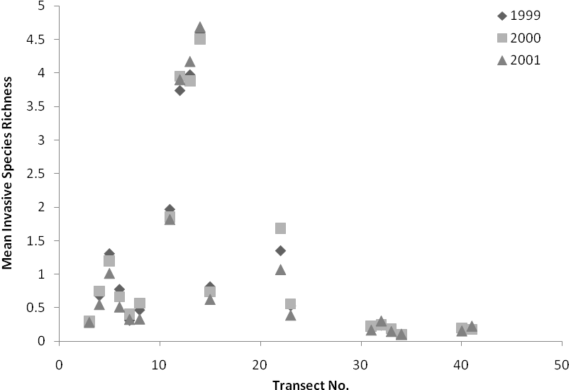  
Figure 2. Average nonnative species richness for Jacobi and Bio (2001). Transects 3-8 were located in the Mauna Loa Boys’ School, 11-15 in Pu‘u Kipu, and 22-41 in Kīlauea Forest.

The Mixed Procedure

Class Level Information

Class Levels Values

Area 3 KF MLBS PK

Year 3 1999 2000 2001

transect 19 3 4 5 6 7 8 11 12 13 14 15

22 23 31 32 33 34 40 41

Cov Parm Group Estimate

transect Area KF 0.1800

transect Area MLBS 8.3933

transect Area PK 0.09767

Residual 0.01114

Solution for Fixed Effects

Standard

Effect Year Estimate Error DF t Value Pr > |t|

Intercept 0.4716 0.1003 18 4.70 0.0002

Year 1999 0.06085 0.03424 36 1.78 0.0840

Year 2000 0.07404 0.03424 36 2.16 0.0373

Year 2001 0 . . . .

Type 3 Tests of Fixed Effects

Num Den

Effect DF DF F Value Pr > F

Year 2 36 2.66 **0.0836**

Figure 3. Mixed-model analysis of variance for change in species richness over time in three study areas for Jacobi and Bio 2001. The change in mean between 1999 and 2001 as well as 2000 and 2001 are significant (p = 0.08, p = 0.037 respectively). Output from SAS software (2008).

Data from a nonnative species transect based pilot study by Jacobi and Bio (2001) demonstrate how to combine analysis over sampling areas within a single community type into an overall test of trend. For this study, three wet forest areas were sampled in 1999, 2000, and 2001 along transects with 3 x 10 m contiguous plots. Nonnative richness was similar across the study areas

except for three of the five transects at Mauna Loa Boys’ School (MLBS) (fig. 2). It is important to stratify (or block) these data by area to accommodate for the observed variability and still test for an overall trend. A mixed model analysis of variance for the 57 average richnesses shows the changes in estimated average richness between 1999 and 2001 as well as 2000 and 2001 are significant (p = 0.08, p = 0.037 respectively). The estimated average richness for 2001 was 0.47 species which is slightly lower than in 2000 (0.53 species) and 1999 (0.55 species). Note that the ANOVA output (fig. 3) includes four variance components – one for each area plus the residual. As expected, the variance for MLBS is high supporting the decision to stratify the data by area for analyses. These data demonstrate how we can determine if target nonnative species richness has changed over time for multiple sampling frames across a community type.

Frequency

Many of the species exhibit zero inflation in transect-by-year level means (table 3). For univariate analyses of species-level cover data, the appropriate model for each outcome must be identified and the most powerful test should be used to detect significant trend. When annual transect means do not demonstrate zero inflation, standard methods such as a *t*-test may be appropriate. When annual transect means do exhibit zero inflation, then the zero-inflated beta distribution (Opsina and Ferrari, 2010) may be a suitable model.

Table 3. Average target invasive species richness for Ainsworth et al. (2008).

|  |  |  |  |
| --- | --- | --- | --- |
| **Species** | **Proportion of zeros at the Transect and Year level** | **Species** | **Proportion of zeros at the Transect and Year level** |
| Adrrip | 0.8 | Hypmut | 0.6 |
| Anehup | 0.8 | Junpla | 0.8 |
| Arubam | 0.9 | Pasedu | 0.9 |
| Budasi | 0.9 | Paslig | 0.9 |
| Carfle | 0.8 | Pastar | 0.7 |
| Conbon | 0.9 | Phatan | 0.6 |
| Cracre | 0.6 | Plamaj | 0.5 |
| Cupcar | 0.8 | Psicat | 0.1 |
| Cyp.spp | 0.1 | Rubell | 0.7 |
| Deppet | 0.7 | Rubros | 0.4 |
| Ereval | 0.7 | Selkra | 0.3 |

The zero-inflated beta (0-beta) distribution is a mixture of a point mass at zero and a beta random variable with range 0<p<1. The parameters of this distribution include *p0*, the proportion of zeros, and the parameters of the beta distribution. We take the beta parameters to be its mean, *μ*, and scale parameter, . We then use a logit model (a non-linear mixed model) to fit the data for *p0* and *µ*. That is, we assume that

 Equation 11

where γ0 is the intercept

*tri* is the random effect of the *i*-th transect, and

γj is the effect of year *j*.

Also,

 Equation 12

where *β*0 is the intercept

*ci* is the random effect of the *i*-th transect, and

*βj* is the effect of year *j*.

Therefore, the mean of p>0 has a logit-linear model in transect and year effects.

Under these two models, our null hypothesis is

 Equation 13

where *T* is the number of years sampled.

The null hypothesis states that year does not affect the proportion of zeros or the mean of the non-zeros. Alternatively, if we are interested in a linear increase or decrease over years, we would use the models

 Equation 14

and

 Equation 15

where *t* denotes the year. Note that the term  in Equation 14 is a fixed slope term and differs from the fixed year effect for year 1 as defined in Equation 11. The definitions of  in Equations 12 and 14 differ analogously.

The null hypothesis states that there is not a linear increase or decrease in either the proportion of zero plots or the mean proportion among nonzero plots for a given species:

H0: γ1=0 and β1=0. Equation 16

To combine data from multiple areas or sampling frames, we must account for the areas in the model. To do this, we added a sample area term yielding:

 Equation 17

and

. Equation 18

Using frequency data for *Psidium cattleianum* (PSICAT) from Ainsworth et al. (2008) (table 4), we demonstrate one way to test the null hypothesis that frequency or the proportion occupied by PSICAT did not change over time. An arcsine-square root transformation is used to meet assumptions of normality. A paired t-test is used to compare the transformed PSICAT means from each year by transect to examine an effect in the year term between the two years. The test results indicate a significant year effect between 2000 and 2008 (t-statistic = -3.557, df = 4, p-value = 0.0237) at the 0.10 level. A simple linear regression model was used to obtain residuals for evaluation and diagnostics indicated that residuals were approximately normal with homogeneous spread.

**Table 4.** Frequency or proportion of plots containing *Psidium cattleianum* (PSICAT) from Ainsworth et al. (2008).

|  |  |  |
| --- | --- | --- |
| **Transect** | **% PSICAT** | |
| **2000** | **2008** |
| 1 | 0.100 | 0.400 |
| 2 | 0.000 | 0.222 |
| 3 | 0.053 | 0.053 |
| 4 | 0.056 | 0.333 |
| 5 | 0.412 | 0.941 |

Using frequency data for *Passiflora tarminiana* (PASTAR) from Ainsworth et al. (2008) (table 5), we examine another approach to trend detection. Residuals from a simple linear regression of the transect factor and the indicator for a single year on the annual transect-level means exhibit non-normality. Using a zero-inflated beta distribution which is appropriate for rates and proportions that are also subject to zero inflation (Opsina and Ferrari, 2010), we fit two separate non-linear mixed models that differed only in the inclusion (full model) or exclusion (reduced model) of the variable for year and computed the log likelihoods for each model. Then using the likelihood ratio test, we compared the log-likelihoods of the two models. In this case, there was no significant difference between the models (p = 0.3193), so we conclude that PASTAR did not significantly change between years. The R code for calculating the likelihood ratio test is presented at the end of SOP 19.

**Table 5.** Frequency or proportion of plots containing *Passiflora tarminiana* (PASTAR) from Ainsworth et al. (2008).

|  |  |  |
| --- | --- | --- |
| **Transect** | **% PASTAR** | |
| **2000** | **2008** |
| 1 | 0.000 | 0.000 |
| 2 | 0.000 | 0.000 |
| 3 | 0.000 | 0.000 |
| 4 | 0.000 | 0.056 |
| 5 | 0.059 | 0.412 |

While trends may be measured on other temporal scales (e.g. quadratic, cyclic), trends for triggering management action will contain a significant linear component that implies a directional change in the outcome of interest (Urquhart and Kincaid 1999). When three or more years of monitoring data are available, then a linear slope will replace the individual year effects in the parametric trend model. The slope effect will measure the linear rate of change of the population outcome. A fixed slope effect can be used in any of the regression modeling approaches for trend as well as the zero-inflated models.

Cover Class

There are eight total cover classes. Research on trend detection of abundance measures from ordinal cover classes indicates that as high as a 15-point cover class scale may be effective for skewed populations (Irvine and Rodhouse, 2010). If cover classes can be determined accurately, then combining classes will be possible to increase within-class observations. Alternatively, methods to account for zero inflation are also considered. Trends in cover class data may be detected with ordinary or generalized least squares only if the assumptions of constant variance and linearity are met (Agresti, 2010) or can be detected with the proportional odds logistic regression model (Irvine and Rodhouse, 2010). A linear effect of time is modeled as the slope coefficient to the year term in the model and can be used in standard linear modeling or in the proportional odds logistic regression model.

The cover class data are categorical instead of continuous; therefore we must use a different model to fit these data than those used for the presence data. Our preferred model is the proportional odds model also known as the ordered logit model. For the full model, we assume

 Equation 19

where p*k* represents the probability of category *k,*

γ0 is the intercept,

*tri* is the random effect of the *i*-th transect, and

γj is the effect of year *j*.

As for the frequency trend analysis, we also fit a reduced model with year excluded and then compare the models using the likelihood ratio test.

Literature Cited

Agresti, A. 2010. Analysis of ordinal categorical data. John Wiley and Sons: Hoboken, NJ.

Ainsworth, A., B. Stevens, L. Hadway, N. Agorastos, I. Cole, and C. M. Litton. 2008. Vegetation response to eight years of feral pig (Sus scrofa) removal in Pu‘u Maka‘ala Natural Area Reserve, Hawai‘i. State of Hawaii, Division of Forestry and Wildlife Unpublished Report, Hilo, Hawaii.

Buhl-Mortensen, L. 1996. Type-II statistical errors in environmental science and the precautionary principle. Marine Pollution Bulletin 32:528-531.

Gibbs, J.P., S. Droege, and P. Eagle. 1998. Monitoring populations of plants and animals. BioScience 48:935-940.

Helsel, D.R. and L.M. Frans. 2006. The Regional Kendall test for trend. Environmental Science and Technology 40:4066-4073.

Hirsch, R. A. and J. R. Slack. 1984. A nonparametric trend test for seasonal data with serial dependence. Water Resources Research 20:727-732.

Irvine, K.M. and T.J. Rodhouse. 2010. Power analysis for trend in ordinal cover classes: implications for long-term vegetation monitoring. Journal of Vegetation Science 21:1152-1161.

Jacobi, J. D. and K. Bio. 2001. Invasive plant species surveys, Olaa-Kilauea Management Area. Department of the Interior, US Geological Survey, Biological Resources Division, Kilauea Field Station Unpublished Report, Hawaii National Park, Hawaii.

Kery, M. and J. S. Hatfield. 2003. Normality of raw data in general linear models: the most widespread myth in statistics. Bulletin of the Ecological Society of America 84:92-94.

Lohr, S. L. 2010. Sampling: Design and Analysis. Brooks/Cole, Cengate Learning, Boston, MA.

Mapstone, B.D. 1995. Scalable decision rules for environmental impact studies: effect size, Type I, and Type II errors. Ecological Applications 5:401-410.

Opsina, R. and S.L.P. Ferrari. 2010. Inflated beta distributions. Statistical Papers 51: 111-126.

Piepho, H.P. and J.O. Ogutu. 2002. A simple mixed model for trend analysis in wildlife populations. Journal of Agricultural, Biological, and Environmental Statistics 7:350-360.

SAS software, Version 9.2 of the SAS System for Windows XP. Copyright © 2008 SAS Institute Inc. SAS and all other SAS Institute Inc. product or service names are registered trademarks or trademarks of SAS Institute Inc., Cary, NC, USA.

Schneider, D. 2007. Example of Generalized Model (GzLM) Using Splus. National Park Service, Pacific Island Network Unpublished Report, Hawaii National Park, Hawaii.

Skalski, J. R. 2005. Long-term monitoring: Basic study designs, estimators, and precision and power calculations. National Park Service, Pacific Island Network Unpublished Report, Hawaii National Park, Hawaii.

Spilke, J., H.P. Piepho, and X. Hu. 2005. Analysis of unbalanced data by mixed linear models using the MIXED procedure of the SAS system. Journal of Agronomy and Crop Science 191:47-54.

Thompson, S. K. 2002. Sampling. John Wiley and Sons, New York, NY.

Urquhart, N.S. and T.M. Kincaid (1999). Designs for detecting trend from repeated surveys of ecological resources. Journal of Agricultural, Biological, and Environmental Statistics 4:404-414.

Code in R for Calculating the Likelihood Ratio Test for Pastar Frequency Data

**Likelihood Ratio Test R Code**

# Read in data file

AkuPlot<-read.table("Aku_All.txt", header=TRUE, sep="\t")

names(AkuPlot)

# Download the following libraries into R

library(gamlss)

library(betareg)

# Copy and paste these functions into R for summarizing results:

expit<-function(x) ifelse(x>700,1,exp(x)/(1+exp(x)))

logit<-function(x) log(x/(1-x))

AkuLik <-function(parms,vars, data, full=TRUE, ymat){

tmp<-rep(0,7)

names(tmp)<-c("const.p","const", "Y1.p", "Y2.p", "Y1", "Y2", "phi")

tmp[vars]<-parms

Rows<- dim(data)[1]

Y1<- data$Y1

Y2<- data$Y2

ones <-rep(1,Rows)

# Model detection probs:

if(full==TRUE) etap<- tmp[3]*Y1 + tmp[4]*Y2

if(full==FALSE) etap<- tmp[1]*ones

p0 <- 1/(1+exp(-etap))

q0 <- 1-p0

# Model occupancy rates

if(full==TRUE) eta<- tmp[5]*Y1 + tmp[6]*Y2

if(full==FALSE) eta<- tmp[2]*ones

mu <- 1/(1+exp(-eta))

prob<- rep(1,Rows)

phi<- tmp[7]

# Calc Log likelihood

print(p0)

prob<- dBEZI(x=ymat, mu=mu, sigma=phi, nu=p0, log=TRUE)

-sum(prob)

}

ResidDiagnostic<-function(fit) {

par(mfrow=c(2,2))

plot(fitted(fit), resid(fit))

qqnorm(resid(fit))

hist(resid(fit))

}

# Psicat

# Calculate transect-level means

Psicat_means<-tapply(AkuPlot$Psicat, list(AkuPlot$Year, AkuPlot$Transect), mean)

# Create data set for trend analysis

Psicat<-data.frame(cbind(Transect=c(1,1,2,2,3,3,4,4,5,5), Year=rep(c(2000,2008),5), Y1= rep(c(1,0),5), Y2= rep(c(0,1),5), Psicat= matrix(Psicat_means,10,1)))

names(Psicat)[5]<-"Psicat"

# Psicat$asPsicat<-asin(sqrt(Psicat$Psicat))

Psicat$Transect<-as.factor(Psicat$Transect)

Psicat$Y1<- Psicat$Year==2000

fit.1<-lm(asPsicat~Y1+ Transect, data = Psicat)

summary(fit.1)

ResidDiagnostic(fit.1)

# From R output

summary(fit.1)

*Call:*

*lm(formula = asPsicat ~ Y1 + Transect, data = Psicat)*

*Coefficients:*

*Estimate Std. Error t value Pr(>|t|)*

*(Intercept) 0.68929 0.12808 5.382 0.00576 \*\**

*Y1TRUE -0.37210 0.10458* ***-3.558 0.02363 \****

*Transect2 -0.25779 0.16536 -1.559 0.19400*

*Transect3 -0.27176 0.16536 -1.643 0.17563*

*Transect4 -0.07652 0.16536 -0.463 0.66757*

*Transect5 0.50802 0.16536 3.072 0.03721 \**

*---*

*Residual standard error: 0.1654 on 4 degrees of freedom*

*Multiple R-squared: 0.9132, Adjusted R-squared: 0.8047*

*F-statistic: 8.418 on 5 and 4 DF, p-value: 0.03014*

# Residuals

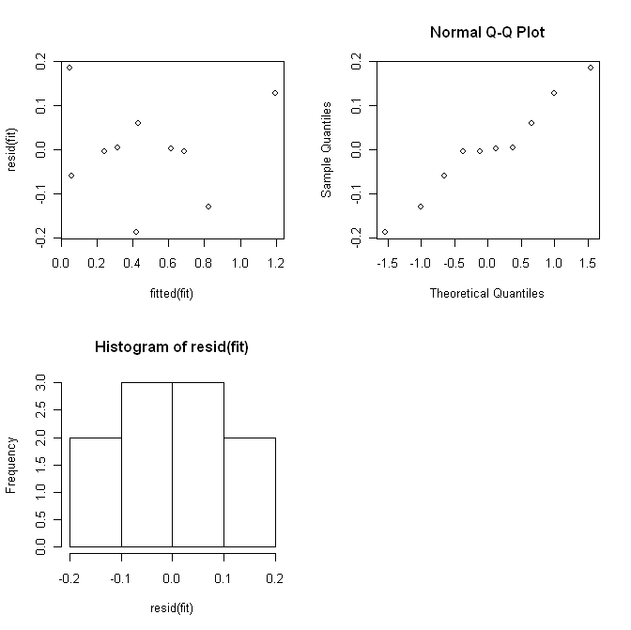

# Pastar

# Calculate transect-level means

Pastar_means<-tapply(AkuPlot$Pastar, list(AkuPlot$Year, AkuPlot$Transect), mean)

# Create data set for trend analysis

Pastar<-data.frame(cbind(Transect=c(1,1,2,2,3,3,4,4,5,5), Year=rep(c(2000,2008),5), Y1= rep(c(1,0),5), Y2= rep(c(0,1),5), Pastar= matrix(Pastar_means,10,1)))

names(Pastar)[5]<-"Pastar"

Pastar$asPastar<-asin(sqrt(Pastar$Pastar))

Pastar$Transect<-as.factor(Pastar$Transect)

Pastar$Y1<- as.numeric(Pastar$Year==2000)

Pastar$Y2<- as.numeric(Pastar$Year==2008)

fit.2a<-lm(Pastar ~Y1+ Transect, data = Pastar)

summary(fit.2a)

*Call:*

*lm(formula = Pastar ~ Y1 + Transect, data = Pastar)*

*Residuals:*

*1 2 3 4 5 6 7 8*

*0.04085 -0.04085 0.04085 -0.04085 0.04085 -0.04085 0.01307 -0.01307*

*9 10*

*-0.13562 0.13562*

*Coefficients:*

*Estimate Std. Error t value Pr(>|t|)*

*(Intercept) 4.085e-02 8.409e-02 0.486 0.653*

*Y1TRUE -8.170e-02 6.866e-02* ***-1.190 0.300***

*Transect2 1.659e-18 1.086e-01 0.000 1.000*

*Transect3 -8.233e-18 1.086e-01 0.000 1.000*

*Transect4 2.778e-02 1.086e-01 0.256 0.811*

*Transect5 2.353e-01 1.086e-01 2.167 0.096 .*

*---*

*Signif. codes: 0 ‘***’ 0.001 ‘**’ 0.01 ‘*’ 0.05 ‘.’ 0.1 ‘ ’ 1*

*Residual standard error: 0.1086 on 4 degrees of freedom*

*Multiple R-squared: 0.6824, Adjusted R-squared: 0.2853*

*F-statistic: 1.719 on 5 and 4 DF, p-value: 0.3099*

ResidDiagnostic(fit.2a)

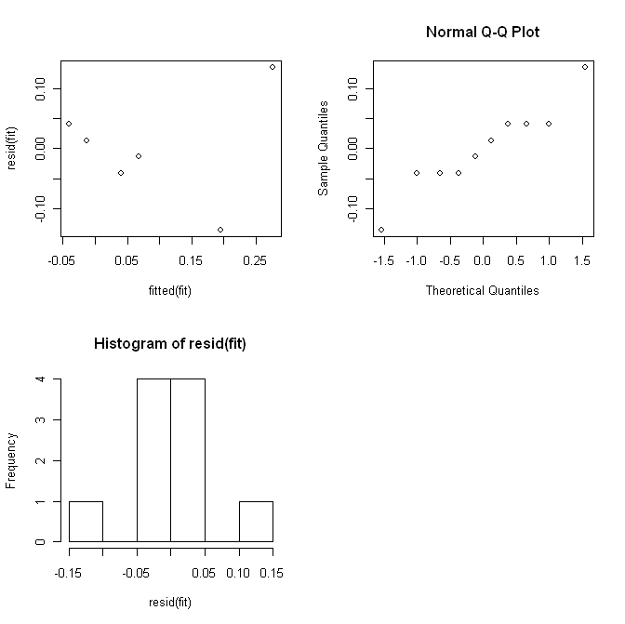

# Fit with arcsine-square root transformation

fit.2b<-lm(asPastar ~Y1+ Transect, data = Pastar)

summary(fit.2b)

*Call:*

*lm(formula = asPastar ~ Y1 + Transect, data = Pastar)*

*Residuals:*

*1 2 3 4 5 6 7 8*

*0.06897 -0.06897 0.06897 -0.06897 0.06897 -0.06897 -0.05000 0.05000*

*9 10*

*-0.15689 0.15689*

*Coefficients:*

*Estimate Std. Error t value Pr(>|t|)*

*(Intercept) 6.897e-02 1.114e-01 0.619 0.5695*

*Y1 -1.379e-01 9.098e-02 -1.516 0.2041*

*Transect2 -5.032e-18 1.438e-01 0.000 1.0000*

*Transect3 -1.562e-17 1.438e-01 0.000 1.0000*

*Transect4 1.190e-01 1.438e-01 0.827 0.4547*

*Transect5 4.708e-01 1.438e-01 3.273 0.0307 \**

*---*

*Signif. codes: 0 ‘***’ 0.001 ‘**’ 0.01 ‘*’ 0.05 ‘.’ 0.1 ‘ ’ 1*

*Residual standard error: 0.1438 on 4 degrees of freedom*

*Multiple R-squared: 0.8212, Adjusted R-squared: 0.5977*

*F-statistic: 3.674 on 5 and 4 DF, p-value: 0.1157*

ResidDiagnostic(fit.2b)

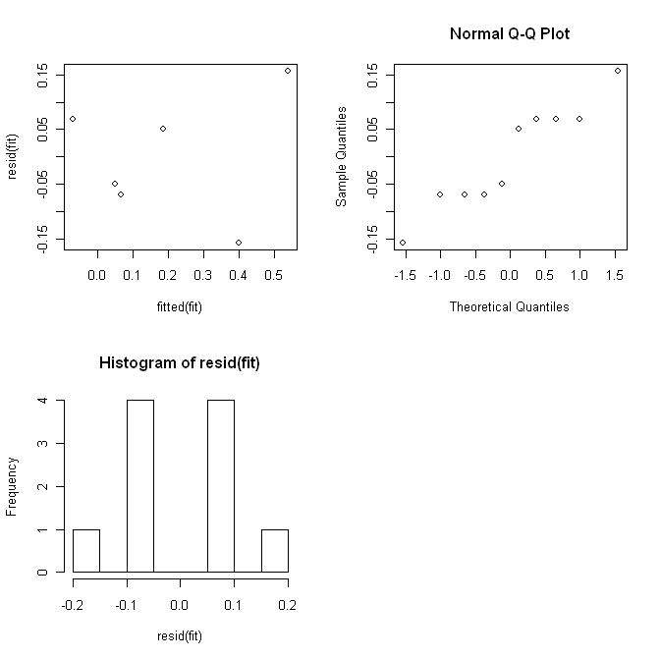

# Residuals do not exhibit normality due to zero inflation

# Zero-inflated beta analysis

# Obtain starting values for the parameters

# Starting values – full model = cell means model by year

fit.full.p<-glm((Pastar==0)~ -1+ Y1+ Y2, family = binomial, data= Pastar)

summary(fit.full.p)

*Coefficients:*

*Estimate Std. Error z value Pr(>|z|)*

*Y1 1.3863 1.1180 1.240 0.215*

*Y2 0.4055 0.9129 0.444 0.657*

fit.full.mu<-betareg(Pastar ~ -1 + Y1 +Y2, data= Pastar[Pastar$Pastar>0,])

summary(fit.full.mu)

*Coefficients (mean model with logit link):*

*Estimate Std. Error z value Pr(>|z|)*

*Y1 -2.0734 0.9768 -2.123 0.0338 \**

*Y2 -1.3084 0.6014 -2.176 0.0296 \**

*Phi coefficients (precision model with identity link):*

*Estimate Std. Error z value Pr(>|z|)*

*(phi) 6.820 5.583 1.222 0.222*

# Starting values – reduced model = equal mean for all years

fit.red.p<-glm((Pastar==0)~ 1, family = binomial, data= Pastar)

summary(fit.red.p)

*Coefficients:*

*Estimate Std. Error z value Pr(>|z|)*

*(Intercept) 0.8473 0.6901 1.228 0.220*

fit.red.mu<-betareg(Pastar ~ 1, data= Pastar[Pastar$Pastar>0,])

summary(fit.red.mu)

*Coefficients (mean model with logit link):*

*Estimate Std. Error z value Pr(>|z|)*

*(Intercept) -1.5303 0.5783 -2.646 0.00814 \*\**

*Phi coefficients (precision model with identity link):*

*Estimate Std. Error z value Pr(>|z|)*

*(phi) 5.705 4.643 1.229 0.219*

# Obtain maximum likelihood estimates of the coefficients for the

# logistic regression models of the parameters of the zero-

# inflated beta distribution

names(tmp)<-c("const.p","const", "Y1.p", "Y2.p", "Y1", "Y2", "phi")

v.full= c("Y1.p", "Y2.p", "Y1", "Y2", "phi")

x.full<-nlm(AkuLik, p= unlist(c(fit.full.p$coef, fit.full.mu$coef[1], fit.full.mu$coef[2])),vars=v.full, data=Pastar, full=TRUE, ymat=Pastar$Pastar, hessian=TRUE)

x.full

v.red= c("const.p","const","phi")

x.red<-nlm(AkuLik, p= unlist(c(fit.red.p$coef, fit.red.mu$coef[1], fit.red.mu$coef[2])),vars=v.red, data= Pastar, full=FALSE, ymat=Pastar$Pastar, hessian=TRUE)

x.red

# Hypothesis test for effect of year

LR.full<- x.full$minimum

LR.red<- x.red$minimum

LRT.stat<- 2*(LR.red-LR.full)

LRT<-1-pchisq(LRT.stat,1)

round(cbind(LRT.stat, LRT.pvalue=LRT), 4)

LRT.stat LRT.pvalue

0.9920 **0.3193**

Standard Operating Procedure (SOP) #20

Reporting

Version 1.0 (April 27, 2010)

Change History

|  |  |  |  |  |
| --- | --- | --- | --- | --- |
| **Version #** | **Date** | **Revised by** | **Changes** | **Justification** |
|  |  |  |  |  |
|  |  |  |  |  |
|  |  |  |  |  |
|  |  |  |  |  |
|  |  |  |  |  |

Only changes in this specific SOP will be logged here. Version numbers will be incremented by a whole number (e.g., Version 1.3 to Version 2.0) when a change is made that significantly affects requirements or procedures. Version numbers will be incremented by decimals (e.g., Version 1.6 to Version 1.7) when there are minor modifications that do not affect requirements or procedures for publication in the series.

Purpose

This SOP provides an overview of the types of reports produced by the Pacific Island Network (PACN) Established Invasive Plant Species Monitoring Protocol. It also provides detailed information on generating the annual and five-year monitoring reports. The purpose of the annual report is to summarize data for the current year, as well as compare the data of the current year with data from previous years. The five-year analysis report takes a more comprehensive approach, examining data of each year with respect to other plant communities, parks, the PACN network, and if possible the Pacific Region. These reports should be produced under the direction of the project lead.

Report Types

The annual and 5-year monitoring reports are part of a broad set of report categories, including (1) protocol reviews, (2) monitoring reports, (3) scientific writing and presentations, (4) management briefings, (5) website communication, and (6) interpretation and outreach. Table 1 describes these report types and their purpose, audiences, responsible parties, production frequency, and review processes.

| **Table 1.** Summary of anticipated products from Established Invasive Plant Species Monitoring Protocol, grouped by type and frequency. | | | | | |
| --- | --- | --- | --- | --- | --- |
| **Type of Report** | **Purpose of Report** | **Targeted Audience** | **Initiated by** | **Frequency of Reporting** | **Review Process** |
| **1. Protocol Review** | | | | | |
| Protocol Review Reports | Document progress made and challenges encountered, where actual procedures fall short or exceed expectations, recommend necessary changes. Document changes since last protocol review report. Document the overall quality of protocol in terms of protocol objectives and implementation, effectiveness, and data management. | Superintendents, park resource staff, Inventory and Monitoring Program (I&M) staff, external scientists, partners | Project Lead | Preliminary report within 1-3 years of implementation and at 5-year intervals after each monitoring cycle. May be possible to include this review in the 5-year Monitoring Report. | Peer review at network and regional level |
| **2. Monitoring Reports** | | | | | |
| Vital Signs Reports, Including Status and Trend Information | Document annual monitoring activities and survey effort, describe current resource status, discuss patterns and trends of monitored resources, present data analysis results. Document changes in monitoring protocol, communicate monitoring efforts to resource managers. For the 5-year report, use a more comprehensive scale of analysis including multiple plant communities, parks, networks and regions. Also include an evaluation of sampling effort with respect to the monitoring objectives (i.e., power analysis). | Park resource staff, PACN staff, external scientists, partners | Project Lead | Annual reports compiled by April 30 each year. 5-year reports compiled by April 30 after each complete monitoring cycle. | Peer review at network level |
| Summary of Vital Sign Reports | Same as annual “Vital Signs Reports” above, but highlights key points for non-technical audiences. Usually this is a bulleted list. | Superintendents, NPS interpreters, public, partners | Project Lead | Annually, compiled by April 30 each year | Peer review at network level |
| PACN contribution to NPS-wide “State of the Parks” Report | Describes current conditions of park resources, reports interesting trends and highlights of monitoring activities, identifies resource issues of concern, explores future issues and directions | Congress, budget office, NPS leadership, Superintendents, general public | Compiled by the Washington Support Office (WASO) from data provided by networks | Annual | Peer review at national level |
| **3. Scientific Writing and Presentations**  (Continued) | |  |  |  |  |
| PACN Vital Signs Monitoring Conference | Review and summarize information on this Vital Sign, help identify emerging issues and generate new ideas | Park resource staff, network staff, external scientists, partners | Project Lead, park scientists | Biennial | Peer review at national level |
| Scientific journal articles and book chapters | Document and communicate advances in knowledge, provides a broader perspective on quality assurance and peer review | External scientists, Park resource managers, and professional staff | Project Lead, park scientists | Variable | Peer review according to journal or book standards |
| Other symposia, conferences and workshops | Review and summarize information on this Vital Sign, help identify emerging issues and generate new ideas | External scientists, professional staff, Park resource managers, and other resource managers. | Project Lead, park scientists | Variable (e.g., Hawai‘i Conservation Conference) | Peer review at network level; for papers may also be peer reviewed |
| **4. Management Briefings** | |  |  |  |  |
| Executive briefings | Update Superintendents and other VIPs on park-specific findings and potential resource issues; suggest action items where appropriate | Individual Superintendents and other VIPs | Project Lead, Network Coordinator | As needed | Peer review by network and monitoring staff |
| **5. Website Posting** |  |  |  |  |  |
| Web-based media | Centralized repository of all final reports and information to ensure products are easily accessible in commonly-used electronic formats (See SOP #18 “Product Posting and Distribution”) | Superintendents, Park resource staff, PACN staff, external scientists, partners, public | Typically the Data Manager | As media is completed | Peer review at network level to NPS web standards as finalized, reviewed products |
| **6. Interpretation and Outreach** | |  |  | (Continued) |  |
| Science Days | Communicate main monitoring findings as well as underlying data; discuss potential significance for management, further monitoring, potential additional research needs, and for outreach | Superintendents, park resource staff, PACN staff, protocol managers, partners, public | Project Lead, Technicians, and others as needed | Variable by park, annual when possible | Meeting / presentation itself is a form of review |
| Interpretive Conversations | Interactive conversations with park interpretive staff to discuss main monitoring findings as well as underlying data; discuss potential significance for management, further monitoring, potential additional research needs, and for outreach | Park interpretive staff, environmental educators, PACN staff | Project Lead, Technicians, and others as needed | Variable by park, annual when possible | Meeting / presentation itself is a form of review |
| Park Interpretive / outreach sessions | Review and summarize information on PACN Vital Signs; engage and involve greater participation in monitoring efforts | Park staff, public, partners | Project Lead, Technicians, and others as needed | Variable | Peer review by network, PICRP staff |
| Park staff meetings (results synthesis) | Communicate results to non-technical audiences, discuss potential significance for management, receive feedback on resource and monitoring issues in park operations | All park staff, volunteers, and partners | Project Lead, Technicians, and others as needed | Annually for each network park | Peer review by network |

Monitoring Reports

The annual and five-year monitoring reports are key elements in the reporting process. The list below provides information on producing these reports including minimal content requirements:

1. Reports should be written following the NPS Natural Resources Publications template, as described in SOP #17 “Product Delivery Specifications and Schedule.”
2. The annual and five-year Inventory and Monitoring Program (I&M) reports should be completed by April 30 in the year following the field season. See SOP #17 for the complete schedule of deliverables.
3. Report the following monitoring parameters for the current year, at a minimum:

* List of field crew members who performed the monitoring
* Detail of the survey effort (number of fixed and random stations sampled in each plant community and park)
* List of species detected in each plant community and park
* Summary statistics (i.e., richness, abundance, etc.) listed in SOP # 19 “Data Analysis.” If applicable, aggregate summary statistics for plant communities with more than one sampling frame (i.e., present statistics for each sampling frame and for the plant community as a whole).
* Trend assessments for variables with asterisks next to them (see table 1, SOP #19). Trend analysis should be conducted for these parameters after two years of data is available. The project lead should conduct or supervise this analysis, in consultation with a contract statistician if necessary.
* The current-year parameter values should be added to a table that lists similar measures for all monitored years.

1. Reports should include or be accompanied by maps of all sampling plot locations, including a table of UTM coordinates for all surveyed plots. Ideally many of the above plant community parameters should be presented in thematic maps to provide an indication of how these parameters vary spatially.
2. The 5-year report should provide the same information as the annual report, as well as:
   * Comparisons between different plant communities, parks, the PACN network as a whole, and if possible the Pacific Region (e.g., comparisons between wet forest plant community parameters at NPSA and wet forest parameters at HAVO, or a comparison of trends in native species density for all PACN parks).
   * A re-evaluation of sampling effort relative to the variability of parameters using standard power analysis to ensure that sample-size needs are sufficient to satisfy the sampling objectives. Power analysis should be used to determine if sampling effort should be adjusted to better achieve the objectives. Methods for power analysis as well as mathematical equations are provided in Appendix C “Sample Size and Power” and SOP #19 “Statistical Data Analysis” in the PACN Established Invasive Plant Species Monitoring Protocol.
   * An evaluation of the operational aspects of the monitoring protocol
3. The project lead should provide a copy of the report and associated data to the PACN data manager for archiving. See SOP #17 “Product Delivery Specifications and Schedule” for additional details on managing digital data and reports.

Standard Operating Procedure (SOP) #21

Revising the Protocol

Version 1.0 (April 27, 2010)

Change History

|  |  |  |  |  |
| --- | --- | --- | --- | --- |
| **Version #** | **Date** | **Revised by** | **Changes** | **Justification** |
|  |  |  |  |  |
|  |  |  |  |  |
|  |  |  |  |  |
|  |  |  |  |  |
|  |  |  |  |  |

Only changes in this specific SOP will be logged here. Version numbers will be incremented by a whole number (e.g., Version 1.3 to Version 2.0) when a change is made that significantly affects requirements or procedures. Version numbers will be incremented by decimals (e.g., Version 1.6 to Version 1.7) when there are minor modifications that do not affect requirements or procedures for publication in the series.

Purpose

This SOP explains how to make and document changes to the Pacific Island Network (PACN) Established Invasive Plant Species Monitoring Protocol narrative and associated Standard Operating Procedures (SOPs) for the Pacific Island Network. Anyone editing the Protocol Narrative or any one of the SOPs must follow this outlined procedure in order to eliminate confusion in how data is collected, managed, analyzed, or reported. All observers should be familiar with this SOP in order to identify and use the most current methodologies.

**Procedure**

The Established Invasive Plant Species Monitoring Protocol Narrative and associated SOPs for the Pacific Island Network represent our effort to document and employ scientifically rigorous methodologies for collecting, managing, analyzing, and reporting monitoring data and information. However, all protocols regardless of initial rigor require editing as new and different information becomes available. Required edits should be made in a timely manner and appropriate reviews undertaken. Careful documentation of changes to the protocol, and a library of previous protocol versions are essential for maintaining consistency in data collection, and for appropriate treatment of the data during data summary and analysis. The MS Access database for each monitoring component contains a field that identifies which protocol version was being used when the data were collected.

In this context of revising the protocol, the rationale for dividing this into a Protocol Narrative with supporting SOPs is based on the following:

* The Protocol Narrative is a general overview of the protocol that gives the history and justification for monitoring and an overview of the sampling methods, but does not provide all of the methodological details. The Protocol Narrative will only be revised if major changes are made to the protocol.
* The SOPs, in contrast, are very specific step-by-step instructions for performing a given task. They are expected to be revised more frequently than the protocol narrative.
* When a SOP is revised, in most cases, it is not necessary to revise the Protocol Narrative to reflect the specific changes made to the SOP.
* All versions of the Protocol Narrative and SOPs will be archived in a Protocol Library.

All edits require review for clarity and technical soundness. Small changes or additions to existing methods will be reviewed in-house by Pacific Island Network staff (e.g. version changes by hundredths). However, if a complete or major change in methods is sought, then an outside review may be required (e.g. version changes by whole numbers). When a major change in methodology is undertaken, either to the entire protocol or individual SOP or narrative components, The Pacific West Region Inventory and Monitoring Program coordinator will be consulted to determine the appropriate level of peer review required. Typically, Regional and National staff of the NPS, and outside experts in government, private sector, and academia with familiarity in invasive plant species monitoring in Pacific Islands will be utilized as reviewers.

1. Edits and revisions to the protocol narrative and associated SOPs will be documented by version in the Revision History Log that is found on the first page of each SOP and second page of the protocol narrative document. Only log changes in the specific protocol narrative or SOP being edited. Version numbers increase incrementally by hundredths (e.g., version 1.01, version 1.02, etc.) for minor changes. Major revisions should be designated with the next whole number (e.g., version 2.0, 3.0, 4.0, etc.). Record the previous version number, date of revision, author of the revision, identify paragraphs and pages where changes are made, and the reason for making the changes along with the new version number.
2. Inform the data manager about changes to the Protocol Narrative or SOP so the new version number can be incorporated in the project database metadata. The database may have to be edited by the data manager to accompany changes in the Protocol Narrative and SOPs.
3. Any changes to associated database design and organization are documented in the Metadata of the project database(s).
4. The appropriate PACN staff is notified of the changes and appropriate level review process initiated as determined in collaboration between the network staff and protocol principal investigator.
5. Once review comments are received and incorporated, post revised versions on the internet and forward copies to all individuals so they can replace the previous version of the effected Protocol Narrative or SOP. Provide a copy to the PACN data manager so it can be included in the network protocol library.

The Department of the Interior protects and manages the nation’s natural resources and cultural heritage; provides scientific and other information about those resources; and honors its special responsibilities to American Indians, Alaska Natives, and affiliated Island Communities.

NPS 988/113810, April 2012

|  |  |
| --- | --- |
|  | |
| National Park Service  U.S. Department of the Interior |  |

**Natural Resource Stewardship and Science**1201 Oakridge Drive, Suite 150  
Fort Collins, CO 80525

EXPERIENCE YOUR AMERICA TM

www.nature.nps.gov